Power BI Inventory Stock Analysis Dashboard
This document presents a Power BI dashboard used for analyzing inventory stock levels. The dashboard helps identify low stock, overstock, and healthy stock levels to support data-driven inventory management decisions.

Dashboard Screenshot
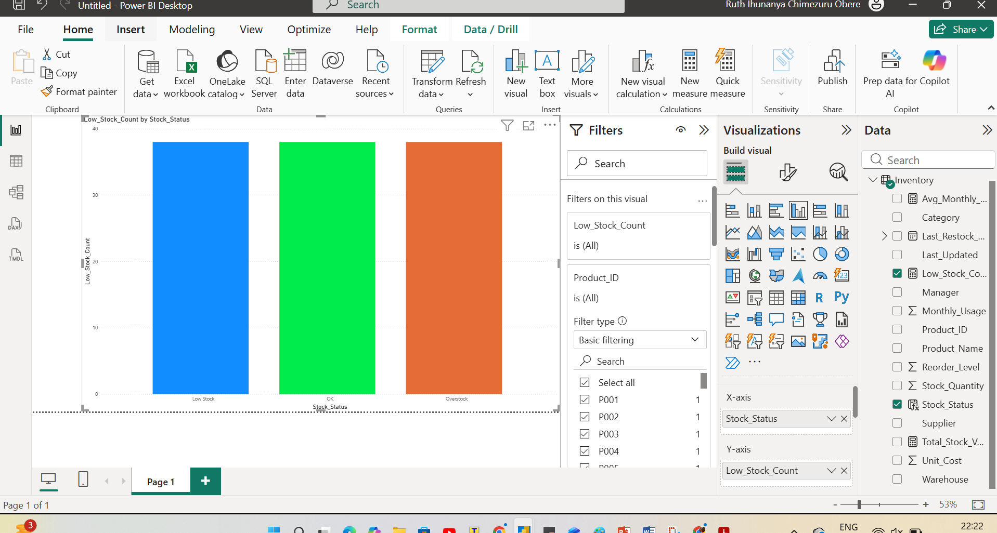

Dashboard Explanation
The bar chart shows the number of products by stock status. Low Stock indicates items needing restocking, OK shows healthy stock, and Overstock shows excess inventory.

Tools Used
- Microsoft Power BI Desktop
- DAX calculations
- Data modeling and filters

Business Value
The dashboard enables quick inventory monitoring, better restocking decisions, and improved operational efficiency.

