Power BI Product Price Comparison Dashboard
This document presents a Power BI dashboard that compares product prices across different retail stores. The dashboard helps identify which store offers cheaper prices for each product and supports cost-saving decisions.

Dashboard Screenshot
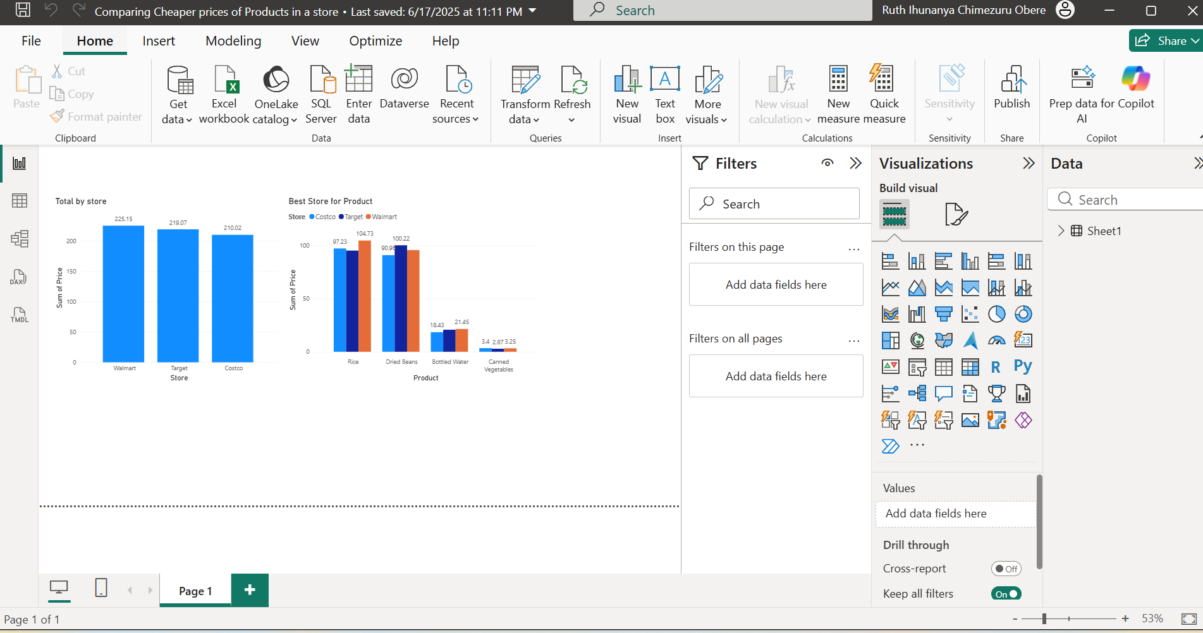

Dashboard Explanation
The dashboard contains bar charts that show the total price by store and a comparison of product prices across Walmart, Target, and Costco. This allows users to quickly see which store is the most affordable for specific products such as rice, beans, bottled water, and canned vegetables.

Tools Used
- Microsoft Power BI Desktop
- Excel dataset
- Data modeling and aggregation
- Bar chart visualizations

Business Value
This analysis helps consumers and businesses make informed purchasing decisions, reduce costs by selecting cheaper stores, and understand overall pricing patterns.

