Power BI Student Test Scores Dashboard
This project analyzes student performance data using Power BI. It focuses on understanding how reading and math scores vary across districts, states, grades, and extracurricular activities to support data-driven decisions in education.

Dashboard Screenshot
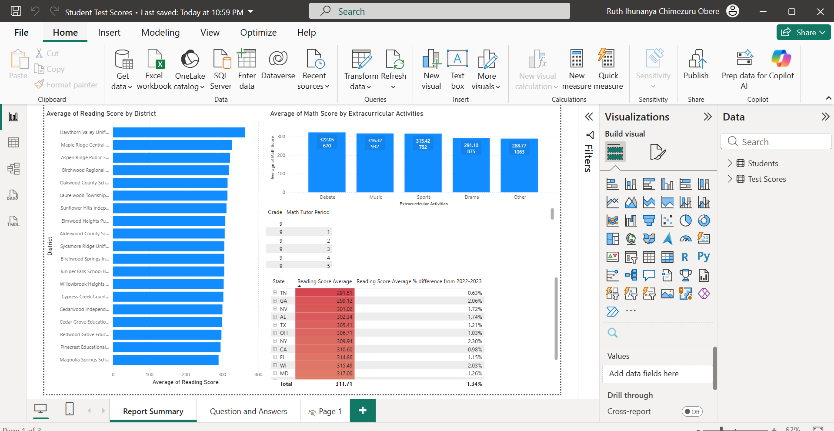

What the Dashboard Shows
- Average Reading Score by District
- Average Math Score by Extracurricular Activities
- Impact of Math Tutor Period by Grade
- State-level Reading Score Averages
- Percentage difference in reading scores compared to previous year

Tools Used
- Power BI Desktop
- DAX Measures
- Data Modeling and Visualizations

Business / Educational Value
The dashboard helps educators and decision-makers identify performance gaps, understand the effect of extracurricular activities, and track year-over-year improvements. It supports targeted interventions and policy decisions.

