Setting up an AWS Lambda function to trigger whenever an object is uploaded to an S3 bucket and update a DynamoDB table
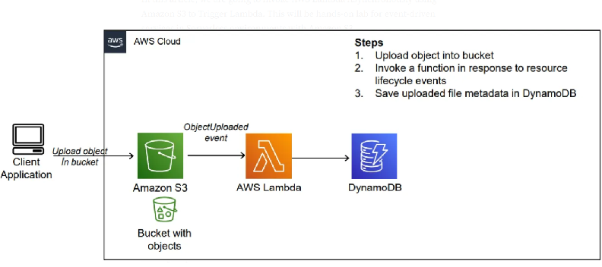
step-by-step procedure for setting up an AWS Lambda function to trigger whenever an object is uploaded to an S3 bucket and update a DynamoDB table:
1. Create an AWS Account: If you haven't already, sign up for an AWS account at https://aws.amazon.com/.
2. Access AWS Management Console: Log in to the AWS Management Console using your AWS account credentials.

3. Open AWS Lambda Console: Navigate to the Lambda service by either searching for "Lambda" in the AWS Management Console or
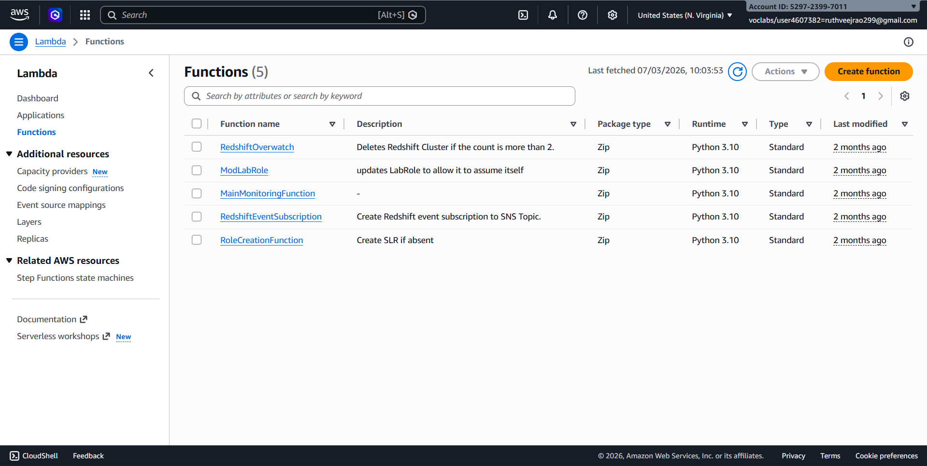
4. Create a New Lambda Function:
- Click on the "Create function" button.
- Choose "Author from scratch".
- Enter a name for your function (e.g., "S3ToDynamoDB").
- Choose Python as the runtime.

- Under "Permissions", create a new role with basic Lambda permissions or choose an existing role that has permissions to access S3 and DynamoDB.

- Click on the "Create function" button.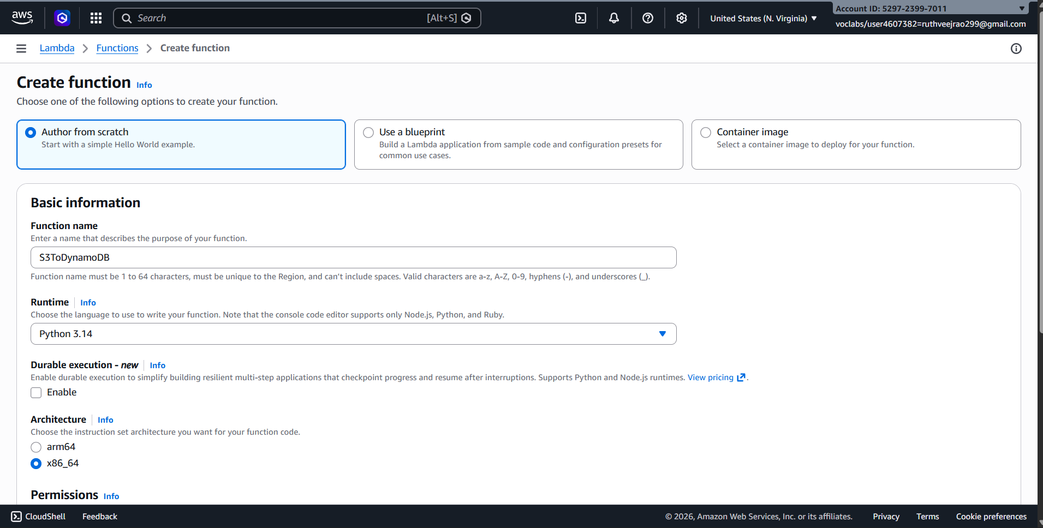
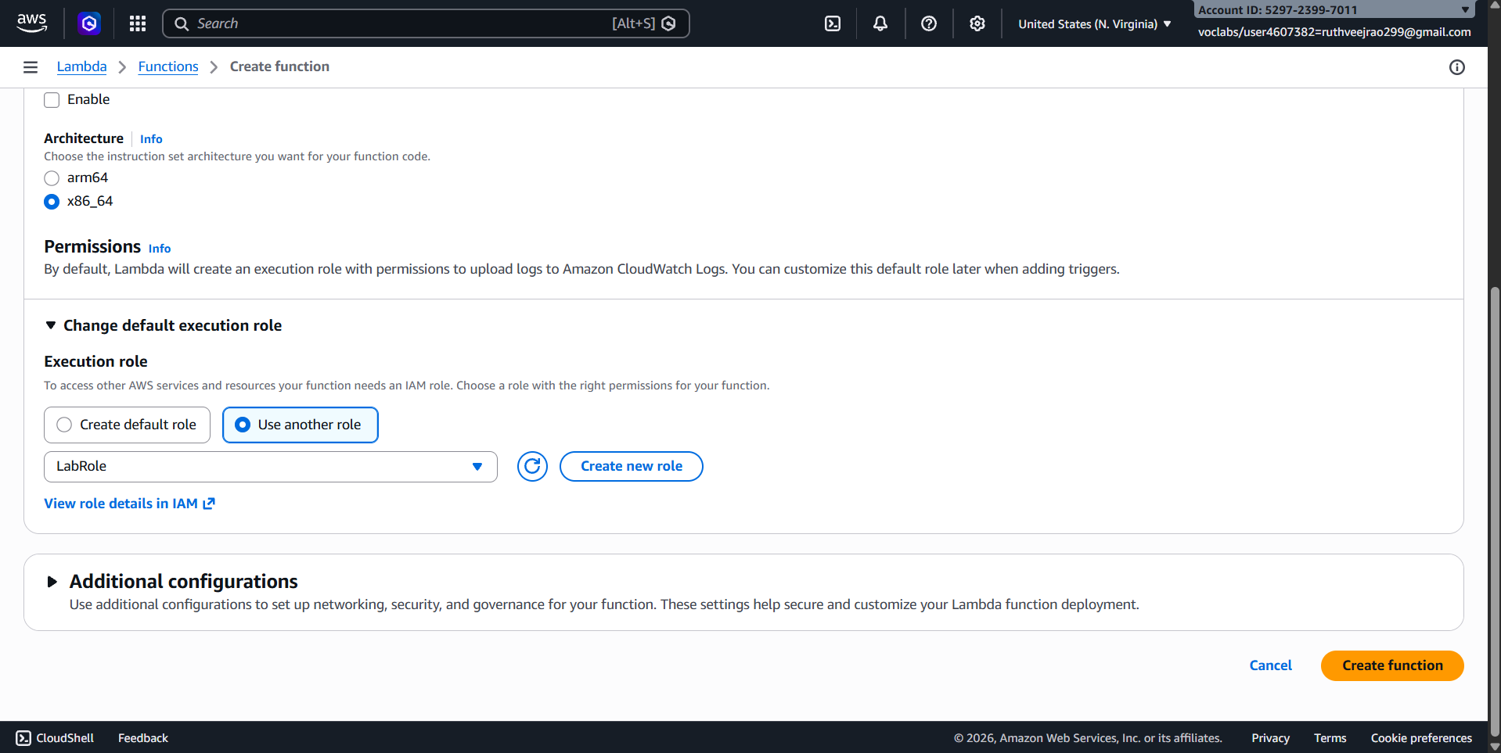
5. Upload Code:
- Write the Python code for your Lambda function. This code will be triggered whenever an object is uploaded to the specified S3 bucket.
- Here's an example code snippet:
import boto3
from uuid import uuid4
def lambda_handler(event, context):
s3 = boto3.client("s3")
dynamodb = boto3.resource('dynamodb')
# Check if the 'Records' key is present in the event
if 'Records' in event:
# Iterate over each record in the event
for record in event['Records']:
bucket_name = record['s3']['bucket']['name']
object_key = record['s3']['object']['key']
size = record['s3']['object'].get('size', -1)
event_name = record.get('eventName', 'Unknown') # Use get() method to handle missing keys
event_time = record.get('eventTime', 'Unknown') # Use get() method to handle missing keys
dynamoTable = dynamodb.Table('newtable')
dynamoTable.put_item(
Item={'unique': str(uuid4()), 'Bucket': bucket_name, 'Object': object_key,'Size': size, 'Event': event_name, 'EventTime': event_time})
else:
# Log a message indicating that the 'Records' key is missing from the event
print("No 'Records' key found in the event.")
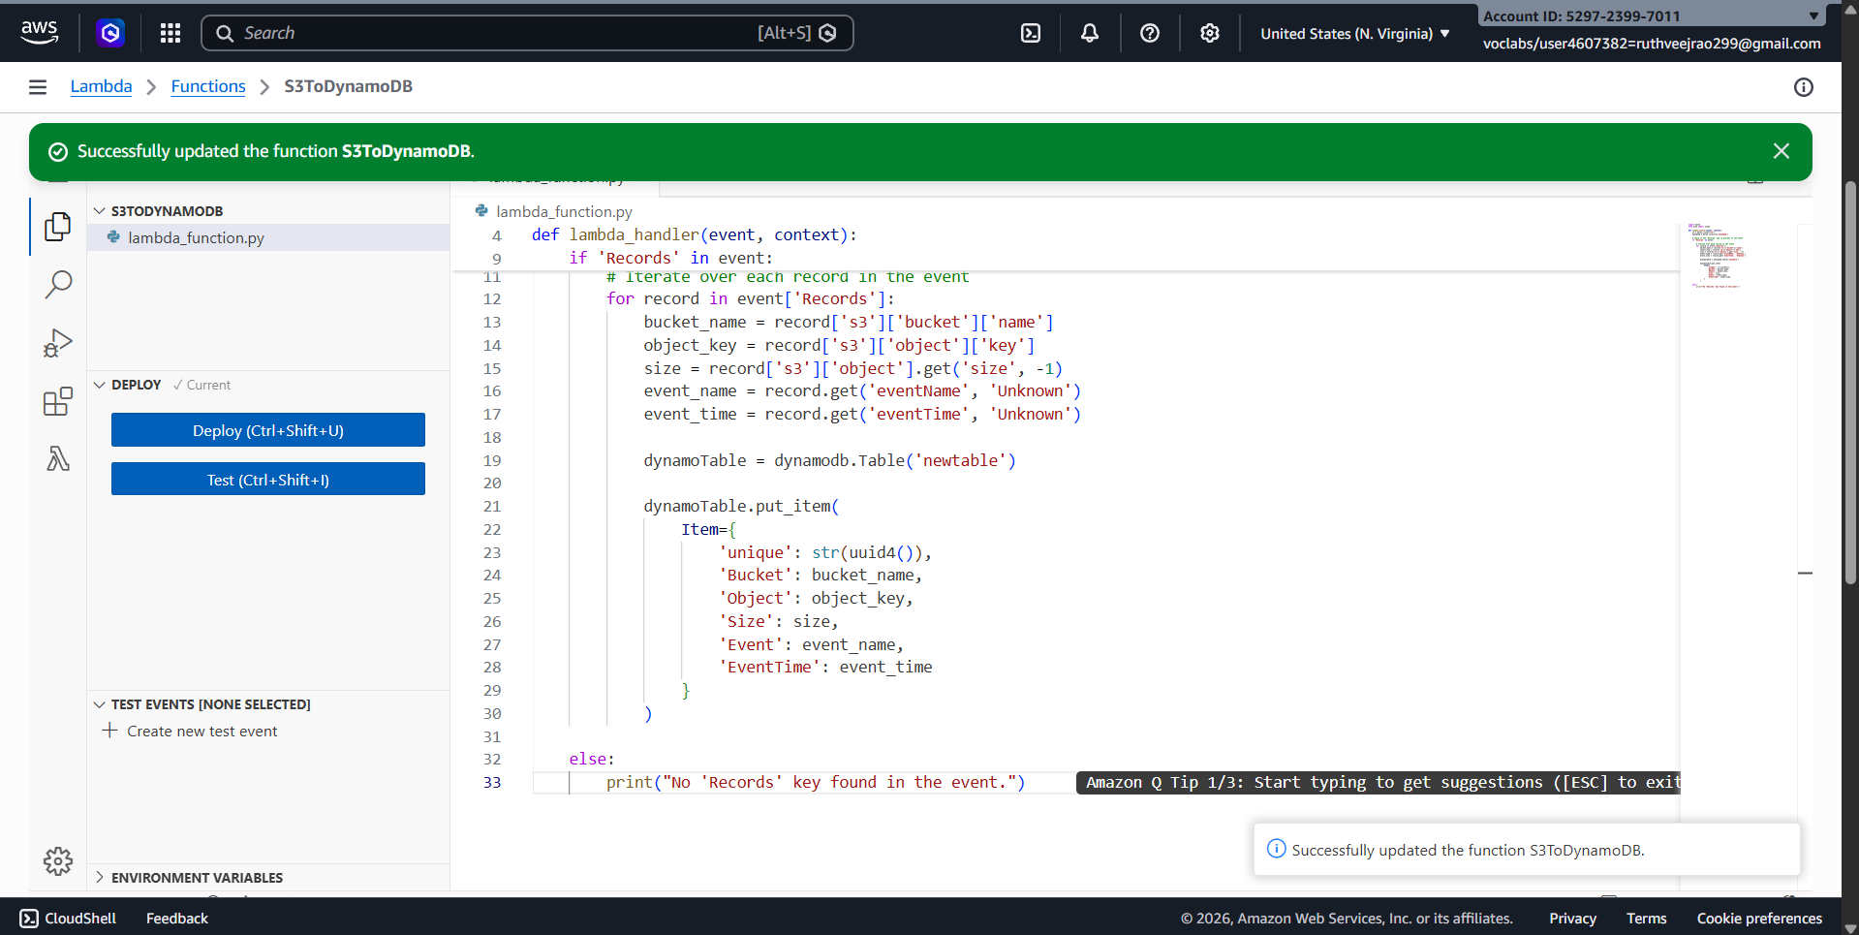

6. Configure Trigger:
- In the Designer section, click on "Add trigger".
- Select "S3" as the trigger type.
- Configure the trigger to listen to the S3 bucket where you want to trigger the Lambda function.
- Specify the event type (e.g., "All object create events").
- Click on the "Add" button.
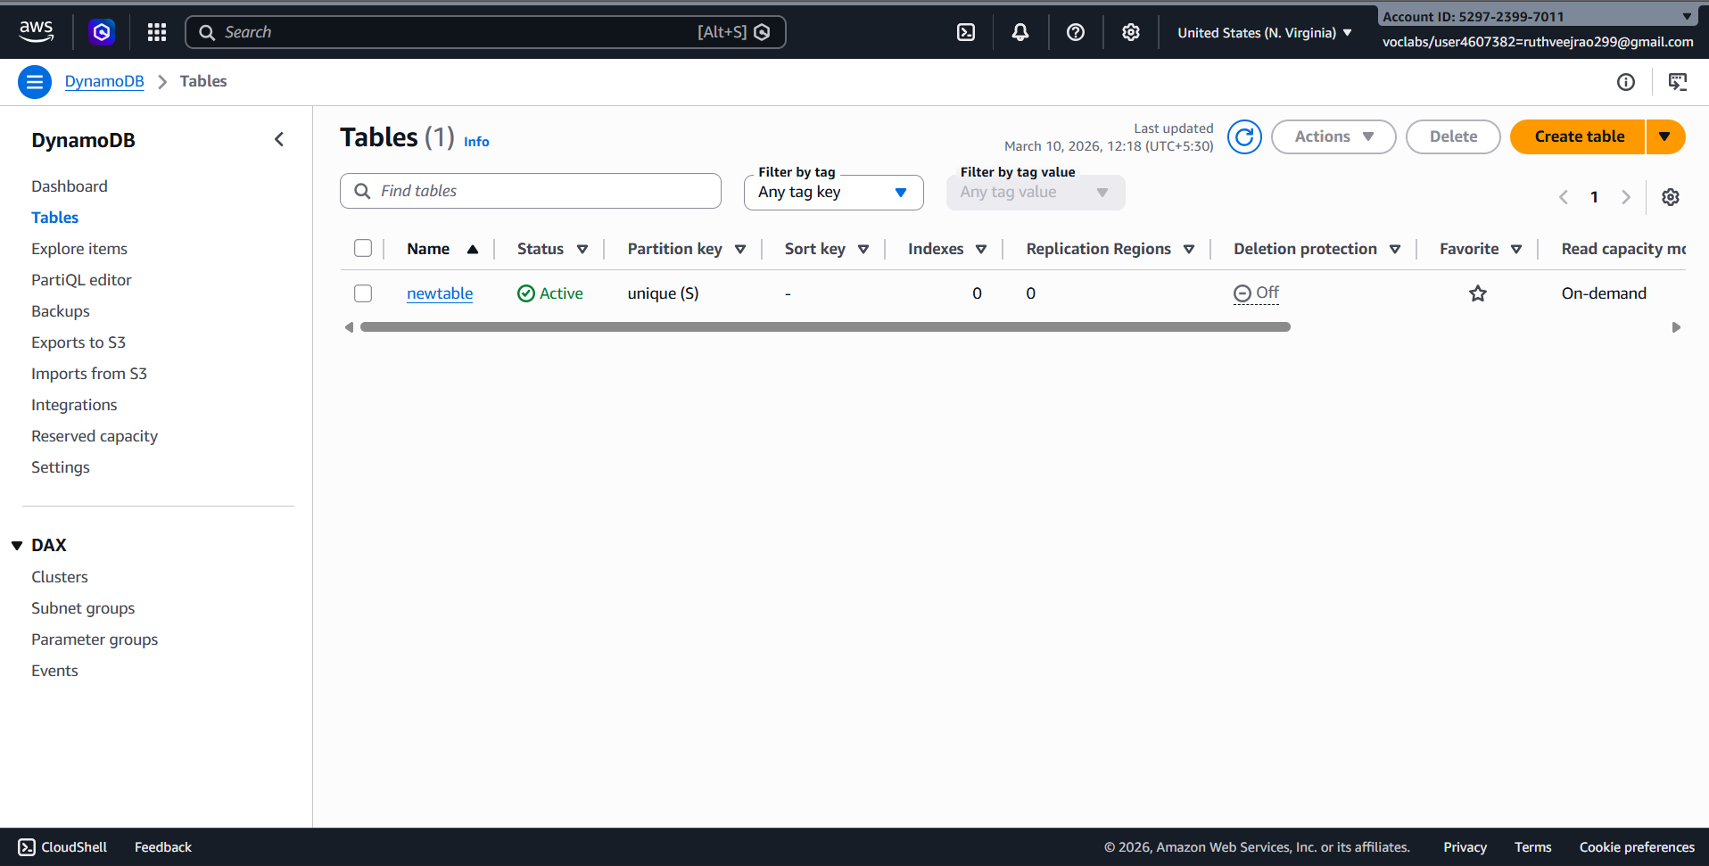
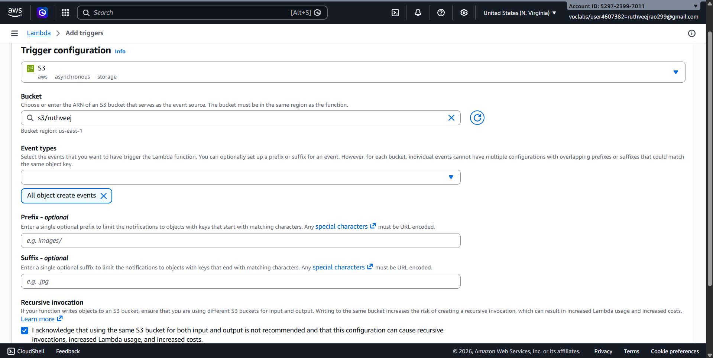
7. Configure Environment Variables (Optional):
- If your Lambda function requires any environment variables (e.g., credentials for accessing DynamoDB), you can set them in the "Configuration" tab under "Environment variables".
8. Test Your Function:
- You can test your Lambda function manually by clicking on the "Test" button in the Lambda console.
- You can create a sample test event or use a custom test event to simulate the S3 event that triggers your function.
9. Save and Deploy:
- Click on the "Deploy" button to deploy your function.
10. Monitor Execution:
- You can monitor the execution of your Lambda function in the Monitoring tab of the Lambda console.
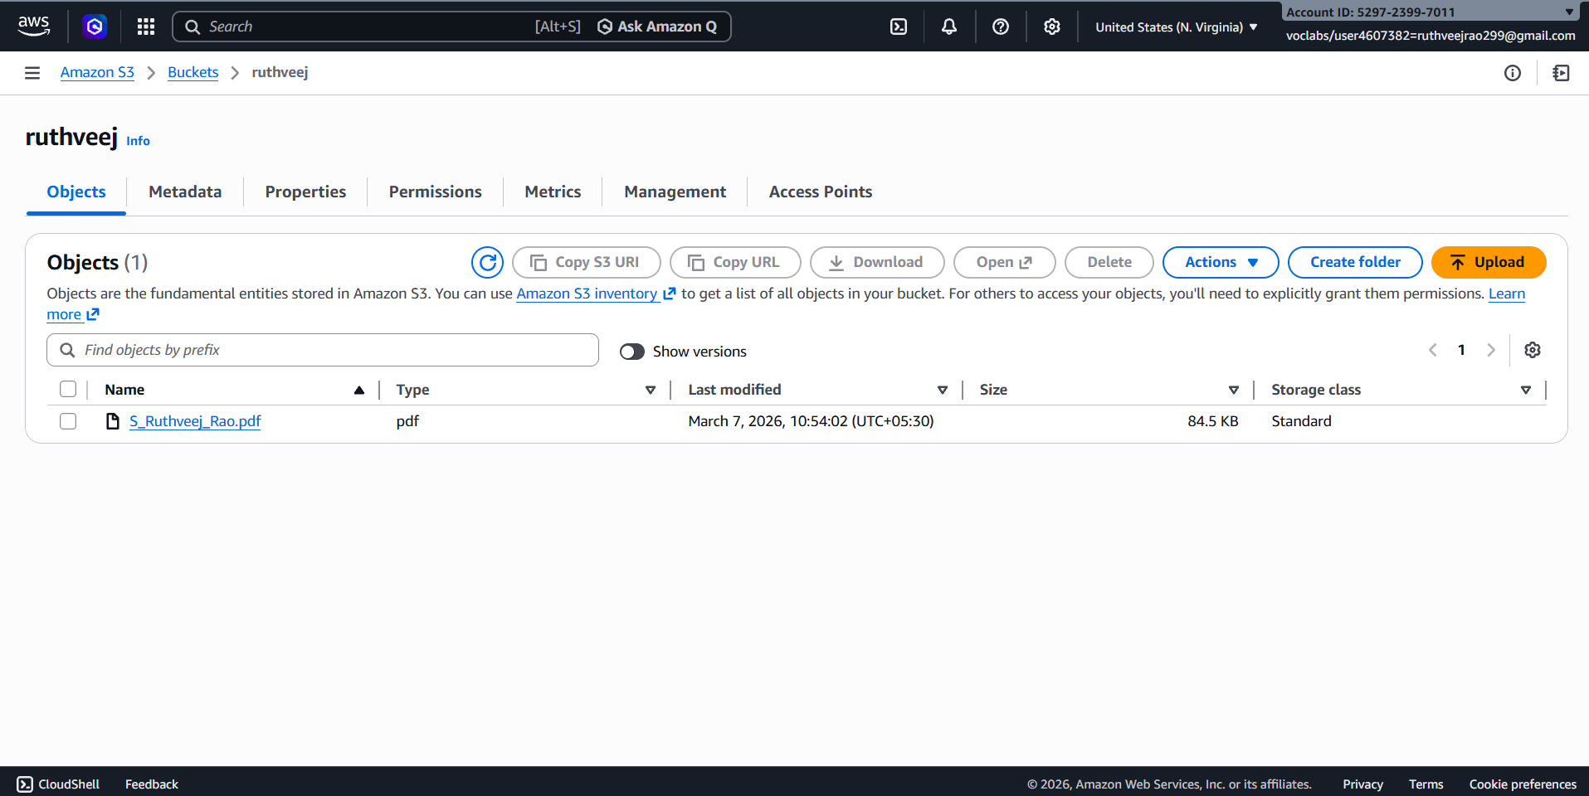
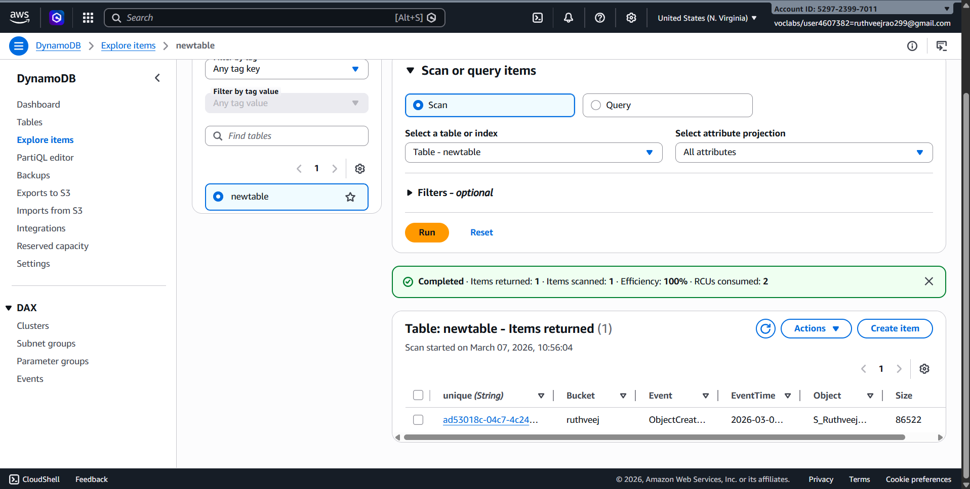
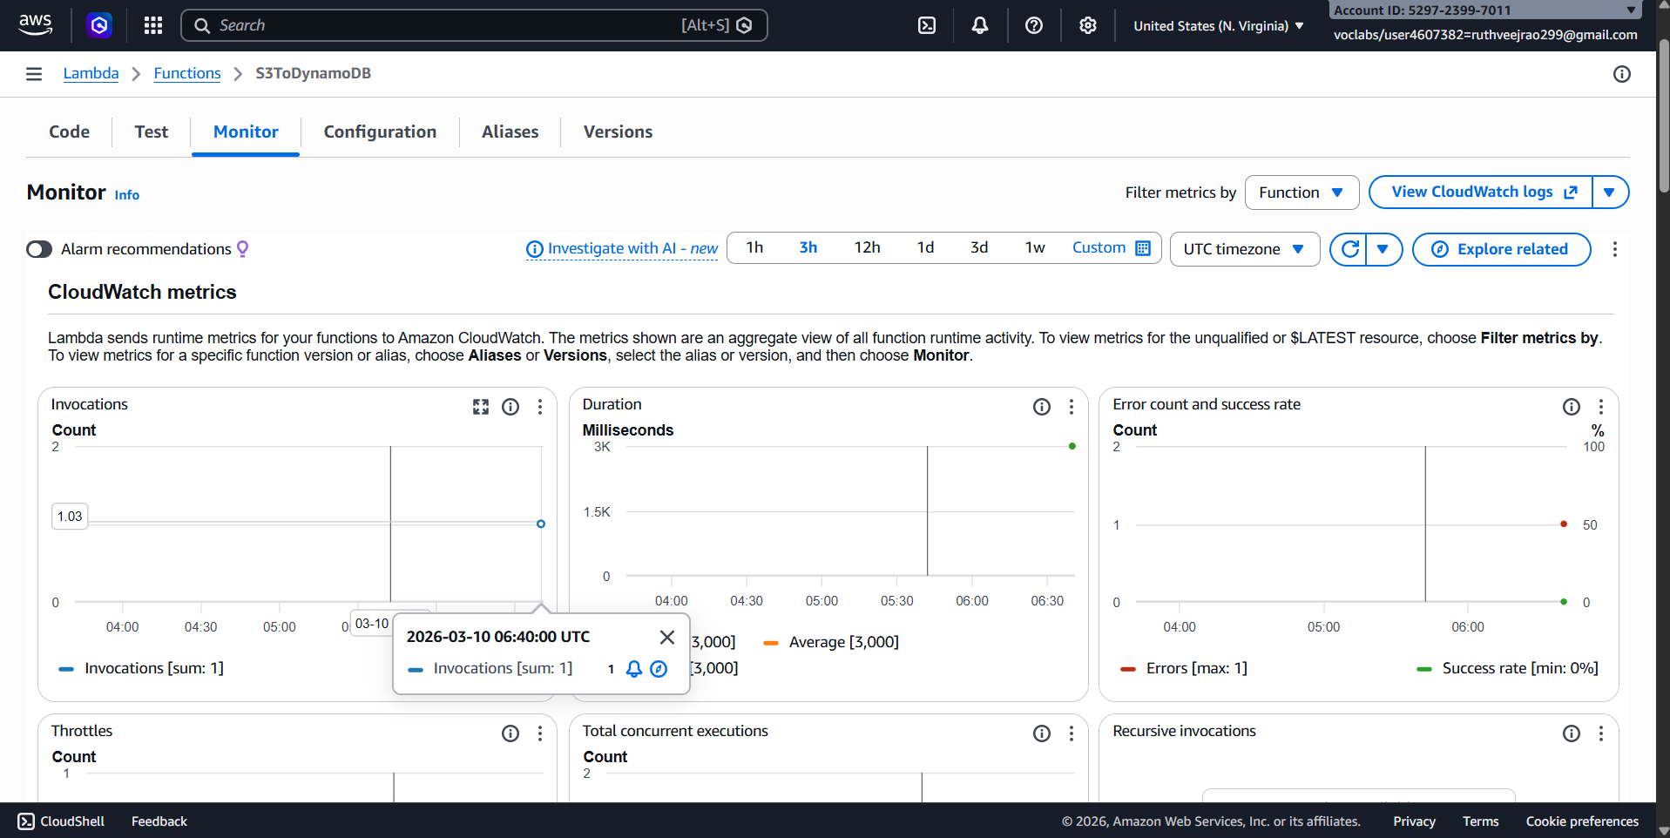
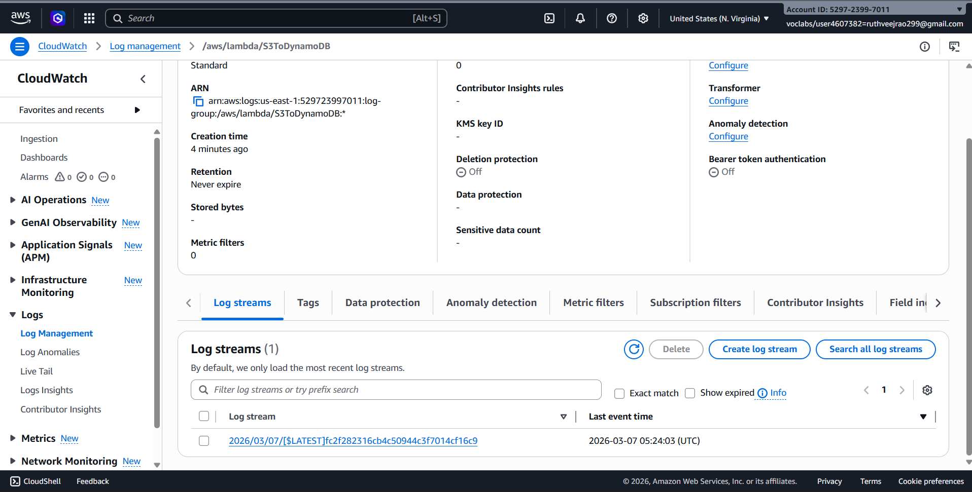
- You can also view logs to troubleshoot any issues that may arise during execution.
successfully set up a Lambda function to trigger whenever an object is uploaded to an S3 bucket and update a DynamoDB table accordingly.

SBQ’s:
A company wants to automatically process images whenever they are uploaded to an S3 bucket. The system should resize the images and store them in another bucket. Which AWS service can be used to automatically run the code when the image is uploaded?
Answer:
This can be done using AWS Lambda. The S3 bucket can trigger the Lambda function whenever a new image is uploaded. The Lambda code will resize the image and store it in another Amazon S3 bucket.

A developer created a Lambda function to store uploaded file details into a DynamoDB table, but the function fails with a permission denied error when writing to the database. What could be the reason and how can it be fixed?
Answer:
The issue is usually because the Lambda function does not have proper permissions. The AWS Identity and Access Management role attached to the function must allow write access to Amazon DynamoDB. Adding the correct policy to the role will fix the problem.

An application needs to run a piece of code every time a new file is uploaded to an S3 bucket to extract metadata and store it in a database. How would you design this using AWS Lambda?
Answer:
First configure Amazon S3 to trigger a AWS Lambda function whenever a new file is uploaded. The Lambda function will extract the metadata from the file and store it in Amazon DynamoDB.

A Lambda function is configured with an S3 trigger, but it is not executing when files are uploaded. What possible configuration issues might cause this problem?
Answer:
The trigger may not be properly configured in Amazon S3, or the event type may be incorrect. Another reason could be missing permissions for AWS Lambda to be invoked by the bucket.

A company wants to process only .jpg image files uploaded to an S3 bucket using Lambda. How can the trigger be configured so that the function runs only for those files?
Answer:
In the Amazon S3 event notification settings, a suffix filter can be added for .jpg files. This way AWS Lambda will only trigger when a JPG image is uploaded.

A Lambda function works correctly for a few uploads but fails when hundreds of files are uploaded simultaneously. What AWS feature helps Lambda handle large numbers of events?
Answer:
AWS Lambda supports automatic scaling and concurrency. It can run multiple instances of the function at the same time to process many events from Amazon S3.

A developer wants to store the table name and bucket name separately from the code so that they can easily change them later. Which Lambda feature can be used to achieve this?
Answer:
This can be done using environment variables in AWS Lambda. The bucket name and table name can be stored there and accessed in the code when needed.

A Lambda function executes but does not show any output in the console, making debugging difficult. Which AWS service can be used to view logs and troubleshoot the issue?
Answer:
Logs from AWS Lambda are stored in Amazon CloudWatch. Developers can check CloudWatch logs to see errors or print statements from the function.

An organization wants a function to run every day at 10 PM to clean temporary files stored in S3. How can Lambda be triggered automatically at a scheduled time?
Answer:
A scheduled rule can be created using Amazon EventBridge. It can trigger the AWS Lambda function every day at 10 PM.

A Lambda function processes uploaded files and stores metadata in DynamoDB, but duplicate records appear in the table when the same file is uploaded again. How can this issue be prevented?
Answer:
The application can use a unique key like the file name or file ID in Amazon DynamoDB. Before inserting a record, the AWS Lambda function can check if the item already exists.

A Lambda function processes files uploaded to S3, but the processing sometimes takes more than 10 minutes. What limitation of Lambda must be considered here?
Answer:
AWS Lambda has a maximum execution time of 15 minutes. If the task takes longer, the function will stop automatically, so another service or design may be required.

A developer wants to allow a Lambda function to read files from S3 and write records into DynamoDB. What type of AWS security configuration must be created?
Answer:
An IAM role must be created using AWS Identity and Access Management. This role will give the AWS Lambda function permission to access Amazon S3 and Amazon DynamoDB.

A company wants to automatically send a notification email whenever a file is uploaded to S3 using Lambda. Which AWS services can be integrated to achieve this?
Answer:
The upload event from Amazon S3 can trigger AWS Lambda. Then the Lambda function can send an email notification using Amazon Simple Notification Service.

A Lambda function is triggered by S3 uploads, but the function keeps running multiple times for the same file. What could be the possible cause?
Answer:
This may happen if multiple event notifications are configured in Amazon S3 for the same event. It can also happen if the AWS Lambda function uploads or modifies the same file again, causing another trigger.

An organization wants to build a fully serverless application where uploaded files are processed automatically without managing servers. Which AWS services can be combined with Lambda to achieve this architecture?
Answer:
A serverless architecture can use Amazon S3 for file storage, AWS Lambda for processing, and Amazon DynamoDB for storing data. These services work together without managing any servers.

