LAB ACTION PLAN FOR WEEK 5

Working with Docker -> First check whether docker installed by command
> docker --version
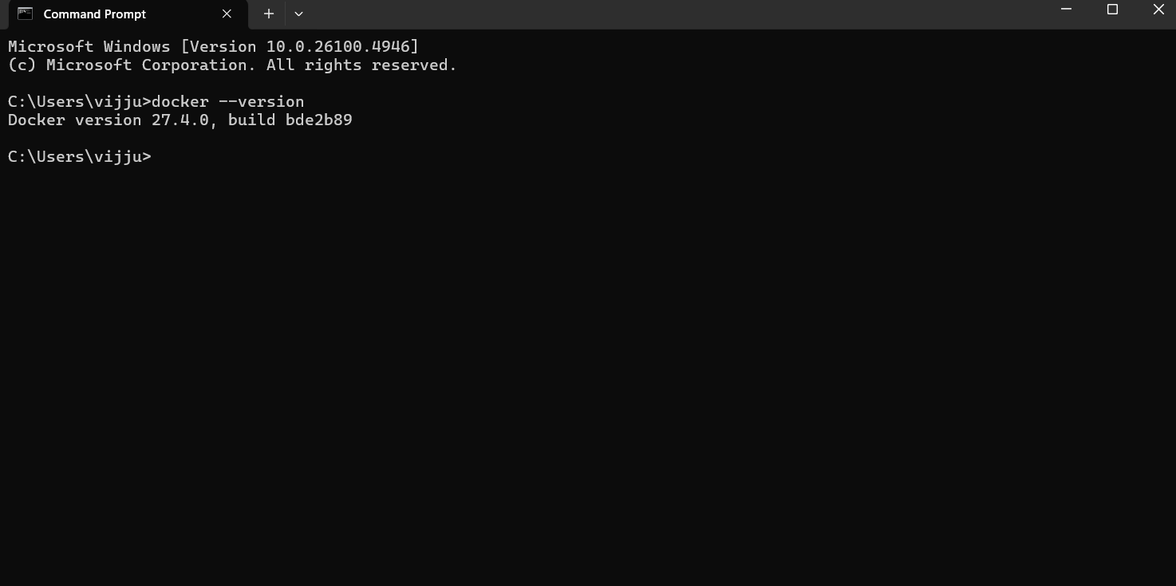
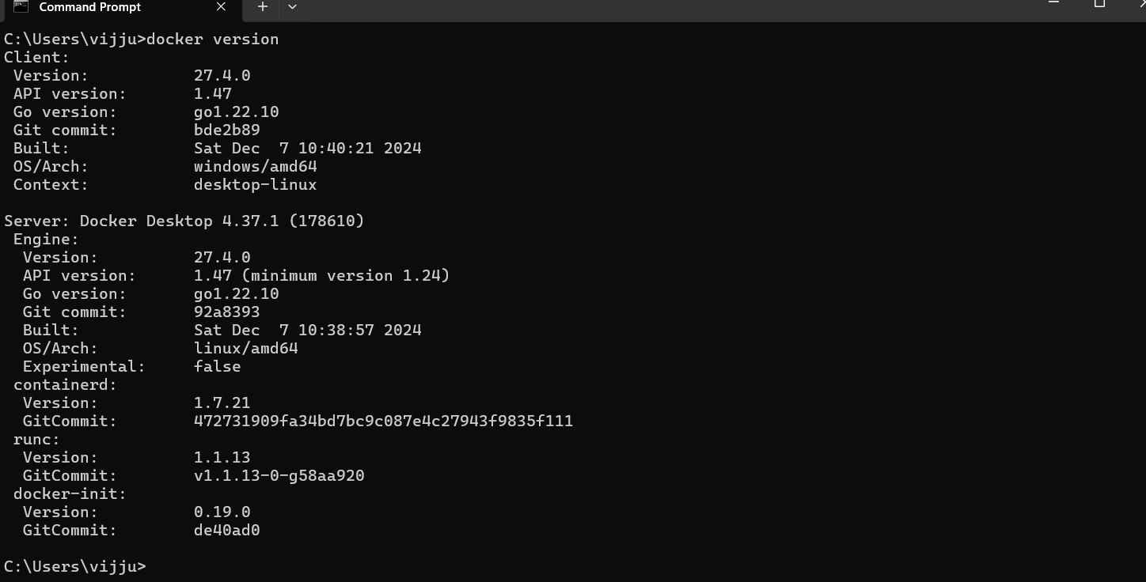
docker version displays the version information of docker client & server running
docker pull [image name] pull a docker image from docker hub
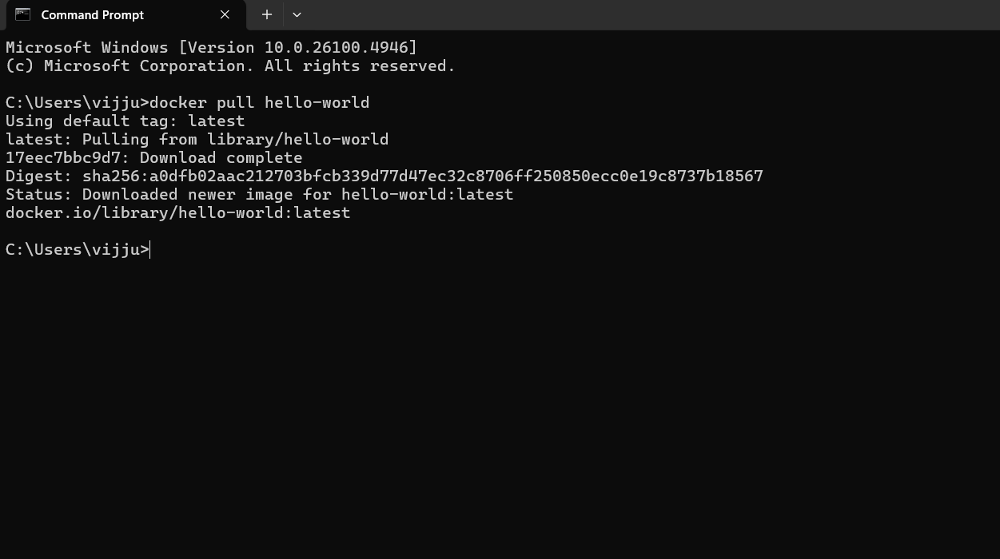
docker image ls displays the list of docker images in the local server
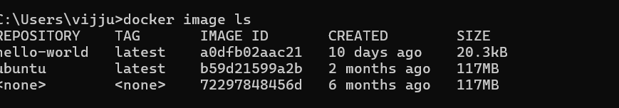
How to run Hello-world Image
docker run [image name] executing a docker image in the local server
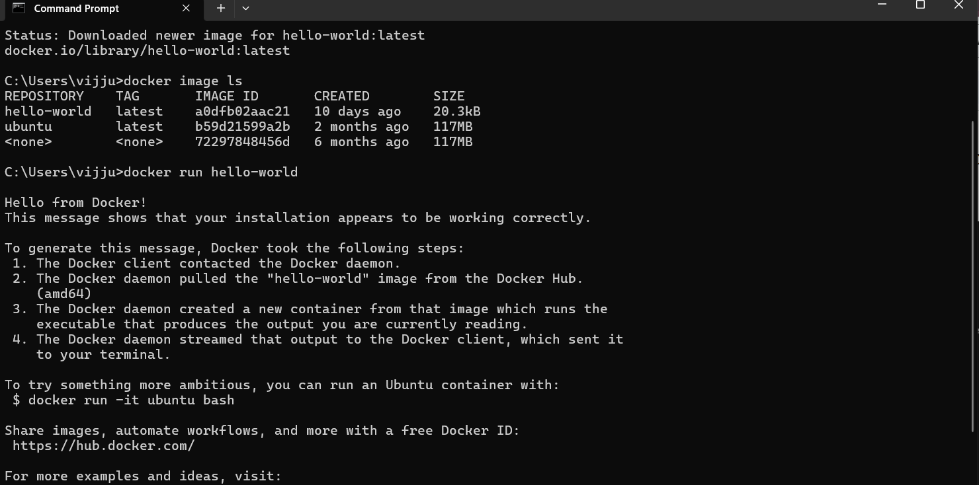
docker ps –a Displays the list of images running currently or previously
docker exec it <container id / name> bash
running a container in interactive mode…. Using bash commands to ammend
the existing image
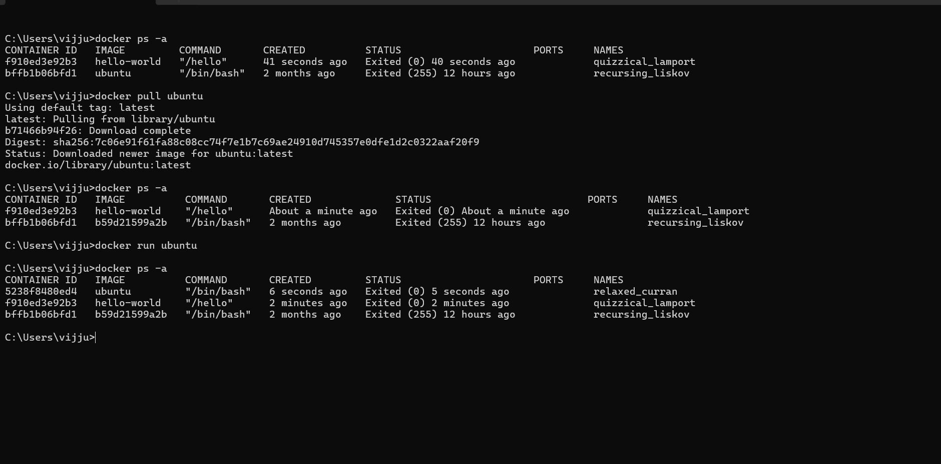
Now run the Ubuntu with echo command
Docker exec command will run the command shell on the ubuntu container
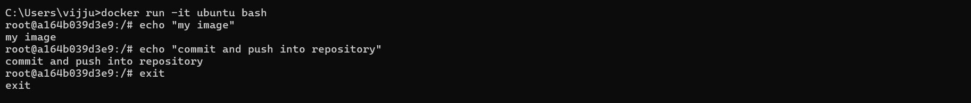
docker ps –a display the list of containers to learn the container id
docker stop <cont id> stop the running container
docker commit <cont id> new name commit the modified container
docker image ls display the list of images
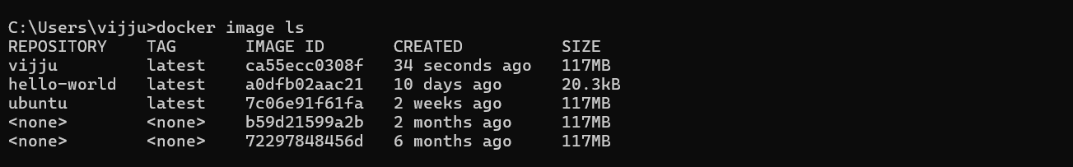
Pushing the changed image from local repository to docker hub
Step-1-Docker Login
docker login - login to docker hub with required credentials
Pushing the images from local repository to docker hub
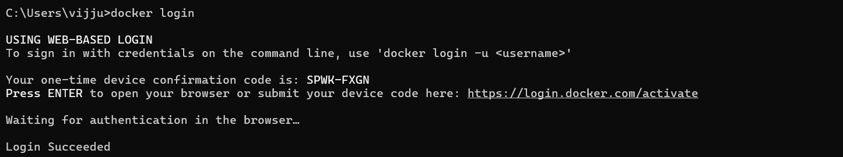
Step-2-Push Command
docker push <image name> push the image to the docker hub repository
Check for your image in Docker Hub
