Elastic File Storage
Amazon Elastic File System (EFS) is a scalable and fully managed file storage service provided by Amazon Web Services (AWS). It allows you to create and configure file systems that can be accessed concurrently from multiple EC2 instances, providing a highly available and scalable storage solution for your applications and workloads.
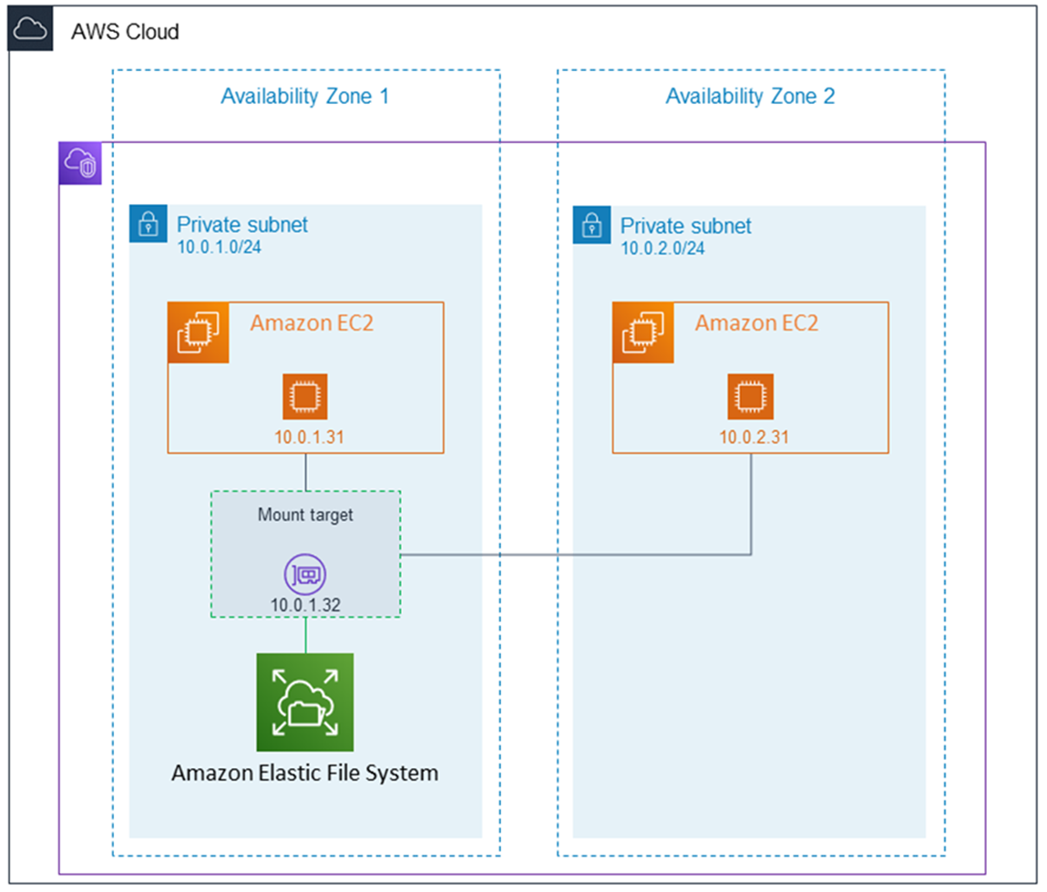
Amazon EFS supports for only Amazon Linux instance:
Step 1: Launching EC2 Instances
1. Sign in to AWS Management Console.
2. Go to the EC2 dashboard.
3. Click on "Launch Instance".
4. Configure instance details:
- Instance Name: EFS-1
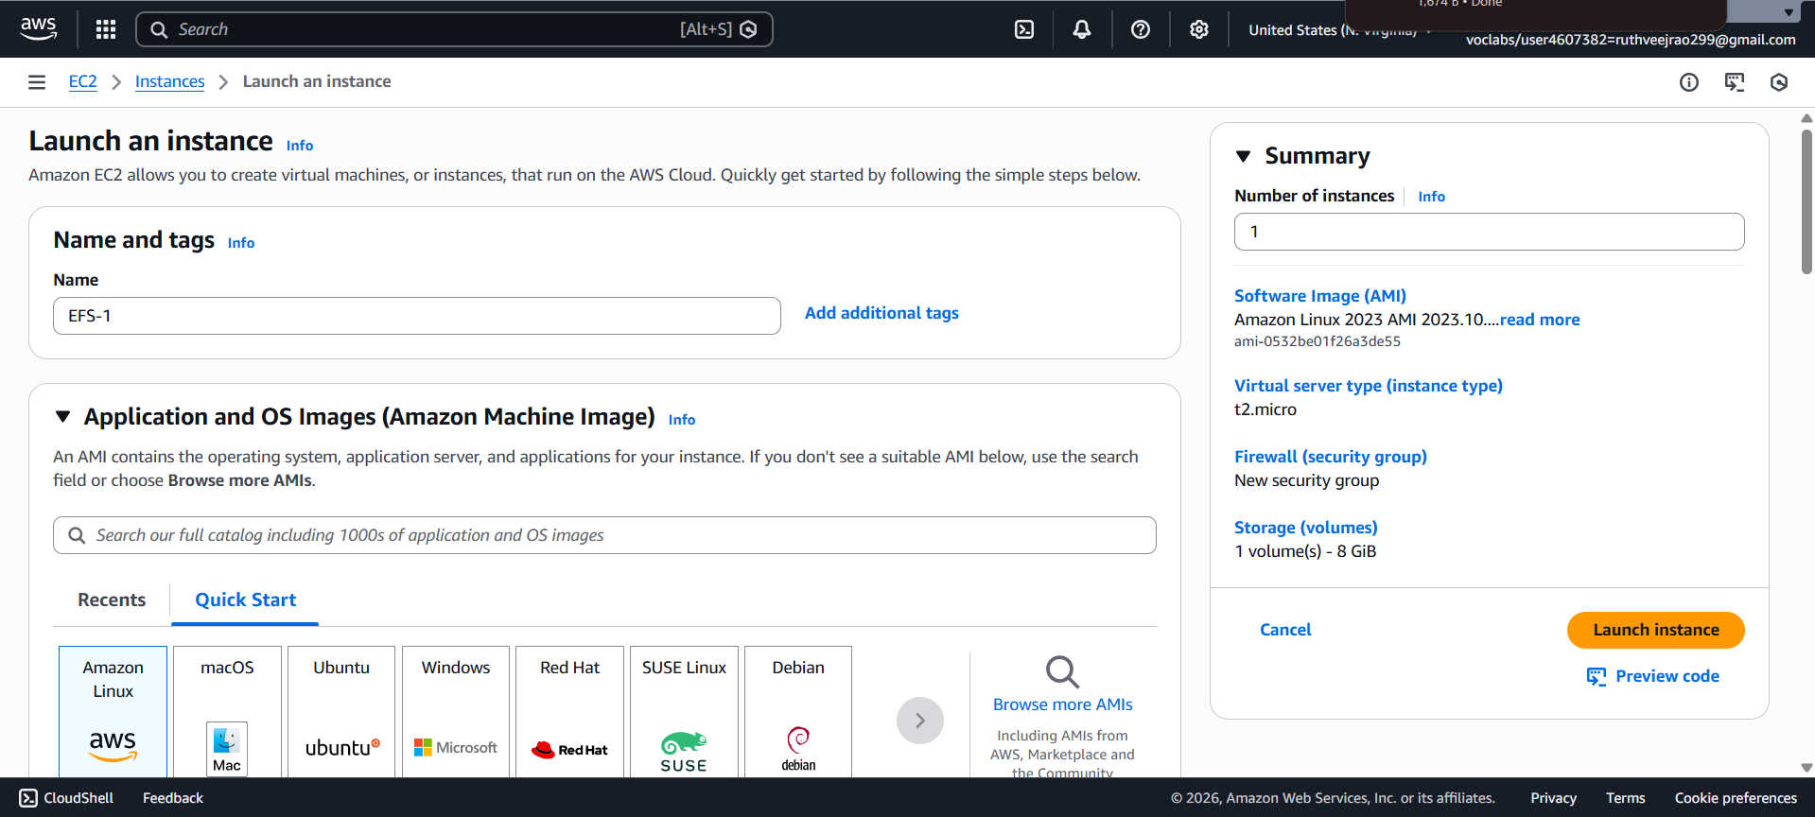

5. Choose an Amazon Machine Image (AMI) for Linux.
6. Select instance type: t2.micro.
- Key Pair: EFS
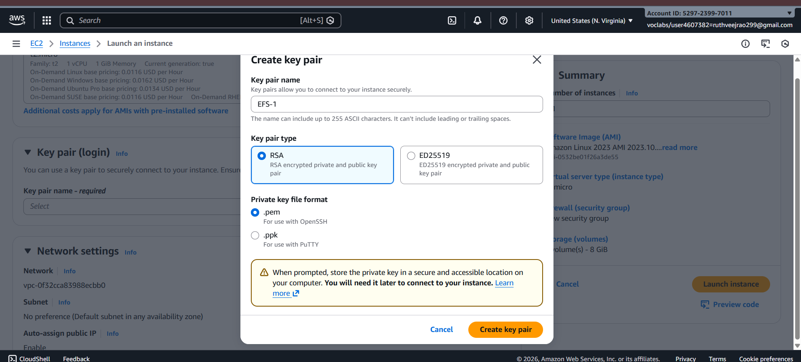
- Network: Choose Subnet-1a
- Security Group: Create a new security group (SG) and add NFS and allow from anywhere.
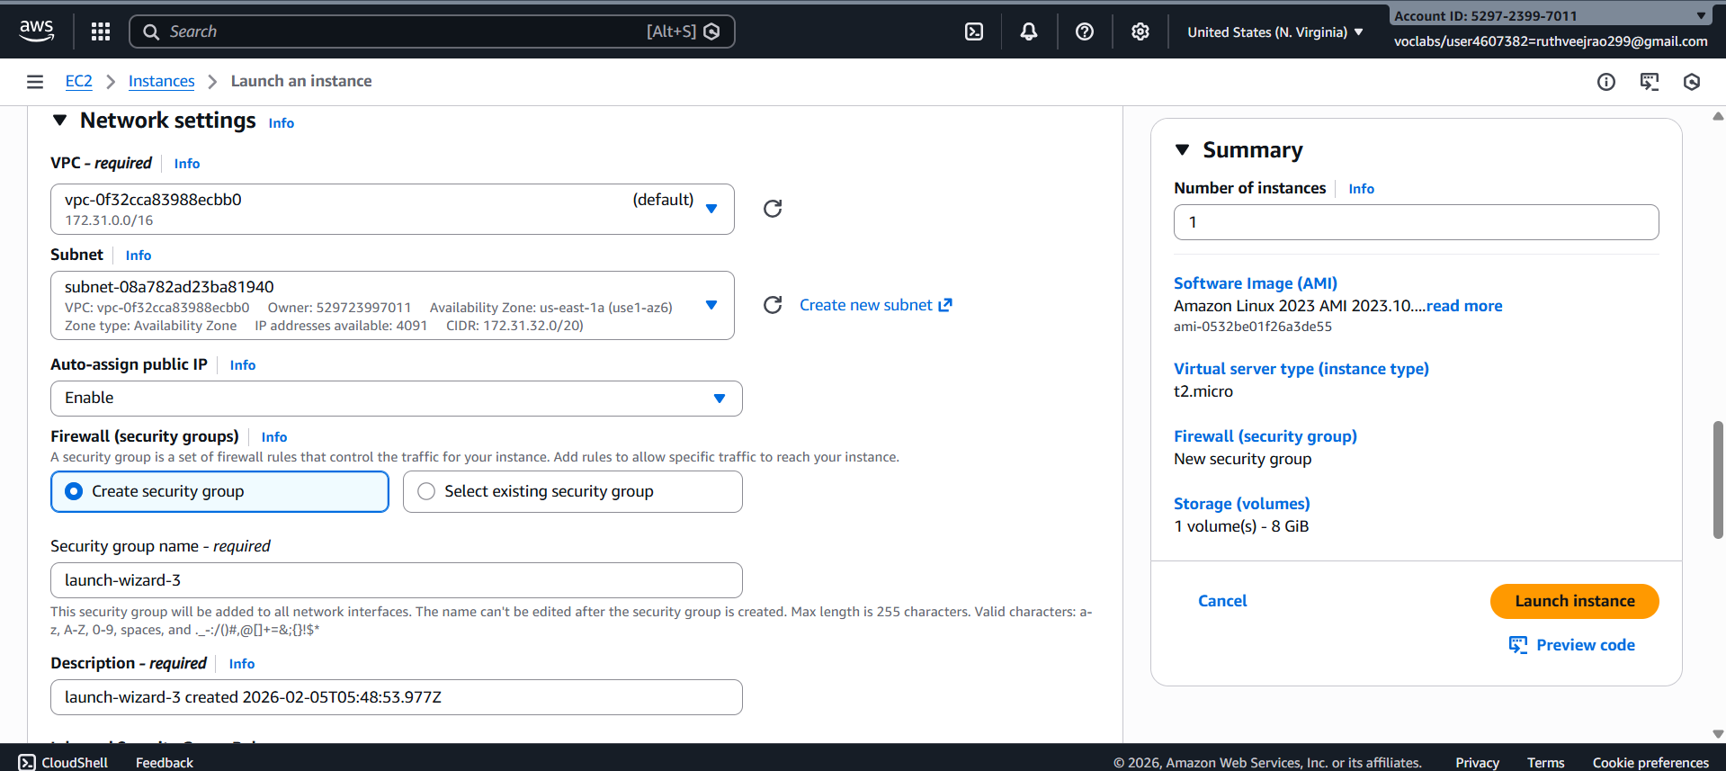
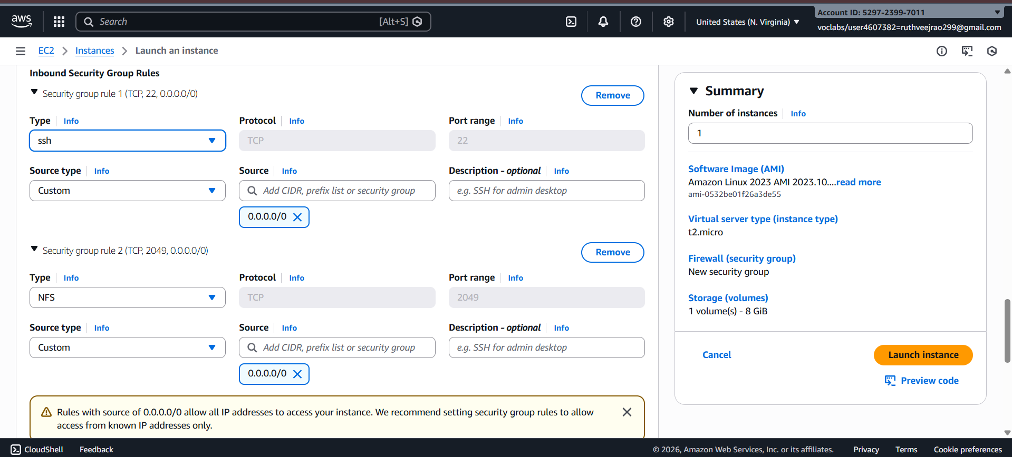
7. Launch the instance.
8. Repeat the above steps to launch another instance named EFS-2 in Subnet-1b with the same configuration.
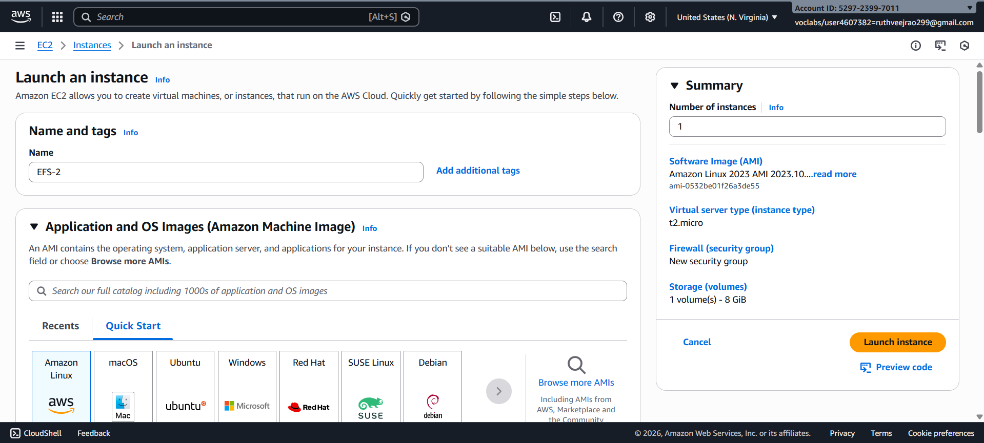
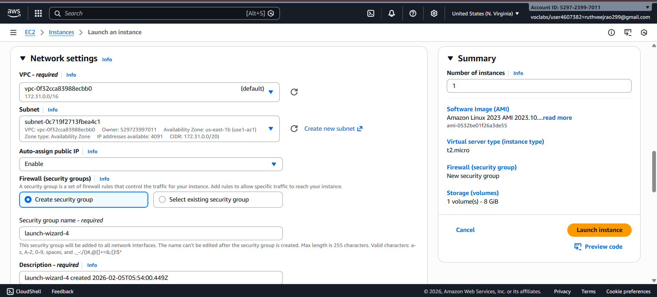
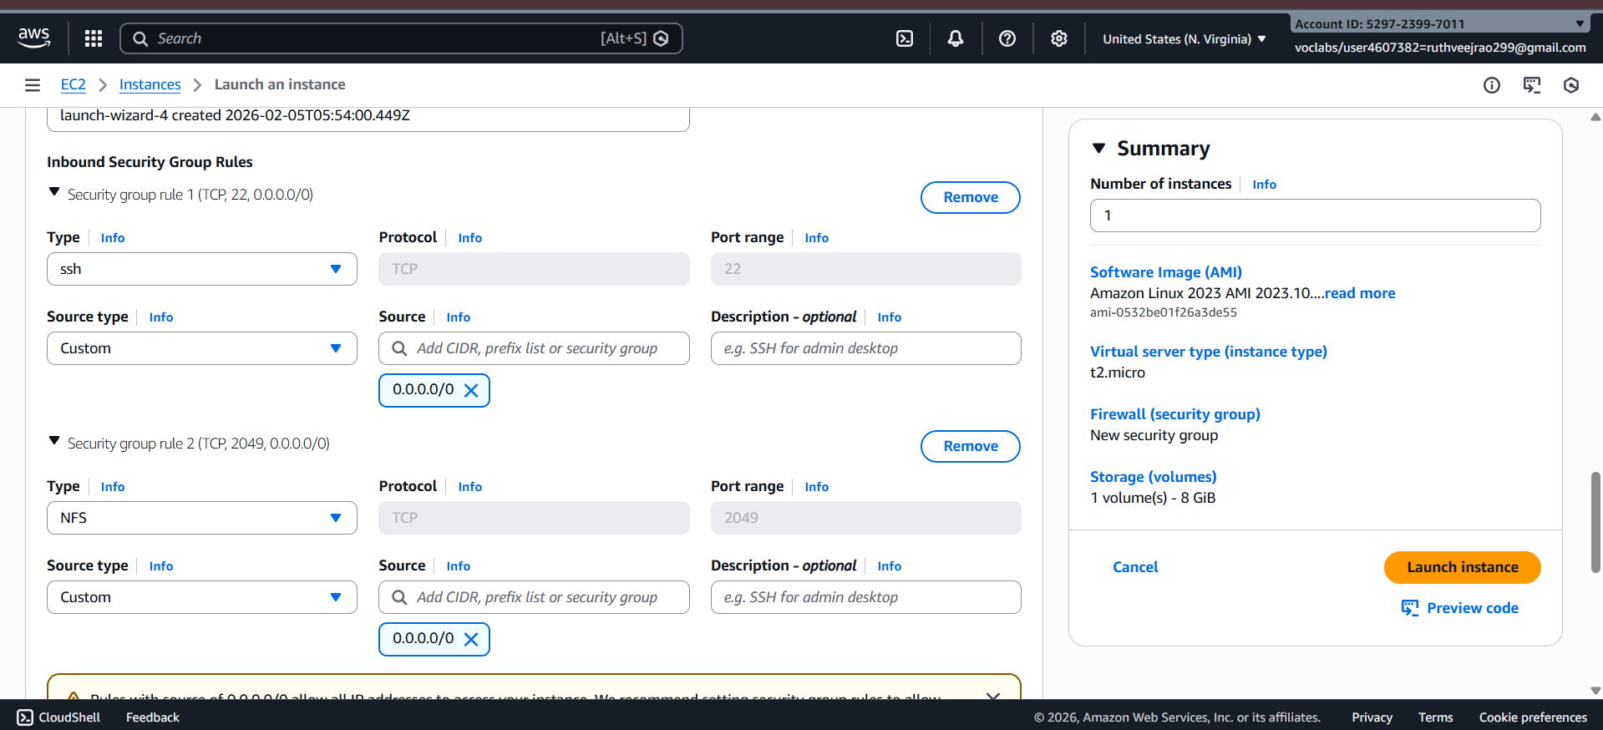
Step 2: Creating an EFS File System
1. Go to the EFS service in the AWS Management Console.
2. Click on "Create file system".
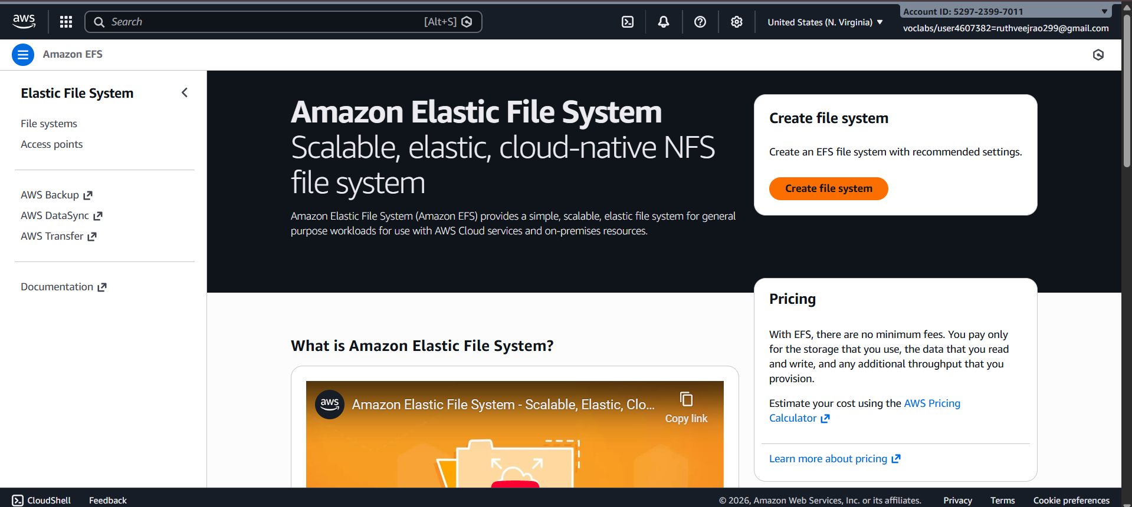
3. Specify details:
- Name: Optional
- VPC: Default
- Enable region button.
Click on "Next".
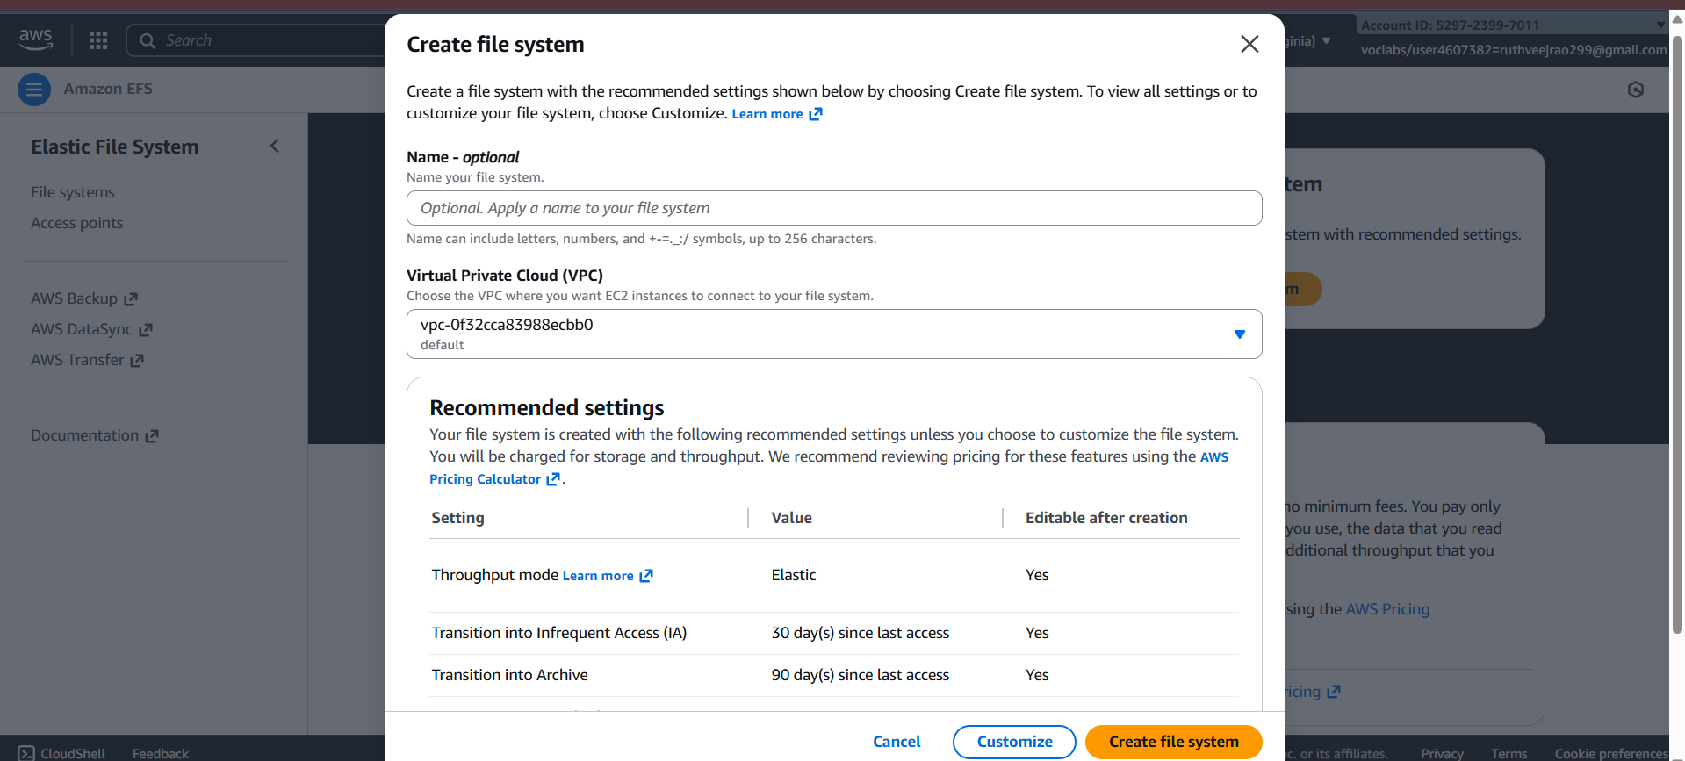
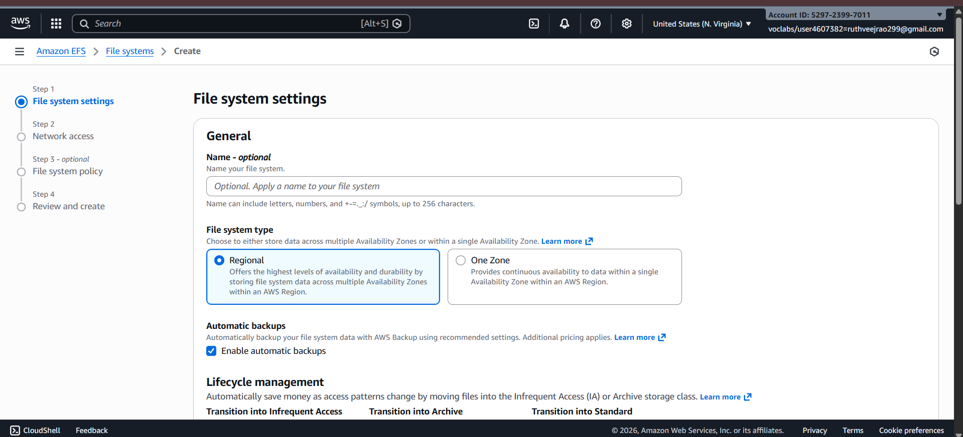
4. In the Network settings:
- Delete all security groups.
- Select the newly created security group (NFS).---which is created while creating instance
Click on "Next" and review the configuration.
Click on "Create file system".
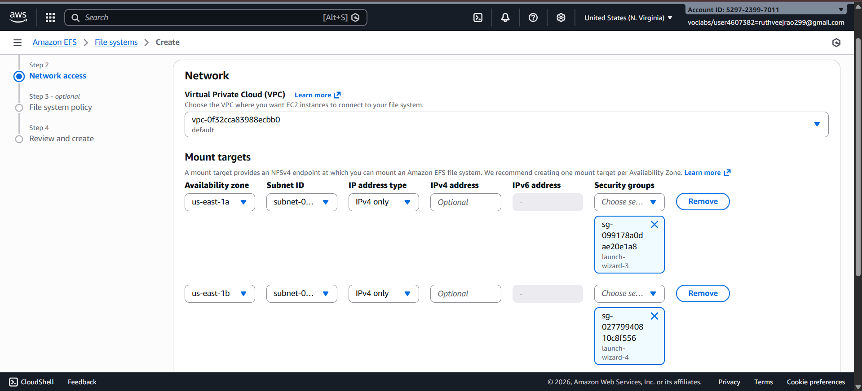
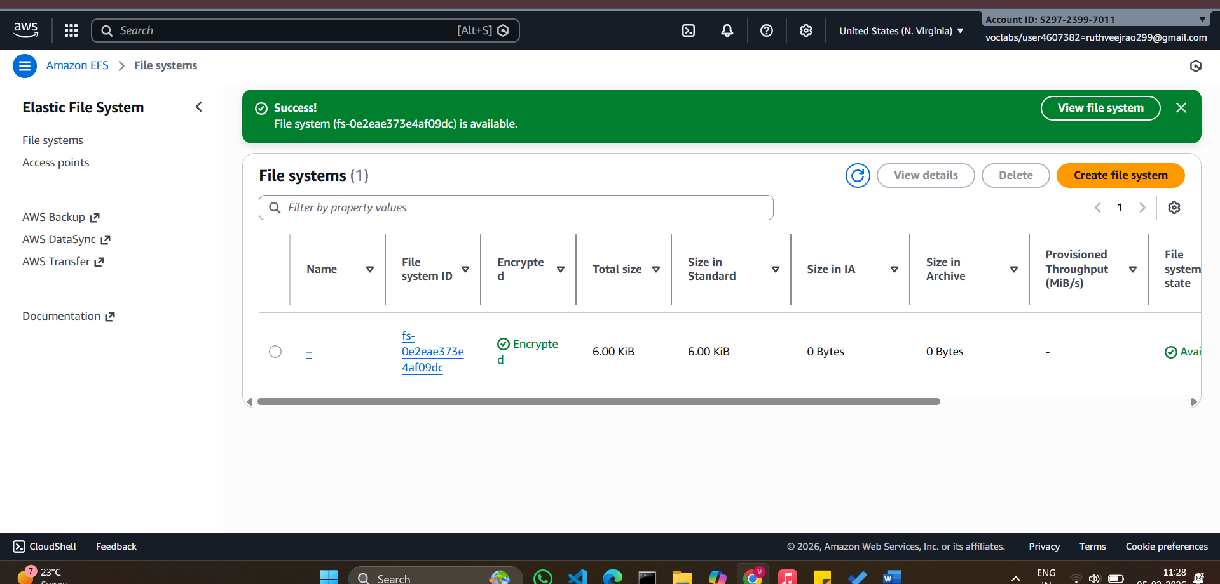
Step 3: Accessing the two EC2 instances named EFS-1 & EFS -2 in two different PowerShell sessions and performing the specified tasks:
Accessing EFS-1 Instances in Two Different PowerShell Sessions:
1. Open Two PowerShell Sessions:
- Open two separate PowerShell windows or tabs on your local machine.
For each Instance:
2. SSH into the Instance:
- Use the SSH command to connect to the EFS-1 instance
ssh -i [path-to-your-keypair.pem] ec2-user@[instance-public-ip]
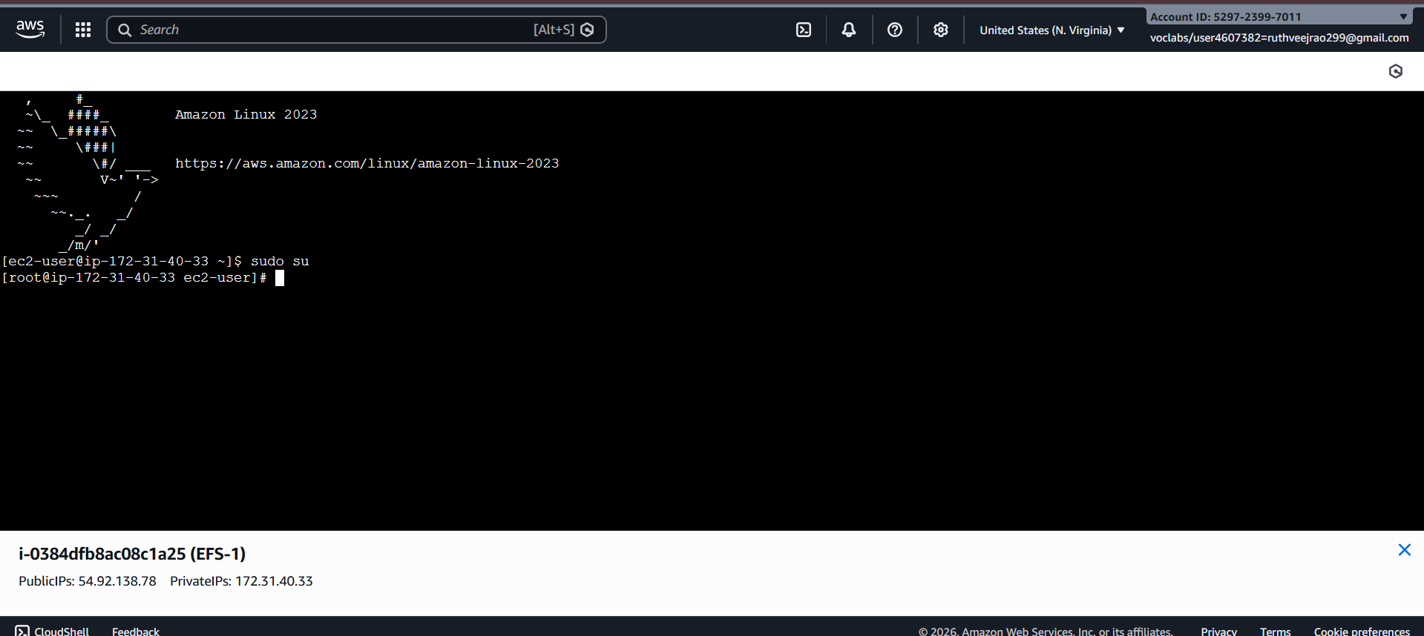
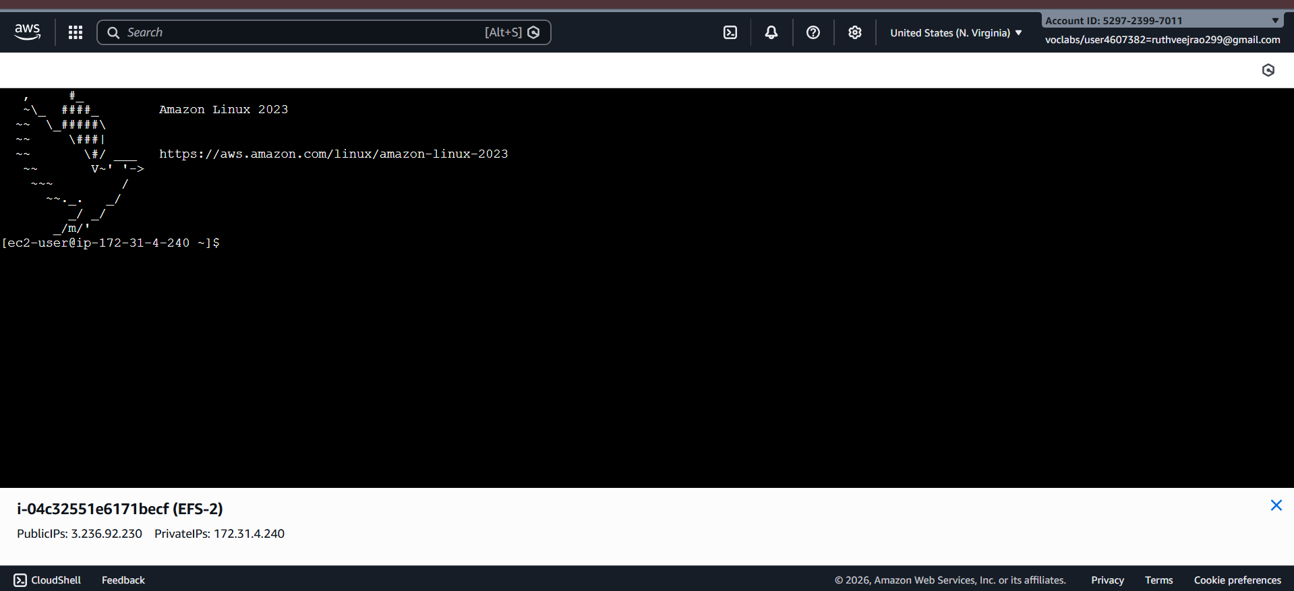
3. Switch to Root User:
- Gain root access by executing the following command:
sudo su
4. Create a Directory:
- Make a directory named "efs" using the following command:
mkdir efs
5. Install Amazon EFS Utilities:
- Use yum package manager to install the Amazon EFS utilities:
yum install -y amazon-efs-utils
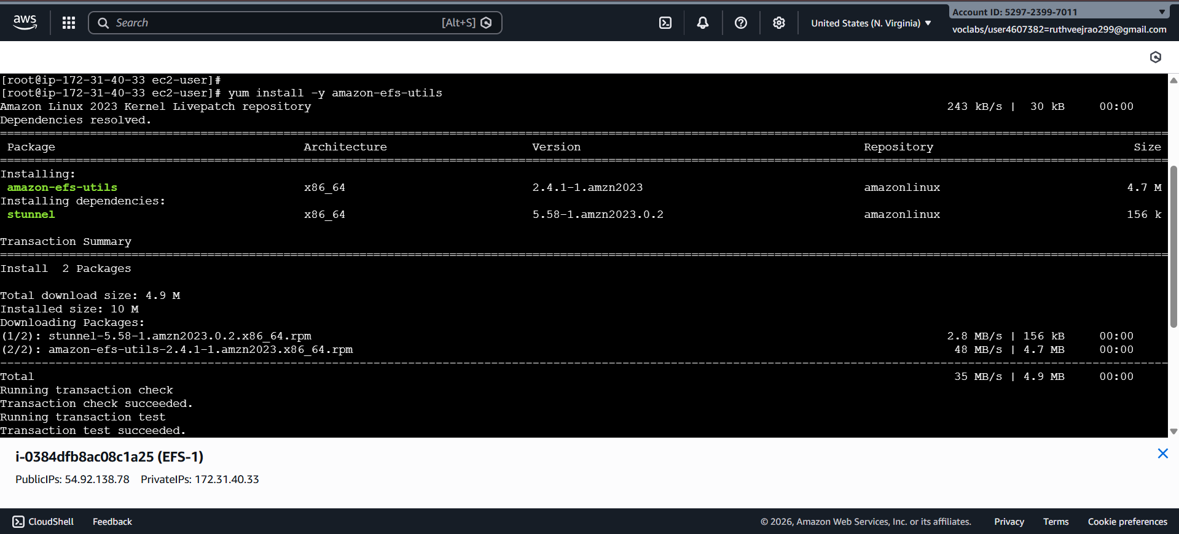’
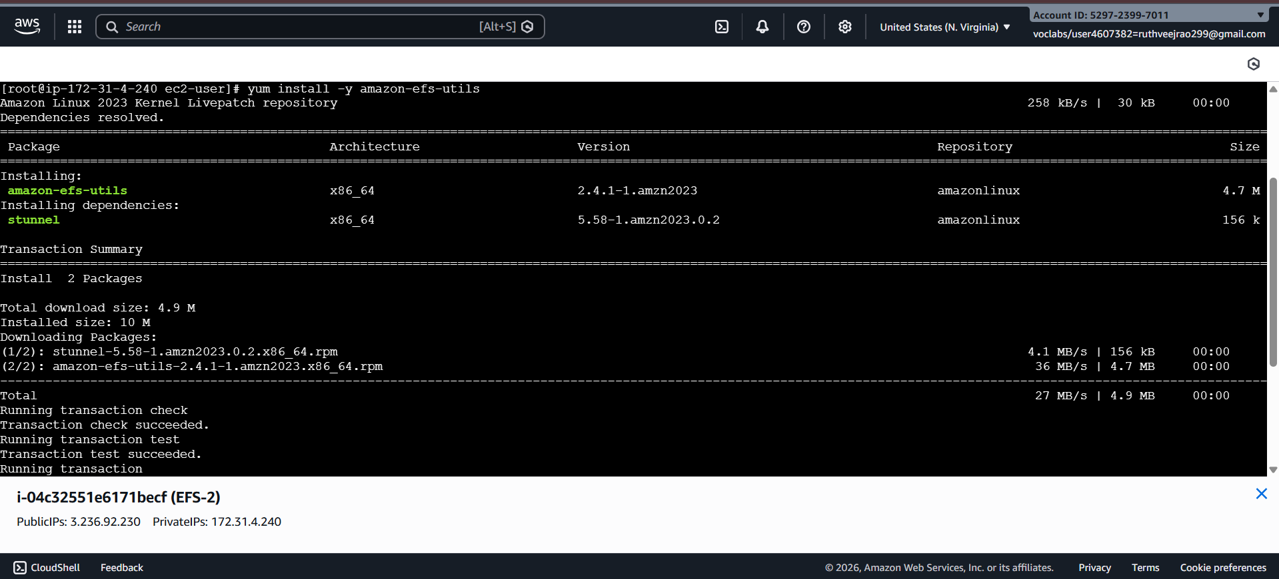
6. List Files:
- Execute the following command to list files in the current directory:
Ls
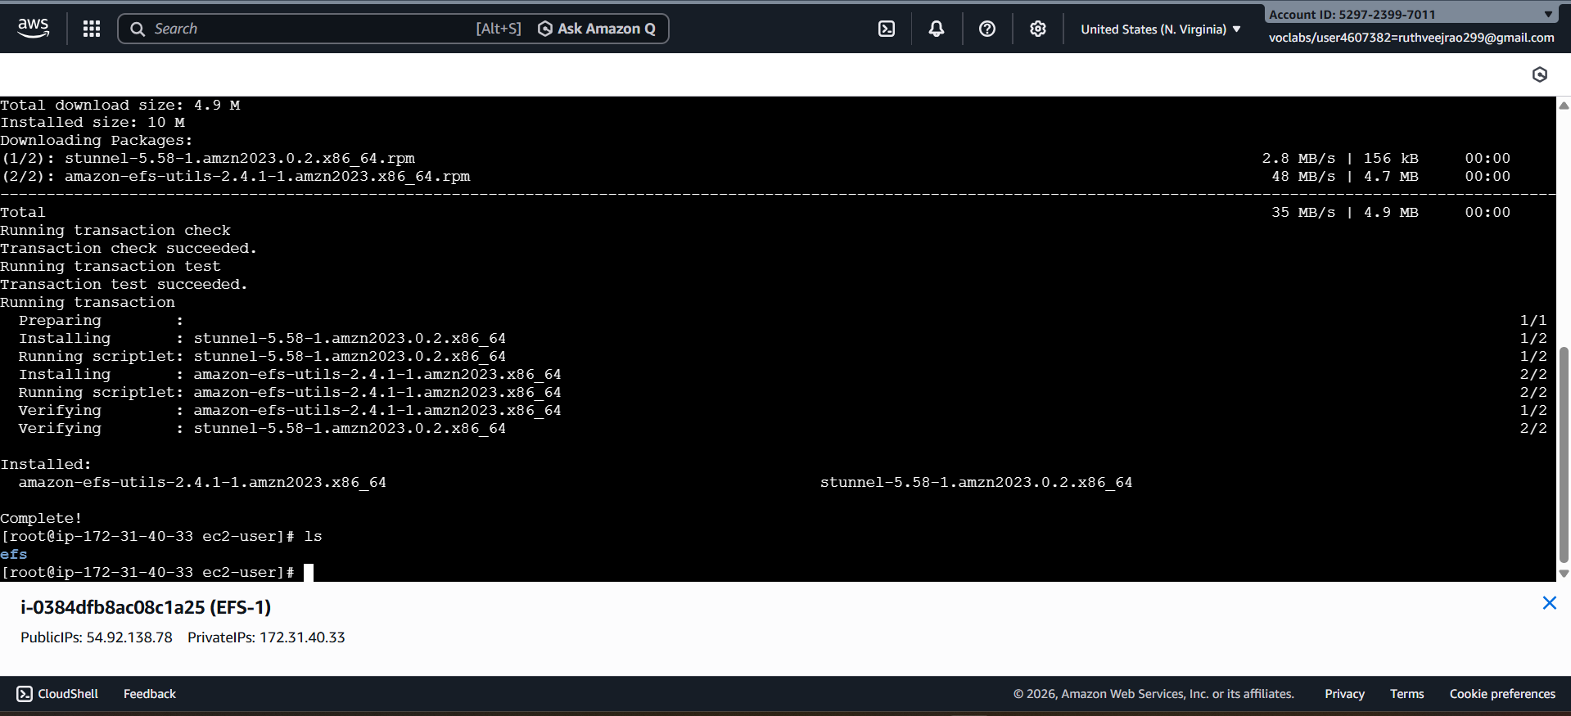
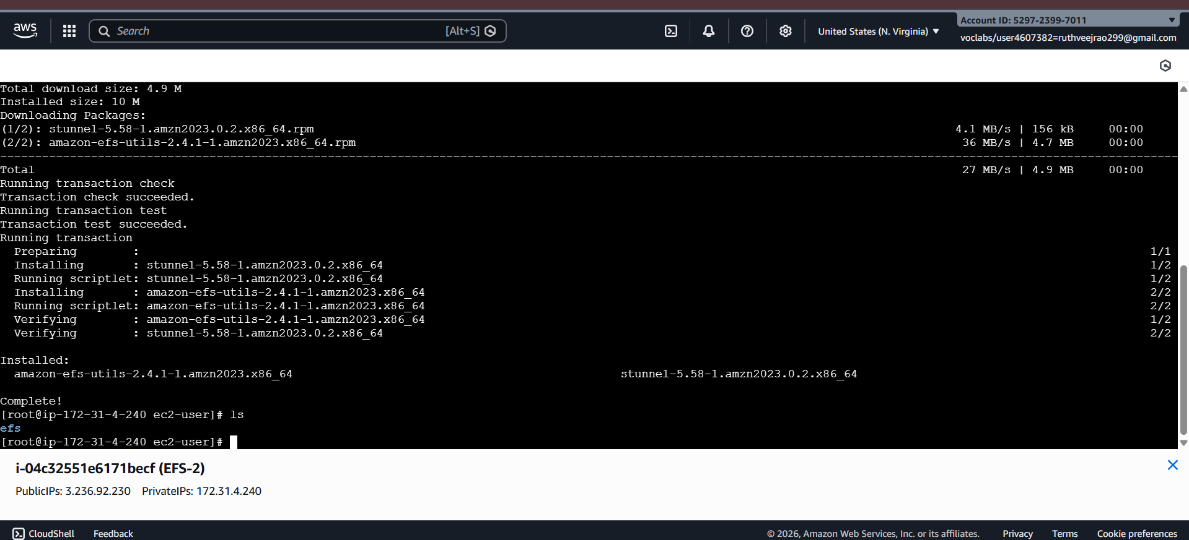
7. Verify Installation (Optional):
- Optionally, you can verify the installation of the Amazon EFS utilities by checking the version:
efs-utils --version
Repeat Steps 2-7 for ------------------------- EFS-2 Instance.
By following these steps, you'll have accessed each EFS-1 instance in separate PowerShell sessions, switched to the root user, created a directory named "efs," installed the Amazon EFS utilities, and listed files in the directory. This setup allows you to configure and manage each instance individually as needed.
Step 4: Attaching EFS to EC2 Instances
1. Go to the EFS service in the AWS Management Console.
2. Click on the target EFS file system.
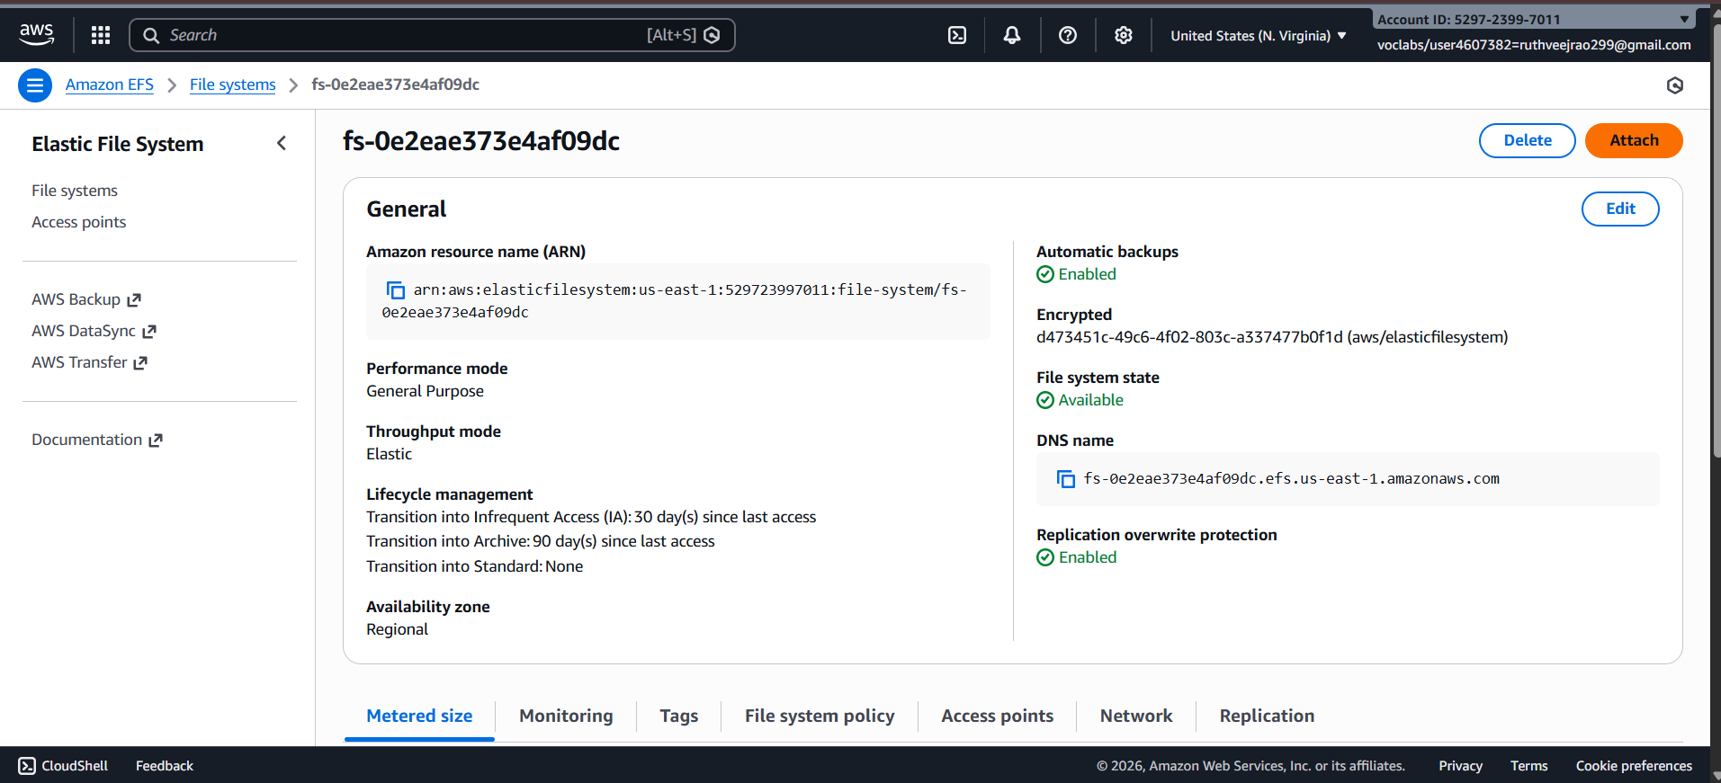
3. Click on the "Attach" button.
4. Choose "Mount via DNS" option.
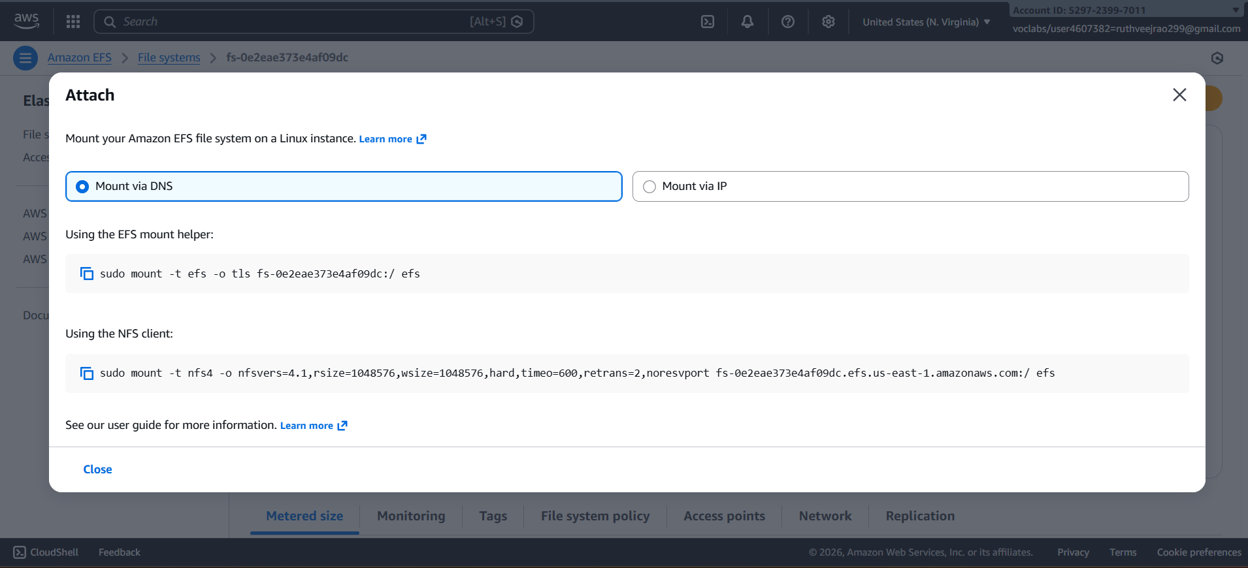sudo mount -t efs -o tls fs-0e2eae373e4af09dc:/ efs
5. Copy the displayed command. ,on both ec2 instances(powershell)
6. Paste and execute the copied command in the terminal to mount the EFS file system onto the instance.
Step 5: Verify and Test EFS
1. Change the directory to EFS on both instances.
2. Create a file on one instance.
3. Verify that the file automatically synchronizes and appears on the other instance.
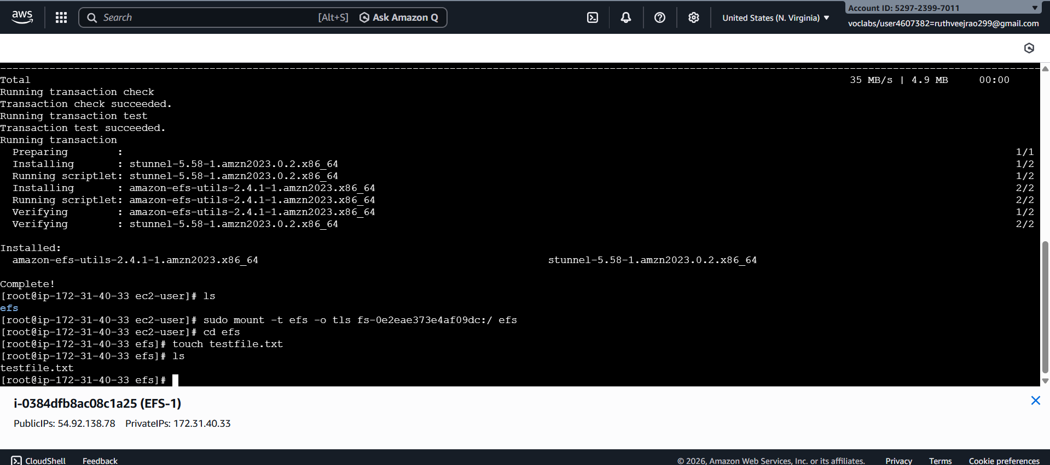
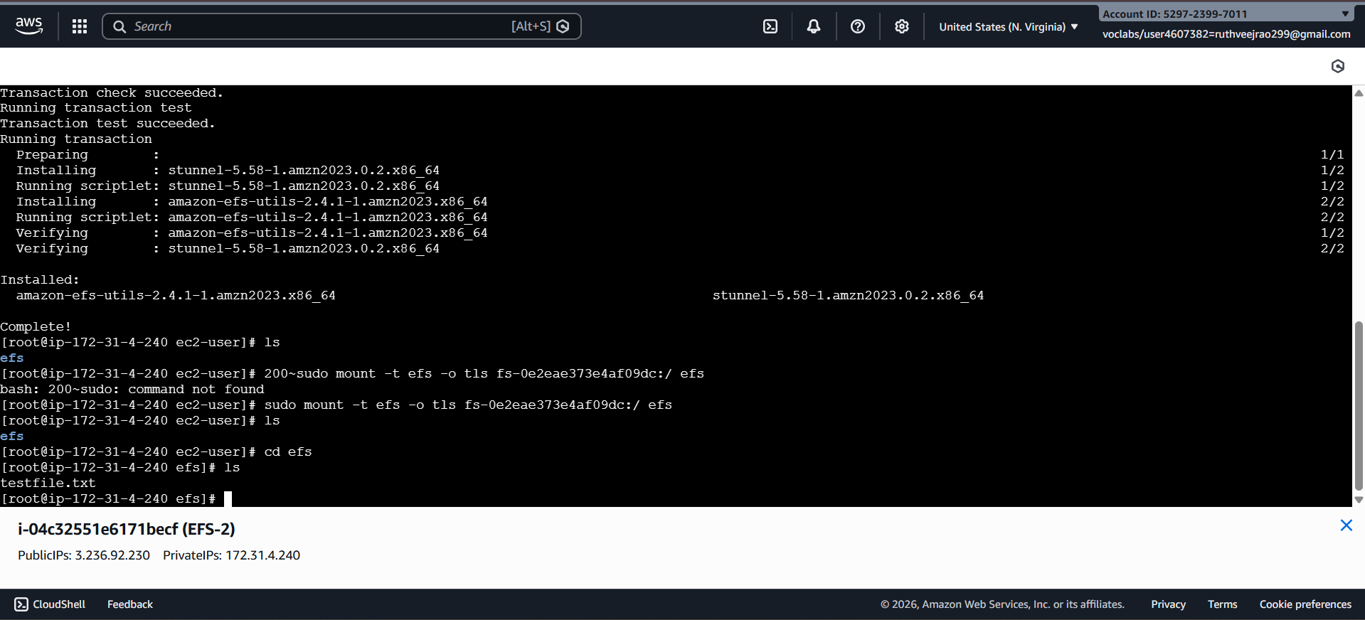
By above steps, we can successfully create EC2 instances, configured them, created an EFS file system, and attached it to the instances in the same availability zone in the Mumbai region. Now, the instances can seamlessly access and share files stored in the EFS file system.

1. Multiple EC2 instances across different Availability Zones must read and write the same files at the same time. Which AWS storage service fits this requirement and why?
Amazon Elastic File System (EFS) is suitable because it is a regional network file system that can be mounted by many EC2 instances in different Availability Zones at once, enabling shared read and write access through the NFS protocol.
2. An application running on EC2 in three different AZs needs a shared file system with low operational overhead. How would EFS support this setup?
EFS automatically provisions mount targets in each Availability Zone and takes care of scaling, replication, and high availability, allowing EC2 instances in all AZs to use the same file system without manual management.
3. You mounted an EFS file system on one EC2 instance. Can another EC2 instance modify the same file simultaneously? What happens in such a scenario?
Yes, multiple EC2 instances can access and update the same file at the same time. EFS relies on NFS mechanisms such as file locking and consistency controls to safely manage concurrent access.
4. Your team tried to attach an EFS file system to an EC2 instance, but the mount command timed out. What networking components would you check first?
First, confirm that an EFS mount target exists in the same Availability Zone as the EC2 instance, and then ensure that the security group permits inbound NFS traffic on port 2049.
5. An EC2 instance in a private subnet is unable to mount EFS. What configuration might be missing at the subnet or VPC level?
The subnet may not have proper network connectivity to the EFS mount target, or the associated security groups and route tables may not allow NFS traffic within the VPC.
6. You created an EFS file system but forgot to create mount targets in all AZs. How will this affect EC2 instances in those AZs?
EC2 instances running in Availability Zones without mount targets will not be able to connect to the EFS file system, resulting in mount errors or connection timeouts.
7. Why does EFS require mount targets in each Availability Zone, and what happens if one AZ goes down?
Mount targets act as local access points for EC2 instances within each Availability Zone. If an AZ becomes unavailable, instances in other AZs can still access EFS through their respective mount targets.
8. Two applications in different subnets need access to the same EFS file system. How should the EFS networking and security groups be configured?
Both subnets must belong to the same VPC, and the security groups for the EFS mount targets should allow NFS traffic from the security groups attached to the EC2 instances.
9. Your security team wants only specific EC2 instances to access EFS. How can security groups be used to enforce this?
By configuring the EFS security group to allow NFS access only from the security groups assigned to approved EC2 instances, unauthorized access can be prevented.
10. While mounting EFS, the command specifies -t nfs4. Why does EFS use NFS, and what advantage does it provide?
EFS is based on the NFS protocol because it enables multiple systems to share files concurrently while maintaining POSIX-compliant permissions and consistent file access behavior.
11. An organization wants to migrate from EBS to EFS because multiple EC2 instances need concurrent access to data. What limitation of EBS is driving this decision?
An EBS volume can generally be attached to only a single EC2 instance at a time, whereas EFS is designed to be accessed simultaneously by many instances.
12. An application team complains about increased latency when accessing EFS from EC2. What factors related to networking or AZ placement should be considered?
Higher latency may occur if EC2 instances access EFS across Availability Zones, or due to network congestion, routing issues, or restrictive security group configurations.
13. Can an EFS file system be accessed from EC2 instances in different VPCs? If yes, what networking setup is required?
Yes, EFS can be shared across VPCs using VPC peering or AWS Transit Gateway, provided that routing tables and security group rules are correctly configured.

🟢 PART 1 — Launch 2 EC2 Instances

STEP 1 — Launch First Instance (EFS-1)
Go to:
EC2 → Launch Instance
Fill:
Name:
EFS-1
AMI:
Amazon Linux 2
Instance Type:
t2.micro
Key Pair:
Create new:
Name: EFS-key
Type: RSA
Format: .pem
Download and SAVE this .pem safely.

🔐 Security Group (VERY IMPORTANT)
Create new security group:
Name:
EFS-SG
Add Inbound Rules:

Rule 1 — SSH
Type: SSH
Port: 22
Source: My IP

Rule 2 — NFS
Type: NFS
Port: 2049
Source: Anywhere (0.0.0.0/0) ← for lab only
⚠️ In real world, NEVER allow from anywhere.
Launch instance.

STEP 2 — Launch Second Instance (EFS-2)
Repeat same steps.
Name:
EFS-2
Important:
- Same VPC
- Different subnet (1a and 1b)
- Same Security Group (EFS-SG)
Launch.

🟢 PART 2 — Create EFS File System

Go to:
EFS service → Create file system

STEP 1 — Basic Settings
Name:
MyEFS
VPC:
Default (same VPC as EC2)
Click Next.

STEP 2 — Network Settings
You will see Mount Targets.
For each AZ:
Make sure:
Security Group:
Select:
EFS-SG
Delete default SG if present.
Click Next → Create.
Wait until:
Available

📝 WRITE THIS DOWN
- File System ID
Example:
fs-0abc123xyz
You will need this.

🟢 PART 3 — Connect to EC2 Instances
Open 2 PowerShell windows.

SSH into EFS-1
ssh -i EFS-key.pem ec2-user@<public-ip-of-EFS-1>

SSH into EFS-2 (second window)
ssh -i EFS-key.pem ec2-user@<public-ip-of-EFS-2>

🟢 PART 4 — Prepare Both Instances
Perform these commands on BOTH instances.

1️⃣ Become Root
sudo su

2️⃣ Install EFS Utilities
yum install -y amazon-efs-utils
COMMAND USED:
- yum → package manager
- amazon-efs-utils → allows mounting EFS easily

3️⃣ Create Mount Directory
mkdir /efs

4️⃣ Check Installation (Optional)
rpm -qa | grep efs

🟢 PART 5 — Mount EFS on Both Instances

Go to:
EFS → Select your File System → Click Attach
Choose:
Mount via DNS
You’ll see command like:
sudo mount -t efs -o tls fs-0abc123xyz:/ /efs
COPY THIS EXACT COMMAND.

On BOTH instances run:
sudo mount -t efs -o tls fs-0abc123xyz:/ /efs
Replace with YOUR file system ID.

Verify Mount
df -h
You should see something like:
fs-0abc123xyz:/ 8.0E 0 8.0E 0% /efs

🟢 PART 6 — Test File Sharing

On EFS-1
cd /efs
Create file:
echo "Hello from EFS-1" > test.txt
Check:
ls
You’ll see:
test.txt

Now go to EFS-2
cd /efs
ls
🎉 You will see:
test.txt
This proves shared storage.

🟢 OPTIONAL — Make EFS Mount Permanent
If you reboot, mount disappears.
To make permanent:
Edit fstab:
nano /etc/fstab
Add:
fs-0abc123xyz:/ /efs efs _netdev,tls 0 0
Save.
Test:
mount -a
Reboot test:
reboot
After reconnect:
df -h

📋 ALL COMMANDS USED IN THIS LAB
ssh -i key.pem ec2-user@IP
sudo su
yum install -y amazon-efs-utils
mkdir /efs
sudo mount -t efs -o tls fs-xxxx:/ /efs
df -h
cd /efs
echo "text" > file.txt
ls
nano /etc/fstab
mount -a
reboot

