Week 5: VPC Creation and Ec2 Instance Connection
🔹 Step 1: Create the VPC
- Go to AWS Management Console → VPC
- Click Create VPC
- Choose VPC only
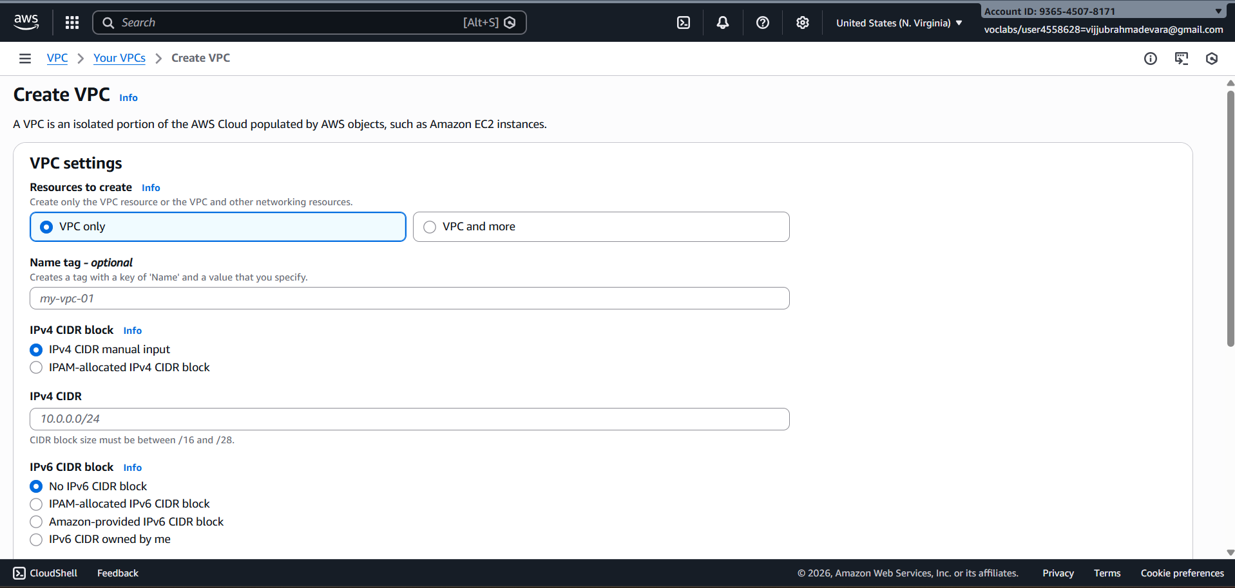
- Enter:
  - Name: Custom-VPC
  - IPv4 CIDR block: e.g. 10.0.0.0/16
- Click Create VPC
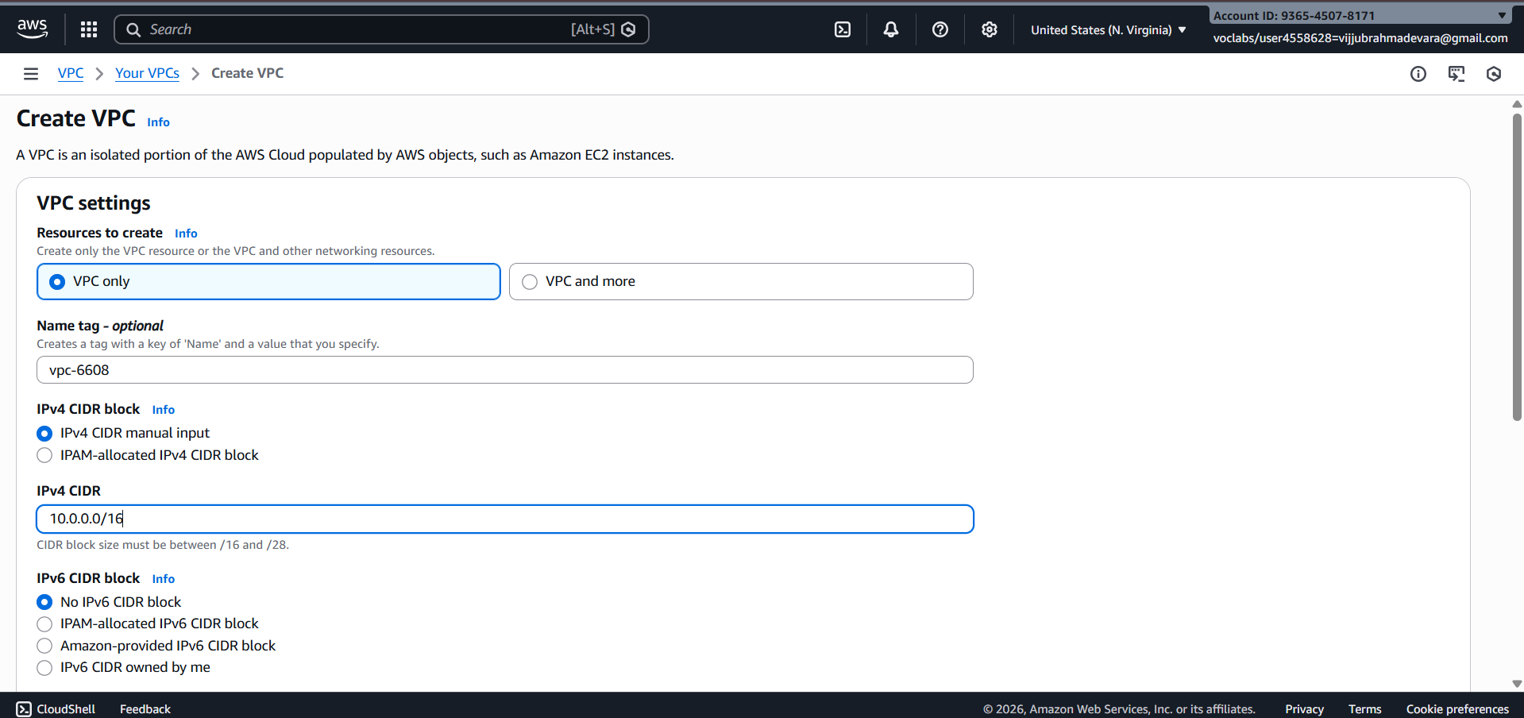
🔹 Step 2: Create Subnets (Public & Private)
Create subnets in same Availability Zones for high availability.
Example:
- Public Subnet: 10.0.1.0/24 (AZ-A)
- Private Subnet: 10.0.2.0/24 (AZ-A)
Steps:
- Go to Subnets → Create subnet
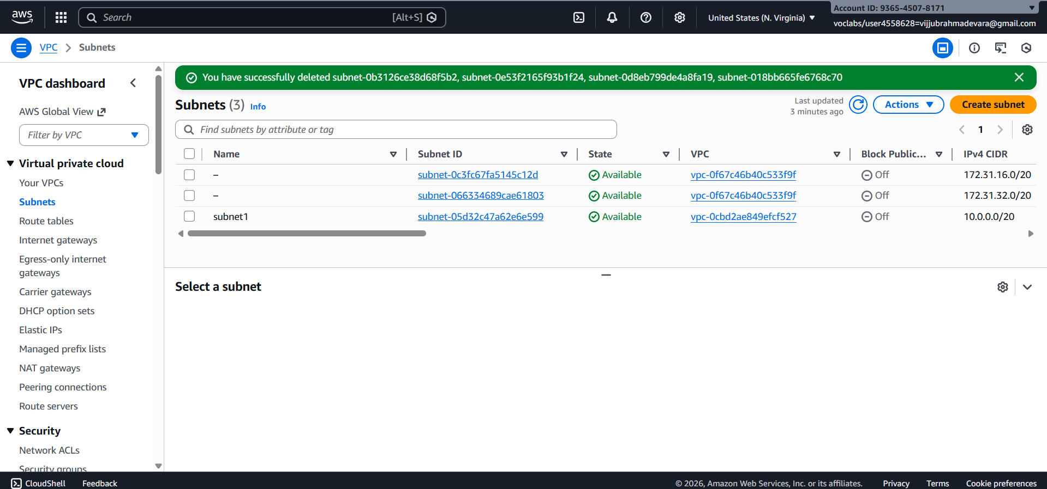
- Select your VPC
- Choose AZ
- Enter CIDR
- Create subnet
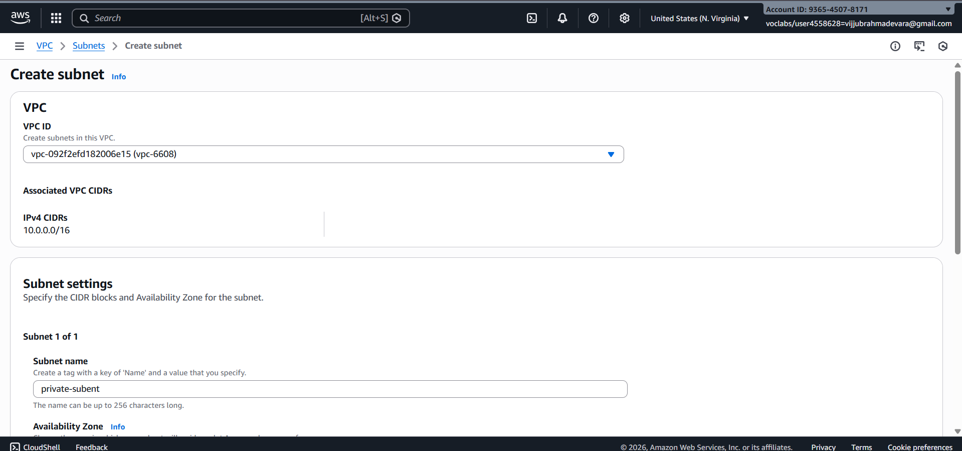
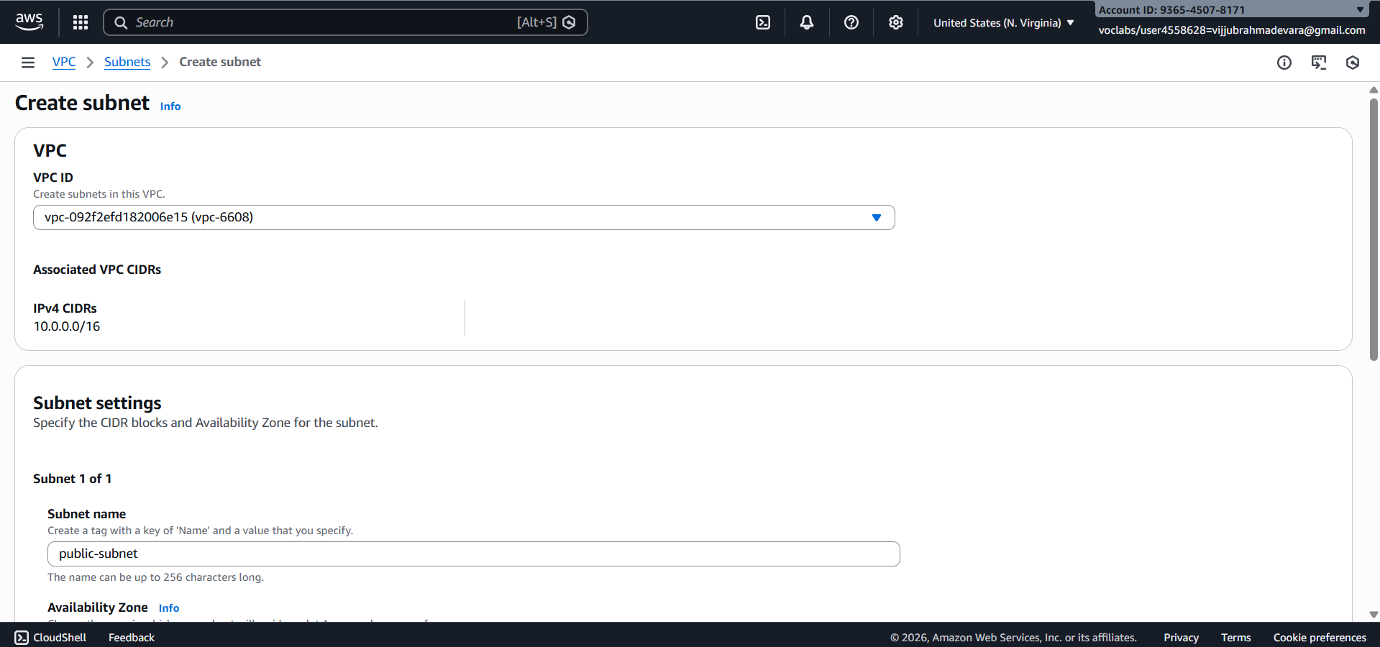
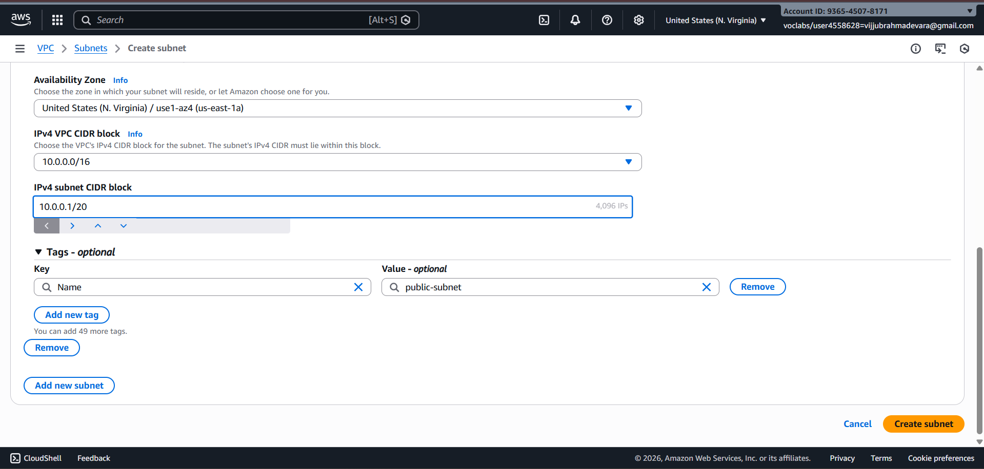
🔹 Step 3: Create an Internet Gateway (IGW)
- Go to Internet Gateways
- Click Create internet gateway
- Name it Custom-IGW
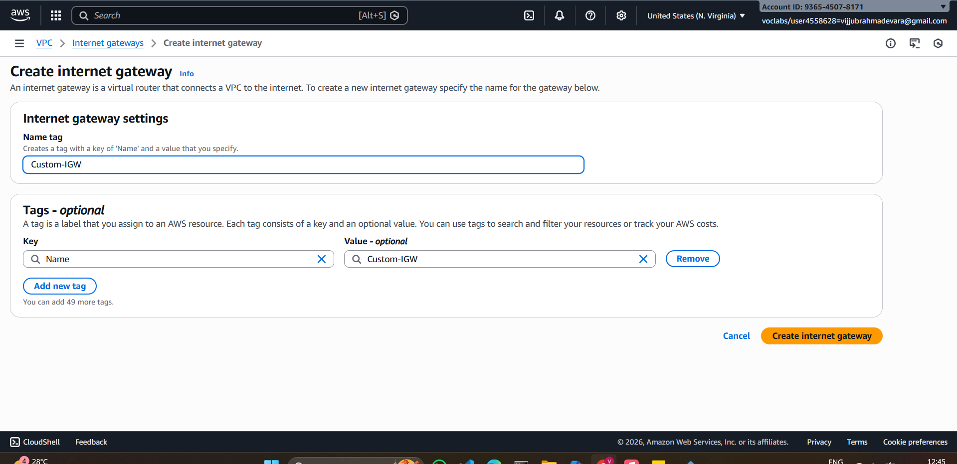
- Attach it to your VPC
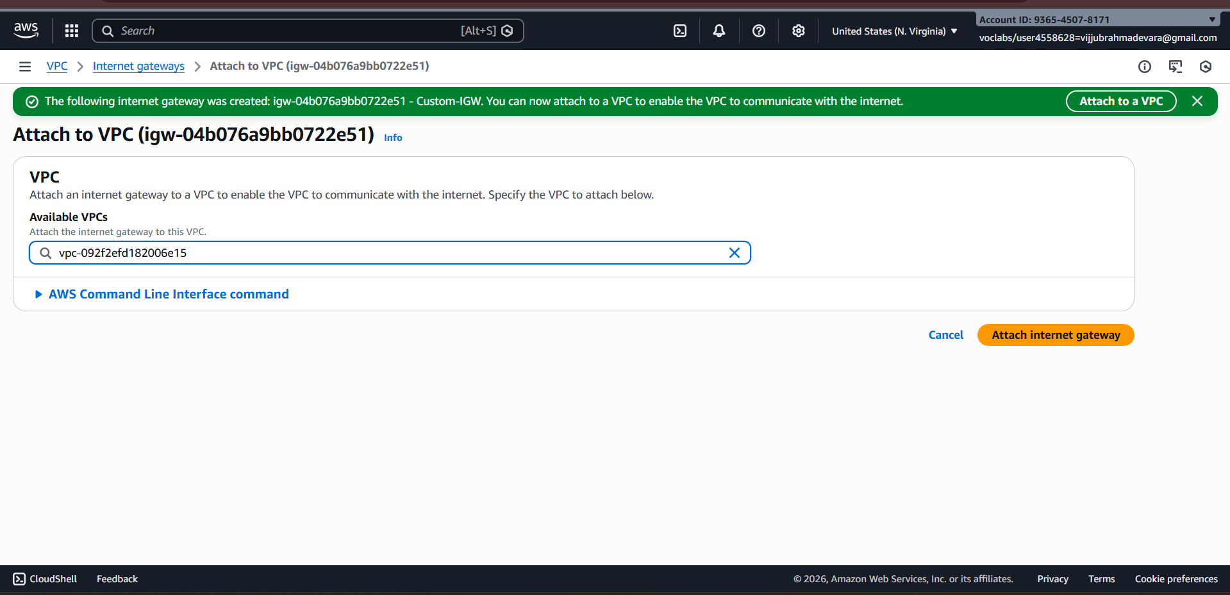

🔹 Step 4: Create Route Tables
You need separate route tables for public and private subnets.
Public Route Table
- Go to Route Tables → Create route table
- Select VPC
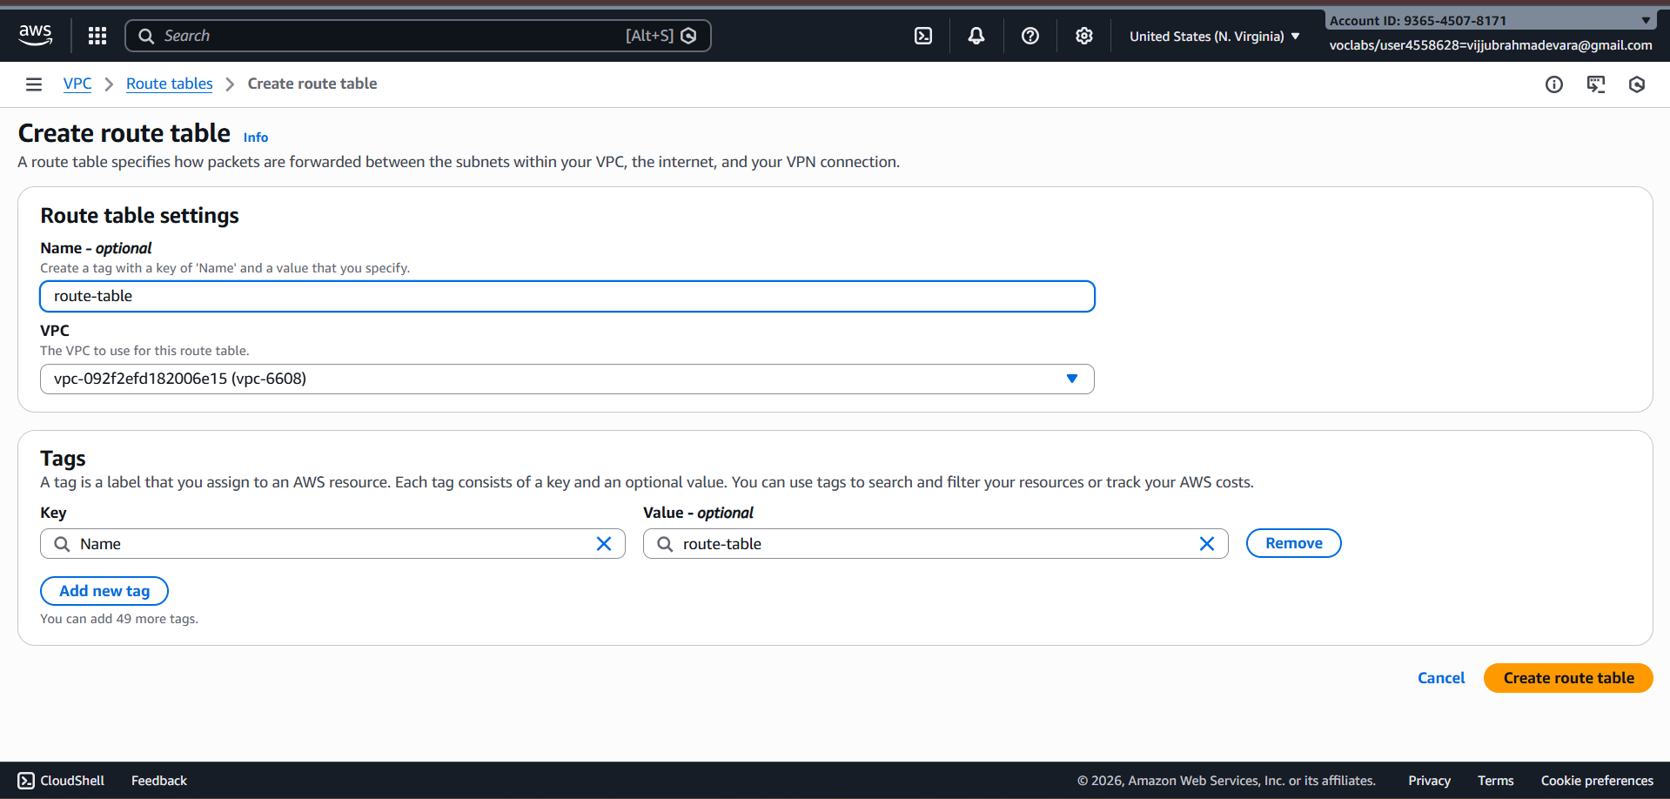
- Add route:
  - Destination: 0.0.0.0/0
  - Target: Internet Gateway
- Associate with public subnet
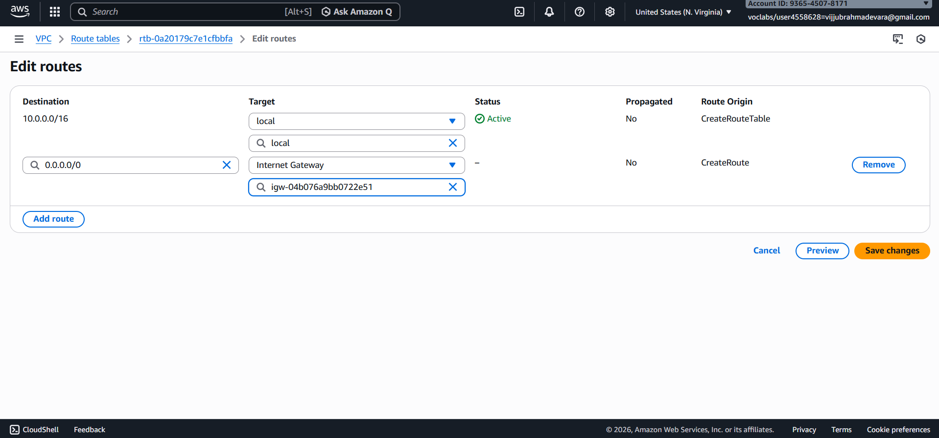
Private Route Table
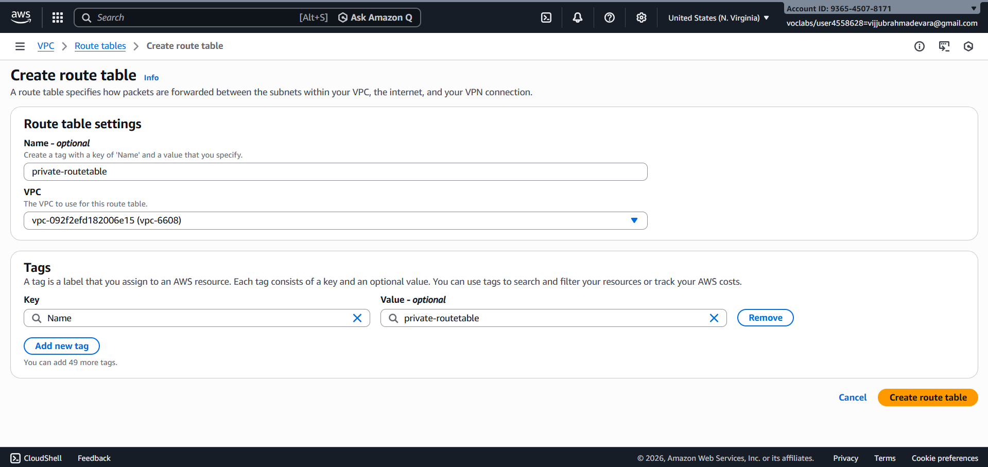
- Keep default local route only (no IGW)
- Associate with private subnet
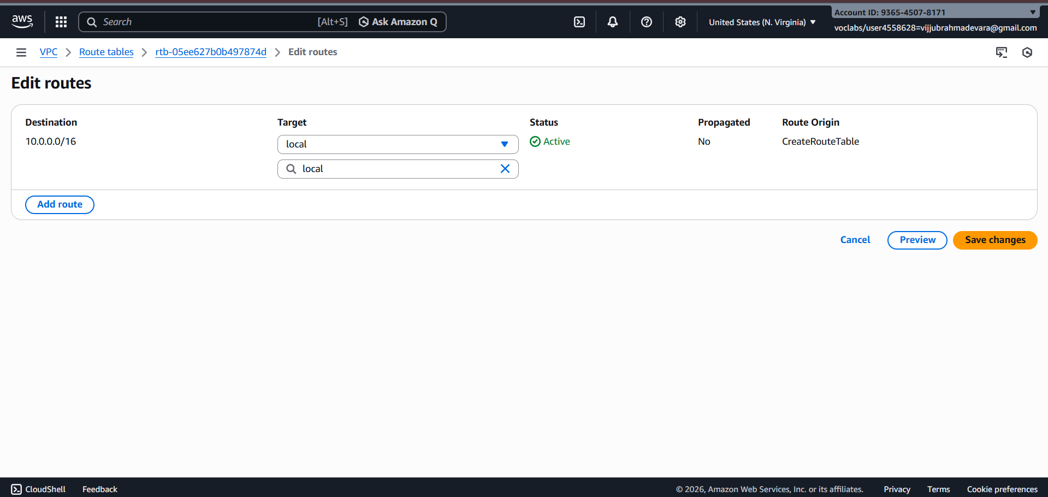
🔹 Step 5: Enable Auto-Assign Public IP (Public Subnet)
- Select Public Subnet
- Go to Edit subnet settings
- Enable Auto-assign public IPv4 address
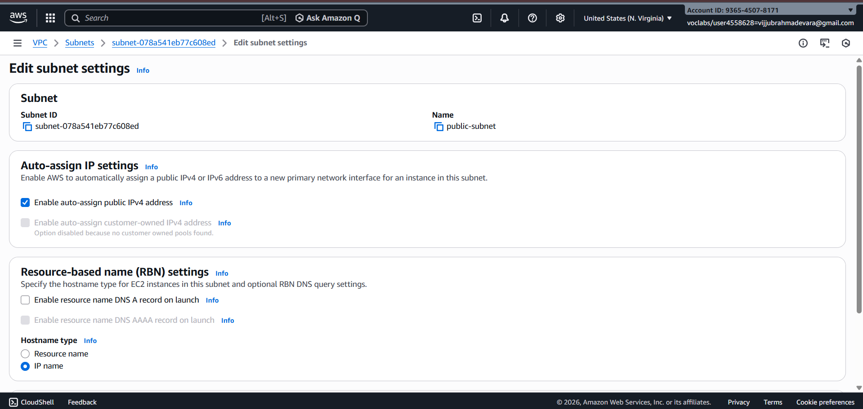
🔹 Step 6: Configure Security Groups
- Create a Security Group
- Add inbound rules:
  - HTTP (80) / HTTPS (443)
  - SSH (22) from trusted IP
- Attach to EC2 instances
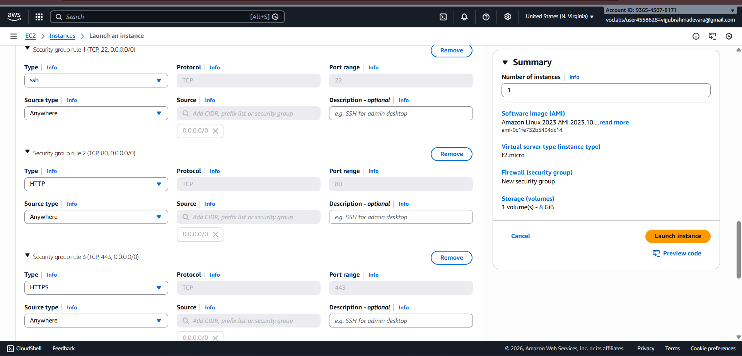
🔹 Step 7: Launch EC2 Instances
- Public EC2 → Public subnet
- Private EC2 → Private subnet
Attach correct security groups.
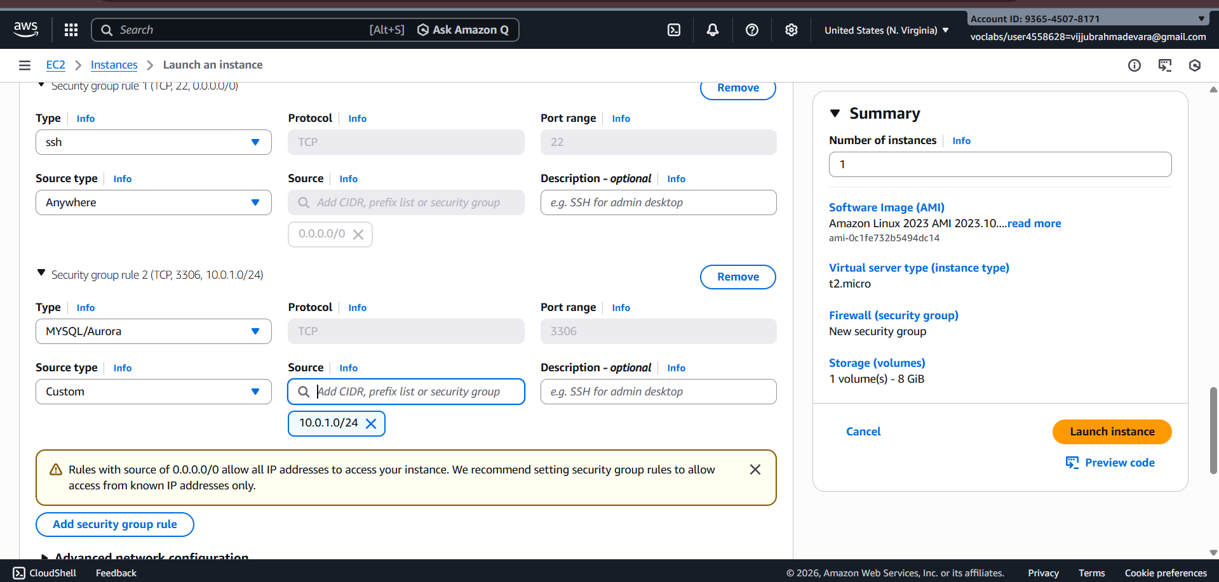
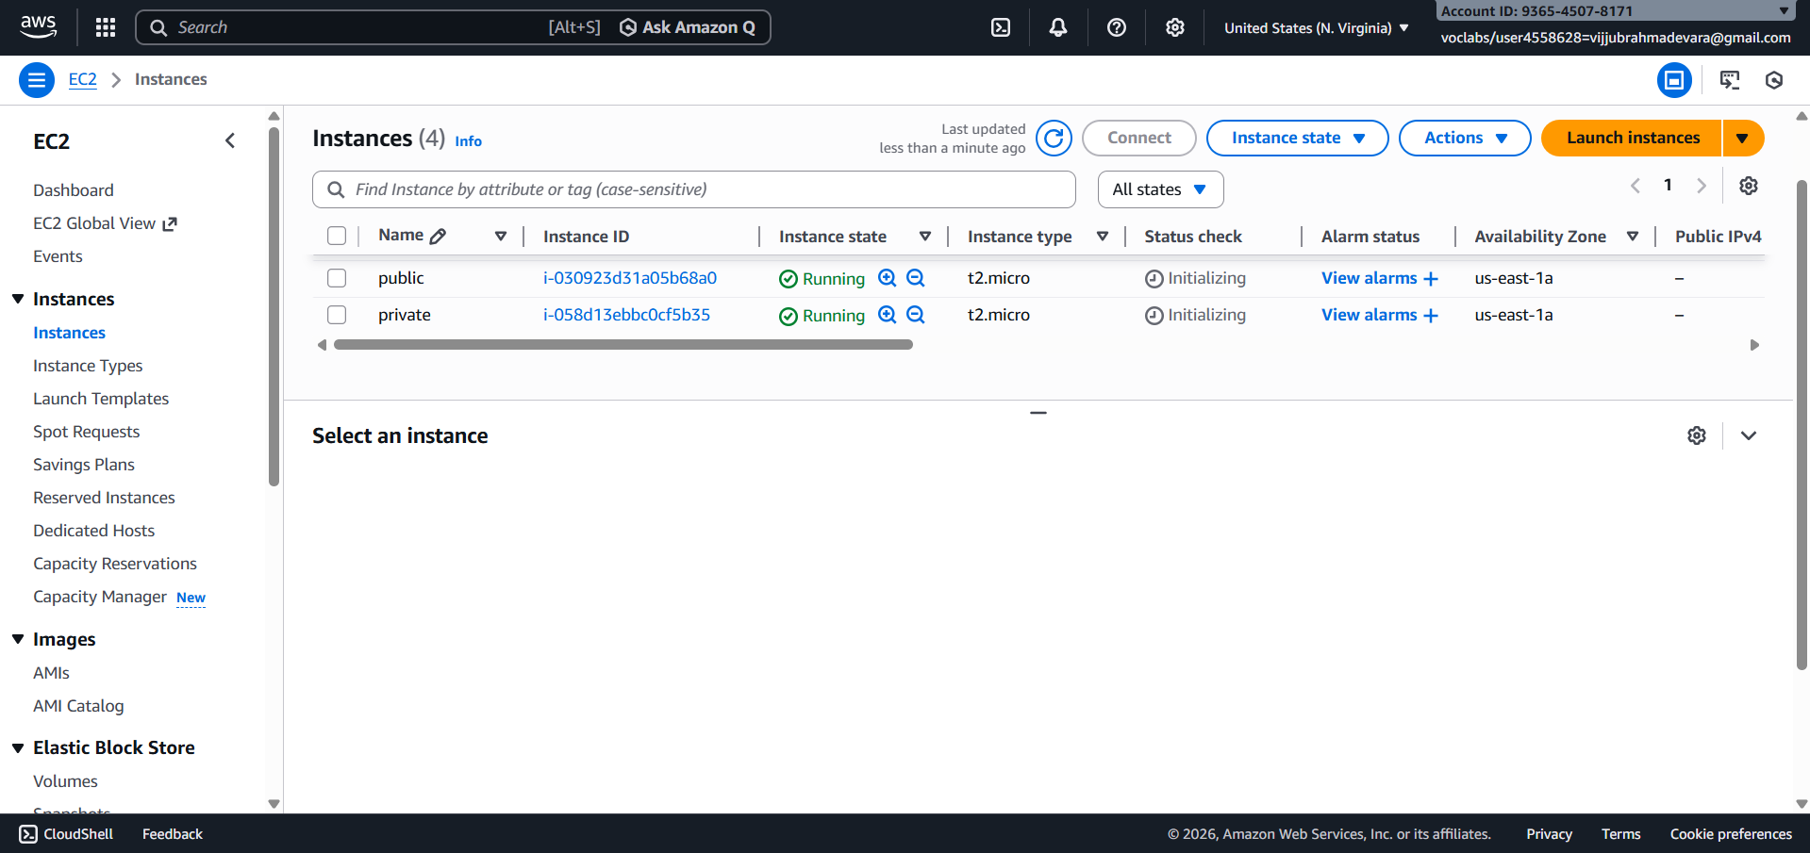
🔹 Step 8: Test the Setup
- Public EC2 → Internet access ✔
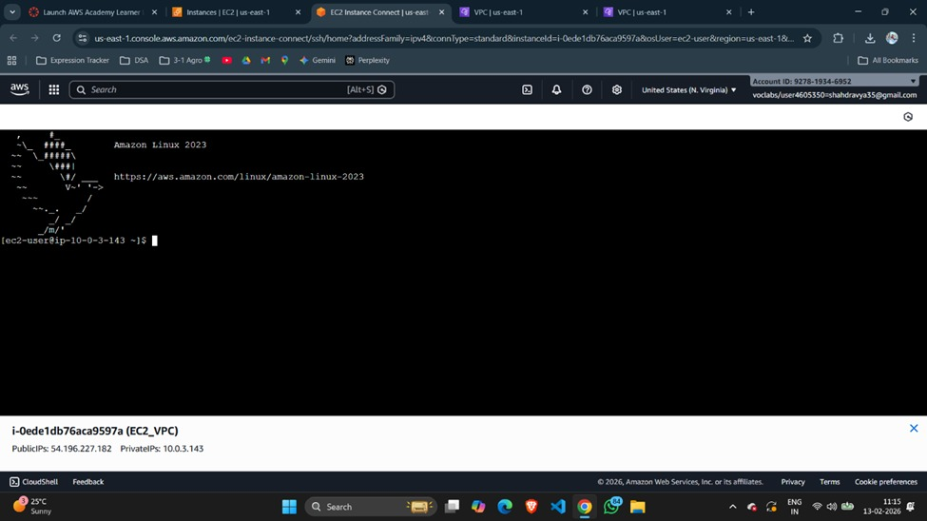
- Private EC2 → Internet via NAT ✔
- Private EC2 → No direct inbound access ✔
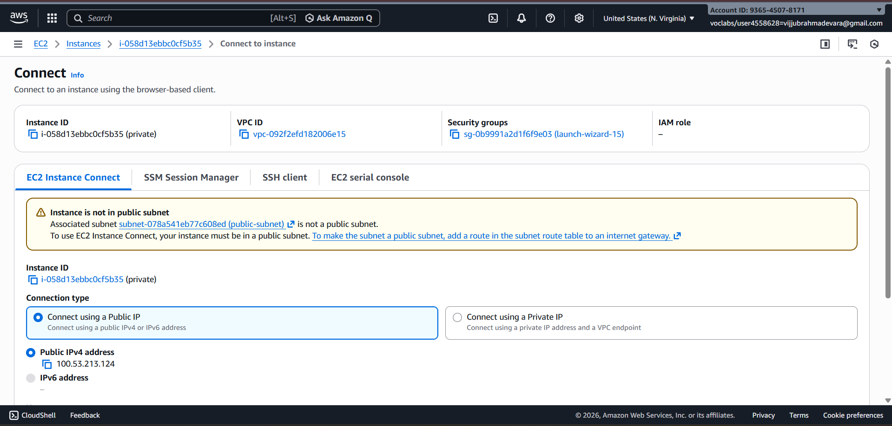

Scenario Based Questions:

1. You have a web application where users access a website, but the database should not be exposed to the internet. How would you design the VPC? Which resources go into public and private subnets?
Ans: Public subnets host internet-facing resources like Load Balancers and NAT Gateways. Private subnets host application servers and databases. The database remains in a private subnet with no route to an Internet Gateway for security.
An EC2 instance in a public subnet cannot access the internet. What VPC components would you check and why?
Ans: Check whether the subnet route table has a 0.0.0.0/0 route to an Internet Gateway, the IGW is attached to the VPC, the instance has a public IP, and security groups/NACLs allow outbound and return traffic.
Your application server needs to connect to an RDS database securely. How would you configure security groups and subnets?
Ans: Place both resources in private subnets and allow database inbound access only from the application server’s security group.
You are asked to design a VPC for 500 servers today, but it should scale to 2,000 servers in the future. How would you choose the CIDR block?
Ans: Choose a large CIDR block such as /16 to support future growth, multiple subnets, and Availability Zones.
A company wants secure connectivity between its on-premises data center and AWS VPC. Which AWS services would you choose and why (VPN vs Direct Connect)?
Ans: Use Site-to-Site VPN for quick, low-cost encrypted connectivity and Direct Connect for high bandwidth, low latency, and stable long-term connections.
You need to connect two VPCs, but both use the same CIDR range. How would you solve this problem?
Ans: Use NAT with Transit Gateway or redesign one VPC’s CIDR since VPC peering does not support overlapping CIDR ranges.
Multiple microservices running in different subnets need to communicate securely. How would you design routing and security groups?
Ans: Use default local routing within the VPC and restrict access using security groups that allow only required service-to-service traffic.
Design a VPC for a 3-tier application (Web, App, DB) with high security and scalability. Explain subnets, route tables, gateways, and security groups.
Ans: Web tier in public subnets with IGW access, App and DB tiers in private subnets, NAT Gateway for outbound access, and security groups allowing only tier-to-tier communication
You suspect unusual traffic inside your VPC. How would you monitor and analyze network traffic?
Ans: Enable VPC Flow Logs and analyze them using CloudWatch Logs or Athena.
Why can’t a private subnet have an Internet Gateway directly attached?
Ans: Internet Gateways attach to VPCs, not subnets; a subnet is private if its route table does not point to an IGW.
What happens if route tables are misconfigured in a VPC?
Ans: Traffic may fail to reach its destination, causing loss of internet access or broken internal communication.
What happens if a route table has no local route?
Ans: This cannot happen because AWS automatically adds a local route for VPC internal traffic.
An EC2 instance allows traffic on port 80 in the security group, but traffic is still blocked. What could be the reason?
Ans: The Network ACL or route table may be blocking traffic, or the instance may not have a public IP.

You need to create a VPC that will host 1,000+ EC2 instances across multiple AZs. How do you decide the CIDR block?
Ans: Select a large CIDR block such as /16 to support scalability and multiple subnets across AZs.

Only a company’s corporate IP should be able to SSH into EC2 instances. How would you implement this securely in AWS VPC?
Ans: Restrict SSH (port 22) in the security group to the company’s public IP range or use a bastion host.

An EC2 instance can send traffic out but cannot receive responses. Which VPC component might be misconfigured and why?
Ans: The instance may lack a public IP or the Network ACL may be blocking inbound ephemeral ports.

🎯 WHAT WE ARE BUILDING
A custom network like this:
Custom VPC (10.0.0.0/16)
│
├── Public Subnet (10.0.1.0/24)
│ └── Public EC2 (Internet access)
│
└── Private Subnet (10.0.2.0/24)
└── Private EC2 (No direct internet)

🟢 STEP 1 — Create the VPC

Go to:
AWS Console → Search → VPC
Click:
Create VPC
Choose:
VPC only
Fill:
Name:
Custom-VPC
IPv4 CIDR:
10.0.0.0/16

What does /16 mean?
It means:
- Total IP range = 65,536 addresses
- Range = 10.0.0.0 → 10.0.255.255
Click:
Create VPC
📌 WRITE DOWN:
- VPC ID (example: vpc-0abc123)

🟢 STEP 2 — Create Subnets

Go to:
Subnets → Create subnet

🔹 Create Public Subnet
VPC:
Custom-VPC
Subnet name:
Public-Subnet
Availability Zone:
ap-south-1a (example)
IPv4 CIDR:
10.0.1.0/24
Click Create.

🔹 Create Private Subnet
Again click Create subnet.
Subnet name:
Private-Subnet
Same AZ (or different if testing HA)
CIDR:
10.0.2.0/24
Click Create.

📌 What /24 means:
256 IP addresses per subnet.

🟢 STEP 3 — Create Internet Gateway (IGW)

Go to:
Internet Gateways → Create
Name:
Custom-IGW
Click Create.
Now:
Click:
Attach to VPC
Select:
Custom-VPC
Click Attach.
✔ Now VPC can connect to Internet.

🟢 STEP 4 — Create Route Tables

🔹 Public Route Table
Go to:
Route Tables → Create
Name:
Public-RT
Select VPC:
Custom-VPC
Create.

Now click:
Routes → Edit routes
Add route:
Destination:
0.0.0.0/0
Target:
Internet Gateway
Save.

Now go to:
Subnet Associations → Edit
Select:
Public-Subnet
Save.

🔹 Private Route Table
Create new route table:
Name:
Private-RT
Select VPC.
Do NOT add internet route.
Only local route remains:
10.0.0.0/16 local
Associate with:
Private-Subnet

🟢 STEP 5 — Enable Auto-Assign Public IP

Go to:
Subnets → Public-Subnet
Click:
Edit subnet settings
Enable:
Auto-assign public IPv4 address
Save.
This ensures public EC2 gets public IP automatically.

🟢 STEP 6 — Create Security Group

Go to:
Security Groups → Create
Name:
Web-SG
Select:
Custom-VPC
Add Inbound Rules:

SSH
Type: SSH
Port: 22
Source: My IP

HTTP
Port: 80
Source: 0.0.0.0/0
Click Create.

🟢 STEP 7 — Launch EC2 Instances

Go to:
EC2 → Launch Instance

🔹 Public EC2
Name:
Public-EC2
AMI:
Amazon Linux
Instance type:
t2.micro
Key pair:
Create or select existing.
Under Network:
VPC:
Custom-VPC
Subnet:
Public-Subnet
Auto-assign public IP:
Enabled
Security Group:
Web-SG
Launch.

🔹 Private EC2
Repeat.
Name:
Private-EC2
Subnet:
Private-Subnet
Auto-assign public IP:
Disabled
Security Group:
Web-SG (or create separate private SG)
Launch.

🟢 STEP 8 — Test the Setup

🔹 Test Public EC2 Internet Access
SSH into Public EC2:
ssh -i key.pem ec2-user@<public-ip>
Test internet:
ping google.com
✔ Should work.

🔹 Test Private EC2
Try SSH directly from your laptop:
It will FAIL ❌
Because:
- No public IP
- No IGW route
✔ Correct behavior.

