Emotion recognition from facial expressions is generally performed in three steps: face detection, features extraction and classification of expressions. Emotion recognition plays a key role in interpersonal relationships. The ability to interpret facial expressions in the social environment allows people to anticipate intentions or situations and respond appropriately. According to Paul Ekman [1], there is a universality of six basic emotions: happiness, surprise, sadness, fear, anger, and disgust. These emotions can be found in all cultures.

Decision Trees are commonly used in data mining with the objective of creating a model that predicts the value of a target (or dependent variable) based on the values of several input (or independent variables).  In today's post, we discuss the CART decision tree methodology.  The CART or Classification & Regression Trees methodology was introduced in 1984 by [Leo Breiman](https://en.wikipedia.org/wiki/Leo_Breiman), [Jerome Friedman](http://www.kdd.org/node/362), [Richard Olshen](http://www-stat.stanford.edu/~olshen/) and [Charles Stone](http://vcresearch.berkeley.edu/charles-stone) as an umbrella term to refer to the following types of decision trees:

Decision trees used are of two main types:

* [**Classification tree**](https://en.wikipedia.org/wiki/Classification_tree) analysis is when the predicted outcome is the class to which the data belongs.
* **Regression tree** analysis is when the predicted outcome can be considered a real number

**Classification Trees**: where the target variable is categorical and the tree is used to

identify the "class" within which a target variable would likely fall into.

[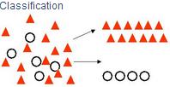](https://1.bp.blogspot.com/-vHvL7gVfvAw/UPNKEYscZpI/AAAAAAAAA14/JmTlZNo41DY/s1600/Classification+visual.PNG)

* **Regression Trees**: where the target variable is continuous and tree is used to predict it's value.

[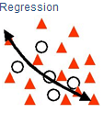](https://4.bp.blogspot.com/-drfCLA5uZ4g/UPNKc9Sa_5I/AAAAAAAAA2A/Jfy9oVklNdU/s1600/Regression+visual.PNG)

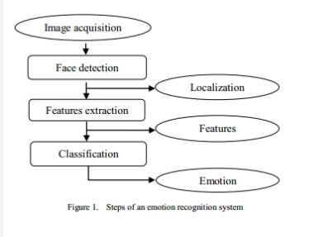

The CART algorithm is structured as a sequence of questions, the answers to which determine what the next question, if any should be.  The result of these questions is a tree like structure where the ends are terminal nodes at which point there are no more questions.  A simple example of a decision tree is as follows [Source: Wikipedia]:

[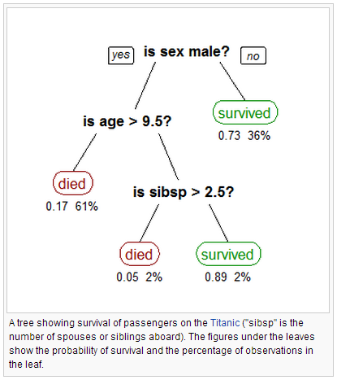](https://1.bp.blogspot.com/-z7ukEqUcfvc/UPNMA9PZRKI/AAAAAAAAA2c/FitWl1yEEC0/s1600/titanic.PNG)

The main elements of CART (and any decision tree algorithm) are:

1. Rules for splitting data at a node based on the value of one variable;
2. Stopping rules for deciding when a branch is terminal and can be split no more; and
3. Finally, a prediction for the target variable in each terminal node.

CART is used to classify facial expressions into six basic emotions (Happy, Sad, Angry, Disgust, Surprise, and Fear) plus neutral state.