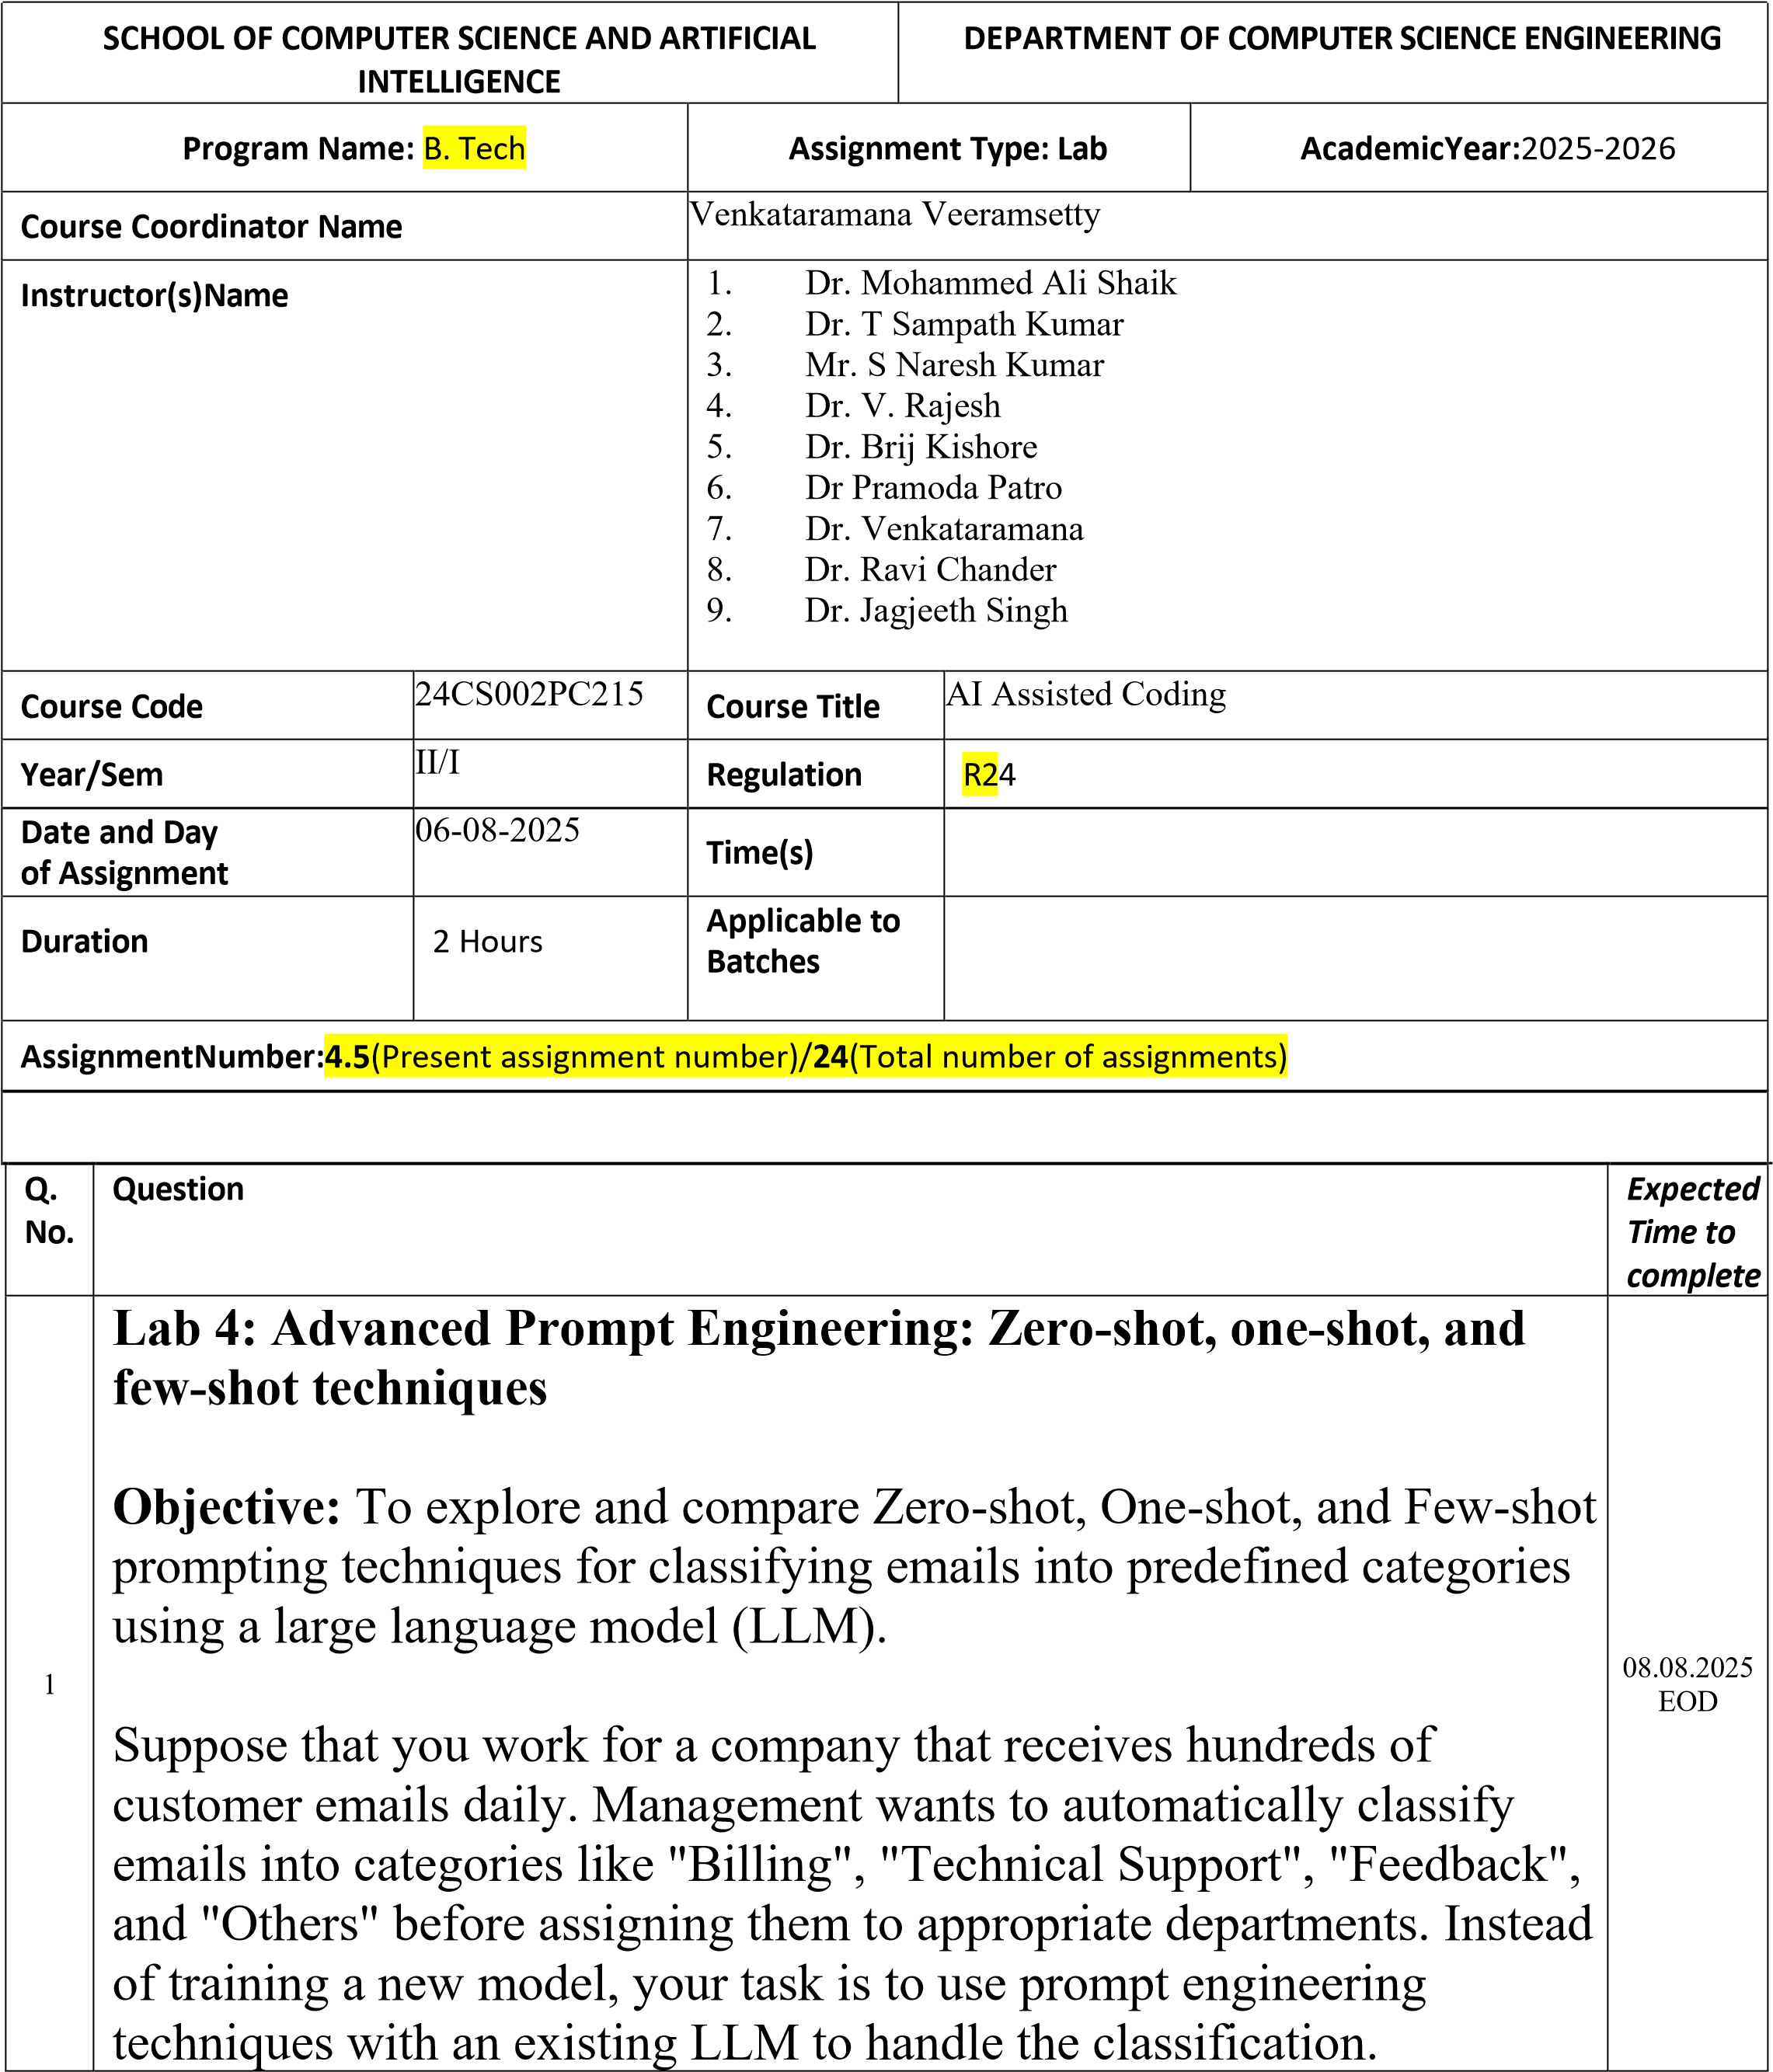

Tasks to be completed are as

below

1

.

**Prepare Sample Data:**

•

Create or collect 10 short email samples, each belonging to one of

the 4 categories.

PROMPT:

give a code Create or collect 10 short email samples, each

belonging to one of the 4 categories

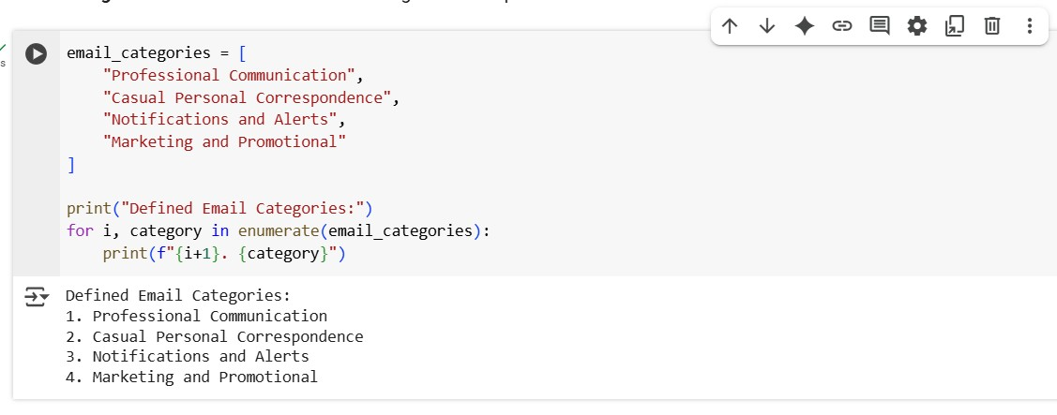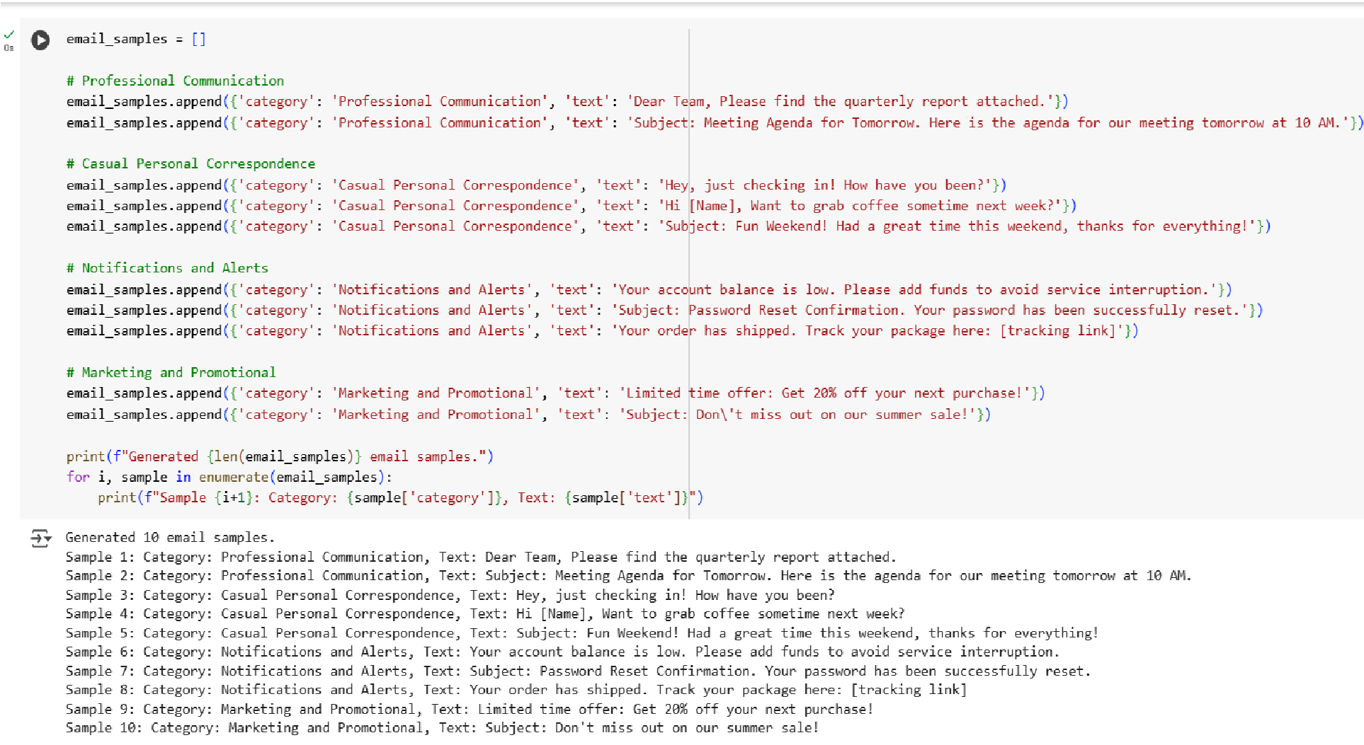

2

.

**Zero**

**-**

**shot Prompting:**

•

Design a prompt that asks the LLM to classify a single email

without providing any examples.

•

Example prompt:

*“*

*Classify the following email into one of the following categories:*

*Billing, Technical Support, Feedback, Others. Email:*

*‘*

*I have not*

*received my invoice for last month.*

*’”*

*Prompt:*

G

enerate

a code which takes emails from the user as an input and let

the code

give output from which category(feedback, billing, technical support

and others) the email belongs to..

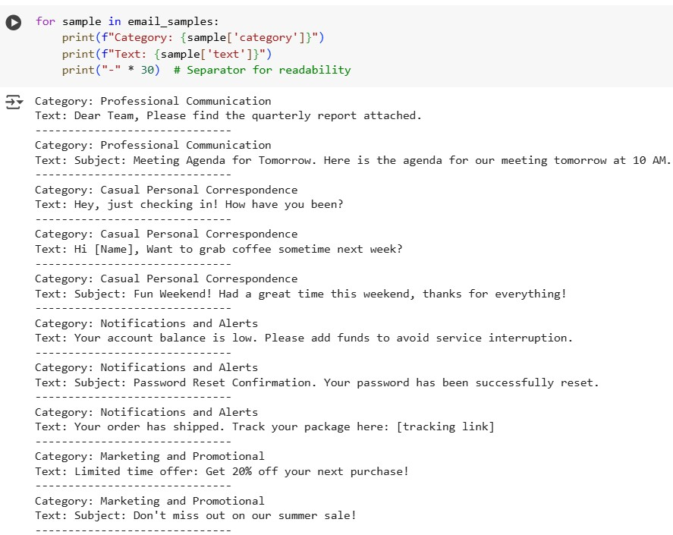

**3**

**. One**

**-**

**shot Prompting:**

•

Add one labeled example before asking the model to classify a

new mail

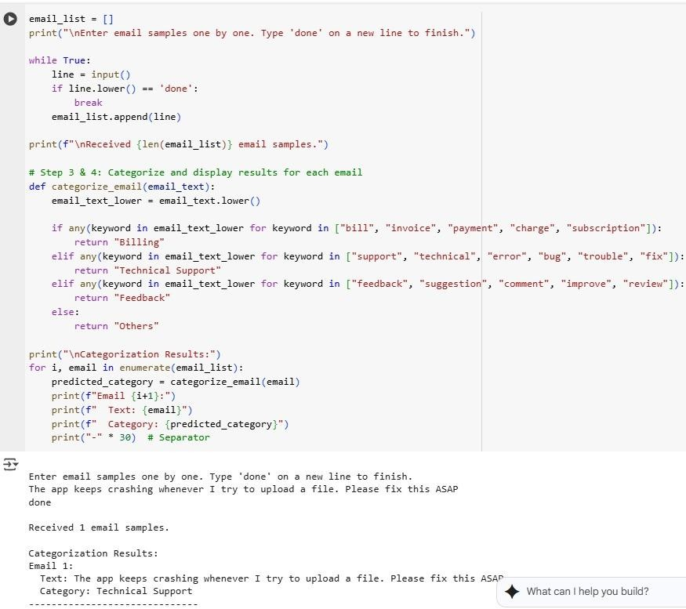

4

.

**Few**

**-**

**shot Prompting:**

•

Use 3

–

5

labeled examples in your prompt before asking the model

to classify a new email.

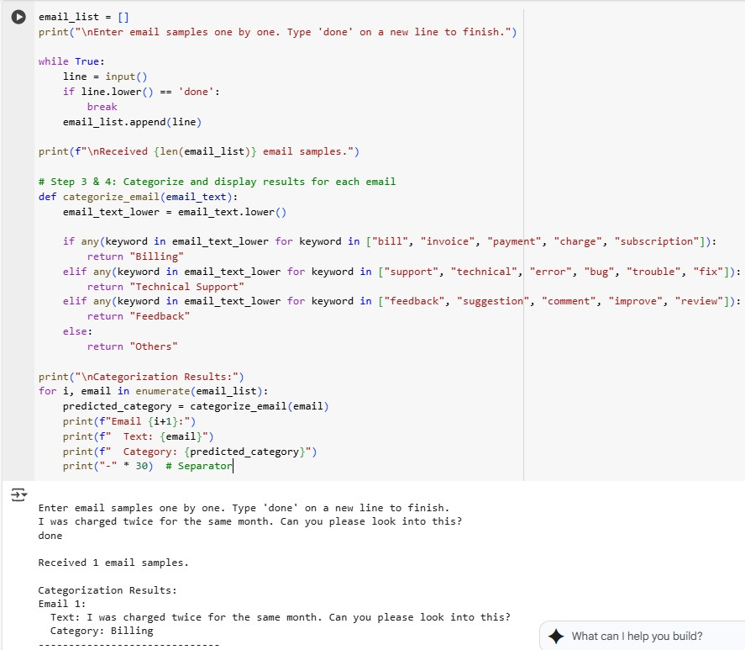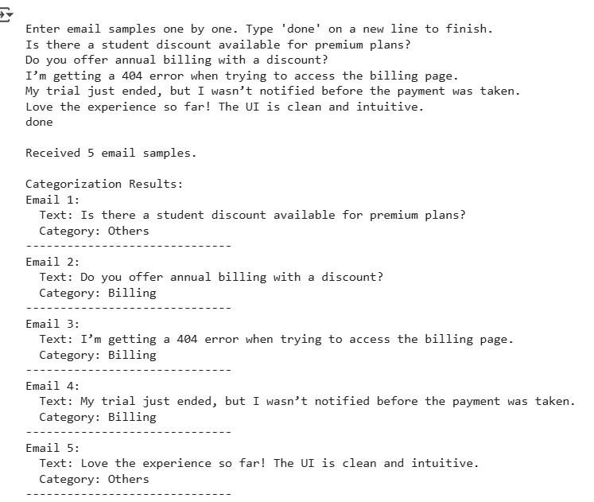

5

.

**Evaluation:**

•

Run all three techniques on the same set of 5 test emails.

•

Compare and document the accuracy and clarity of responses

.

:

TEST EMAILS ON BILLING

5

**5**

**TEST EMAILS ON FEEDBACK**

**:**

**5**

**TEST EMAILS ON TECHNICAL SUPPORT**

**:**

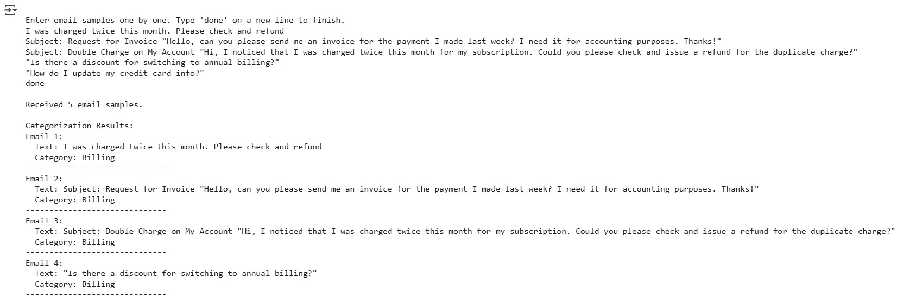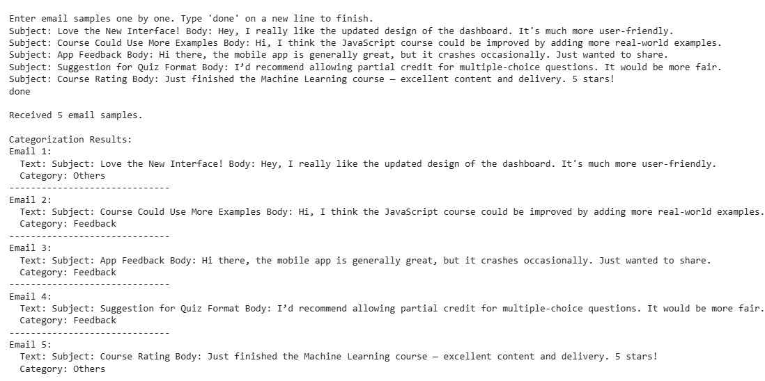

**5**

**TEST EMAILS ON OTHERS**

**:**

**Requirements:**

•

VS Code with

Github Copilot

or Cursor

IDE

and/or Google Colab with

Gemini

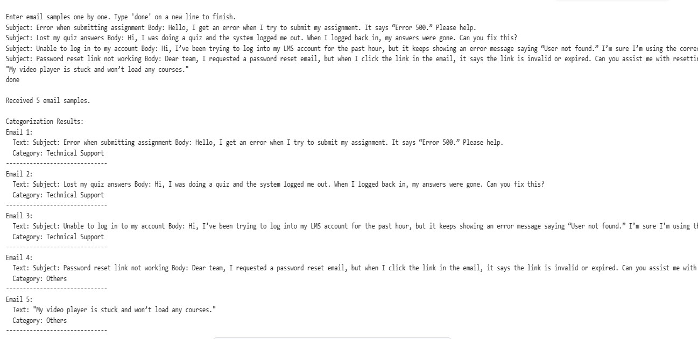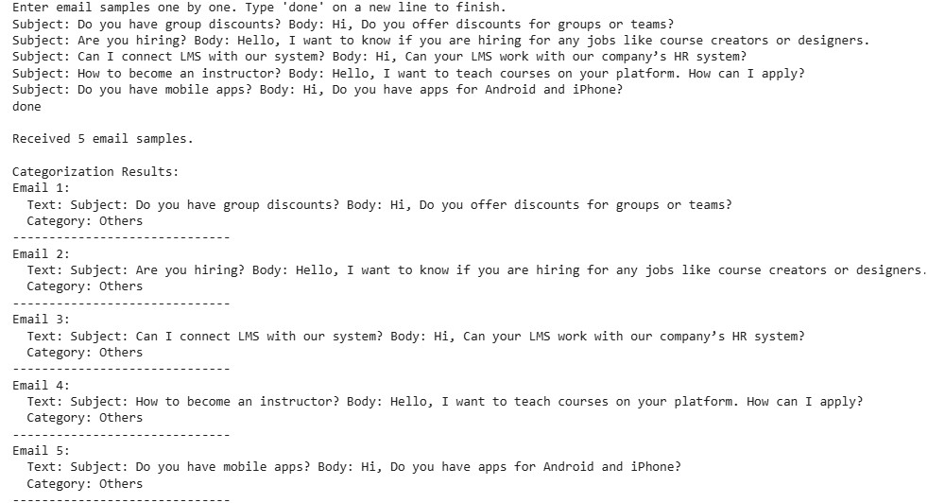

|  |  |  |
| --- | --- | --- |
|  | **Deliverables:**     * A .txt or .md file showing prompts and model responses. * A comparison table showing classification accuracy for each technique. • A short reflection on which method was most effective and why   . |  |