**AI ASSISTED CODING**

**LAB ASSIGNMENT - 3.2**

**S.Ruthvika**

**2403A53051**

**24BTCAICYB02**

**Task Description#1**

* Ask AI to write a function to calculate compound interest, starting with only the function name. Then add a docstring, then input-output example.

**Expected Output#1**

* Comparison of AI-generated code styles.

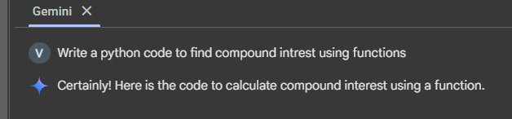

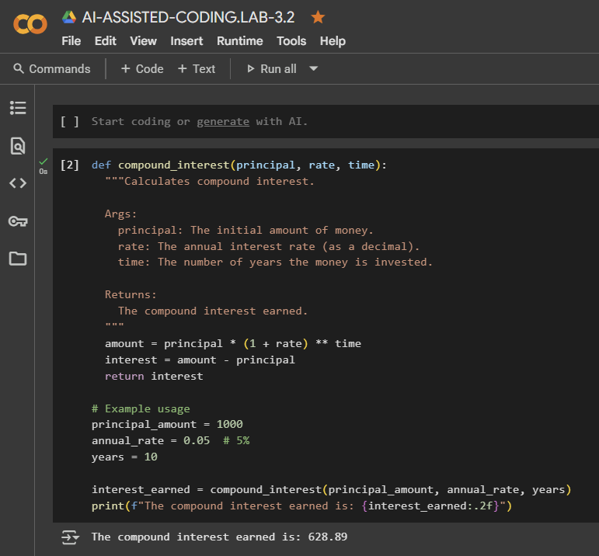

**Task Description#2**

* Do math stuff, then refine it to: # Write a function to calculate average, median, and mode of a list of numbers.

**Expected Output#2**

* AI-generated function evolves from unclear to accurate multi-statistical operation.

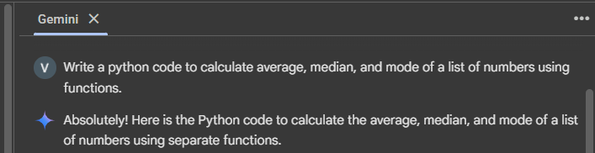

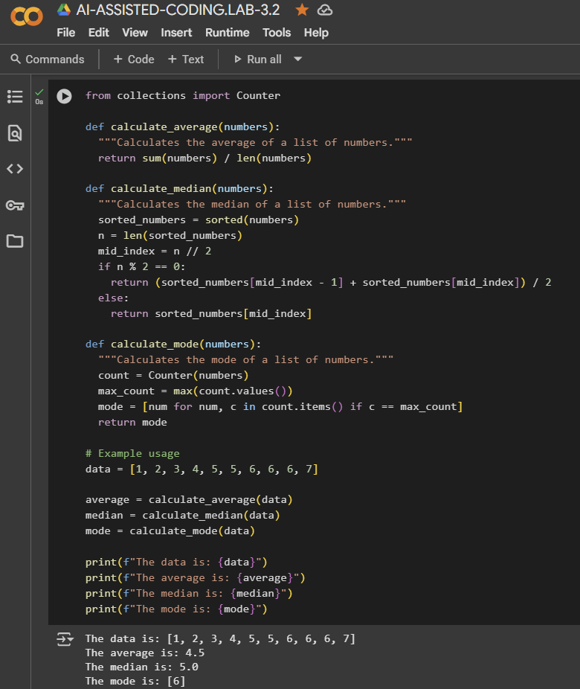

**Task Description#3**

* Provide multiple examples of input-output to the AI for convert_to_binary(num) function. Observe how AI uses few-shot prompting to generalize.

**Expected Output#3**

* Enhanced AI output with clearer prompts .

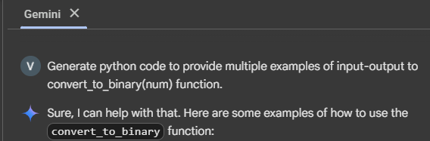

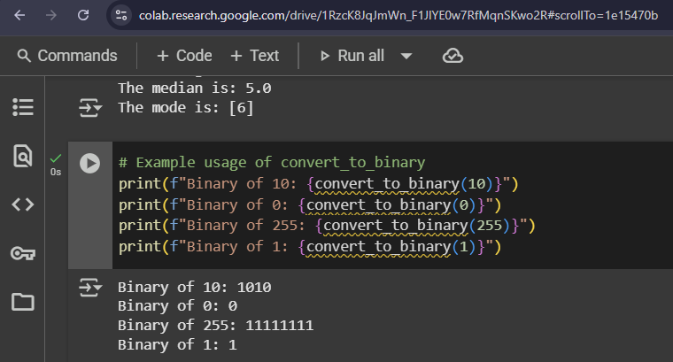

**Task Description#4**

* Create an user interface for an hotel to generate bill based on customer requirements.

**Expected Output#4**

* Consistent functions with shared logic.

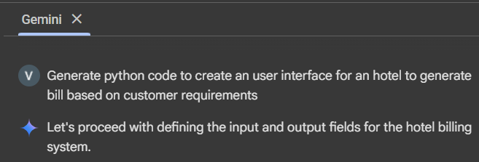

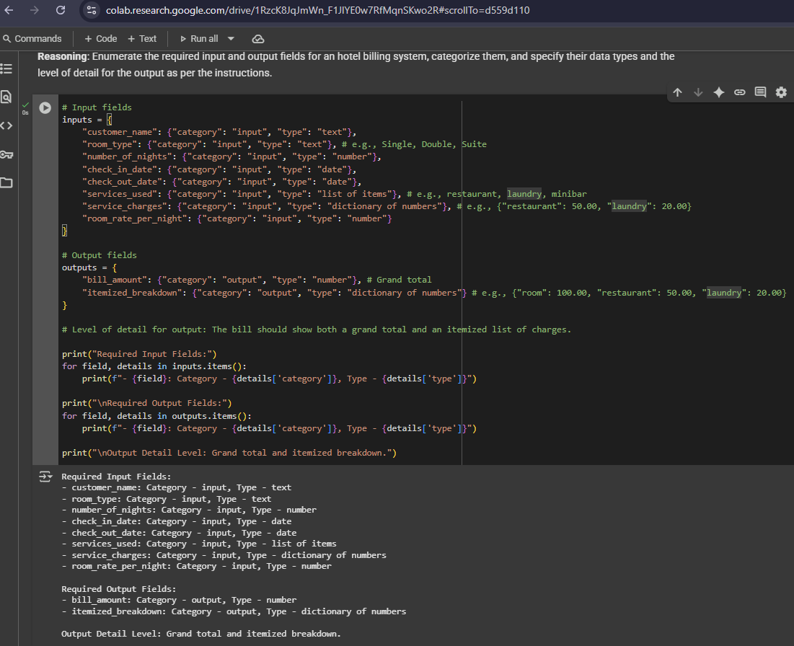

**Task Description#5**

* Analyzing Prompt Specificity: Improving Temperature Conversion Function with Clear Instructions.

**Expected Output#5**

* Code quality difference analysis for various prompts.



