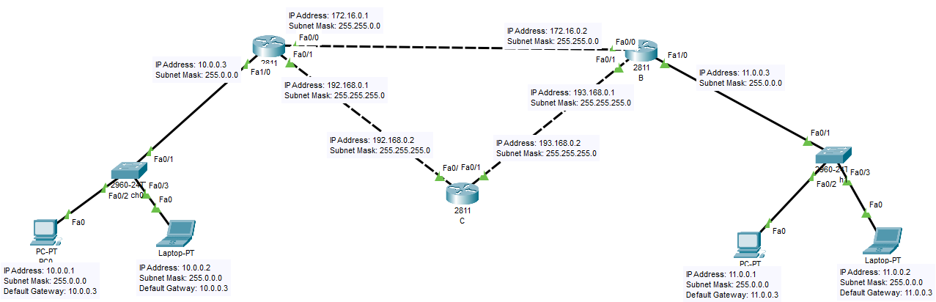
--- System Configuration Dialog ---
Would you like to enter the initial configuration dialog? [yes/no]: no
Press RETURN to get started!
Router>enable
Router#configure terminal
Enter configuration commands, one per line. End with CNTL/Z.
Router(config)#hostname A
A(config)#interface fa1/0
A(config-if)#ip address 10.0.0.3 255.0.0.0
A(config-if)#no shutdown
A(config-if)#
%LINK-5-CHANGED: Interface FastEthernet1/0, changed state to up
%LINEPROTO-5-UPDOWN: Line protocol on Interface FastEthernet1/0, changed state to up
A(config)#interface fa0/0
A(config-if)#ip address 172.16.0.1 255.255.0.0
A(config-if)#no shutdown
A(config-if)#
%LINK-5-CHANGED: Interface FastEthernet0/0, changed state to up
A(config-if)#interface fa0/1
A(config-if)#ip address 192.168.0.1 255.255.255.0
A(config-if)#no shutdown
A(config-if)#
%LINK-5-CHANGED: Interface FastEthernet0/1, changed state to up
A(config-if)#exit
A(config)#ip route 11.0.0.0 255.0.0.0 172.16.0.2
A(config)#

--- System Configuration Dialog ---
Would you like to enter the initial configuration dialog? [yes/no]: no
Press RETURN to get started!
Router>enable
Router#configure terminal
Enter configuration commands, one per line. End with CNTL/Z.
Router(config)#hostname B
B(config)#
B(config)#
B(config)#
B(config)#interface fa0/0
B(config-if)#ip address 172.16.0.2 255.255.0.0
B(config-if)#no shutdown
B(config-if)#
%LINK-5-CHANGED: Interface FastEthernet0/0, changed state to up
%LINEPROTO-5-UPDOWN: Line protocol on Interface FastEthernet0/0, changed state to up
B(config-if)#
B(config-if)#
B(config-if)#interface fa1/0
B(config-if)#ip address 11.0.0.3 255.0.0.0
B(config-if)#no shutdown
B(config-if)#
%LINK-5-CHANGED: Interface FastEthernet1/0, changed state to up
%LINEPROTO-5-UPDOWN: Line protocol on Interface FastEthernet1/0, changed state to up
B(config)#interface fa0/1
B(config-if)#ip address 193.168.0.1 255.255.255.0
B(config-if)#no shutdown
B(config-if)#
%LINK-5-CHANGED: Interface FastEthernet0/1, changed state to up
B(config-if)#exit
B(config)#ip route 10.0.0.0 255.0.0.0 172.16.0.1
B(config)#

--- System Configuration Dialog ---
Would you like to enter the initial configuration dialog? [yes/no]: no
Press RETURN to get started!
Router>
Router>
Router>enable
Router#configure terminal
Enter configuration commands, one per line. End with CNTL/Z.
Router(config)#hostname C
C(config)#interface fa0/0
C(config-if)#ip address 192.168.0.2 255.255.255.0
C(config-if)#no shutdown
C(config-if)#
%LINK-5-CHANGED: Interface FastEthernet0/0, changed state to up

%LINEPROTO-5-UPDOWN: Line protocol on Interface FastEthernet0/0, changed state to up
C(config-if)#interface fa0/1
C(config-if)#ip address 193.168.0.2 255.255.255.0
C(config-if)#no shutdown
C(config-if)#
%LINK-5-CHANGED: Interface FastEthernet0/1, changed state to up

%LINEPROTO-5-UPDOWN: Line protocol on Interface FastEthernet0/1, changed state to up

