

CLDV Project 1

ST10101136



September 5, 2024

Ruth N'zola

Project 1

Contents

Customer screenshots (Backend and Frontend) 2

Products (5 stored) 3

Order processing (Queues, 5 stored) 4

Containers (Multimedia content stored/Blob storage) 5

File share/upload (Contracts, with Azure Files) 6

## Customer screenshots (Backend and Frontend)

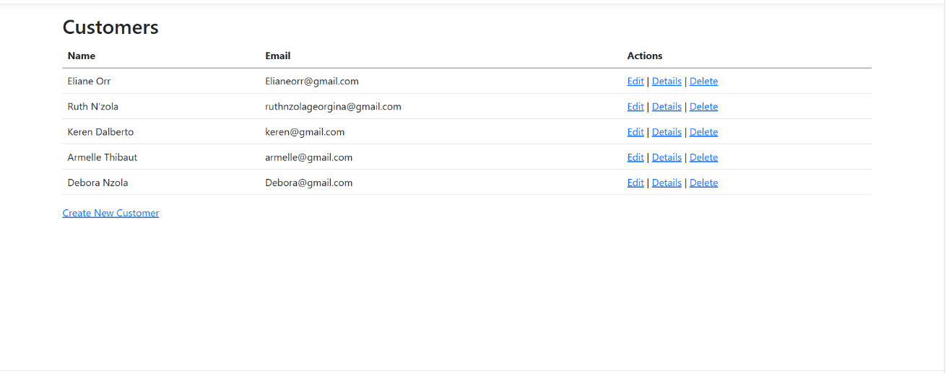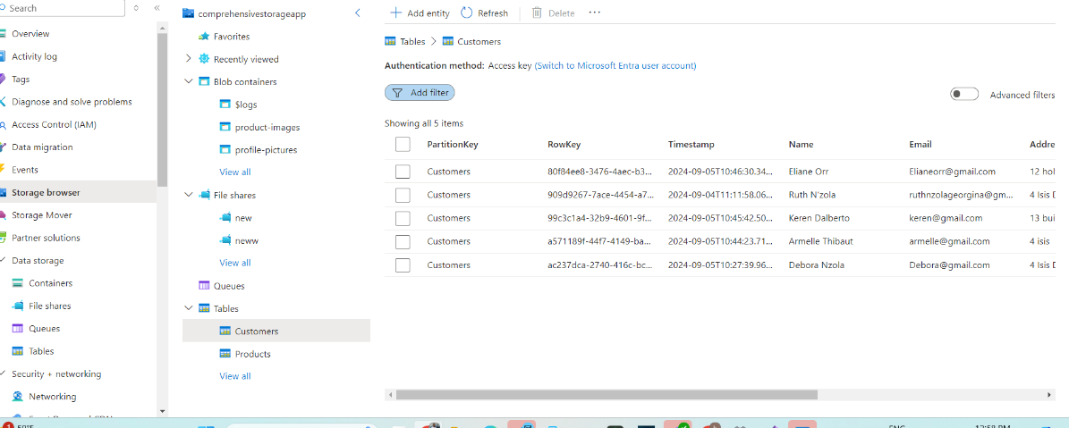

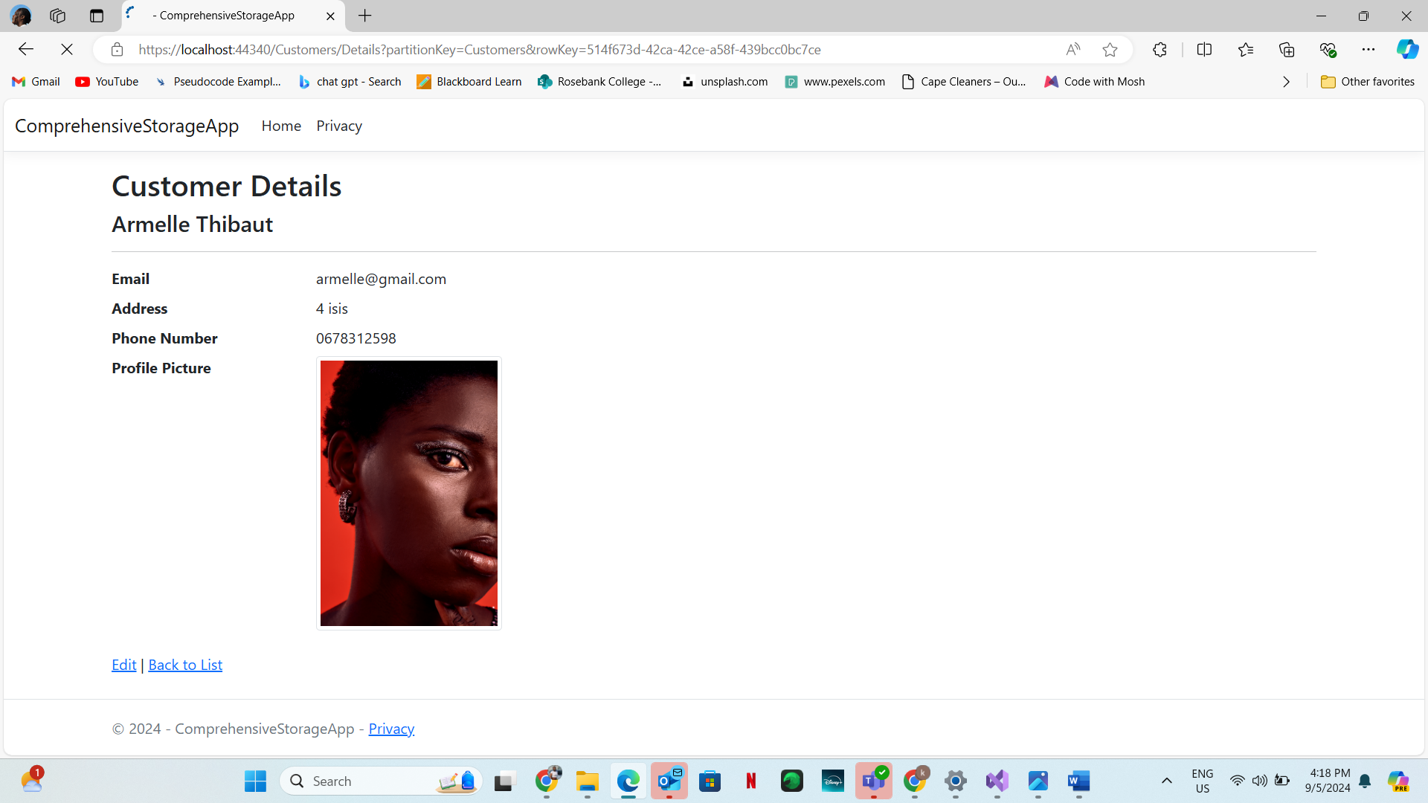

## Products (5 stored)

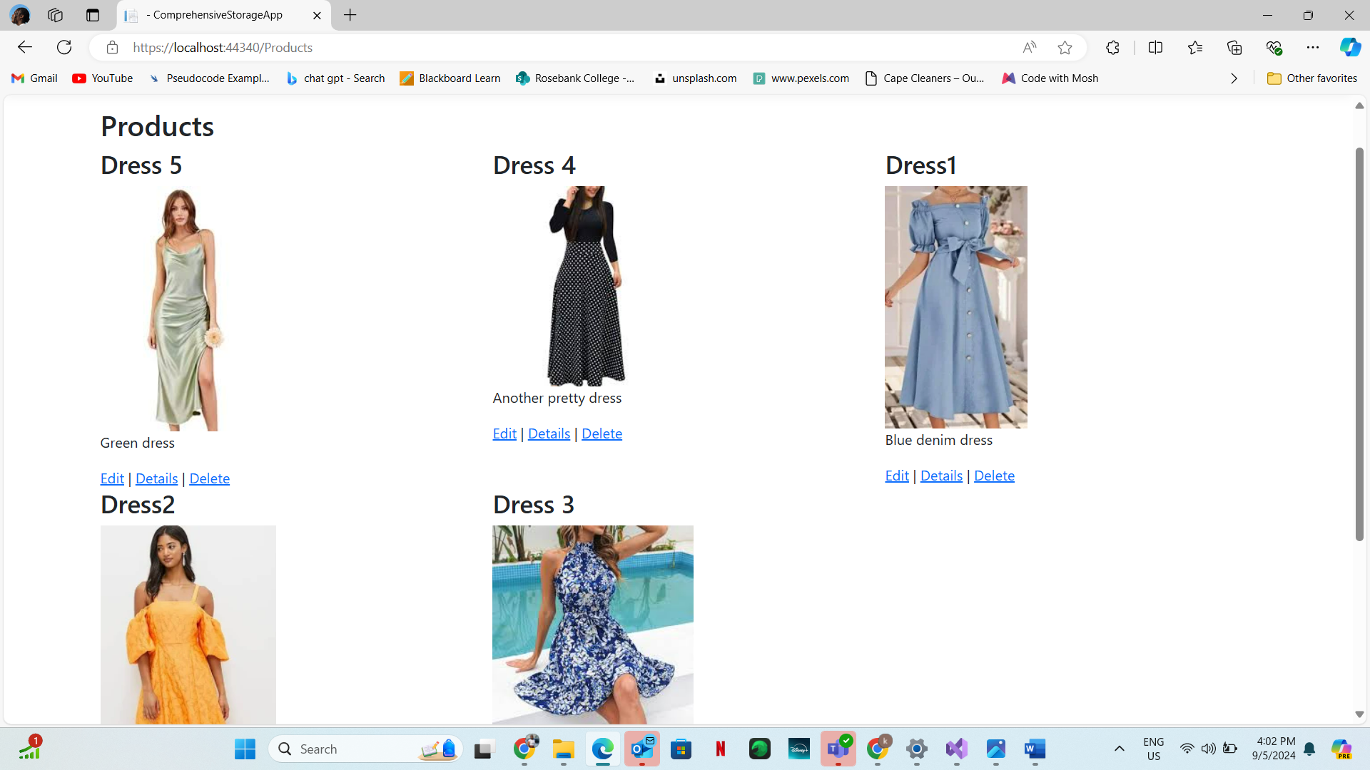

## Order processing (Queues, 5 stored)

## Containers (Multimedia content stored/Blob storage)

## File share/upload (Contracts, with Azure Files)

