Task 13: Docker Swarm Cronjobs

# 1. Objective

The objective of this task is to research and implement cronjobs in Docker Swarm. Unlike Kubernetes, Docker Swarm does not support cronjobs natively, so we use tools like swarm-cronjob to achieve the desired functionality.

# 2. What is Docker Swarm?

Docker Swarm is a native clustering and orchestration tool provided by Docker. It allows you to manage a cluster of Docker nodes and deploy services across them.

# 3. Why CronJobs in Docker Swarm?

Docker Swarm lacks a native cronjob controller. However, we can simulate cronjob behavior using the host cron system or tools like swarm-cronjob, which schedules services based on cron syntax.

# 4. Tool Used: swarm-cronjob

We use the open-source project 'swarm-cronjob' by crazy-max. It runs as a service on manager nodes and uses Docker service labels to schedule jobs.

# 5. Setup Instructions

Step 1: Initialize Docker Swarm

Command:  
docker swarm init

Step 2: Deploy swarm-cronjob service

Command:  
docker service create \  
 --name swarm-cronjob \  
 --mount type=bind,source=/var/run/docker.sock,target=/var/run/docker.sock \  
 --constraint 'node.role == manager' \  
 --detach=true \  
 crazymax/swarm-cronjob:latest

Step 3: Create a cronjob-enabled service using Docker labels

Command:  
docker service create \  
 --name hello-world-job \  
 --label swarm.cronjob.enable=true \  
 --label swarm.cronjob.schedule="*/2 * * * *" \  
 --label swarm.cronjob.skip-running=true \  
 busybox:latest echo "Hello from Docker Swarm Cronjob"

Step 4: Check logs and service status

Commands:  
docker service logs swarm-cronjob  
docker service ps hello-world-job

# 6. Work Flow

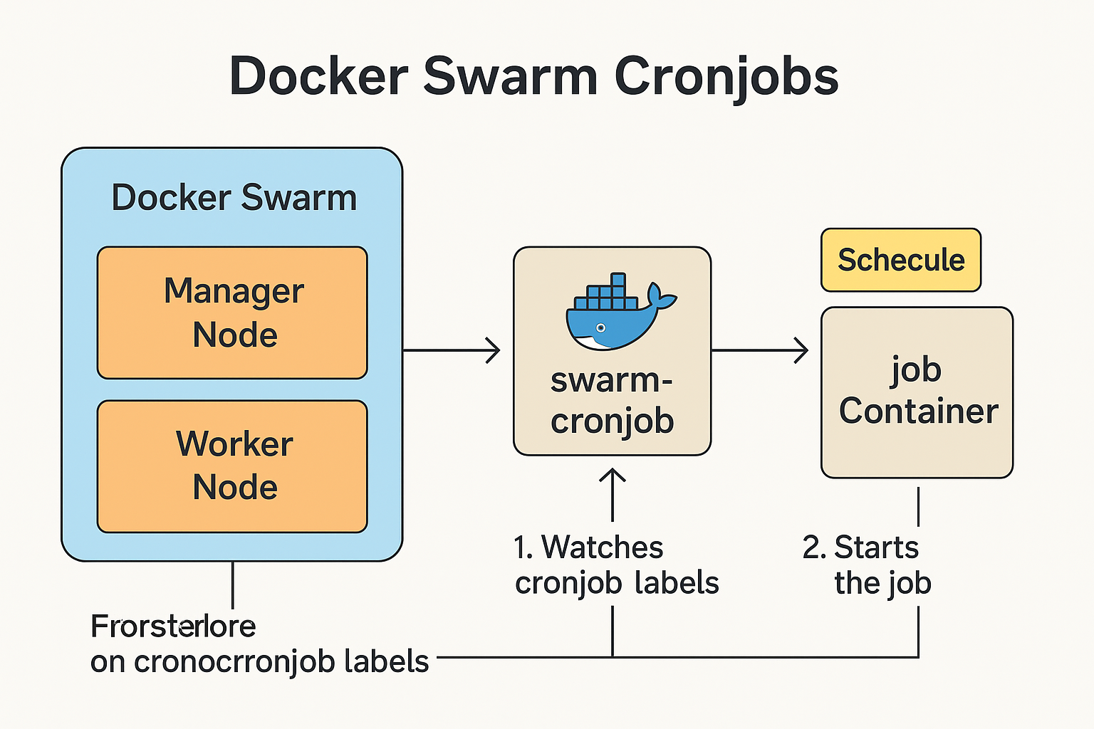

# 7. Cleanup Commands

Commands:  
docker service rm hello-world-job  
docker service rm swarm-cronjob

# 8. Conclusion

Using the swarm-cronjob service, we can simulate cronjob-like behavior in Docker Swarm. This approach is effective and production-ready even though Swarm lacks native cronjob support.

# 9. Tools and Technologies Used

|  |  |  |
| --- | --- | --- |
| Category | Tool/Technology | Purpose |
| Containerization | Docker | To run containers and manage services |
| Orchestration | Docker Swarm | To deploy and manage container services in a clustered environment |
| Scheduler | swarm-cronjob | Open-source tool to simulate cronjobs in Docker Swarm |
| Base Image | busybox | Lightweight container image used for scheduled task (e.g., echo job) |
| CLI Tool | Docker CLI | Used to run commands to create and manage services |
| Logging | Docker service logs | To inspect logs from cronjob and swarm-cronjob services |
| Infrastructure | Linux OS (Host) | Required for Docker Swarm and cronjob scheduling |
| Documentation | Microsoft Word (.docx) | For creating task documentation |
| Version Control | Git + GitHub | To track changes and collaborate through branches and pull requests |

# 10. References

- swarm-cronjob GitHub Repository: https://github.com/crazy-max/swarm-cronjob

- Docker Swarm Documentation: https://docs.docker.com/engine/swarm/

- Docker CLI Reference: https://docs.docker.com/engine/reference/commandline/cli/

- BusyBox Image: <https://hub.docker.com/_/busybox>

# 11. Work Screenshot’s

