Road Accident Analysis SQL Queries

- CY Casualties –

SELECT SUM(number_of_casualties) AS CY_Casualties
FROM road_accident
WHERE YEAR(accident_date) = '2022'
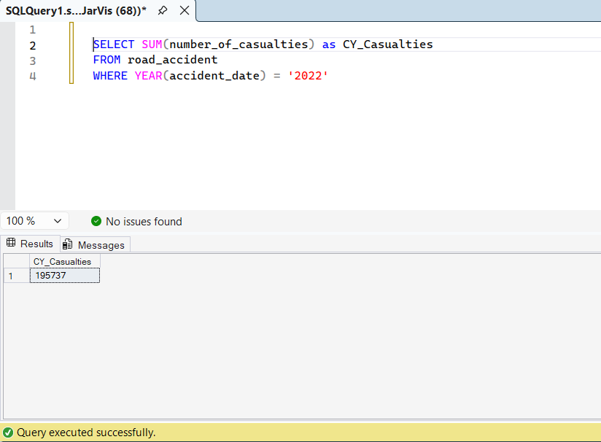

- CY Accidents –

SELECT COUNT(DISTINCT accident_index) AS CY_Accidents
FROM road_accident
WHERE YEAR(accident_date) = '2022'
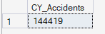

- CY Fatal Casualties –

SELECT SUM(number_of_casualties) AS CY_Fatal_Casualties
FROM road_accident
WHERE YEAR(accident_date) = '2022' AND accident_severity = 'Fatal'

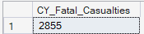

- CY Slight Casualties –

SELECT SUM(number_of_casualties) AS CY_Slight_Casualties
FROM road_accident
WHERE YEAR(accident_date) = '2022' AND accident_severity = 'Slight'

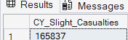

- Percentage Serious Casualty –

SELECT CAST(SUM(number_of_casualties) AS DECIMAL(10,2))*100 /
(SELECT CAST(SUM(number_of_casualties) AS DECIMAL(10,2)) FROM road_accident) AS PCT_Serious_Casualty
FROM road_accident
WHERE accident_severity = 'Slight'

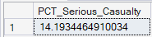

- Casualties by Vehicle Type -
SELECT
CASE
WHEN vehicle_type IN ('Agricultural vehicle') THEN 'Agricultural'
WHEN vehicle_type IN ('Car', 'Taxi/Private hire car') THEN 'Cars'
WHEN vehicle_type IN ('Motorcycle 125cc and under', 'Motorcycle 50cc and under', 'Motorcycle over 500cc', 'Motorcycle over 125cc and up to 500cc', 'Pedal cycle') THEN 'Bikes'
WHEN vehicle_type IN ('Bus or coach (17 or more pass seats', 'Minibus (8 - 16 passenger seats)') THEN 'Bus'
WHEN vehicle_type IN ('Goods 7.5 tonnes mgw and over', 'Goods over 3.5t. and under 7.5t', 'Van / Goods 3.5 tonnes mgw or under') THEN 'Van'
ELSE 'Other'
END AS vehicle_group,
SUM(number_of_casualties) as CY_Casualties
FROM road_accident
WHERE YEAR(accident_date) = '2022'
GROUP BY
CASE
WHEN vehicle_type IN ('Agricultural vehicle') THEN 'Agricultural'
WHEN vehicle_type IN ('Car', 'Taxi/Private hire car') THEN 'Cars'
WHEN vehicle_type IN ('Motorcycle 125cc and under', 'Motorcycle 50cc and under', 'Motorcycle over 500cc', 'Motorcycle over 125cc and up to 500cc', 'Pedal cycle') THEN 'Bikes'
WHEN vehicle_type IN ('Bus or coach (17 or more pass seats', 'Minibus (8 - 16 passenger seats)') THEN 'Bus'
WHEN vehicle_type IN ('Goods 7.5 tonnes mgw and over', 'Goods over 3.5t. and under 7.5t', 'Van / Goods 3.5 tonnes mgw or under') THEN 'Van'
ELSE 'Other'
END

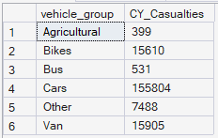

- Previous Year Casualties Monthly Trend -
SELECT DATENAME(MONTH, accident_date) AS Month_Name, SUM(number_of_casualties) AS PY_Casualties
FROM road_accident
WHERE YEAR(accident_date) = '2021'
GROUP BY DATENAME(MONTH, accident_date)
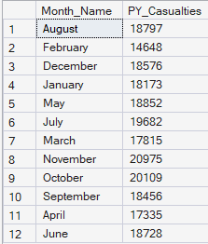

- CY Casualty by Road Type -
SELECT road_type, SUM(number_of_casualties) AS CY_Casualties
FROM road_accident
WHERE YEAR(accident_date) = '2022'
GROUP BY road_type

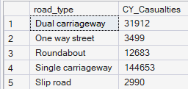

- CY Casualties Urban/Rural -
SELECT urban_or_rural_area, SUM(number_of_casualties) AS CY_Casualties FROM road_accident
WHERE YEAR(accident_date) = '2022'
GROUP BY urban_or_rural_area

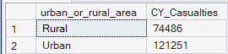

- CY Casualties Urban/Rural Percentage -
SELECT urban_or_rural_area, SUM(number_of_casualties) * 100 /
(SELECT SUM(number_of_casualties) FROM road_accident WHERE YEAR(accident_date) = '2022')
FROM road_accident
WHERE YEAR(accident_date) = '2022'
GROUP BY urban_or_rural_area
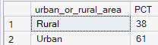

- Total Casualties by Urban/Rural and Percentage –

SELECT urban_or_rural_area, SUM(number_of_casualties) AS Total_casualties, CAST(SUM(number_of_casualties) * 100 AS DECIMAL(10,2)) /
(SELECT CAST(SUM(number_of_casualties) AS DECIMAL(10,2)) FROM road_accident) --WHERE YEAR(accident_date) = '2022')
AS PCT
FROM road_accident
--WHERE YEAR(accident_date) = '2022'
GROUP BY urban_or_rural_area

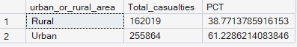

- CY Casualties PCT by Light Condition -
SELECT
CASE
WHEN light_conditions IN ('Daylight') THEN 'Day'
WHEN light_conditions IN ('Darkness - lighting unknown','Darkness - lights lit', 'Darkness - lights unlit', 'Darkness - no lighting') THEN 'Night'
END AS Light_Condition,
CAST (CAST(SUM(number_of_casualties) AS DECIMAL(10,2))*100 /
(SELECT CAST(SUM(number_of_casualties) AS DECIMAL(10,2)) FROM road_accident WHERE YEAR(accident_date) = '2022') AS DECIMAL(10,2))
AS CY_Casualties_PCT
FROM road_accident
WHERE YEAR(accident_date) = '2022'
GROUP BY
CASE
WHEN light_conditions IN ('Daylight') THEN 'Day'
WHEN light_conditions IN ('Darkness - lighting unknown','Darkness - lights lit', 'Darkness - lights unlit', 'Darkness - no lighting') THEN 'Night'
END

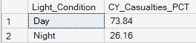

- Top 10 cities Total Casualty –

SELECT TOP 10 local_authority, SUM(number_of_casualties) AS Total_Casualties
FROM road_accident
GROUP BY local_authority
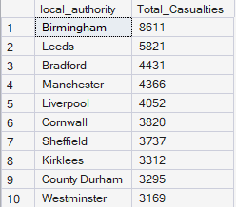
ORDER BY Total_Casualties DESC

