Big Data Analytics

LAB-2

USN- 1BM21CS173

Date- 01-04-2024

I. Perform the following DB operations using MongoDB.

1. Create a database “Student” with the following attributes Rollno, Age, ContactNo, Email-

Id.



2. Insert appropriate values

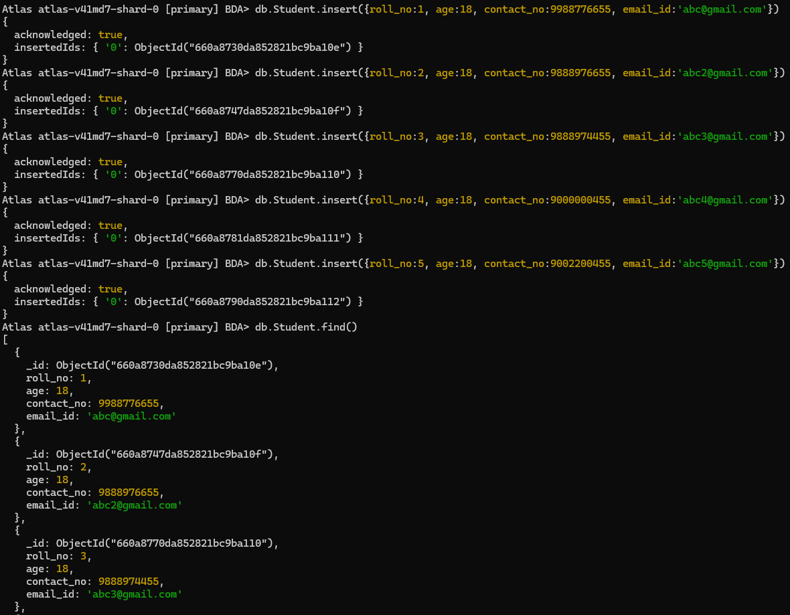

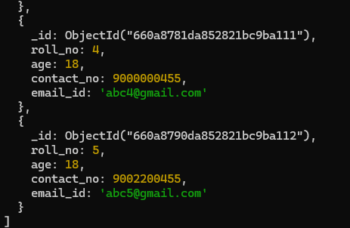

3. Write query to update Email-Id of a student with rollno 10.

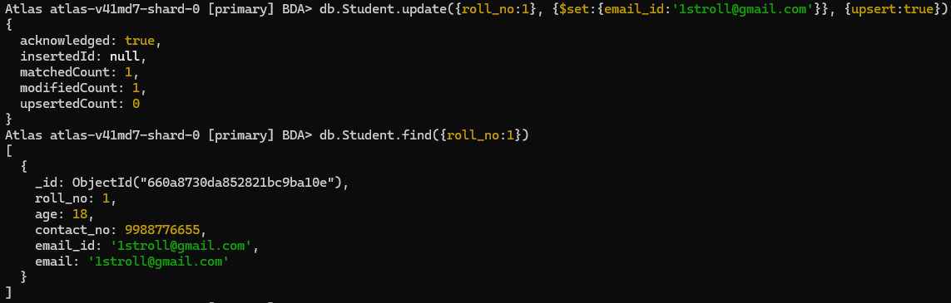

4. . Replace the student name from “ABC” to “FEM” of rollno 11



II. Perform the following DB operations using MongoDB.

1. Create a collection by name Customers with the following attributes.

Cust_id, Acc_Bal, Acc_Type

2. Insert at least 5 values into the table

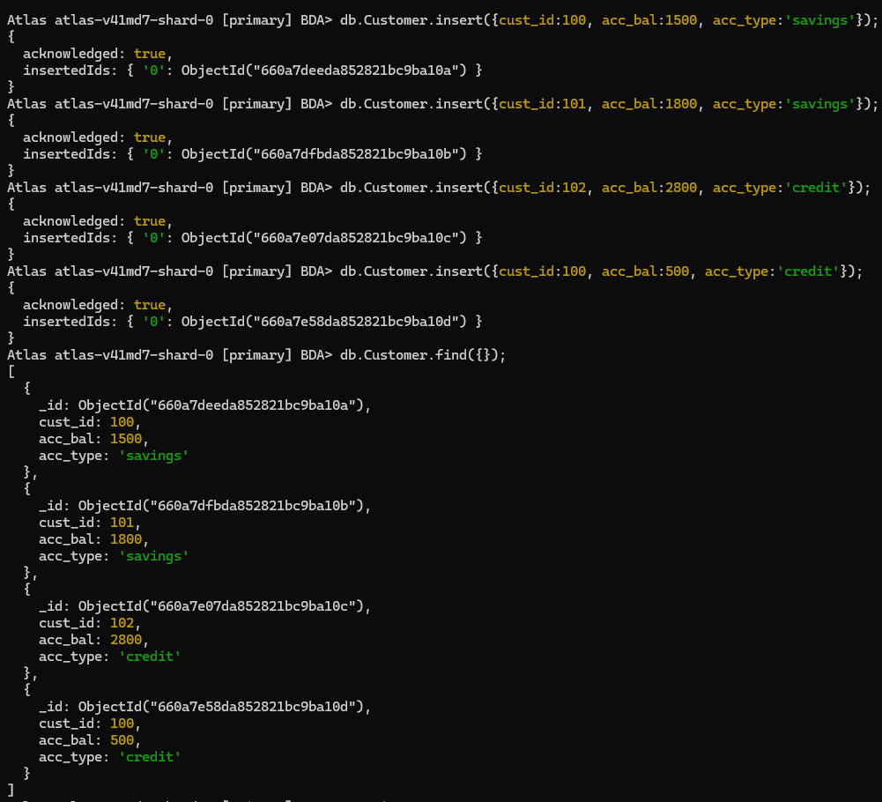

3. Write a query to display those records whose total account balance is greater than

1200 of account type ‘Z’ for each customer_id.

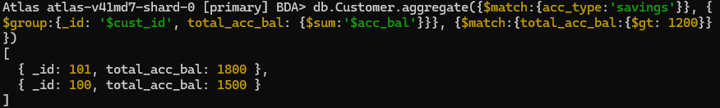

4. Determine Minimum and Maximum account balance for each customer_id

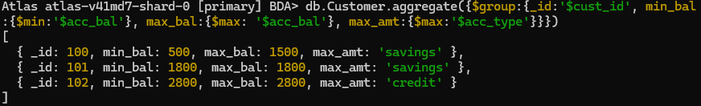

I. CREATE DATABASE IN MONGODB.

use myDB;

Confirm the existence of your database

db;

To list all databases

show dbs;

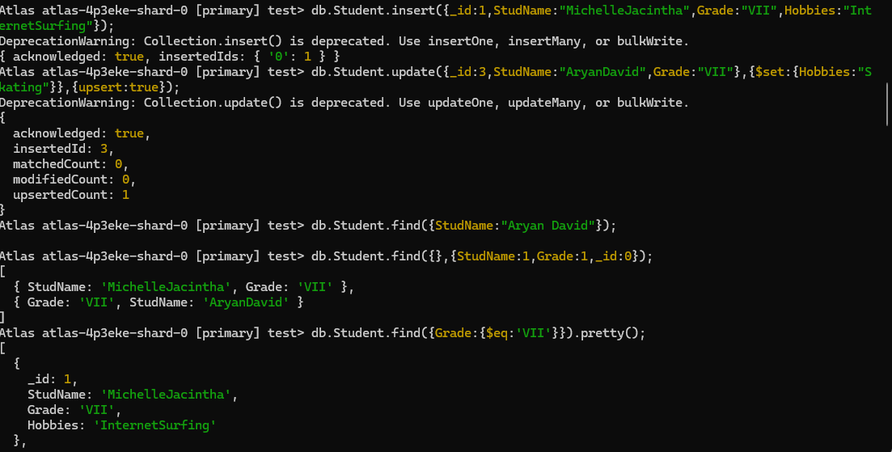

II. CRUD (CREATE, READ, UPDATE, DELETE) OPERATIONS

1. To create a collection by the name “Student”. Let us take a look at the collection list

prior to the creation of the new collection “Student”.

db.createCollection(“Student”); =&gt; sql equivalent CREATE TABLE STUDENT(…);

2. To drop a collection by the name “Student”.

db.Student.drop();

3. Create a collection by the name “Students” and store the following data in it.

db.Student.insert({_id:1,StudName:&quot;MichelleJacintha&quot;,Grade:&quot;VII&quot;,Hobbies:&quot;InternetS

urfing&quot;});

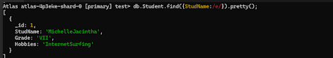

4. Insert the document for “AryanDavid” in to the Students collection only if it does not

already exist in the collection. However, if it is already present in the collection, then

update the document with new values. (Update his Hobbies from “Skating” to “Chess”.

) Use “Update else insert” (if there is an existing document, it will attempt to update it,

if there is no existing document then it will insert it).

db.Student.update({_id:3,StudName:&quot;AryanDavid&quot;,Grade:&quot;VII&quot;},{$set:{Hobbies:&quot;Skatin

g&quot;}},{upsert:true});

5. FIND METHOD

A. To search for documents from the “Students” collection based on certain search

criteria.

db.Student.find({StudName:&quot;Aryan David&quot;});

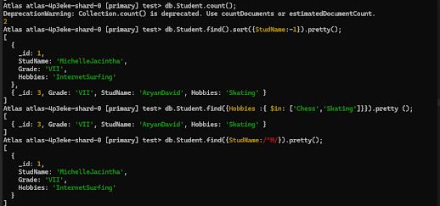

B. To display only the StudName and Grade from all the documents of the Students

collection. The identifier_id should be suppressed and NOT displayed.

db.Student.find({},{StudName:1,Grade:1,_id:0});

C. To find those documents where the Grade is set to ‘VII’

db.Student.find({Grade:{$eq:&#39;VII&#39;}}).pretty();

D. To find those documents from the Students collection where the Hobbies is set to

either ‘Chess’ or is set to ‘Skating’.

db.Student.find({Hobbies :{ $in: [&#39;Chess&#39;,&#39;Skating&#39;]}}).pretty ();

E. To find documents from the Students collection where the StudName begins with “M”.

db.Student.find({StudName:/^M/}).pretty();

F. To find documents from the Students collection where the StudNamehas an “e” in any

position.

db.Student.find({StudName:/e/}).pretty();

G. To find the number of documents in the Students collection.

db.Student.count();

H. To sort the documents from the Students collection in the descending order of

StudName.

db.Student.find().sort({StudName:-1}).pretty();



IX. to set a particular field value to NULL

db.Students.update({_id:3},{$set:{Location:null}})

X. Count the number of documents in Student Collections

db.Students.count()

XI. Count the number of documents in Student Collections with grade :VII

db.Students.count({Grade:”VII”})

retrieve first 3 documents

db.Students.find({Grade:”VII”}).limit(3).pretty();

Sort the document in Ascending order

db.Students.find().sort({StudName:1}).pretty();

Note:

for desending order : db.Students.find().sort({StudName:-1}).pretty();

to Skip the 1 st two documents from the Students Collections

db.Students.find().skip(2).pretty()



XII. Create a collection by name “food” and add to each document add a “fruits” array

db.food.insert( { _id:1, fruits:[&#39;grapes&#39;,&#39;mango&#39;,&#39;apple&#39;] } )

db.food.insert( { _id:2, fruits:[&#39;grapes&#39;,&#39;mango&#39;,&#39;cherry&#39;] } )

db.food.insert( { _id:3, fruits:[&#39;banana&#39;,&#39;mango&#39;] } )

To find those documents from the “food” collection which has the “fruits array”

constitute of “grapes”, “mango” and “apple”.

db.food.find ( {fruits: [&#39;grapes&#39;,&#39;mango&#39;,&#39;apple&#39;] } ). pretty().

To find in “fruits” array having “mango” in the first index position.

db.food.find ( {&#39;fruits.1&#39;:&#39;grapes&#39;} )

To find those documents from the “food” collection where the size of the array is two.

db.food.find ( {“fruits”: {$size:2}} )

To find the document with a particular id and display the first two elements from the

array “fruits”

db.food.find({_id:1},{“fruits”:{$slice:2}})

To find all the documets from the food collection which have elements mango and

grapes in the array “fruits”

db.food.find({fruits:{$all:[“mango”,”grapes”]}})

update on Array:

using particular id replace the element present in the 1 st index position of the fruits

array with apple

db.food.update({_id:3},{$set:{&#39;fruits.1&#39;:&#39;apple&#39;}})

insert new key value pairs in the fruits array

db.food.update({_id:2},{$push:{price:{grapes:80,mango:200,cherry:100}}})

Note: perform query operations using - pop, addToSet, pullAll and pull



XII. Aggregate Function :

Create a collection Customers with fields custID, AcctBal, AcctType.

Now group on “custID” and compute the sum of “AccBal”.

db.Customers.aggregate ( {$group : { _id : “$custID”,TotAccBal : {$sum:”$AccBal”} } } );

match on AcctType:”S” then group on “CustID” and compute the sum of “AccBal”.

db.Customers.aggregate ( {$match:{AcctType:”S”}},{$group : { _id : “$custID”,TotAccBal :

{$sum:”$AccBal”} } } );

match on AcctType:”S” then group on “CustID” and compute the sum of “AccBal” and

total balance greater than 1200.

db.Customers.aggregate ( {$match:{AcctType:”S”}},{$group : { _id : “$custID”,TotAccBal :

{$sum:”$AccBal”} } }, {$match:{TotAccBal:{$gt:1200}}});

Assignment:

Creation of Cursor:

Create Collection “Alphabets”

Insert Documents with fields “_id” and “alphabet”

use cursor to iterate through the “Alphabets” Collection.

