WEEK-4
USN-1BM21CS173
DATE - 13-07-2023

Write a C program to simulate Real-time CPU scheduling algorithms:
a) Rate Monotonic
#include<stdio.h>
#include<conio.h>
#include<math.h>
void main(){
int n;
float e[20],p[20];
int i;
float ut,u,x,y;

printf("\n Enter Number of Processes :: ");
scanf("%d",&n);
for(i=0;i<n;i++){
printf("\n Enter Execution Time for P%d ::",(i+1));
scanf("%f",&e[i]);
printf("\n Enter Period for P%d ::",(i+1));
scanf("%f",&p[i]);
}
for(i=0;i<n;i++){
x=e[i]/p[i];
ut+=x;
}
y=(float)n;
y=y*((pow(2.0,1/y))-1);
u=y;
if(ut<u){
printf("\n As %f < %f ,",ut,u);
printf("\n The System is surely Schedulable");
}
else
printf("\n Not Sure.....");
getch();
}
OUTPUT-
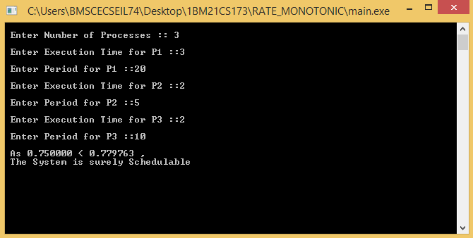

b) Earliest Deadline First
#include <stdio.h>

#define MAX_TASKS 10

typedef struct {
int arrival_time;
int execution_time;
int deadline;
int remaining_time;
int waiting_time;
int turnaround_time;
} Task;

void initializeTasks(Task tasks[], int num_tasks) {
int i;
for (i = 0; i < num_tasks; i++) {
printf("Enter arrival time for task %d: ", i + 1);
scanf("%d", &tasks[i].arrival_time);
printf("Enter execution time for task %d: ", i + 1);
scanf("%d", &tasks[i].execution_time);
printf("Enter deadline for task %d: ", i + 1);
scanf("%d", &tasks[i].deadline);
tasks[i].remaining_time = tasks[i].execution_time;
tasks[i].waiting_time = 0;
tasks[i].turnaround_time = 0;
}
}

int findEarliestDeadlineTask(Task tasks[], int num_tasks, int current_time) {
int earliest_deadline_task = -1, i;
for (i = 0; i < num_tasks; i++) {
if (tasks[i].remaining_time > 0 && tasks[i].arrival_time <= current_time) {
if (earliest_deadline_task == -1 || tasks[i].deadline < tasks[earliest_deadline_task].deadline) {
earliest_deadline_task = i;
}
}
}
return earliest_deadline_task;
}

int main() {
int num_tasks;
printf("Enter the number of tasks: ");
scanf("%d", &num_tasks);

Task tasks[MAX_TASKS];
initializeTasks(tasks, num_tasks);

int current_time = 0;
int completed_tasks = 0;
int total_waiting_time = 0;
int total_turnaround_time = 0;

printf("\nEDF CPU Scheduling:\n");
while (completed_tasks < num_tasks) {
int current_task = findEarliestDeadlineTask(tasks, num_tasks, current_time);

if (current_task != -1) {
printf("Time %d: Running Task %d\n", current_time, current_task + 1);
tasks[current_task].remaining_time--;

if (tasks[current_task].remaining_time == 0) {
completed_tasks++;
tasks[current_task].turnaround_time = current_time + 1 - tasks[current_task].arrival_time;
tasks[current_task].waiting_time = tasks[current_task].turnaround_time - tasks[current_task].execution_time;
total_waiting_time += tasks[current_task].waiting_time;
total_turnaround_time += tasks[current_task].turnaround_time;
printf("Time %d: Task %d completed\n", current_time + 1, current_task + 1);
}
} else {
printf("Time %d: CPU idle\n", current_time);
}

current_time++;
}

double avg_waiting_time = (double)total_waiting_time / num_tasks;
double avg_turnaround_time = (double)total_turnaround_time / num_tasks;

printf("\n process\t executiontime \t arrival time\tdeadline\twait_time\tturnaroundtime");
int i;
for(i=0;i<num_tasks;i++){
printf("\n%d\t\t%d\t\t%d\t\t%d\t\t%d\t\t%d",i+1,tasks[i].execution_time,tasks[i].arrival_time,tasks[i].deadline,tasks[i].waiting_time,tasks[i].turnaround_time);
}

printf("\nAverage Waiting Time: %.2lf\n", avg_waiting_time);
printf("Average Turnaround Time: %.2lf\n", avg_turnaround_time);

return 0;
}
OUTPUT-
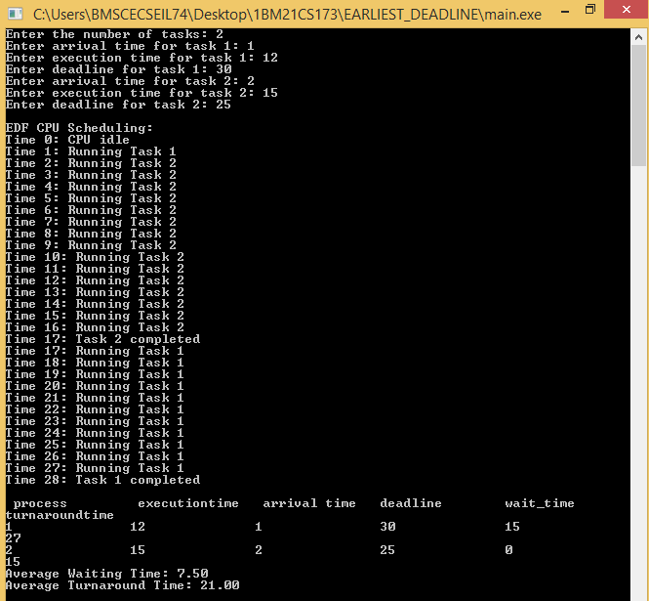

c) Proportional Scheduling
#include <stdio.h>

typedef struct Process {
char name;
int weight;
int cpu_time;
} Process;

void proportionalShareScheduling(Process processes[], int num_processes, int total_cpu_time) {
int total_weights = 0;
int i;
for (i = 0; i < num_processes; i++) {
total_weights += processes[i].weight;
}
for (i = 0; i < num_processes; i++) {
processes[i].cpu_time = (processes[i].weight * total_cpu_time) / total_weights;
}
}

int main() {
int num_processes;
printf("Enter the number of processes: ");
scanf("%d", &num_processes);
Process processes[num_processes];
int i;
for (i = 0; i < num_processes; i++) {
printf("Enter the name of process %d: ", i + 1);
scanf(" %c", &processes[i].name);

printf("Enter the weight of process %c: ", processes[i].name);
scanf("%d", &processes[i].weight);
}

int total_cpu_time;
printf("Enter the total CPU time: ");
scanf("%d", &total_cpu_time);
int sum=0;
for(i=0; i<num_processes; i++){
sum += processes[i].weight;
}
if(sum > total_cpu_time){
printf("Not possible");
exit(0);
}
proportionalShareScheduling(processes, num_processes, total_cpu_time);

printf("Process\tWeight\tCPU Time\n");
for (i = 0; i < num_processes; i++) {
printf("%c\t%d\t%d\n", processes[i].name, processes[i].weight, processes[i].cpu_time);
}

return 0;
}
OUTPUT-
