install.packages("arules")

install.packages("arulesViz")

library(arules)

library(arulesViz)

data(Groceries)

head(g)

head(Groceries)

itemFrequencyPlot(Groceries,topN=20,type="absolute")

OP:

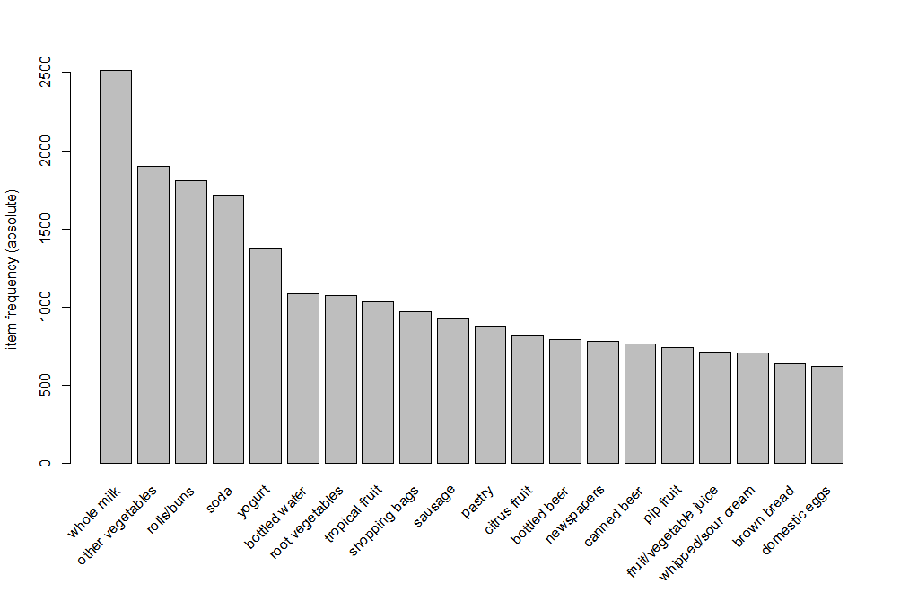

itemFrequencyPlot(Groceries,topN=20,type="relative")

OP:

