1. Qqnorm and qqline

qqnorm(per_index$jpi_resi,col="blue")

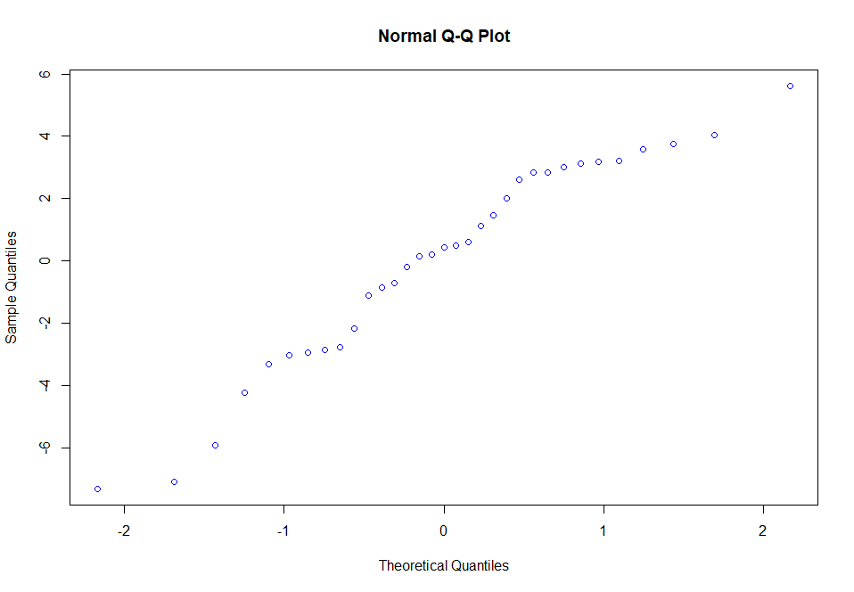 qqline(per_index$jpi_resi,col="blue")

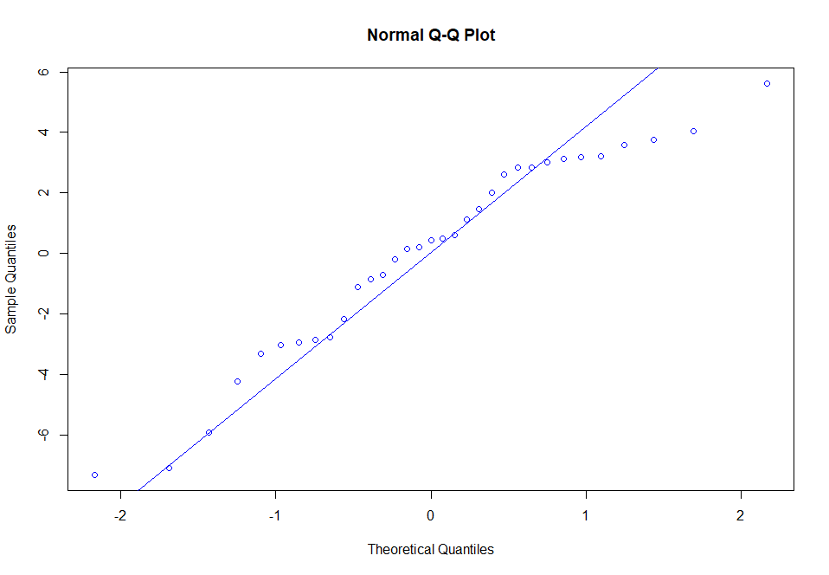

On Bank Data

Age and number of years of experience showed Multicolinearity

loss_model<-lm(Losses.in.Thousands~Ac_No+Age+Years.of.Experience+Number.of.Vehicles+Gender+Married,data=loss)

library(car)

vif(loss_model)

OP:

> vif(loss_model)

Ac_No Age Years.of.Experience Number.of.Vehicles

1.000089 176.511316 176.517874 1.000178

Gender Married

1.000801 1.000264

Age & No of Experience Show high value of vif so Multicolinearity exists.Therefore,drop either of them.

loss_model1<-lm(Losses.in.Thousands~Ac_No+Years.of.Experience+Number.of.Vehicles+Gender+Married,data=loss)

vif(loss_model1)

OP:

> vif(loss_model1)

Ac_No Years.of.Experience Number.of.Vehicles Gender

1.000086 1.000223 1.000175 1.000120

Married

1.000183

1.qqnorm and qq line on bank data

qqnorm(loss$resi,col="blue")

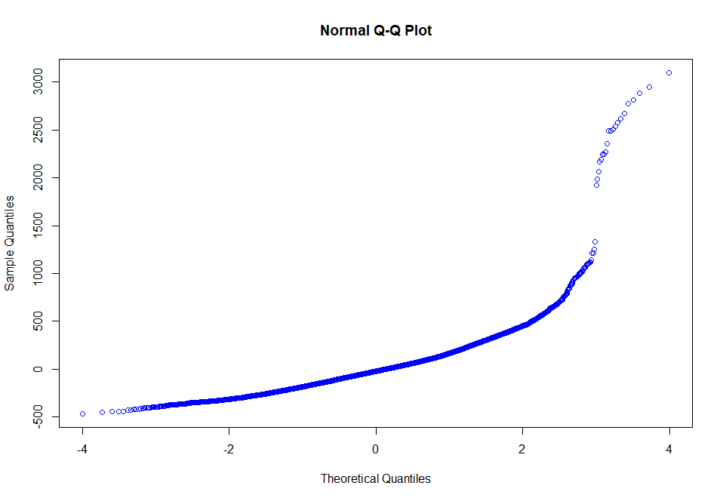

qqline(loss$resi,col="blue")

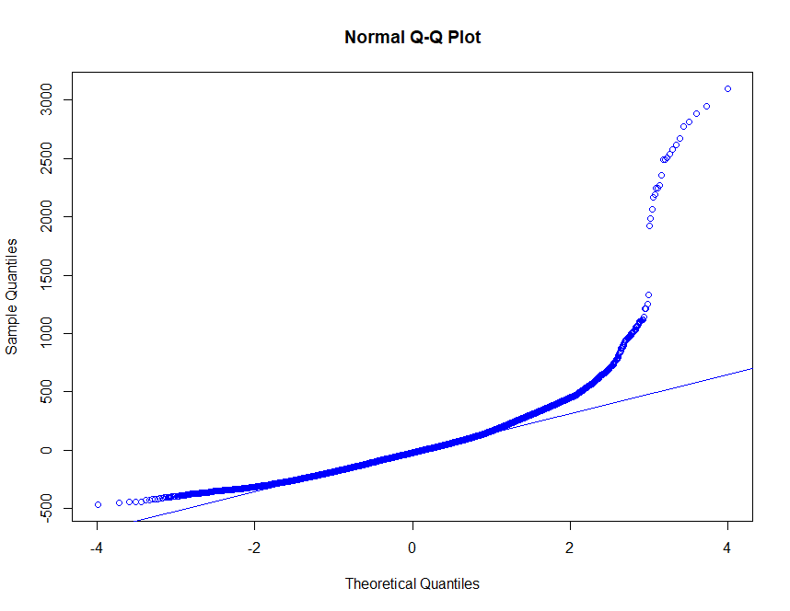

Boxplot

boxplot(loss$resi)

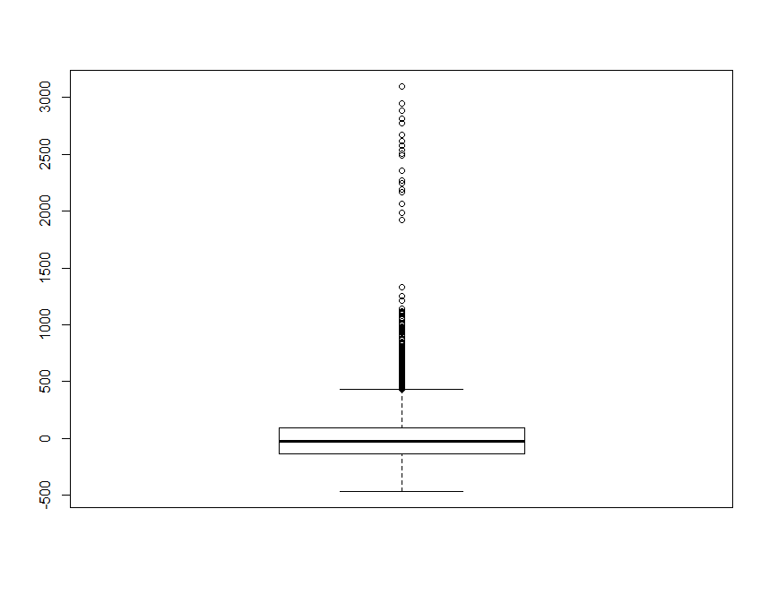Shapiro Test for 5000values

shapiro.test(loss_limited_values$resi)

> shapiro.test(loss_limited_values$resi)

Shapiro-Wilk normality test

data: loss_limited_values$resi

W = 0.77116, p-value < 2.2e-16

All these methods are used to check whether available follows a Normal Distribution/not