LAB 2 – Wireframing & App UI Flow Planning

Aptitude App for Placement Preparation

Table of Contents
- 1. Introduction
- 2. App Overview
- 3. Screen Identification
- 4. Low-Fidelity Wireframes
- 5. UI Flow Diagram
- 6. Navigation Logic
- 7. Conclusion

Introduction
This document presents the wireframing and UI flow planning for the Aptitude App, a comprehensive mobile application designed for placement preparation. The wireframes demonstrate the visual structure, layout organization, and component placement for all essential screens without focusing on final styling or colors.
The UI flow diagram illustrates the complete navigation pattern, ensuring smooth and logical user experience throughout the application.

App Overview
- Application Name: Aptitude App
- Purpose: A Flutter-based mobile application for aptitude test preparation targeting placement exams

Core Features:
- AI-generated aptitude quizzes
- Multiple subjects: Mathematics/Quants, Logical Reasoning, VARC
- Progress tracking and performance analytics
- Adaptive difficulty levels
- Comprehensive quiz history

Screen Identification
Based on the app requirements and use cases, the following screens have been designed:
# | Screen Name | Purpose
1 | Splash Screen | App branding and initial loading
2 | Login Screen | User authentication
3 | Sign Up Screen | New user registration
4 | Home/Dashboard Screen | Main navigation hub and subject selection
5 | Quiz Configuration Screen | Quiz setup and customization
6 | Quiz Screen | Active quiz-taking interface
7 | Result Screen | Quiz performance display
8 | History Screen | Past quiz records and review
9 | Analytics/Performance Screen | Performance metrics and insights
10 | Profile Screen | User account and settings

Total Screens: 10 ✓ (Exceeds minimum requirement of 6-8 screens)

Low-Fidelity Wireframes

1. Authentication Flow Screens
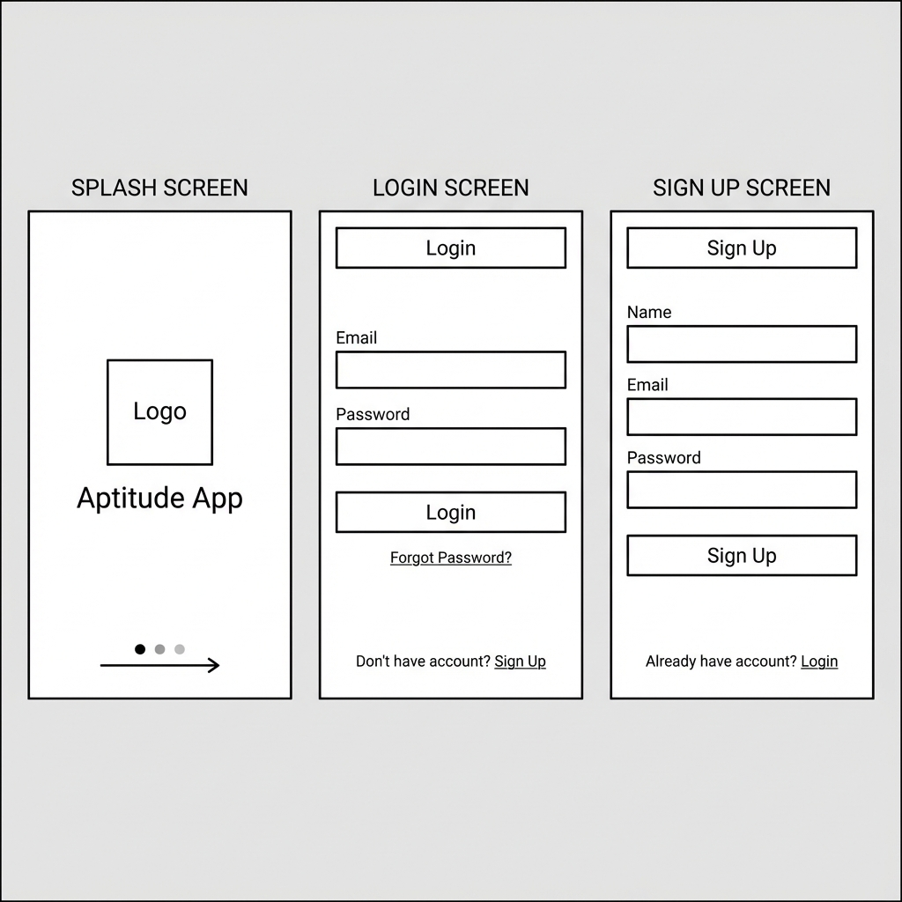

Splash Screen

Components:
- App logo placeholder (centered)
- App name text
- Loading indicator
- Layout: Centered vertical alignment with minimal elements

Login Screen

Components:
- AppBar with "Login" title
- Email input field
- Password input field
- Login button
- "Forgot Password?" link
- "Don't have account? Sign Up" link
- Layout: Vertical form layout with clear call-to-action

Sign Up Screen

Components:
- AppBar with "Sign Up" title
- Name input field
- Email input field
- Password input field
- Sign Up button
- "Already have account? Login" link
- Layout: Extended vertical form with registration fields

2. Core Feature Screens
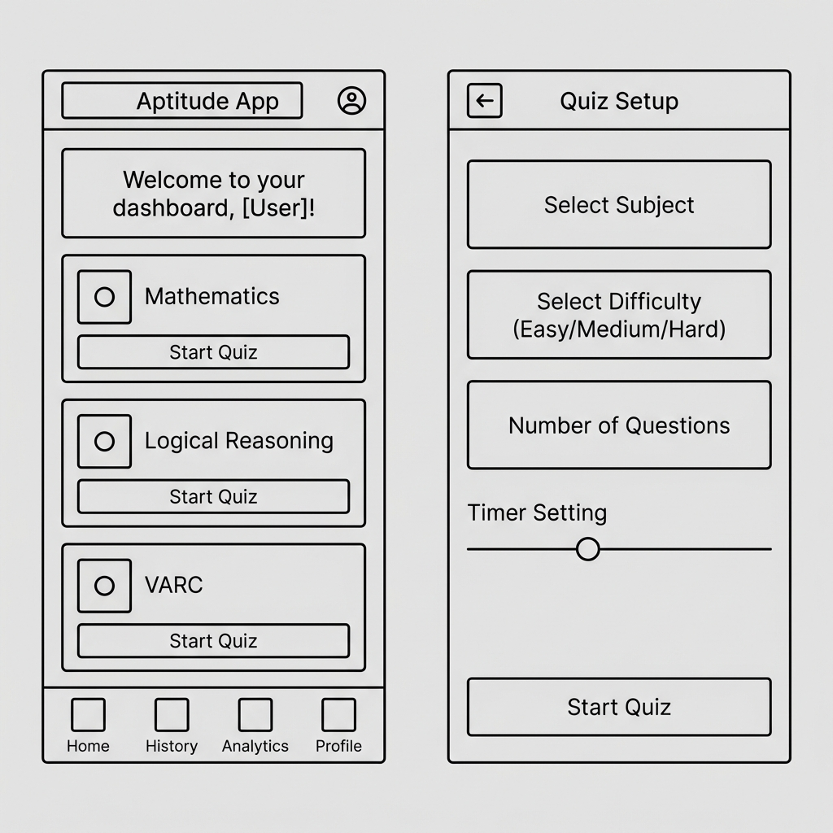

Home/Dashboard Screen

Components:
- AppBar with app title and profile icon
- Welcome message section
- Three subject cards (Mathematics, Logical Reasoning, VARC)
- Each card contains: Icon placeholder, Subject title, "Start Quiz" button
- Bottom navigation bar (Home, History, Analytics, Profile)
- Layout: Card-based grid layout with bottom navigation

Quiz Configuration Screen

Components:
- AppBar with "Quiz Setup" title and back button
- Subject selector dropdown
- Difficulty selector dropdown (Easy/Medium/Hard)
- Number of questions input
- Timer setting slider
- "Start Quiz" button
- Layout: Vertical form layout with clear hierarchy

3. Quiz Interaction Screens
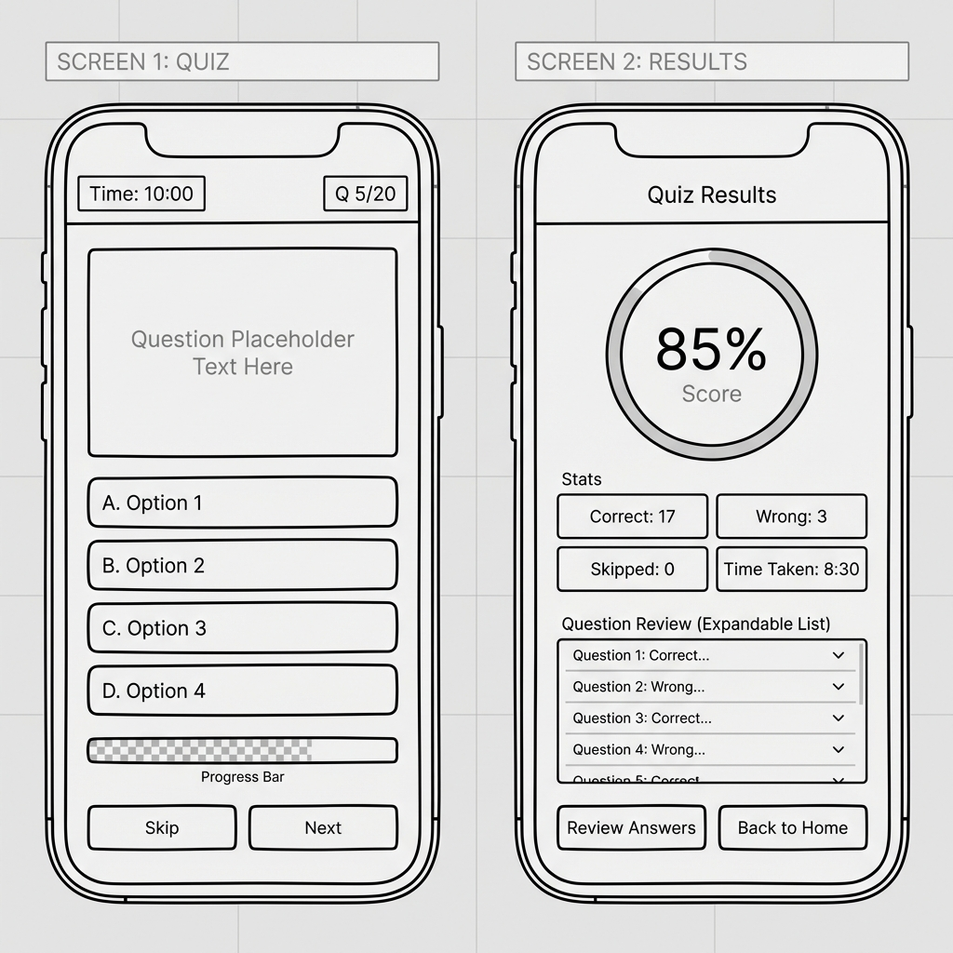

Quiz Screen

Components:
- AppBar with timer display and question counter
- Question card with placeholder text
- Four option buttons (A, B, C, D)
- Progress bar
- "Skip" and "Next" buttons
- Layout: Single question focus with clear option selection

Result Screen

Components:
- AppBar with "Quiz Results" title
- Circular score display (percentage)
- Stats section (Correct, Wrong, Skipped, Time Taken)
- Question review expandable list
- "Review Answers" and "Back to Home" buttons
- Layout: Summary-focused with detailed breakdown

4. Tracking & Profile Screens
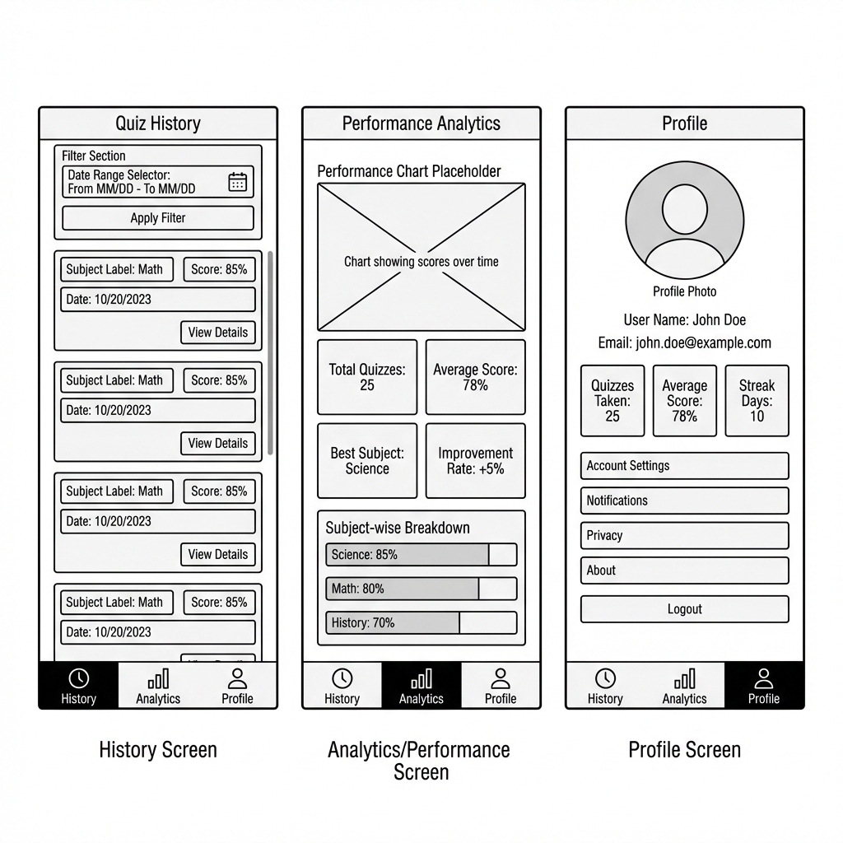

History Screen

Components:
- AppBar with "Quiz History" title
- Date range filter section
- Scrollable quiz history cards
- Each card shows: Subject, Score percentage, Date, "View Details" button
- Bottom navigation bar (History active)
- Layout: List-based layout with filtering options

Analytics/Performance Screen

Components:
- AppBar with "Performance Analytics" title
- Performance chart placeholder
- Stats grid (Total Quizzes, Average Score, Best Subject, Improvement Rate)
- Subject-wise breakdown list
- Bottom navigation bar (Analytics active)
- Layout: Data visualization focused with key metrics

Profile Screen

Components:
- AppBar with "Profile" title
- Circular profile photo placeholder
- User name and email
- Personal stats (Quizzes Taken, Average Score, Streak Days)
- Settings menu items (Account Settings, Notifications, Privacy, About)
- Logout button
- Bottom navigation bar (Profile active)
- Layout: User-centric with organized settings menu

UI Flow Diagram
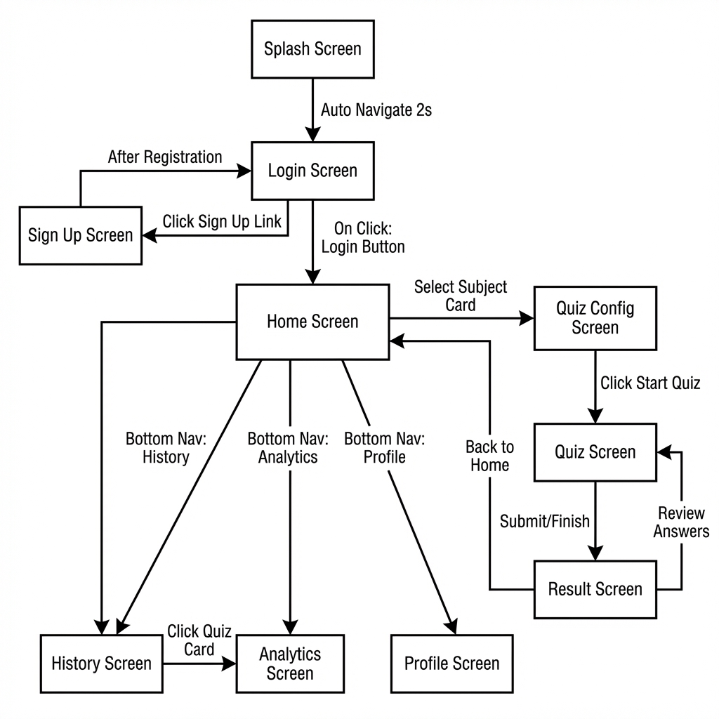

Flow Description

Entry Point:
- App starts at Splash Screen
- Auto-navigates to Login Screen after 2 seconds

Authentication Flow:
- Users can login or navigate to Sign Up Screen
- After successful registration, users return to Login
- Successful login directs to Home Screen

Main Navigation Hub (Home Screen):
- Central hub with access to all major features
- Subject cards lead to Quiz Configuration Screen
- Bottom navigation provides access to History, Analytics, and Profile screens

Quiz Flow (Primary User Journey):
- 1. Select subject from Home → Quiz Config Screen
- 2. Configure quiz settings → Quiz Screen
- 3. Complete quiz → Result Screen
- 4. Option to review answers (loops back to Quiz Screen) or return to Home

Navigation Logic

Primary Navigation Patterns

1. Authentication Flow
Splash Screen automatically transitions to Login after initial load. Login provides bidirectional navigation with Sign Up. Successful authentication grants access to main app features.

2. Bottom Navigation (Persistent)
The app uses a persistent bottom navigation bar accessible from Home Screen, History Screen, Analytics Screen, and Profile Screen. This enables quick switching between main sections without backtracking.

3. Quiz Journey (Linear with Branches)
- Linear Path: Home → Quiz Config → Quiz → Results
- Branch Options:
- From Results: Review answers or return home
- From Home: Access any subject independently

4. Data Access Flows
- History Screen connects to Result Screen for viewing past quiz details
- All screens can return to Home as the central hub
- Profile provides access to app-wide settings

5. Navigation Controls
- Back buttons: Present in secondary screens for intuitive navigation
- Bottom nav: Instant access to main sections
- Action buttons: Context-specific navigation (e.g., "Start Quiz", "View Details")

User Experience Considerations
- Minimal clicks: Core actions (starting a quiz) require only 2 clicks from home
- Clear hierarchy: Home acts as central hub with clear pathways
- Escape routes: Users can always return to Home or navigate to other sections
- Contextual actions: Each screen provides relevant next steps

Conclusion
This wireframing exercise has established a comprehensive visual blueprint for the Aptitude App. The 10 designed screens cover all essential functionality:
✅ Authentication & Onboarding (3 screens)
✅ Core Quiz Features (4 screens)
✅ Progress Tracking & Analytics (2 screens)
✅ User Management (1 screen)
The wireframes follow best practices:
• Simple, low-fidelity design focusing on structure
• Clear component hierarchy and spacing
• Logical content organization
• User-friendly layout patterns
The UI flow diagram demonstrates:
• Smooth navigation between screens
• Logical user journeys
• Multiple access paths to key features
• Clear entry and exit points
These wireframes and flow diagrams will serve as the foundation for:
• Implementing UI components in Flutter
• Building navigation structure
• Developing CRUD operations
• Creating consistent user experience

Documentation Status: Complete and ready for submission ✓

Prepared by: [Your Name]
Roll Number: [Your Roll Number]
Date: February 2, 2026
Lab: LAB 2 – Wireframing & App UI Flow Planning

