LAB 2 – Wireframing & App UI Flow Planning

Aptitude App for Placement Preparation

Table of Contents
- 1. Introduction
- 2. App Overview
- 3. Screen Identification
- 4. Low-Fidelity Wireframes
- 5. UI Flow Diagram
- 6. Navigation Logic
- 7. Conclusion

Introduction
This document presents the wireframing and UI flow planning for the Aptitude App, a comprehensive mobile application designed for placement preparation. The wireframes demonstrate the visual structure, layout organization, and component placement for all essential screens without focusing on final styling or colors.
The UI flow diagram illustrates the complete navigation pattern, ensuring smooth and logical user experience throughout the application.

App Overview
- Application Name: Aptitude App
- Purpose: A Flutter-based mobile application for aptitude test preparation targeting placement exams

Core Features:
- AI-generated aptitude quizzes
- Multiple subjects: Mathematics/Quants, Logical Reasoning, VARC
- Progress tracking and performance analytics
- Adaptive difficulty levels
- Comprehensive quiz history

Screen Identification
Based on the app requirements and use cases, the following screens have been designed:
# | Screen Name | Purpose
1 | Splash Screen | App branding and initial loading
2 | Login Screen | User authentication
3 | Sign Up Screen | New user registration
4 | Home/Dashboard Screen | Main navigation hub and subject selection
5 | Quiz Configuration Screen | Quiz setup and customization
6 | Quiz Screen | Active quiz-taking interface
7 | Result Screen | Quiz performance display
8 | History Screen | Past quiz records and review
9 | Analytics/Performance Screen | Performance metrics and insights
10 | Profile Screen | User account and settings

Total Screens: 10 ✓ (Exceeds minimum requirement of 6-8 screens)

Low-Fidelity Wireframes

1. Splash Screen
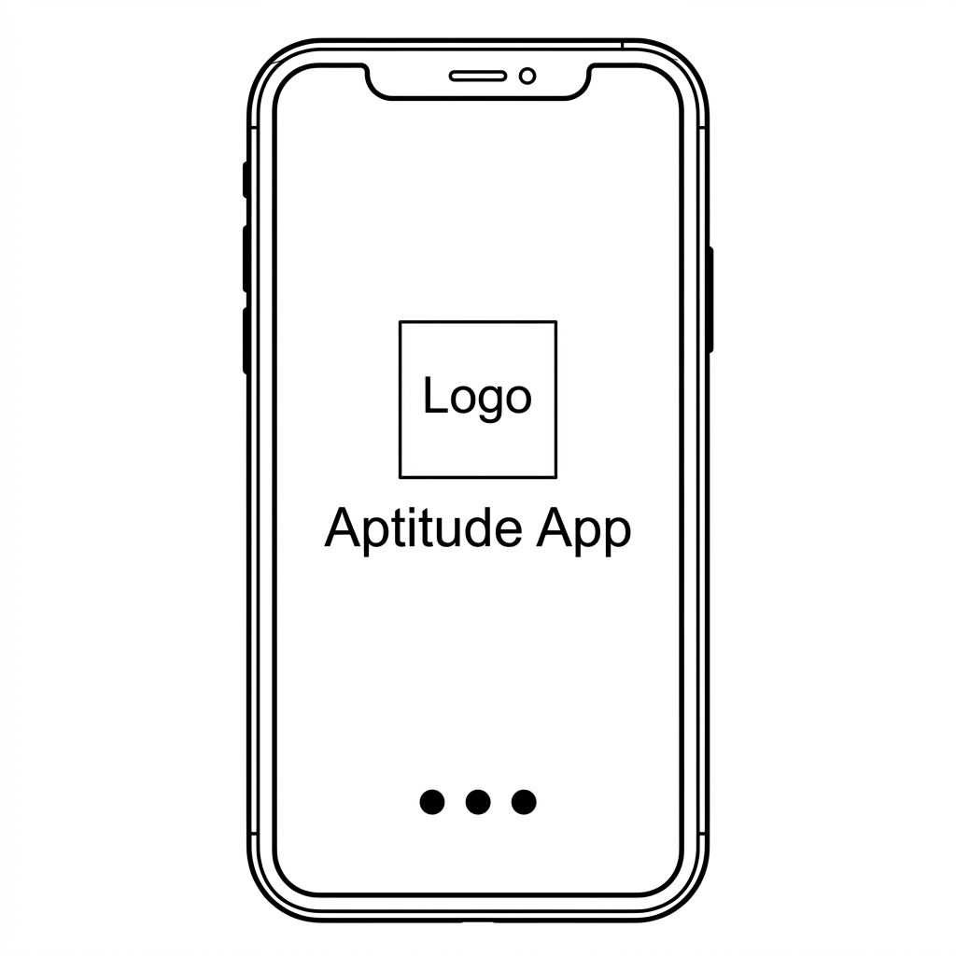

Components:
- App logo placeholder (centered)
- App name text
- Loading indicator
- Layout: Centered vertical alignment with minimal elements

2. Login Screen
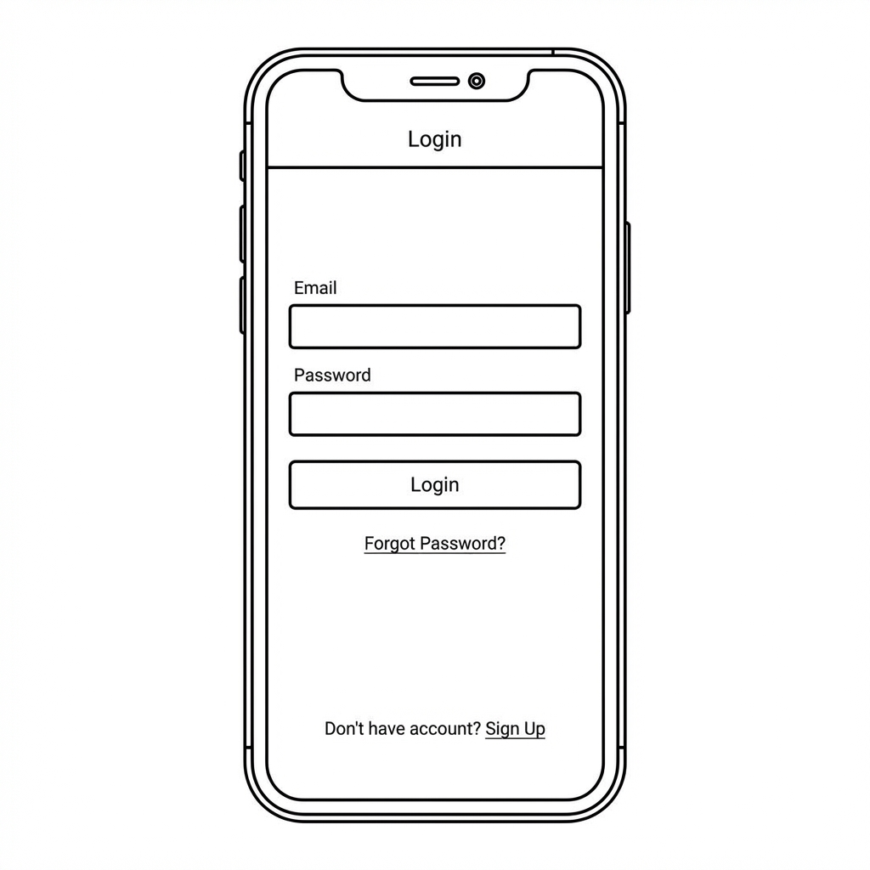

Components:
- AppBar with "Login" title
- Email input field
- Password input field
- Login button
- "Forgot Password?" link
- "Don't have account? Sign Up" link
- Layout: Vertical form layout with clear call-to-action

3. Sign Up Screen
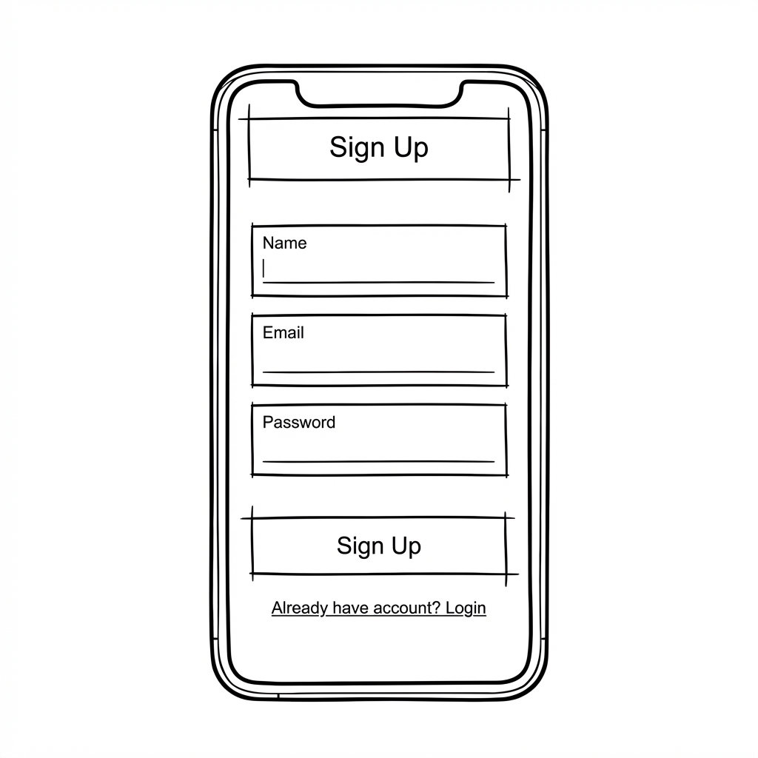

Components:
- AppBar with "Sign Up" title
- Name input field
- Email input field
- Password input field
- Sign Up button
- "Already have account? Login" link
- Layout: Extended vertical form with registration fields

4. Home/Dashboard Screen
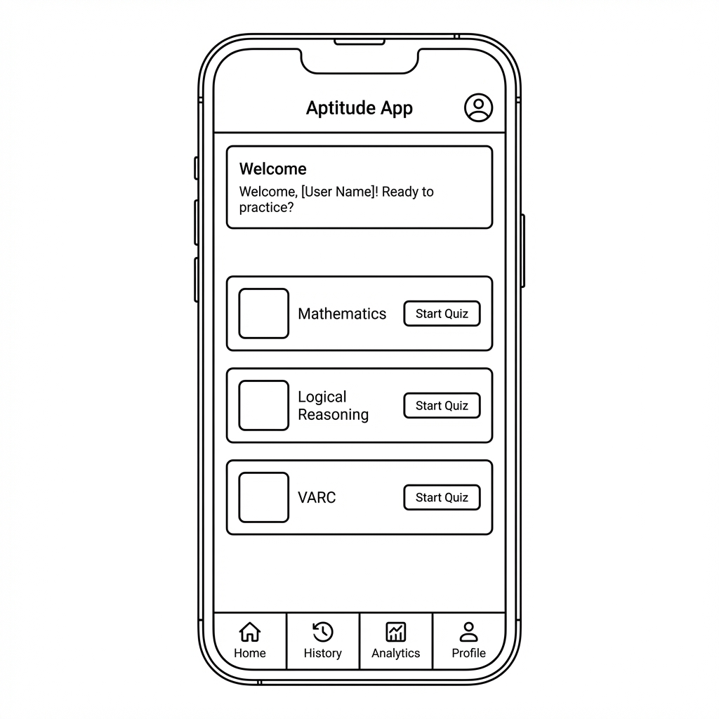

Components:
- AppBar with app title and profile icon
- Welcome message section
- Three subject cards (Mathematics, Logical Reasoning, VARC)
- Each card contains: Icon placeholder, Subject title, "Start Quiz" button
- Bottom navigation bar (Home, History, Analytics, Profile)
- Layout: Card-based grid layout with bottom navigation

5. Quiz Configuration Screen
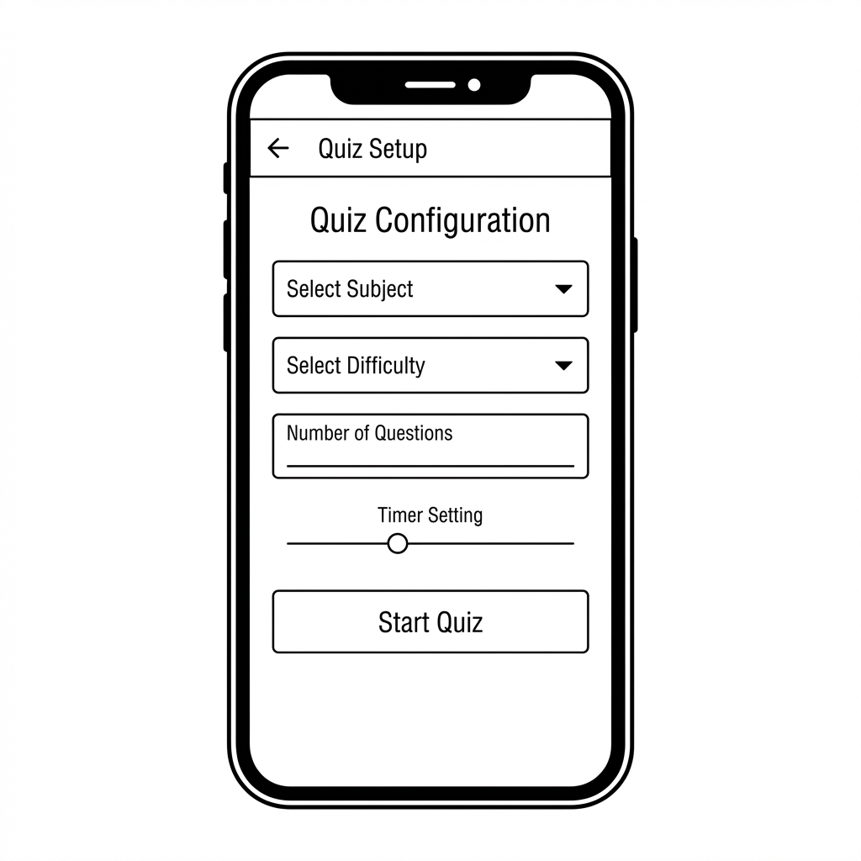

Components:
- AppBar with "Quiz Setup" title and back button
- Subject selector dropdown
- Difficulty selector dropdown (Easy/Medium/Hard)
- Number of questions input
- Timer setting slider
- "Start Quiz" button
- Layout: Vertical form layout with clear hierarchy

6. Quiz Screen
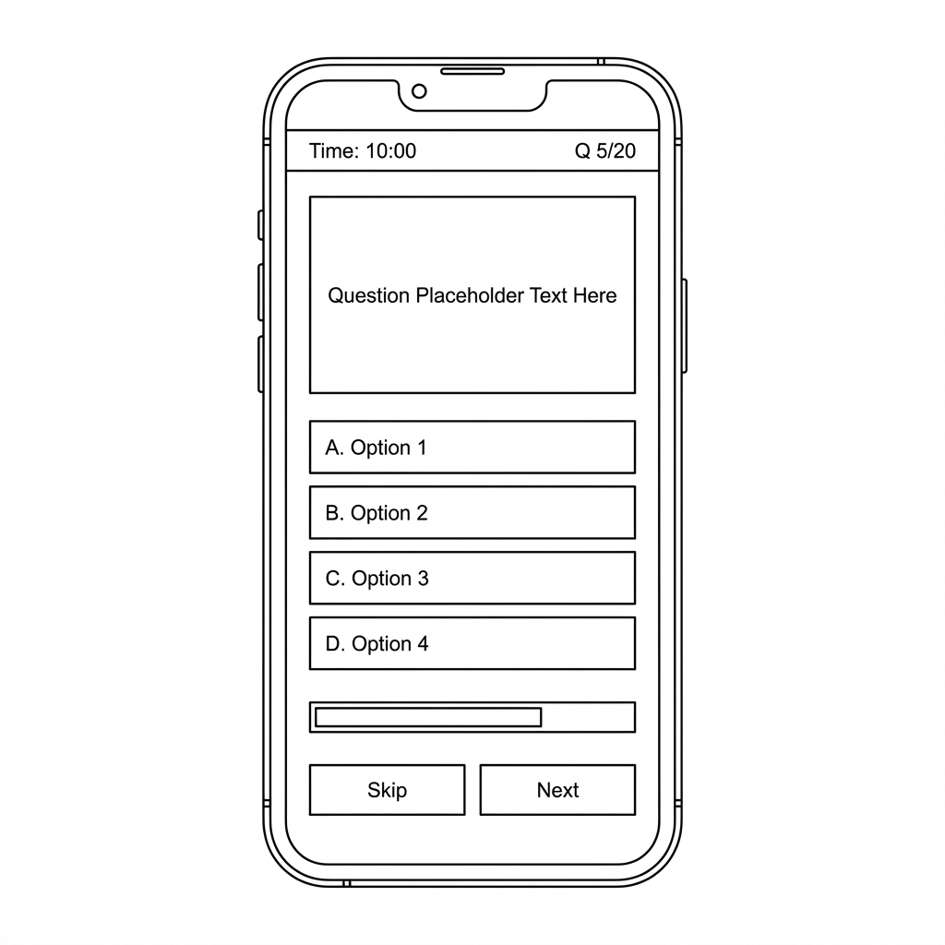

Components:
- AppBar with timer display and question counter
- Question card with placeholder text
- Four option buttons (A, B, C, D)
- Progress bar
- "Skip" and "Next" buttons
- Layout: Single question focus with clear option selection

7. Result Screen
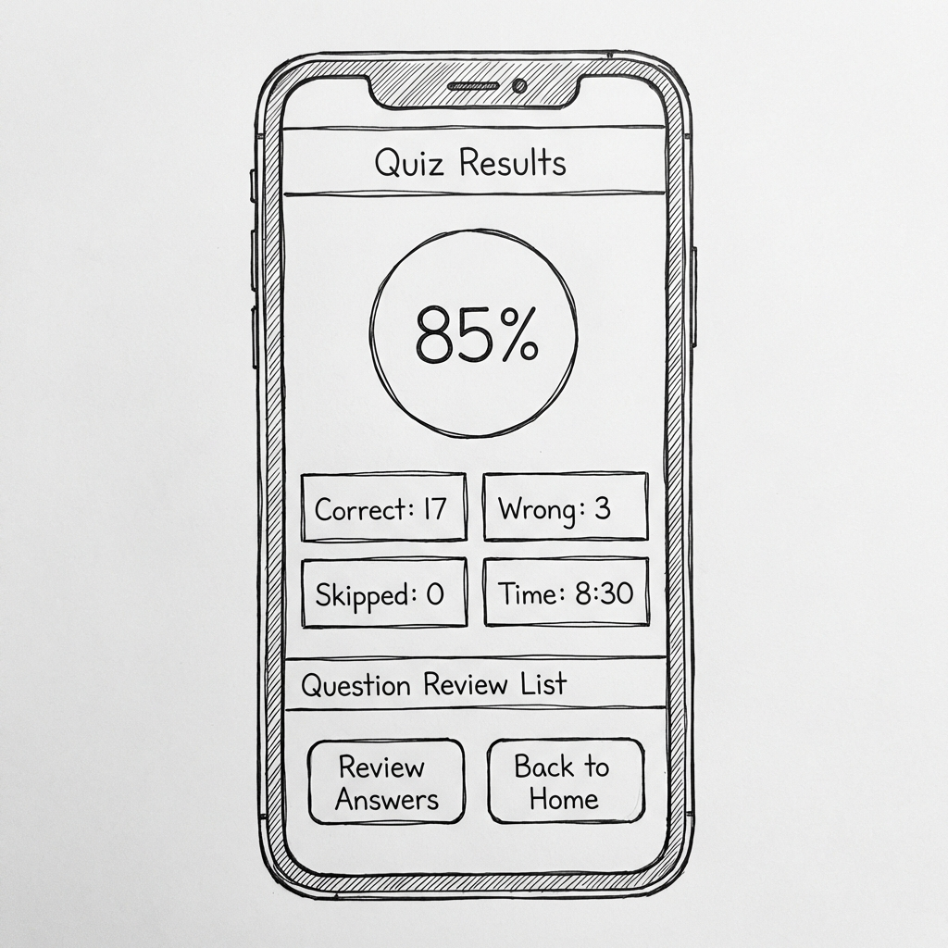

Components:
- AppBar with "Quiz Results" title
- Circular score display (percentage)
- Stats section (Correct, Wrong, Skipped, Time Taken)
- Question review expandable list
- "Review Answers" and "Back to Home" buttons
- Layout: Summary-focused with detailed breakdown

8. History Screen
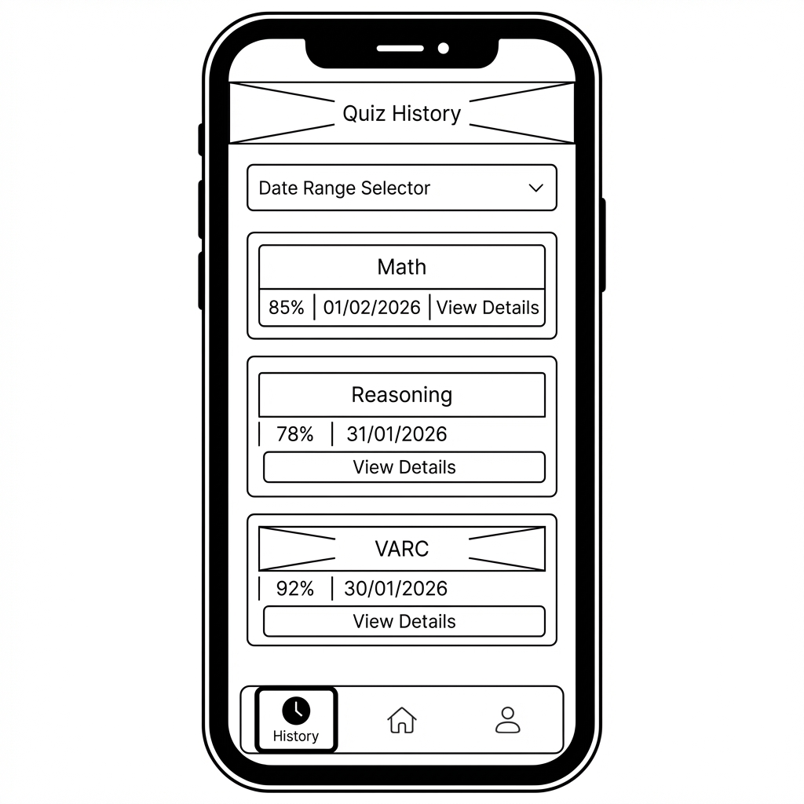

Components:
- AppBar with "Quiz History" title
- Date range filter section
- Scrollable quiz history cards
- Each card shows: Subject, Score percentage, Date, "View Details" button
- Bottom navigation bar (History active)
- Layout: List-based layout with filtering options

9. Analytics/Performance Screen
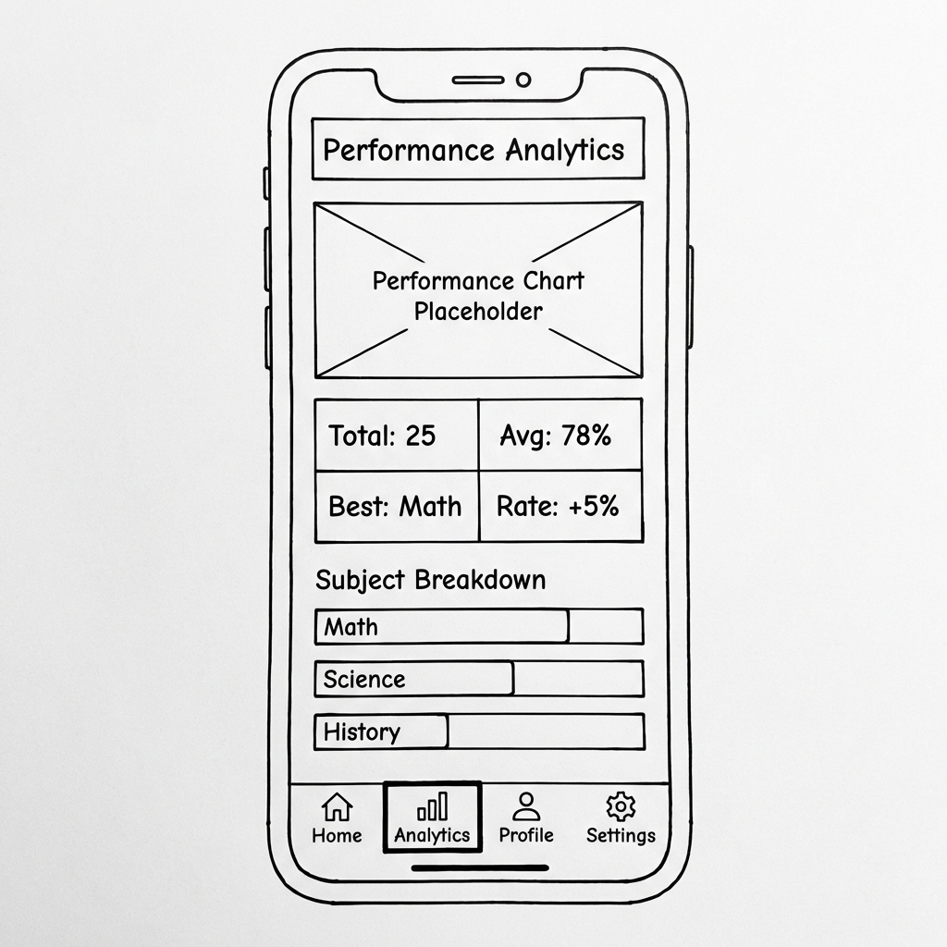

Components:
- AppBar with "Performance Analytics" title
- Performance chart placeholder
- Stats grid (Total Quizzes, Average Score, Best Subject, Improvement Rate)
- Subject-wise breakdown list
- Bottom navigation bar (Analytics active)
- Layout: Data visualization focused with key metrics

10. Profile Screen
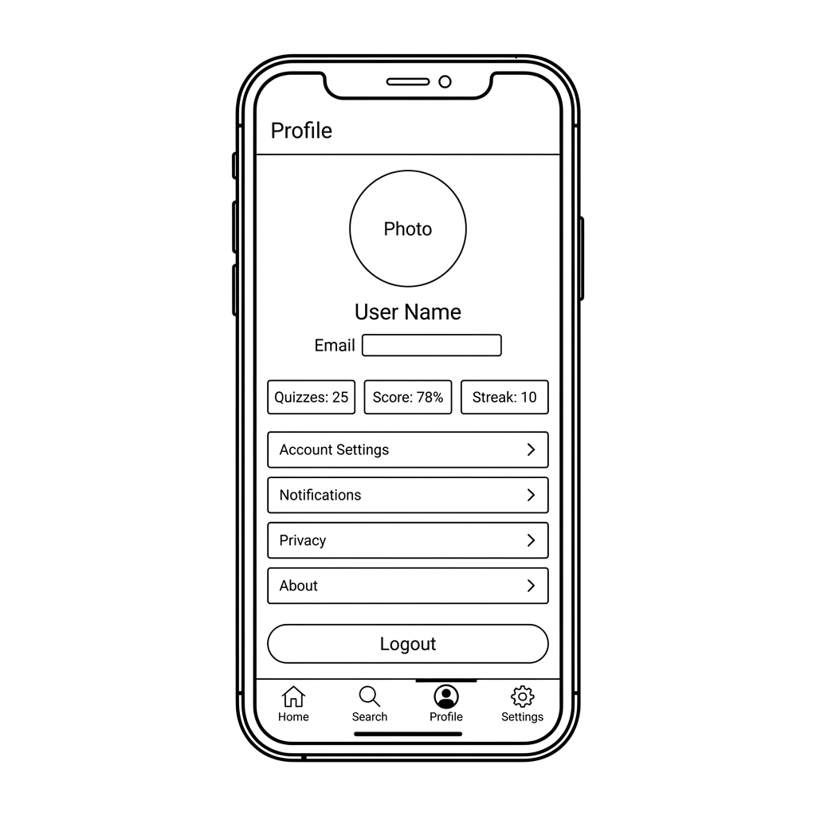

Components:
- AppBar with "Profile" title
- Circular profile photo placeholder
- User name and email
- Personal stats (Quizzes Taken, Average Score, Streak Days)
- Settings menu items (Account Settings, Notifications, Privacy, About)
- Logout button
- Bottom navigation bar (Profile active)
- Layout: User-centric with organized settings menu

UI Flow Diagram
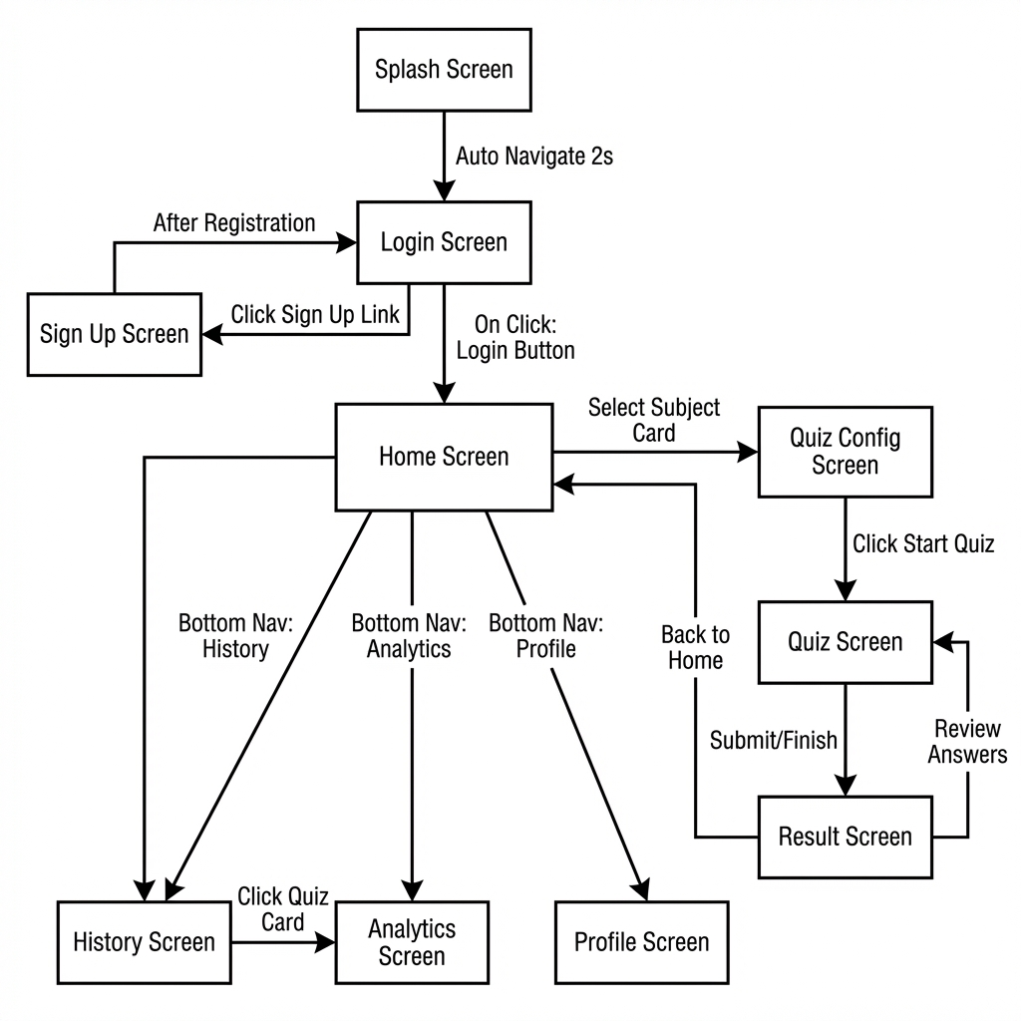

Flow Description

Entry Point:
- App starts at Splash Screen
- Auto-navigates to Login Screen after 2 seconds

Authentication Flow:
- Users can login or navigate to Sign Up Screen
- After successful registration, users return to Login
- Successful login directs to Home Screen

Main Navigation Hub (Home Screen):
- Central hub with access to all major features
- Subject cards lead to Quiz Configuration Screen
- Bottom navigation provides access to History, Analytics, and Profile screens

Quiz Flow (Primary User Journey):
- 1. Select subject from Home → Quiz Config Screen
- 2. Configure quiz settings → Quiz Screen
- 3. Complete quiz → Result Screen
- 4. Option to review answers (loops back to Quiz Screen) or return to Home

Navigation Logic
The Aptitude App uses a hub-and-spoke navigation pattern with the Home screen as the central hub. Users authenticate via Splash and Login screens, then access three main areas through bottom navigation: quiz features, performance tracking, and profile management.
The quiz journey follows a linear path (Home → Config → Quiz → Results) with branching options to review answers or return home. Persistent bottom navigation enables quick switching between History, Analytics, and Profile sections. All screens provide intuitive back buttons and action buttons for context-specific navigation.
Key navigation features include minimal clicks to core actions (only 2 clicks from home to start a quiz), clear screen hierarchy, multiple access paths to features, and contextual next steps on each screen.

Conclusion
This wireframing exercise established a comprehensive visual blueprint for the Aptitude App covering 10 screens across authentication (3 screens), core quiz features (4 screens), progress tracking (2 screens), and user management (1 screen).
The wireframes follow low-fidelity design principles with clear component hierarchy, logical organization, and user-friendly layouts. The UI flow diagram demonstrates smooth navigation, logical user journeys, and clear entry/exit points.
These wireframes will serve as the foundation for implementing UI components in Flutter, building navigation structure, and creating a consistent user experience.

Documentation Status: Complete and ready for submission ✓

Prepared by: [Your Name]
Roll Number: [Your Roll Number]
Date: February 2, 2026
Lab: LAB 2 – Wireframing & App UI Flow Planning

