1 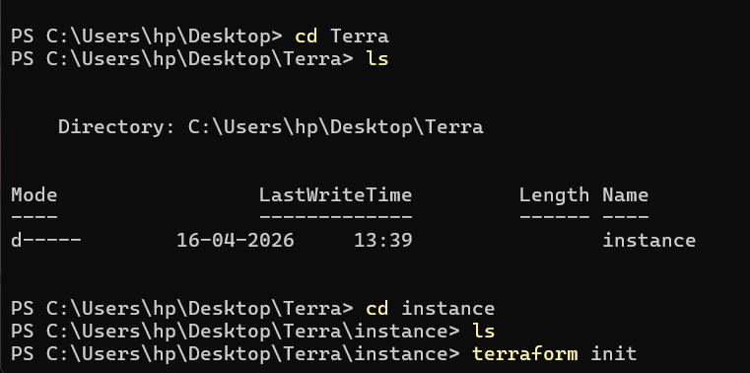
Create a Folder to start your project in.
2 . Create a new main.tf file
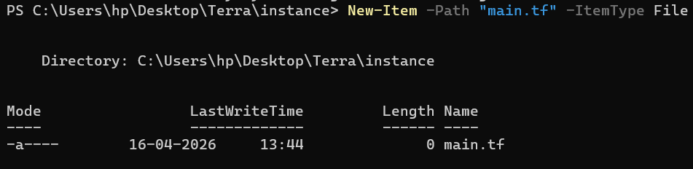
3. write the EC2 creation in the main.tf
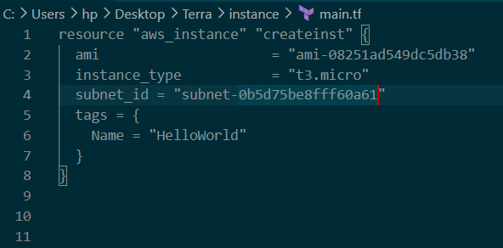

4. initialize so it can download aws dependencies
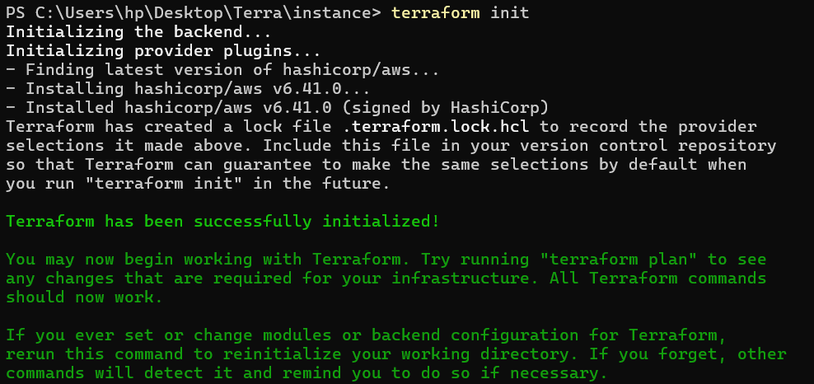
5. terraform plan the terraform apply.c check if error. What type, if the region is correct, if correct take the details like ami-id and subnet id of that region only.
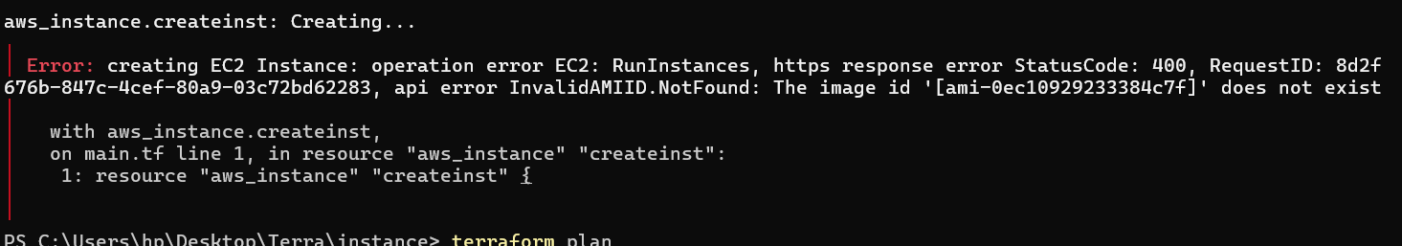
6. terrarform plan
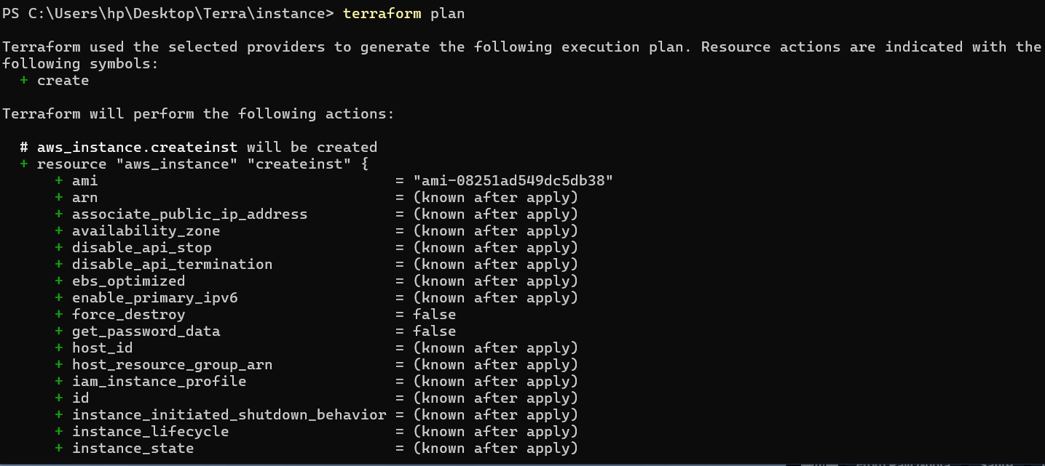
7. terraform apply
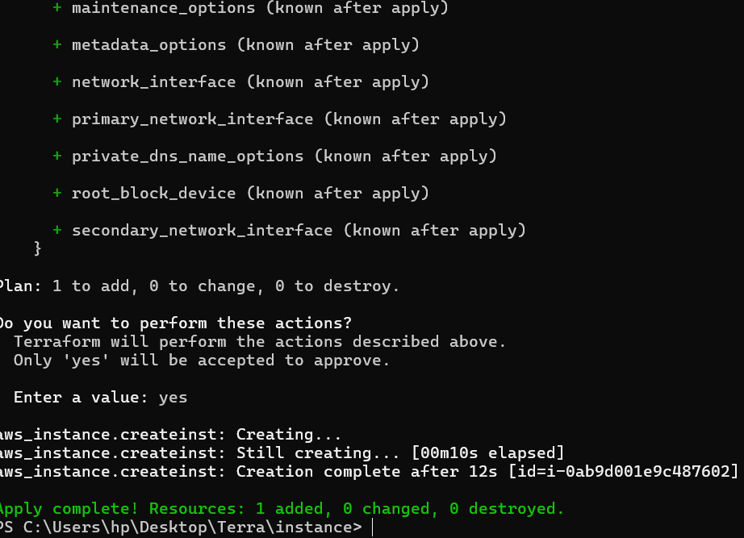
8. check result in AWS console
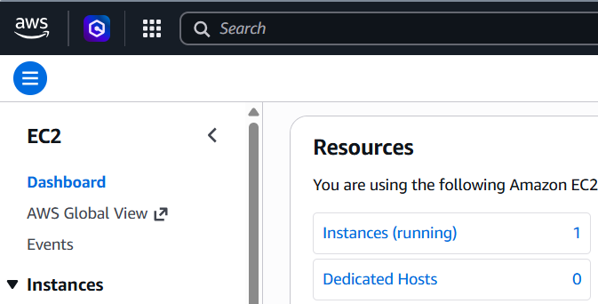

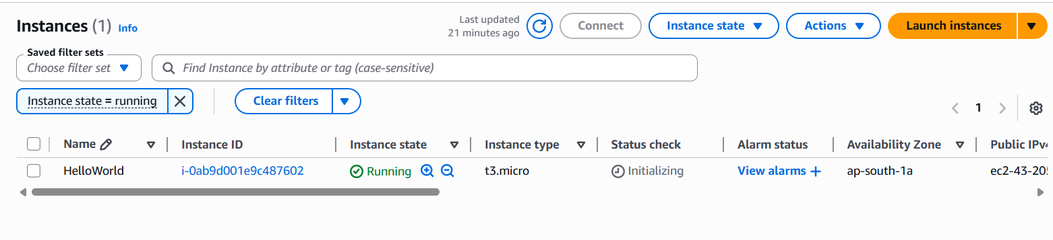
10. then terraform destroy to terminated the instances.
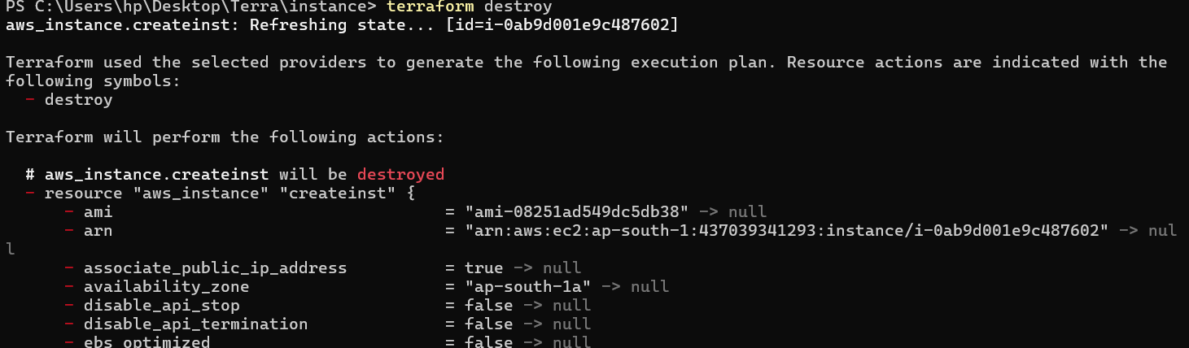
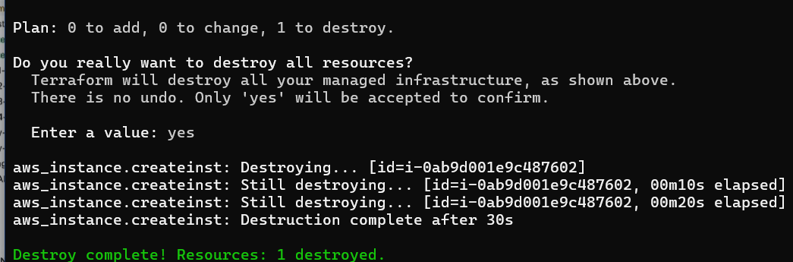
Check in the console
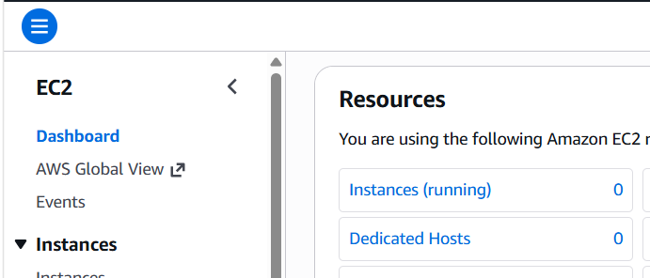
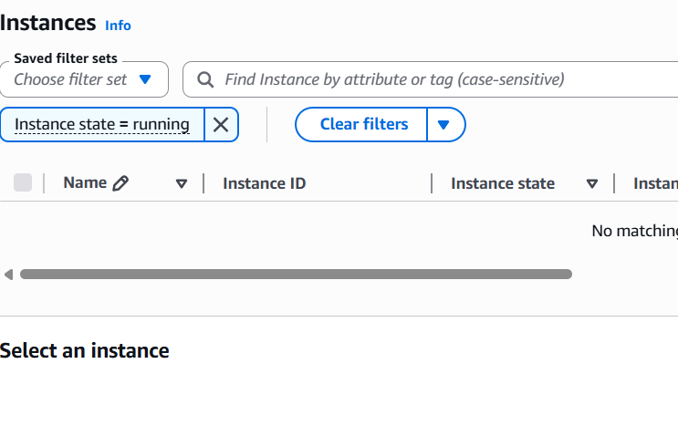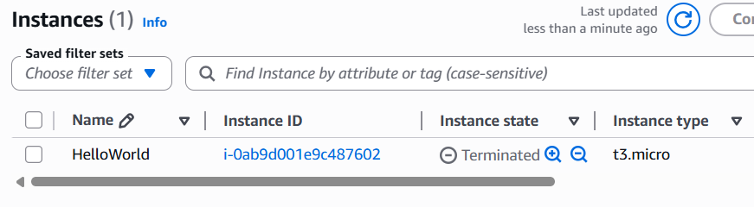
11. also deactivate/ delete the access key.

