Practical 10

Software Testing Practical 10 – Logout / Session Management Testing
Student Name: ________________________________
Roll No / Enrollment No: ________________________________
Subject: Software Testing
Practical No: 10
Application / URL: ________________________________
Date: ____ / ____ / ______
Tool Used: Browser / Manual Testing

Objective
To design and execute test cases, compare expected and actual results, and capture PASS/FAIL screenshots as evidence.

Test Cases and Screenshots
Test Case ID: TC_01
Test Case Title: Logout successfully
Test Data / Input: User is logged in
Test Steps:
- Open the application/page.
- Enter the given test data.
- Perform the required action.
- Observe and record the result.
Expected Result: User should be logged out and redirected to login page
Actual Result: ______________________________________________
Status: PASS
Screenshot:
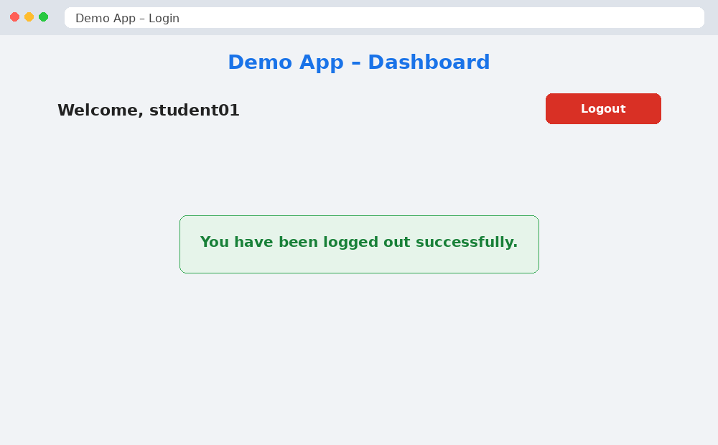
Figure 1: TC_01 – Successful Logout – PASS
_______________________________________________________________________________________________

Test Case ID: TC_02
Test Case Title: Access secured page after logout
Test Data / Input: User logs out, then opens secured URL or presses Back
Test Steps:
- Open the application/page.
- Enter the given test data.
- Perform the required action.
- Observe and record the result.
Expected Result: User should not access secured page; login page should appear
Actual Result: ______________________________________________
Status: FAIL
Screenshot:
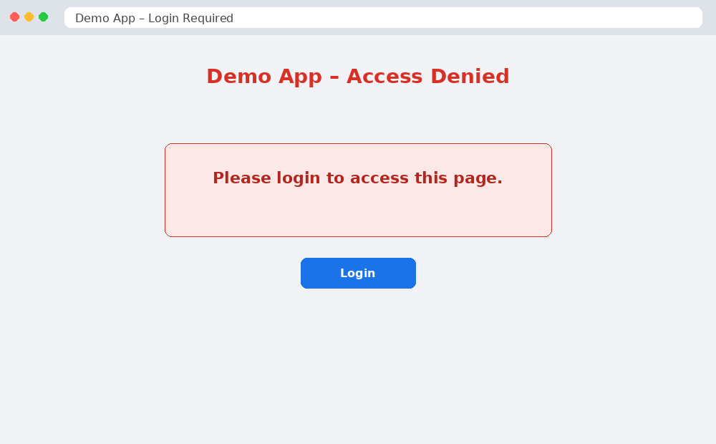
Figure 2: TC_02 – Secured Page After Logout – FAIL
_______________________________________________________________________________________________

Test Case ID: TC_03
Test Case Title: Session expiry after logout
Test Data / Input: User attempts action after logout
Test Steps:
- Open the application/page.
- Enter the given test data.
- Perform the required action.
- Observe and record the result.
Expected Result: Session should be invalid and user must login again
Actual Result: ______________________________________________
Status: FAIL
Screenshot:
[PASTE SCREENSHOT HERE]
Figure Caption: ______________________________________________
_______________________________________________________________________________________________

Result
All test cases were executed. PASS and FAIL screenshots have been captured and attached with the respective test cases.

