Practical 8

Software Testing Practical 8 – Registration / Form Validation Testing
Student Name: ________________________________
Roll No / Enrollment No: ________________________________
Subject: Software Testing
Practical No: 8
Application / URL: ________________________________
Date: ____ / ____ / ______
Tool Used: Browser / Manual Testing

Objective
To design and execute test cases, compare expected and actual results, and capture PASS/FAIL screenshots as evidence.

Test Cases and Screenshots
Test Case ID: TC_01
Test Case Title: Submit form with all valid data
Test Data / Input: All required fields filled with valid data
Test Steps:
- Open the application/page.
- Enter the given test data.
- Perform the required action.
- Observe and record the result.
Expected Result: Form should submit successfully and confirmation message should appear
Actual Result: ______________________________________________
Status: PASS
Screenshot:
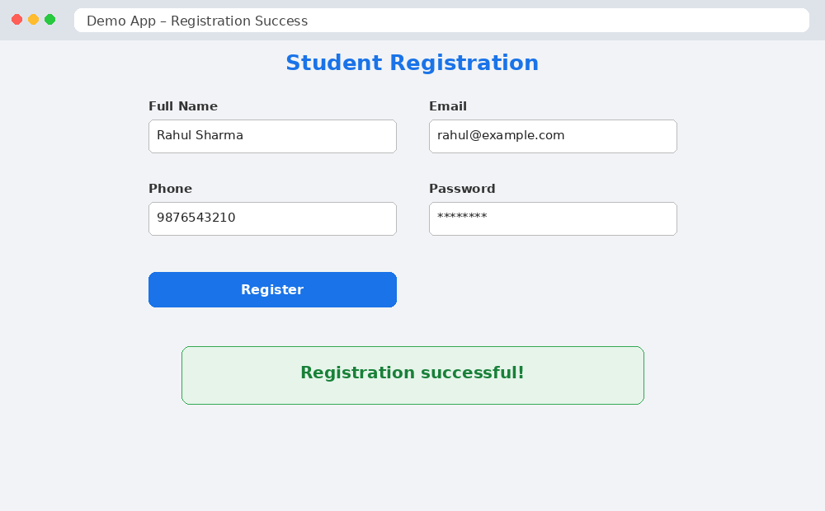
Figure 1: TC_01 – Valid Registration – PASS
_______________________________________________________________________________________________

Test Case ID: TC_02
Test Case Title: Submit form with blank required field
Test Data / Input: One required field left blank
Test Steps:
- Open the application/page.
- Enter the given test data.
- Perform the required action.
- Observe and record the result.
Expected Result: Validation message should appear for the blank field
Actual Result: ______________________________________________
Status: FAIL
Screenshot:
[PASTE SCREENSHOT HERE]
Figure Caption: ______________________________________________
_______________________________________________________________________________________________

Test Case ID: TC_03
Test Case Title: Enter invalid email format
Test Data / Input: Email: abc123
Test Steps:
- Open the application/page.
- Enter the given test data.
- Perform the required action.
- Observe and record the result.
Expected Result: Validation message 'Enter a valid email address' should appear
Actual Result: ______________________________________________
Status: FAIL
Screenshot:
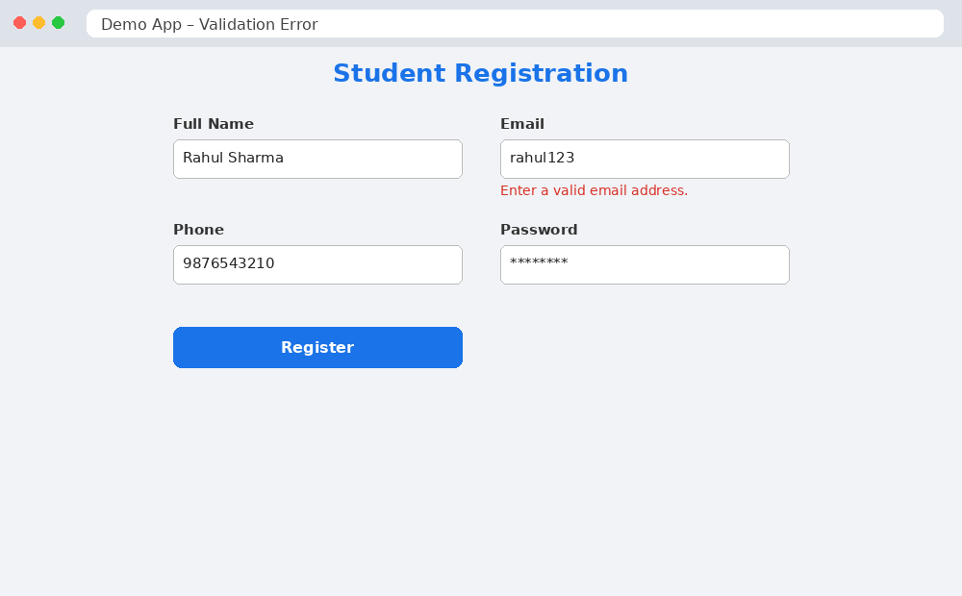
Figure 2: TC_03 – Invalid Email – FAIL
_______________________________________________________________________________________________

Test Case ID: TC_04
Test Case Title: Enter short password
Test Data / Input: Password with fewer than minimum characters
Test Steps:
- Open the application/page.
- Enter the given test data.
- Perform the required action.
- Observe and record the result.
Expected Result: Password validation message should appear
Actual Result: ______________________________________________
Status: FAIL
Screenshot:
[PASTE SCREENSHOT HERE]
Figure Caption: ______________________________________________
_______________________________________________________________________________________________

Test Case ID: TC_05
Test Case Title: Enter mismatched confirm password
Test Data / Input: Password and Confirm Password different
Test Steps:
- Open the application/page.
- Enter the given test data.
- Perform the required action.
- Observe and record the result.
Expected Result: Error message 'Passwords do not match' should appear
Actual Result: ______________________________________________
Status: FAIL
Screenshot:
[PASTE SCREENSHOT HERE]
Figure Caption: ______________________________________________
_______________________________________________________________________________________________

Test Case ID: TC_06
Test Case Title: Enter invalid phone number
Test Data / Input: Phone number with letters or fewer digits
Test Steps:
- Open the application/page.
- Enter the given test data.
- Perform the required action.
- Observe and record the result.
Expected Result: Validation message for valid phone number should appear
Actual Result: ______________________________________________
Status: FAIL
Screenshot:
[PASTE SCREENSHOT HERE]
Figure Caption: ______________________________________________
_______________________________________________________________________________________________

Result
All test cases were executed. PASS and FAIL screenshots have been captured and attached with the respective test cases.

