Practical 9

Software Testing Practical 9 – Search Functionality Testing
Student Name: ________________________________
Roll No / Enrollment No: ________________________________
Subject: Software Testing
Practical No: 9
Application / URL: ________________________________
Date: ____ / ____ / ______
Tool Used: Browser / Manual Testing

Objective
To design and execute test cases, compare expected and actual results, and capture PASS/FAIL screenshots as evidence.

Test Cases and Screenshots
Test Case ID: TC_01
Test Case Title: Search with valid existing keyword
Test Data / Input: Valid keyword present in application
Test Steps:
- Open the application/page.
- Enter the given test data.
- Perform the required action.
- Observe and record the result.
Expected Result: Relevant search results should be displayed
Actual Result: ______________________________________________
Status: PASS
Screenshot:
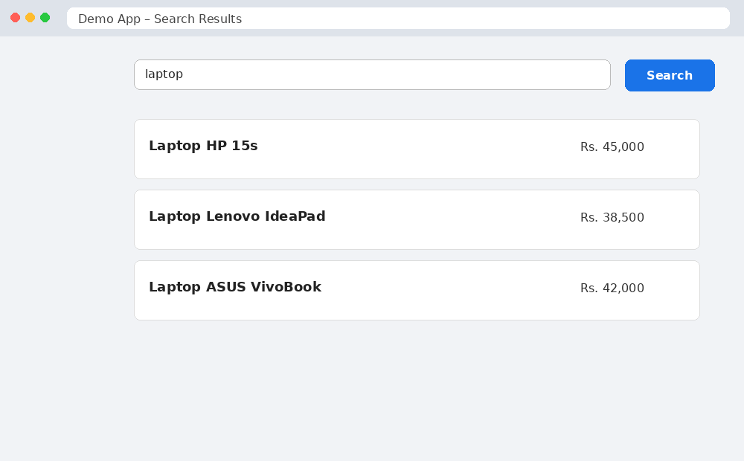
Figure 1: TC_01 – Valid Search – PASS
_______________________________________________________________________________________________

Test Case ID: TC_02
Test Case Title: Search with invalid/non-existing keyword
Test Data / Input: Random/non-existing keyword
Test Steps:
- Open the application/page.
- Enter the given test data.
- Perform the required action.
- Observe and record the result.
Expected Result: Message such as 'No results found' should appear
Actual Result: ______________________________________________
Status: FAIL
Screenshot:
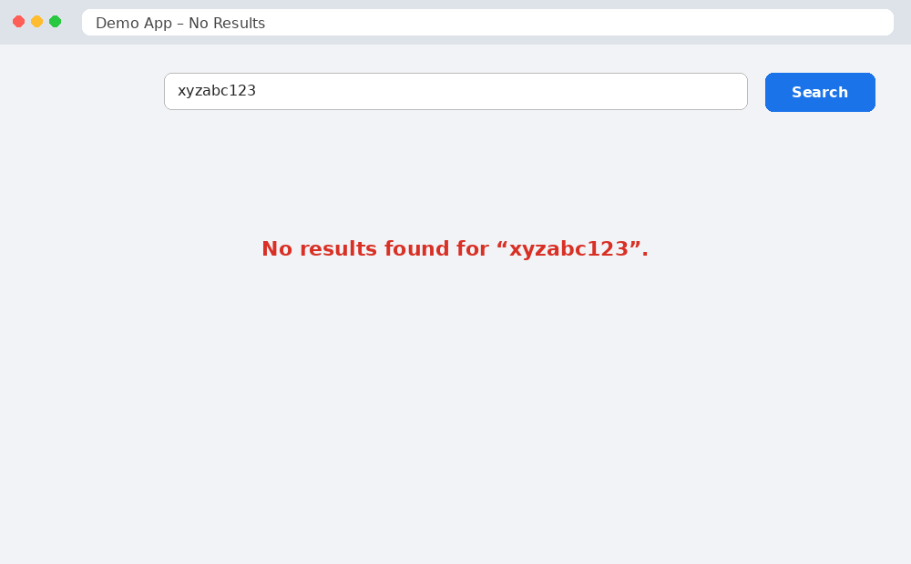
Figure 2: TC_02 – No Results Found – FAIL
_______________________________________________________________________________________________

Test Case ID: TC_03
Test Case Title: Search with blank search box
Test Data / Input: Blank keyword
Test Steps:
- Open the application/page.
- Enter the given test data.
- Perform the required action.
- Observe and record the result.
Expected Result: Validation message or default records may be displayed
Actual Result: ______________________________________________
Status: FAIL
Screenshot:
[PASTE SCREENSHOT HERE]
Figure Caption: ______________________________________________
_______________________________________________________________________________________________

Test Case ID: TC_04
Test Case Title: Search with special characters
Test Data / Input: Keyword containing @#$%
Test Steps:
- Open the application/page.
- Enter the given test data.
- Perform the required action.
- Observe and record the result.
Expected Result: Application should handle input safely and show no results or validation message
Actual Result: ______________________________________________
Status: FAIL
Screenshot:
[PASTE SCREENSHOT HERE]
Figure Caption: ______________________________________________
_______________________________________________________________________________________________

Test Case ID: TC_05
Test Case Title: Search with partial keyword
Test Data / Input: Partial spelling of an existing record
Test Steps:
- Open the application/page.
- Enter the given test data.
- Perform the required action.
- Observe and record the result.
Expected Result: Relevant matching results should be displayed
Actual Result: ______________________________________________
Status: PASS
Screenshot:
[PASTE SCREENSHOT HERE]
Figure Caption: ______________________________________________
_______________________________________________________________________________________________

Result
All test cases were executed. PASS and FAIL screenshots have been captured and attached with the respective test cases.

