CSI HACKATHON 2026 • MINDCRAFT 2K26 • FINTECH DOMAIN
FinFlow AI
Intelligent & Explainable Financial Journey Orchestration
From fragmented forms and disconnected checks to one guided, transparent, and trustworthy financial journey — powered by AI.

"We are not automating a form. We are orchestrating trust."

Table of Contents
This table of contents is generated from the document headings. In Microsoft Word, right-click and choose "Update Field" (or press F9) to refresh page numbers after any edits.
Table of Contents 1
Executive Overview 1
Project Title 1
One-Line Elevator Pitch 1
Executive Summary 1
Brief Understanding of the Project 1
Why the Problem Matters 1
Expected Impact 1
Innovation Highlights 1
Prototype Vision 1
Section 1 — Project Synopsis (Proposal & Feasibility) 1
1.1 Project Title & Objective 1
1.2 Problem Statement 1
1.3 Problem Context 1
Current Challenges 1
Existing Approaches and Why They Fall Short 1
Why Current Solutions Fall Short 1
1.4 Proposed Solution 1
How the Solution Works 1
Key Innovation 1
Why It Is Practical 1
1.5 Unique Selling Proposition (USP) 1
Competitive Advantages 1
Section 2 — Product Requirements Document (PRD) 1
2.1 Product Vision 1
2.2 Strategic Goals 1
2.3 User Personas 1
Priya Sharma — The SME Owner (Primary User) 1
Rohan Mehta — The Relationship Manager / Loan Officer (Secondary User) 1
Ananya Iyer — The Risk & Compliance Officer (Stakeholder / Beneficiary) 1
2.4 User Stories 1
2.5 Core Use Cases 1
2.6 Feature Breakdown (MoSCoW) 1
2.7 User Journey 1
2.8 Screen Flow 1
2.9 UX Principles 1
2.10 Success Metrics (KPIs) 1
2.11 Risks & Mitigation 1
2.12 Assumptions 1
2.13 Dependencies 1
2.14 Demo Flow 1
Section 3 — Software Requirements Specification (SRS) 1
3.1 System Overview 1
Module Responsibilities (Summary) 1
3.2 Module Breakdown 1
3.2.1 Journey Orchestrator Service 1
3.2.2 Document Intelligence Service 1
3.2.3 Risk & Eligibility Engine 1
3.2.4 Explainable Decision Engine 1
3.2.5 Next-Best-Action Service 1
3.3 Functional Requirements 1
Module: Journey Orchestrator 1
Module: Document Intelligence 1
Module: Risk & Eligibility Engine 1
Module: Explainable Decision Engine 1
Module: Next-Best-Action Service 1
3.4 Non-Functional Requirements 1
Performance 1
Scalability 1
Security 1
Reliability 1
Availability 1
3.5 External Interfaces 1
UI Constraints 1
REST APIs — Sample Endpoints 1
Third-Party Integrations & Protocols 1
Sample Request — Create Journey 1
Sample Response 1
3.6 Database Design 1
Core Entities, Keys & Constraints 1
3.7 Data Flow 1
3.8 Algorithms & Core Logic 1
Decision-Making / AI Workflow (Processing Pipeline) 1
Scoring Mechanism (Summary) 1
3.9 Deployment Architecture 1
3.10 Testing Strategy 1
Sample Test Cases 1
Section 4 — Implementation Plan (24–48 Hour Roadmap) 1
4.1 Phase-wise Timeline 1
4.2 Team Responsibility Matrix 1
Section 5 — Future Roadmap 1
5.1 Version 1 — Immediate Post-Hackathon Improvements 1
5.2 Version 2 — Advanced Features 1
5.3 Long-Term Vision 1
Section 6 — Conclusion 1
Why This Solution Matters 1
Why It Is Feasible 1
How the MVP Demonstrates Real-World Potential 1
The Long-Term Vision Beyond the Hackathon 1

Executive Overview

Project Title
FinFlow AI — Intelligent & Explainable Financial Journey Orchestration

One-Line Elevator Pitch
ELEVATOR PITCH
FinFlow AI turns a fragmented, multi-tool financial application process into one intelligent, guided journey — understanding customer intent, verifying evidence, assessing risk, explaining every decision in plain language, and recommending the Next Best Action until the case is resolved.

Executive Summary

Brief Understanding of the Project
Financial services have digitized individual transactions — payments, KYC, document uploads, credit checks — but the end-to-end customer journey behind a loan, claim, or credit application remains fragmented across disconnected forms, verification tools, and support channels. FinFlow AI is a single orchestration layer that sits above these fragmented tools. It captures customer intent, verifies financial evidence using OCR and AI-based document intelligence, assesses eligibility and risk using a hybrid rules-plus-ML engine, explains every decision in human-readable language, and continuously recommends the Next Best Action to move the case toward resolution. For the 24-hour hackathon, the team will build a complete, working MVP centered on one high-value, well-scoped journey — SME (Small & Medium Enterprise) lending — while designing the platform so the same orchestration core generalizes to insurance claims, retail credit, and other financial journeys in future iterations.

Why the Problem Matters
The core gap is not a lack of technology — it is a lack of unification. Individual point solutions already exist for OCR, chatbots, rules engines, and workflow tools, but none of them own the complete journey from intent to action. This fragmentation directly produces three costly outcomes: repeated data entry and document complexity for customers; manual, high-effort verification and operational load for financial institutions; and inconsistent evidence trails with limited explainability for risk and compliance teams — at a time when digital-payment fraud is high in volume and loan/advances fraud is significant in value, and regulators increasingly expect AI-assisted financial decisions to be transparent, fair, and auditable.

Expected Impact
FinFlow AI reduces customer friction by replacing repeated forms and opaque waiting with a single guided journey and clear next steps; it reduces institutional cost by automating document verification and first-pass risk triage; and it reduces compliance risk by producing an explainable, auditable decision trail for every case — improving trust for customers, efficiency for institutions, and transparency for regulators simultaneously.

Innovation Highlights
- Journey Graph: a stateful, auditable model of "where every case is" — not just a chatbot answering questions, but a system that knows and drives the next step.
- Evidence Ledger: a structured, versioned record of every document, extracted field, and confidence score, so evidence is traceable and reusable.
- Explainable Decision Layer: every eligibility and risk outcome is paired with a plain-language reason, generated using retrieval-augmented reasoning over policy and case evidence — not a black box score.
- Next Best Action AI: the system proactively tells the customer or the officer what to do next, rather than leaving them to figure it out.

Prototype Vision
Within the 24-hour build window, the team will deliver a working MVP demonstrating the complete SME lending journey end-to-end: intent capture, document upload and AI-based verification, rule- and ML-based eligibility and risk scoring, an explainable decision with clear reasoning, and a recommended Next Best Action — all visible through a live Journey Tracker UI, backed by a real (not mocked) FastAPI backend, a real database, and a real (or realistically simulated) LLM/OCR pipeline running on synthetic financial data.

Section 1 — Project Synopsis (Proposal & Feasibility)
This section is written for judges, mentors, and stakeholders who need to understand the project quickly: what problem it solves, for whom, why it matters, and why the proposed solution is both innovative and feasible within a 24-hour build.

1.1 Project Title & Objective
- Project Title: FinFlow AI — Intelligent & Explainable Financial Journey Orchestration
- Mission Statement: To replace fragmented, opaque financial application processes with a single, intelligent, explainable journey that customers can trust and institutions can rely on.
- Primary Objective: Design and demonstrate a working AI-orchestrated SME lending journey — from intent capture to an explainable eligibility decision and a recommended next action — built on a modular architecture that generalizes to other financial journeys such as insurance claims and retail credit.

1.2 Problem Statement
Financial services are digital, but the customer journey remains fragmented. Customers applying for loans, claims, or other financial services must navigate disconnected forms, documents, verification steps, eligibility checks, and support channels — creating repetition, delays, confusion, and opaque decisions. The screenshot below captures the team's original problem-understanding analysis as presented in the CSI Hackathon Round 1 idea submission.
In practical terms: an SME owner seeking working-capital finance today re-enters the same information across multiple forms, uploads financial documents that are manually re-verified at every step, waits without visibility into what is happening or why, and — if declined — often receives no clear, actionable reason. The gap is not a missing point solution; it is the absence of a layer that unifies intent, evidence, risk, decision, and action into one coherent, explainable journey.

1.3 Problem Context

Current Challenges
- Customers repeat the same information across intake forms, KYC steps, and support conversations, with no shared context between them.
- Document verification is largely manual or semi-manual, creating operational load and inconsistent turnaround times.
- Risk and compliance teams work with inconsistent evidence and limited explainability, making fraud signals harder to trust and decisions harder to defend.

Existing Approaches and Why They Fall Short
Existing Approach | Limitation
Chatbots | Answer questions but do not execute or own the underlying journey.
OCR / Document AI tools | Extract data accurately but do not connect extracted evidence to a decision.
Rule / risk engines | Score cases reliably but do not understand broader customer context or intent.
Workflow systems | Move tasks between queues but apply no intelligent reasoning to the case.

Why Current Solutions Fall Short
Each existing tool automates one link in the chain — but no tool owns the chain itself. The result is a set of well-optimized fragments and a poorly-optimized whole: the customer still experiences delay, repetition, and opacity, even when every individual component "works." Finance has digitized transactions; it has not unified the journey.

1.4 Proposed Solution

How the Solution Works
FinFlow AI converts a customer's financial request into one guided journey. It captures intent through a conversational, form-light interface; verifies supporting documents using OCR and AI-based extraction; assesses eligibility and risk with a hybrid rules-plus-machine-learning engine; explains every decision in plain language grounded in policy and evidence; and recommends the Next Best Action — repeating this loop until the journey reaches resolution.
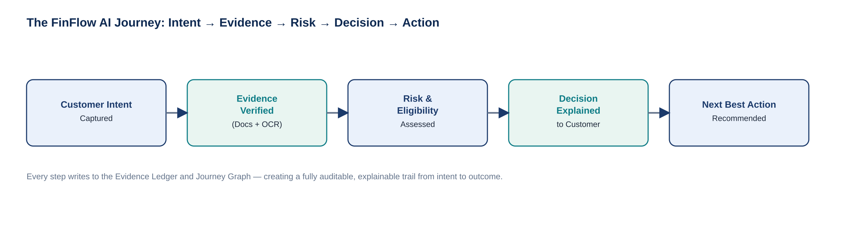
Figure 1.2 — The FinFlow AI journey: Intent → Evidence → Risk → Decision → Action.

Key Innovation
Unlike point solutions that automate individual tasks, FinFlow AI connects the entire financial journey through three coordinated capabilities: a Journey Graph that always knows the current state and next step of a case; an Evidence Ledger that keeps every extracted fact traceable back to its source document with a confidence score; and a Next-Best-Action engine that turns a static decision into an ongoing, guided conversation.

Why It Is Practical
The solution deliberately scopes its hackathon MVP to a single, well-understood journey — SME lending — using synthetic and openly structured financial data, production-grade but open-source-friendly technologies (FastAPI, PostgreSQL with pgvector, scikit-learn/XGBoost, an LLM with retrieval-augmented generation), and a modular service boundary that lets each capability (document intelligence, risk scoring, explainability, next-best-action) be built, tested, and demoed independently within the 24-hour window.

1.5 Unique Selling Proposition (USP)
Dimension | FinFlow AI Advantage
Journey ownership | Owns the full intent-to-action journey, not a single step within it.
Explainability by design | Every decision ships with a plain-language, policy-grounded reason — not a bare score.
Auditability | Journey Graph + Evidence Ledger create a traceable, replayable record for every case.
Proactivity | Next Best Action guides the customer forward instead of leaving them to interpret a status label.
Domain-agnostic core | Same orchestration engine generalizes from SME lending to claims and retail credit.

Competitive Advantages
- Fuses document intelligence, risk scoring, and explainability into one continuous pipeline instead of three disconnected tools.
- Produces regulator-friendly, human-readable justifications rather than opaque model scores — directly addressing the fairness and transparency expectations placed on financial AI.
- Built on a modular microservice boundary, so the MVP is both a convincing demo and a credible foundation for a production system.

Section 2 — Product Requirements Document (PRD)
This section defines what should be built and why users need it — translating the problem and solution from Section 1 into concrete product requirements, personas, user stories, and success criteria.

2.1 Product Vision
- Long-Term Vision: To become the default intelligence layer for financial journeys — the trusted orchestration engine that any bank, NBFC, or fintech plugs in to turn fragmented forms, checks, and tools into one guided, explainable customer experience.
- Product Philosophy: Decisions without explanations erode trust, and journeys without guidance create abandonment. FinFlow AI is built on the principle that every automated decision must be explainable, every step must be visible to the customer, and every case must always have a clear next action.

2.2 Strategic Goals
Goal | Measurable Objective
Reduce journey friction | Cut the number of separate touchpoints a customer needs to complete an SME loan application from 6+ to a single guided flow.
Accelerate verification | Reduce average document verification time from hours (manual) to under 2 minutes (AI-assisted) in the MVP demo.
Improve transparency | Ensure 100% of eligibility/risk decisions in the MVP are accompanied by a human-readable explanation.
Demonstrate feasibility | Ship a working, end-to-end demoable MVP within the 24-hour hackathon window.

2.3 User Personas

Priya Sharma — The SME Owner (Primary User)
- Background: Runs a 12-person textile trading business in Pune; has applied for working-capital loans before and found the process slow and repetitive.
- Goals: Get a fast, clear decision on a working-capital loan without repeating paperwork across channels.
- Pain Points: Re-entering the same business details multiple times; unclear document requirements; no visibility into application status; vague rejection reasons.
- Technical Proficiency: Comfortable with WhatsApp and basic mobile apps; not a power user of complex dashboards.

Rohan Mehta — The Relationship Manager / Loan Officer (Secondary User)
- Background: Handles 40–60 active SME loan cases at a mid-size NBFC; spends much of the day manually cross-checking documents and chasing missing information.
- Goals: Process more cases per day with confidence in the evidence and risk signals behind each one.
- Pain Points: Manual document verification; inconsistent case notes; difficulty explaining rejections to customers in a defensible way.
- Technical Proficiency: Proficient with internal CRM/workflow tools; moderate comfort with dashboards and reports.

Ananya Iyer — The Risk & Compliance Officer (Stakeholder / Beneficiary)
- Background: Oversees fraud and credit-risk review for the lending portfolio; must justify automated decisions to auditors and regulators.
- Goals: Ensure every AI-assisted decision is explainable, consistent with policy, and traceable to underlying evidence.
- Pain Points: Limited explainability from black-box scoring tools; inconsistent audit trails across systems; fraud signals scattered across tools.
- Technical Proficiency: High technical/domain proficiency; comfortable with structured risk reports and audit logs.

2.4 User Stories
- As an SME owner, I want to describe my financing need in plain language so that I do not have to fill out a long, jargon-heavy form from scratch.
- As an SME owner, I want to upload my financial documents once and have them automatically verified so that I am not asked for the same document twice.
- As an SME owner, I want to see exactly why my application was approved, declined, or needs more information so that I can trust and act on the outcome.
- As an SME owner, I want to know the next step in my application at every point so that I never feel stuck or ignored.
- As a relationship manager, I want an AI-generated summary of each applicant's risk and eligibility so that I can review cases faster without losing confidence in the decision.
- As a risk and compliance officer, I want every automated decision logged with its evidence and reasoning so that I can audit and defend the decision if challenged.
- As a risk and compliance officer, I want to be alerted to inconsistencies or fraud signals in submitted documents so that I can intervene before disbursal.

2.5 Core Use Cases
Use Case | Primary Actor | Description
Submit financing request | SME Owner | Customer describes intent and requested amount; system initializes a Journey and asks for the minimum required evidence.
Upload & verify documents | SME Owner / System | Customer uploads financial documents; OCR + AI extraction validates fields and flags inconsistencies automatically.
Assess risk & eligibility | System | Hybrid rules + ML engine scores the application and determines a risk band and eligibility outcome.
Explain decision | System | Explainability service generates a plain-language justification grounded in policy and extracted evidence.
Recommend next action | System | Next-Best-Action service tells the customer or officer exactly what to do next to progress the case.
Review & override case | Relationship Manager / Risk Officer | Authorized staff review the AI-generated recommendation, evidence, and reasoning, and approve, decline, or escalate.

2.6 Feature Breakdown (MoSCoW)
Priority | Description
Must Have (MVP) | Intent capture form/chat, document upload with OCR extraction, rule + ML eligibility scoring, explainable decision output, journey status tracker.
Should Have (Important) | Next Best Action recommendations, fraud/inconsistency flagging, relationship-manager review dashboard.
Could Have (Nice-to-have) | Multi-language conversational intent capture, SMS/WhatsApp journey notifications, voice-based document Q&A.
Won't Have (Future) | Multi-product journey support (insurance, retail credit), core-banking integration, real-time credit-bureau API integration.

2.7 User Journey
The end-to-end experience follows five stages, mirroring the Intent → Evidence → Risk → Decision → Action model introduced in Section 1: the customer states their financing need in a guided intake flow; uploads supporting financial documents which are verified in near real time; receives a risk and eligibility assessment with a visible confidence indicator; is shown a plain-language explanation of the outcome; and is guided to a concrete next action — whether that is submitting one more document, accepting an offer, or connecting with a relationship manager.

2.8 Screen Flow
Step | Screen | Purpose
1 | Welcome & Intent Capture | Customer states financing need (amount, purpose) in a short guided form/chat.
2 | Document Upload | Customer uploads financial documents (bank statements, GST returns, ID proof).
3 | Verification in Progress | Live status as OCR/AI extracts and validates each document.
4 | Risk & Eligibility Result | Risk band and eligibility outcome shown with a confidence indicator.
5 | Explainable Decision | Plain-language reasoning behind the outcome, referencing specific evidence.
6 | Next Best Action | Clear recommended next step, with a single primary call-to-action button.
7 | Journey Tracker | Persistent view of journey history, current stage, and completed milestones.

2.9 UX Principles
- Simplicity: One clear action per screen; plain language instead of financial jargon; progress always visible.
- Accessibility: High-contrast, readable typography; keyboard- and screen-reader-friendly components; content that works on low-bandwidth mobile connections.
- Responsiveness: Mobile-first layout, since most SME owners will access FinFlow AI primarily from a phone.
- User-first design: Every AI output (risk score, decision, recommendation) is paired with a reason and a next step — never a bare number or status label.

2.10 Success Metrics (KPIs)
Metric | Type | Target (MVP Demo)
Task completion rate | Quantitative | ≥ 90% of demo journeys reach a final decision without manual intervention.
Document verification time | Quantitative | Under 2 minutes per document set in the live demo.
Decision explainability coverage | Quantitative | 100% of decisions include a generated explanation.
User satisfaction (judge/mentor feedback) | Qualitative | Positive feedback on clarity of journey and explanation quality.
Engagement / journey completion | Quantitative | Low drop-off between intent capture and final decision in demo walkthroughs.
Adoption readiness | Qualitative | Mentors assess the MVP as a credible foundation for pilot deployment.

2.11 Risks & Mitigation
Risk | Likelihood | Impact | Mitigation
LLM/OCR API rate limits or downtime during demo | Medium | High | Cache demo responses locally and use a fallback synthetic-data mode for the live demonstration.
Limited time to integrate all modules in 24 hours | High | Medium | Build modules with clean API contracts first; integrate incrementally; keep a working vertical slice at every checkpoint.
ML risk model performs poorly on synthetic data | Medium | Medium | Use a hybrid rules-plus-ML approach so eligibility logic remains sound even if the ML component is under-trained.
Explanations feel generic rather than case-specific | Medium | High | Ground explanations in retrieval over the specific application's extracted evidence and policy clauses, not generic templates.
Scope creep beyond the single SME lending journey | Medium | Medium | Freeze scope to one journey for the MVP; log all additional ideas directly into the Future Roadmap (Section 5).

2.12 Assumptions
- The hackathon MVP will operate on synthetic or anonymized/sample financial documents rather than live customer data.
- A single lending product (SME working-capital loan) is sufficient to demonstrate the full orchestration journey.
- Judges and evaluators will assess the prototype via a live or recorded guided demo rather than a production deployment.
- Third-party LLM/OCR APIs used in the prototype are available and reachable during the hackathon window.

2.13 Dependencies
Dependency | Type | Notes
LLM API (RAG-based reasoning) | External API | Powers intent understanding and explanation generation; requires stable internet access.
OCR / Document AI service | External API / Library | Extracts structured fields from uploaded financial documents.
Cloud hosting (AWS) | Infrastructure | Hosts backend services, database, and object storage for the deployed MVP.
Internet connectivity | Infrastructure | Required for API calls and live demo access; local fallback recommended.
Synthetic financial dataset | Data | Used in place of real customer data for document verification and risk scoring during the hackathon.

2.14 Demo Flow
The live demonstration is designed to be judge-friendly: it opens with the problem in a single sentence, walks through one complete SME lending journey live, highlights the innovation at the exact moment it appears on screen, and closes with a concrete statement of impact.
Stage | What Happens
Opening | 30-second framing: "Financial services are digital, but the journey is not." Set up the core gap.
Problem | Show the fragmented-tools table (Section 1.3) — chatbots, OCR, risk engines, workflow tools that don't connect.
Live Walkthrough | Submit a real SME loan request live: intent capture → document upload → verification in progress.
Key Feature Demonstration | Show risk & eligibility result with confidence, then the plain-language explanation tied to specific evidence.
Innovation Highlight | Point directly at the Journey Graph / Evidence Ledger view and the Next Best Action recommendation.
Closing Impact Statement | "FinFlow AI doesn't just automate finance — it orchestrates trusted, explainable financial journeys from intent to action."

Section 3 — Software Requirements Specification (SRS)
This section is written as a professional, IEEE-inspired technical specification, scoped to be practical and fully implementable within a 24-hour hackathon prototype while reflecting production-grade architectural thinking.

3.1 System Overview
FinFlow AI is a client-server, service-oriented system. A React/TypeScript single-page client communicates with a FastAPI backend through a versioned REST API, authenticated via JWT. The backend is organized into five cooperating modules — Journey Orchestrator, Document Intelligence, Risk & Eligibility Engine, Explainable Decision Engine, and Next-Best-Action Service — each independently deployable and independently testable. An AI/ML layer (LLM with retrieval-augmented generation, OCR engine, and a scikit-learn/XGBoost risk model) is consumed by these modules as internal services rather than exposed directly to the client, keeping the client-server contract stable even as the underlying models evolve.
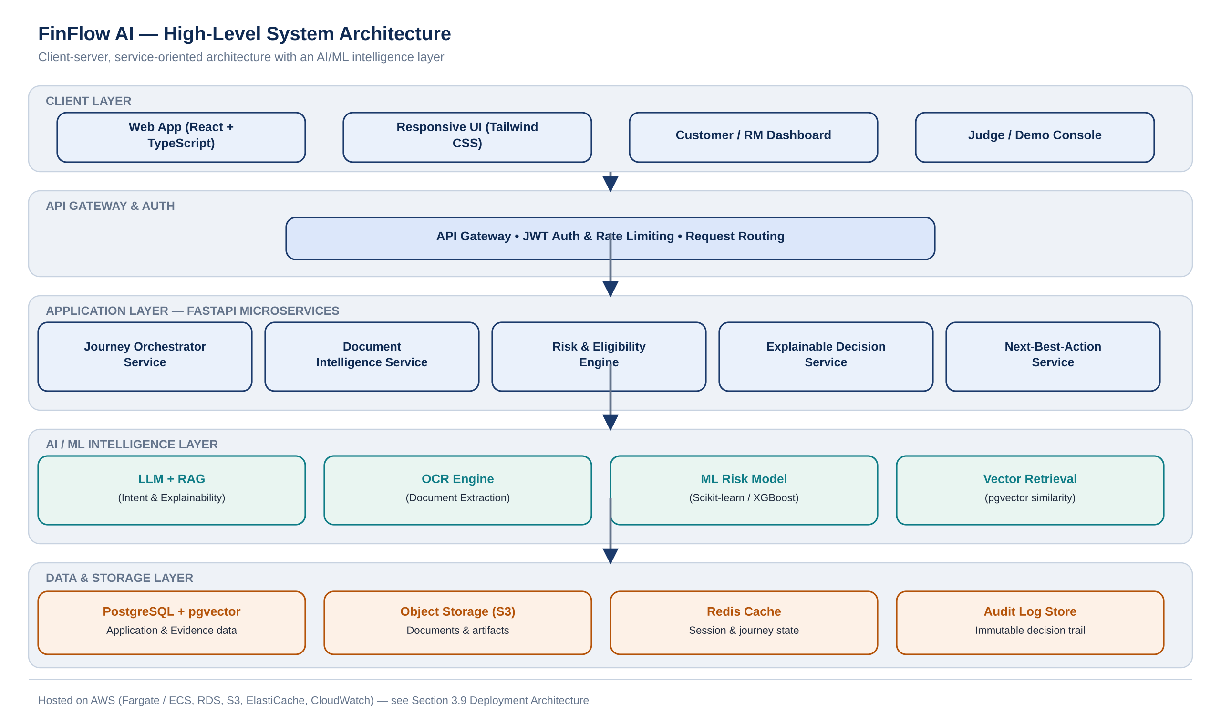
Figure 3.1 — High-Level System Architecture.

Module Responsibilities (Summary)
Each module owns one stage of the Intent → Evidence → Risk → Decision → Action journey and exposes a narrow, well-defined API to the Journey Orchestrator, which is the only module aware of the overall case state.

3.2 Module Breakdown

3.2.1 Journey Orchestrator Service
- Purpose: Owns the Journey Graph — the authoritative state machine for every case — and coordinates calls to all other services.
- Inputs: Customer intent payload, service responses from Document Intelligence, Risk Engine, Decision Engine, and Next-Best-Action Service.
- Outputs: Current journey state, stage transitions, and the aggregated response returned to the client.
- Responsibilities: Initialize new journeys; validate stage transitions; persist journey state; expose journey status to the client and to the relationship-manager dashboard.

3.2.2 Document Intelligence Service
- Purpose: Extracts and validates structured data from uploaded financial documents.
- Inputs: Uploaded document files (PDF/image) and an expected document-type hint.
- Outputs: Structured field-value pairs with confidence scores, written to the Evidence Ledger.
- Responsibilities: Run OCR extraction; validate extracted fields against expected formats; flag missing or inconsistent fields for review.

3.2.3 Risk & Eligibility Engine
- Purpose: Determines the eligibility outcome and risk band for an application.
- Inputs: Verified evidence from the Evidence Ledger, applicant-declared data, and configured product eligibility rules.
- Outputs: Risk score, risk band, and a preliminary eligibility outcome.
- Responsibilities: Apply deterministic business rules; run the ML risk model; combine both into a single, reproducible outcome.

3.2.4 Explainable Decision Engine
- Purpose: Converts the risk/eligibility outcome into a plain-language, policy-grounded explanation.
- Inputs: Risk & eligibility outcome, relevant policy clauses, and the specific evidence that drove the outcome.
- Outputs: Human-readable decision reasoning, stored alongside the decision record.
- Responsibilities: Retrieve relevant policy/evidence context (RAG); generate a reasoning narrative; ensure every explanation is traceable to specific inputs.

3.2.5 Next-Best-Action Service
- Purpose: Recommends the single most useful next step for the customer or officer at any point in the journey.
- Inputs: Current journey state, decision outcome, and outstanding requirements.
- Outputs: A ranked list of recommended actions, with the top action surfaced as the primary call-to-action.
- Responsibilities: Evaluate journey state against a rules-based action catalogue; rank candidate actions by priority and impact.

3.3 Functional Requirements

Module: Journey Orchestrator
Req ID | Description | Input | Processing | Output | Business Rule
FR-JO-01 | Initialize a new customer journey | Customer intent + requested amount | Validate payload; create Journey and Application records | Journey ID + initial stage | A journey cannot be created without a minimum viable intent payload.
FR-JO-02 | Advance journey to next stage | Current stage + stage-completion signal | Validate transition against allowed state machine paths | Updated journey stage | Stage transitions must follow the defined Intent→Evidence→Risk→Decision→Action order.

Module: Document Intelligence
Req ID | Description | Input | Processing | Output | Business Rule
FR-DI-01 | Extract structured fields from an uploaded document | Document file + expected type | OCR extraction, field parsing, confidence scoring | Structured evidence record | Fields below a minimum confidence threshold are flagged for manual review.
FR-DI-02 | Detect inconsistent or duplicate documents | New document + existing Evidence Ledger entries | Cross-check extracted values against prior submissions | Consistency flag | Conflicting values on the same field across documents must be flagged, not silently overwritten.

Module: Risk & Eligibility Engine
Req ID | Description | Input | Processing | Output | Business Rule
FR-RE-01 | Compute eligibility outcome | Verified evidence + product rules | Apply deterministic eligibility rules | Eligible / Not Eligible / Needs Review | An application missing mandatory evidence cannot be marked Eligible.
FR-RE-02 | Compute risk score and band | Verified evidence + historical feature set | Run ML risk model (scikit-learn/XGBoost) | Risk score (0–1) + risk band (Low/Medium/High) | Risk band thresholds are configurable per product, not hard-coded.

Module: Explainable Decision Engine
Req ID | Description | Input | Processing | Output | Business Rule
FR-ED-01 | Generate a plain-language decision explanation | Risk/eligibility outcome + relevant evidence + policy text | Retrieval-augmented generation over policy + case evidence | Reasoning text linked to the Decision record | Every explanation must cite at least one specific evidence field or policy clause.

Module: Next-Best-Action Service
Req ID | Description | Input | Processing | Output | Business Rule
FR-NBA-01 | Recommend the next action for a case | Journey state + decision outcome + outstanding requirements | Evaluate action catalogue against current state; rank by priority | Ranked action list, top action highlighted | A journey must never be left without at least one recommended next action.

3.4 Non-Functional Requirements

Performance
- Response time: 95th-percentile API response time under 2 seconds for synchronous endpoints (excluding long-running document processing).
- Throughput: support at least 20 concurrent journey submissions in the MVP demo environment without degradation.
- Concurrent users: architecture supports horizontal scaling beyond the MVP's demo-time concurrency target.

Scalability
- Future growth: modular service boundaries allow each module (Document Intelligence, Risk Engine, etc.) to scale independently.
- Horizontal expansion: stateless FastAPI services behind a load balancer allow additional instances to be added without code changes.

Security
- Authentication: JWT-based authentication for all API endpoints beyond public intent capture.
- Authorization: role-based access control distinguishing Customer, Relationship Manager, and Risk & Compliance roles.
- Password protection: passwords hashed with a strong adaptive algorithm (e.g., bcrypt/argon2); never stored or logged in plain text.
- Encryption: TLS in transit for all API traffic; encryption at rest for stored documents and evidence.
- Input validation: strict schema validation on all API inputs using Pydantic models.
- Session handling: short-lived access tokens with refresh-token rotation.

Reliability
- Error handling: consistent, structured error responses across all services, with no unhandled exceptions surfaced to the client.
- Recovery: idempotent document-upload and journey-update endpoints so retried requests do not corrupt state.
- Fault tolerance: a failure in one module (e.g., LLM API timeout) degrades gracefully rather than blocking the entire journey.

Availability
The MVP targets demo-time availability suitable for a live hackathon walkthrough; the production-oriented deployment design (Section 3.9) targets a realistic 99.5% uptime objective with managed, auto-recovering cloud infrastructure.

3.5 External Interfaces

UI Constraints
The client is a responsive, mobile-first single-page application built with React, TypeScript, and Tailwind CSS, communicating exclusively through the versioned REST API described below — no direct database or model access from the client.

REST APIs — Sample Endpoints
Method | Endpoint | Purpose
POST | /api/v1/auth/login | Authenticate a user and issue a JWT access token.
POST | /api/v1/journeys | Create a new journey from a customer intent payload.
GET | /api/v1/journeys/{id} | Fetch the current status and stage of a journey.
POST | /api/v1/journeys/{id}/documents | Upload a document for evidence extraction.
GET | /api/v1/journeys/{id}/risk | Fetch the current risk and eligibility assessment.
GET | /api/v1/journeys/{id}/decision | Fetch the explainable decision for the journey.
GET | /api/v1/journeys/{id}/next-action | Fetch the current recommended next best action.
GET | /api/v1/dashboard | Fetch relationship-manager dashboard case queue.

Third-Party Integrations & Protocols
- LLM provider API (HTTPS/JSON) for intent understanding and explanation generation, using a retrieval-augmented prompt built from case evidence and policy context.
- OCR / Document AI service (HTTPS/JSON or SDK) for structured field extraction from uploaded documents.
- All internal and external communication uses HTTPS with JSON payloads; internal service-to-service calls follow the same REST contracts for consistency.

Sample Request — Create Journey
POST /api/v1/journeys
Authorization: Bearer <jwt_token>
Content-Type: application/json

{
"product_type": "sme_working_capital",
"requested_amount": 500000,
"intent_summary": "Need working capital to fulfil a bulk textile order",
"applicant": { "user_id": "b3f1...", "business_name": "Sharma Textiles" }
}

Sample Response
201 Created
Content-Type: application/json

{
"journey_id": "8f2c9e40-...",
"stage": "EVIDENCE_COLLECTION",
"status": "ACTIVE",
"next_action": {
"type": "UPLOAD_DOCUMENT",
"message": "Upload your last 6 months of bank statements to continue."
}
}

3.6 Database Design
The MVP uses PostgreSQL with the pgvector extension, enabling both structured relational storage for journeys and evidence, and vector similarity search for retrieval-augmented explanation generation from policy documents.

Core Entities, Keys & Constraints
Entity | Primary Key | Key Foreign Keys | Notable Constraints
User | user_id | — | email UNIQUE; role IN (customer, rm, risk_officer)
Application | application_id | user_id → User | requested_amount > 0; status IN defined enum set
Document | document_id | application_id → Application | ocr_status IN (pending, verified, flagged)
EvidenceItem | evidence_id | document_id → Document | confidence BETWEEN 0 AND 1
RiskAssessment | risk_id | application_id → Application | one-to-one with Application; risk_score BETWEEN 0 AND 1
Decision | decision_id | application_id → Application | one-to-one with RiskAssessment/Application
NextBestAction | action_id | application_id → Application | priority ≥ 1
JourneyStep | step_id | application_id → Application | stage IN defined journey-stage enum
AuditLog | audit_id | application_id → Application | append-only; no UPDATE/DELETE permitted at the application layer

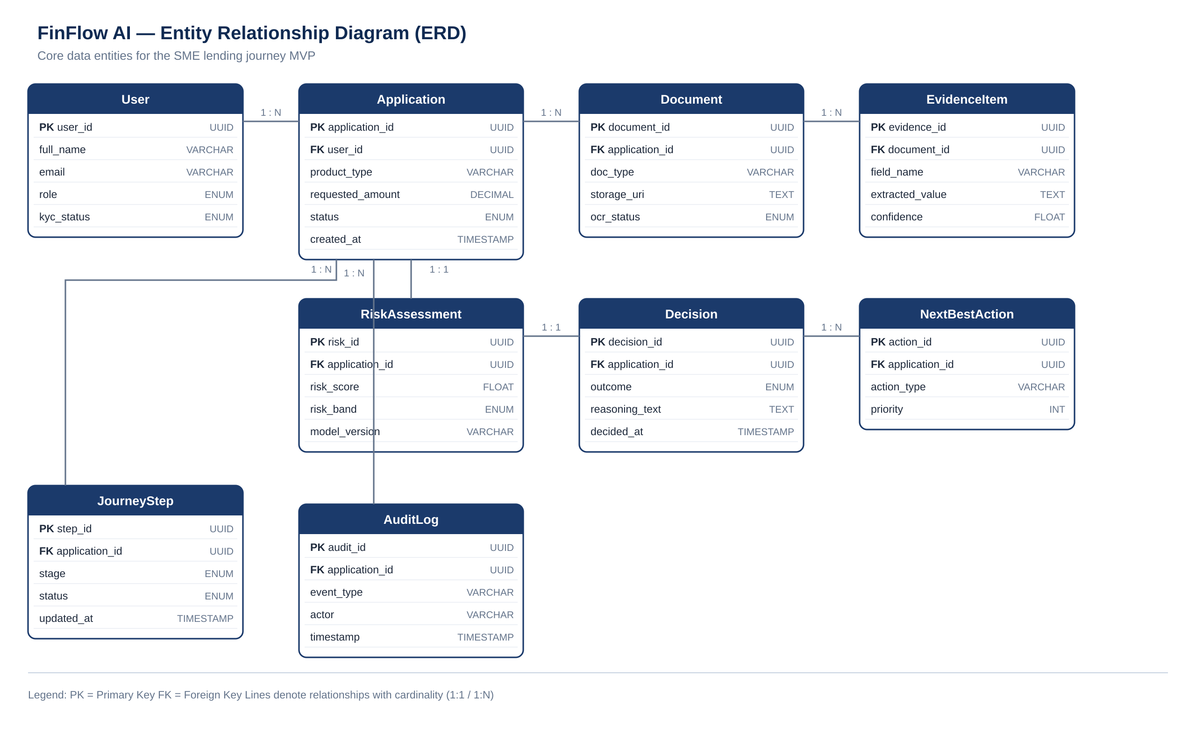
Figure 3.2 — Entity Relationship Diagram (ERD).

3.7 Data Flow
The system context and first-level decomposition are shown below, illustrating how information moves between external entities, FinFlow AI's processing modules, and its data stores.
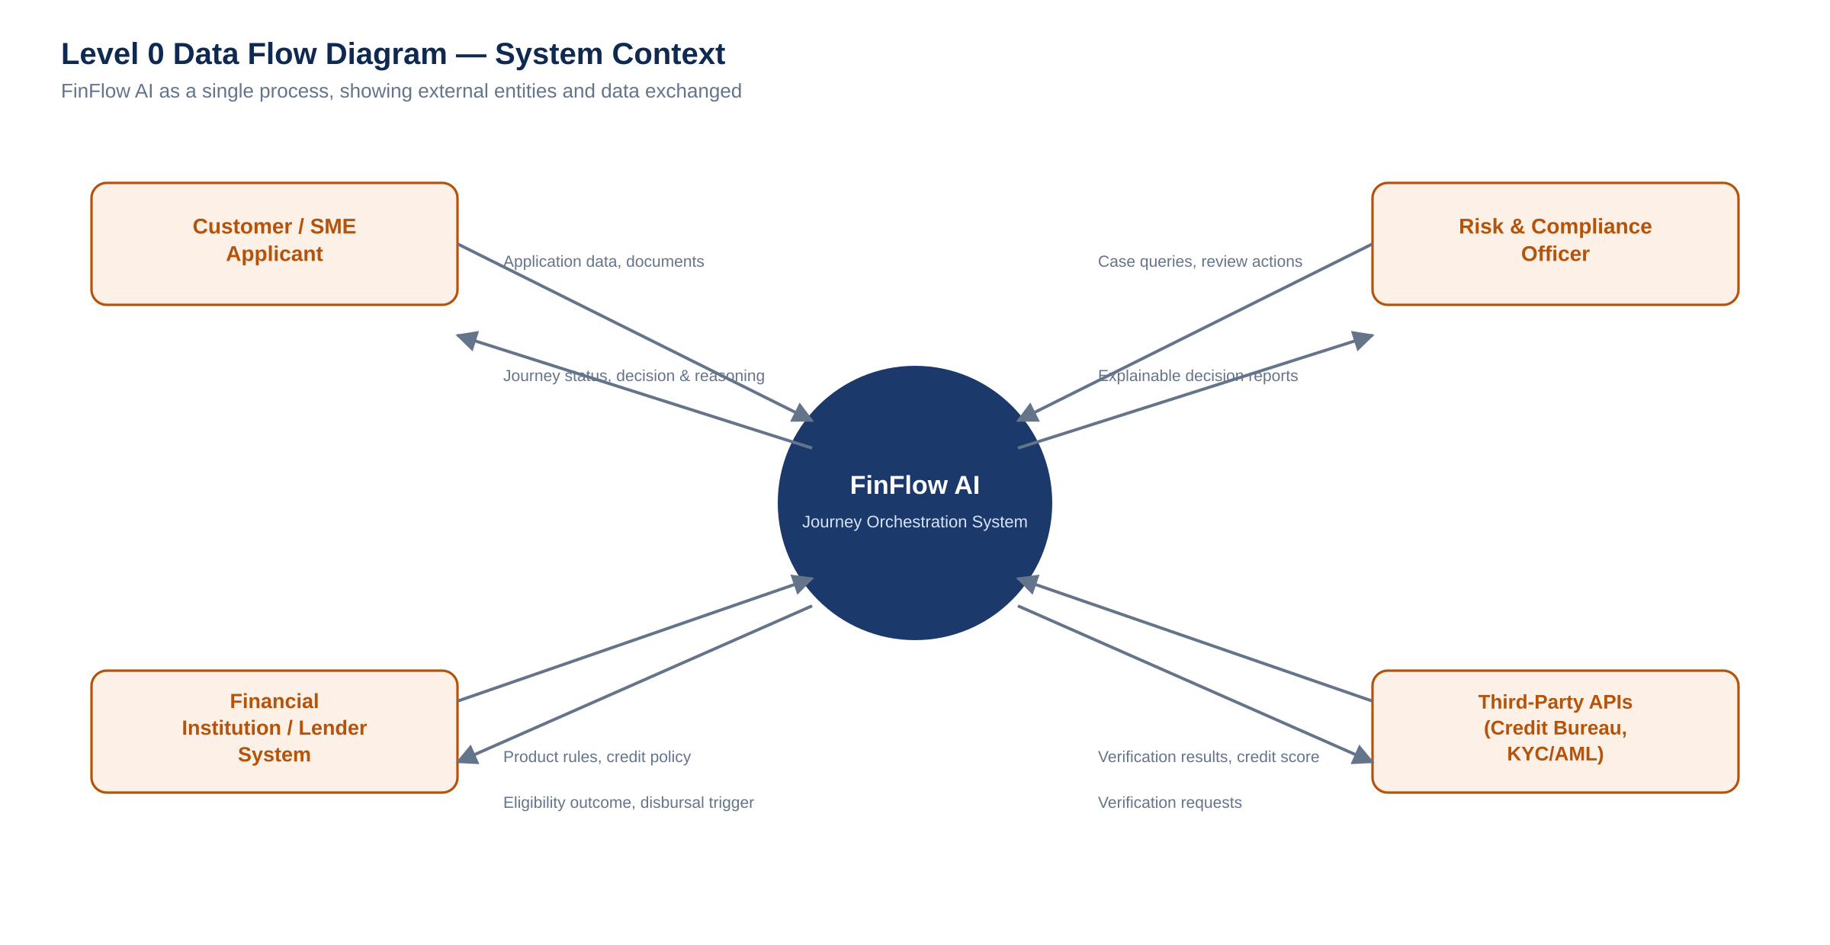
Figure 3.3 — Level 0 Data Flow Diagram (System Context).
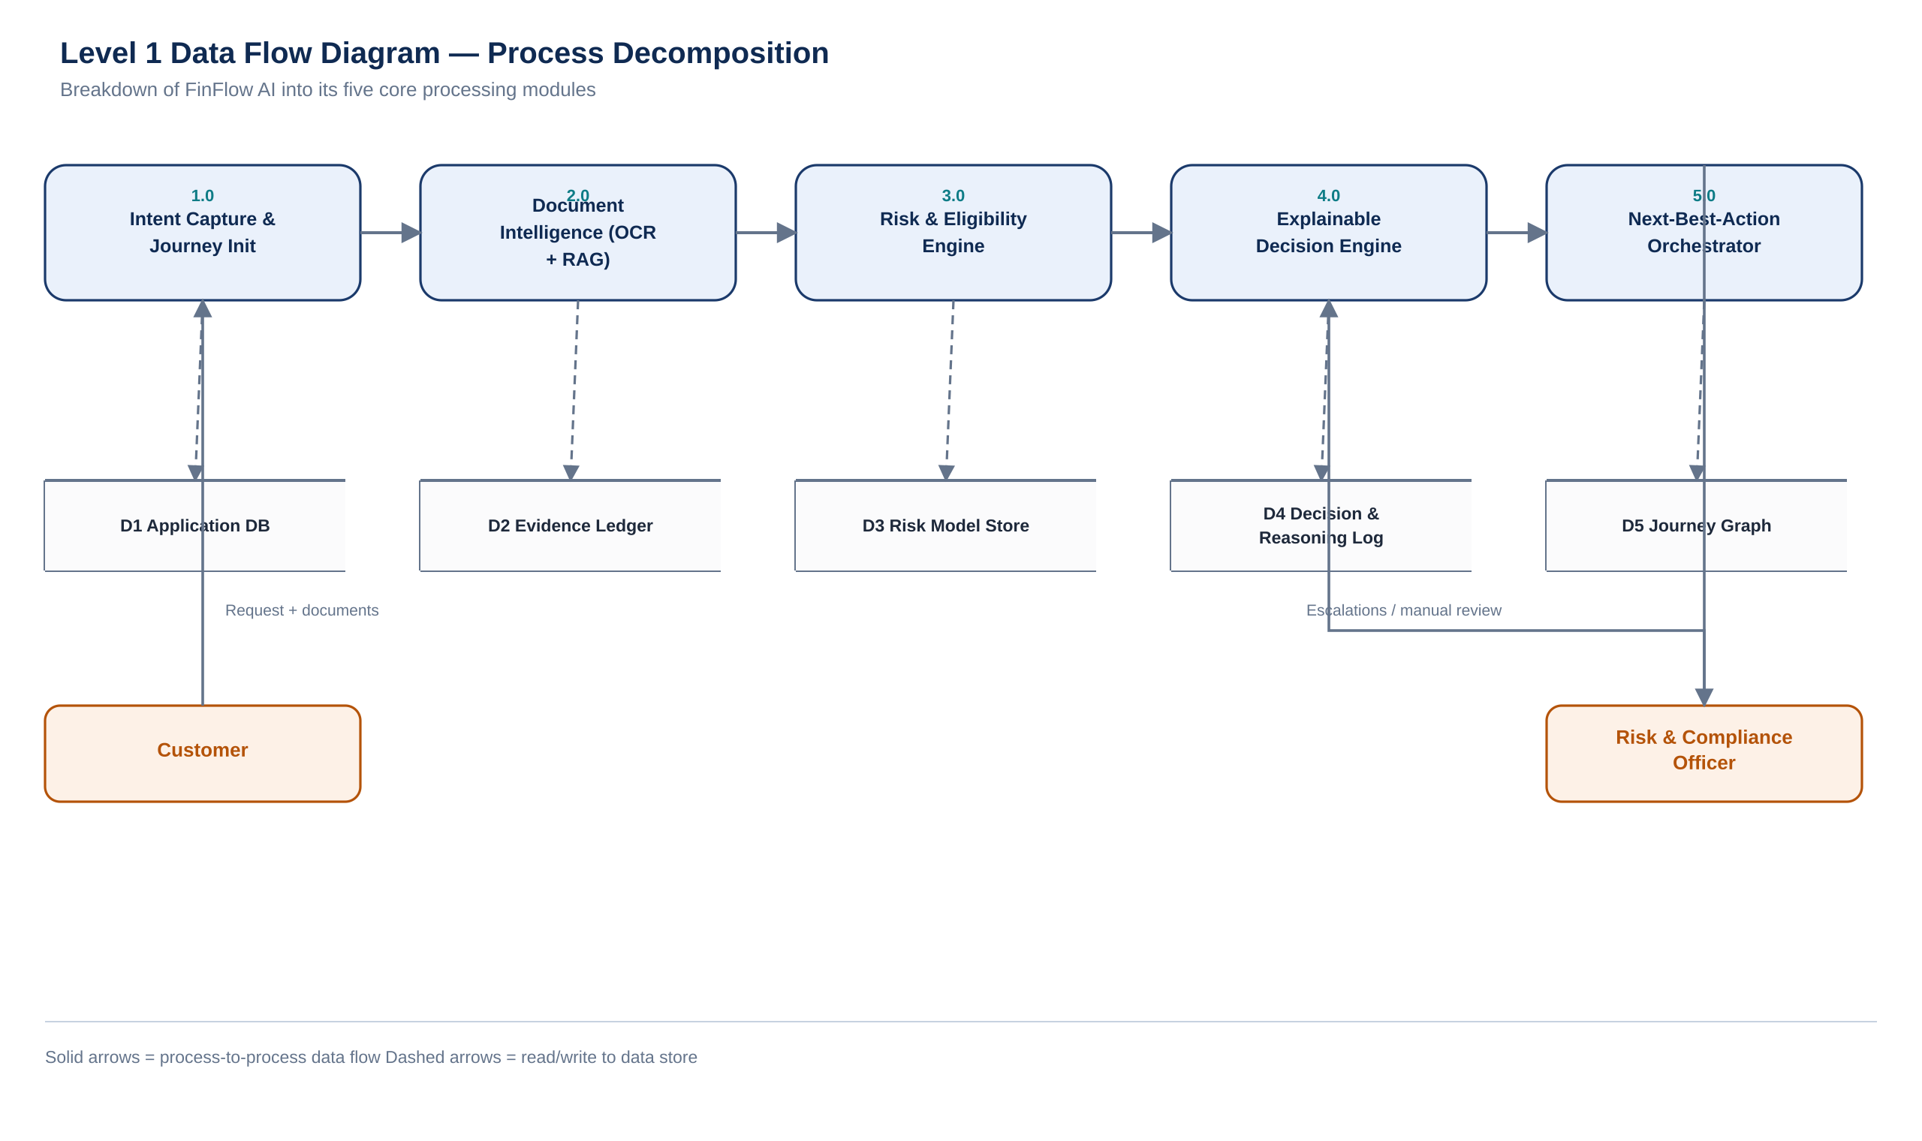
Figure 3.4 — Level 1 Data Flow Diagram (Process Decomposition).

3.8 Algorithms & Core Logic

Decision-Making / AI Workflow (Processing Pipeline)
The core processing pipeline combines deterministic business rules with a trained ML risk model, and only then hands the combined outcome to the explanation layer — ensuring the explanation always describes the actual decision logic rather than a separate, disconnected narrative.
FUNCTION process_application(application):
evidence = evidence_ledger.get(application.id)

# 1. Deterministic eligibility rules
rule_result = eligibility_rules.evaluate(application, evidence)
IF rule_result == HARD_FAIL:
RETURN Decision(outcome="NOT_ELIGIBLE", reason=rule_result.reason)

# 2. ML risk scoring
features = build_feature_vector(application, evidence)
risk_score = risk_model.predict_proba(features)
risk_band = band_from_score(risk_score)

# 3. Combine rule outcome + risk band into final decision
outcome = decision_matrix(rule_result, risk_band)

# 4. Explainable reasoning (RAG over policy + evidence)
context = retrieve_context(application, evidence, policy_store)
reasoning = llm.generate_explanation(outcome, context)

RETURN Decision(outcome=outcome, risk_band=risk_band, reasoning=reasoning)

Scoring Mechanism (Summary)
- Rule layer applies hard eligibility gates (e.g., minimum business vintage, mandatory KYC completeness) before any ML scoring occurs.
- ML layer (XGBoost) scores creditworthiness on financial-ratio and document-derived features, producing a probability that is mapped to Low/Medium/High risk bands using configurable, product-specific thresholds.
- Final decision matrix combines the rule outcome and risk band, so a low-risk score can never override a hard rule failure.

3.9 Deployment Architecture
The MVP is designed for a realistic AWS deployment: a static React client served through CloudFront/S3, a FastAPI backend running on ECS Fargate behind an Application Load Balancer, PostgreSQL with pgvector on RDS, document storage on S3, and Redis via ElastiCache for session and journey-state caching.
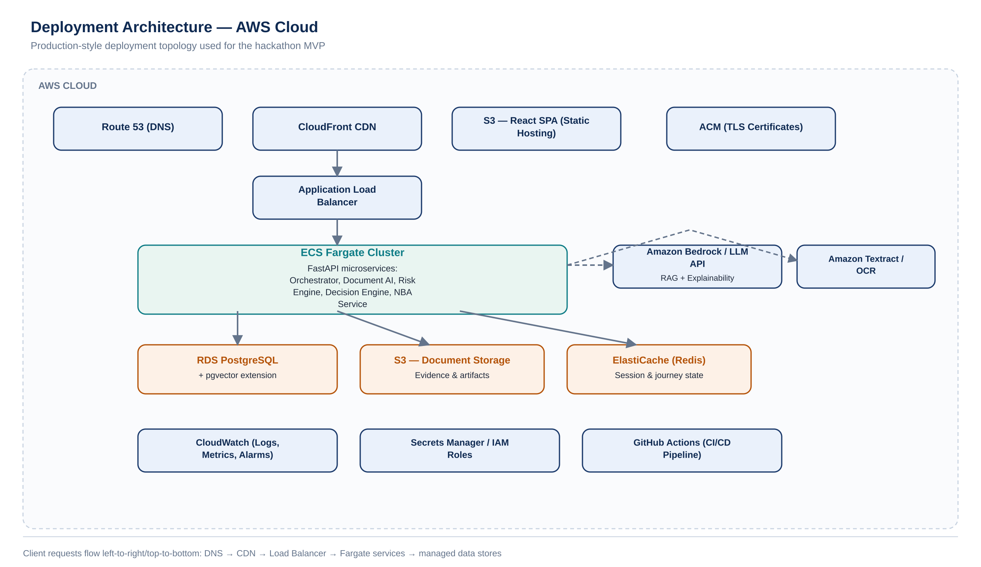
Figure 3.5 — Deployment Architecture (AWS Cloud).

3.10 Testing Strategy
- Unit Testing: pytest coverage for eligibility rules, risk-band mapping, and API request/response schemas.
- Integration Testing: verify Journey Orchestrator correctly sequences calls across Document Intelligence, Risk Engine, Decision Engine, and Next-Best-Action Service.
- System Testing: full end-to-end journey run against a seeded synthetic dataset, from intent capture to next-action recommendation.
- API Testing: contract tests against the OpenAPI schema for every endpoint listed in Section 3.5.
- User Acceptance Testing: scripted walkthroughs with the three personas from Section 2.3 to validate the journey feels guided and explainable.

Sample Test Cases
Test ID | Scenario | Expected Result
TC-01 | Submit journey with all mandatory evidence and strong financials | Outcome = ELIGIBLE; risk band = Low; explanation cites specific evidence fields.
TC-02 | Submit journey missing a mandatory KYC document | Outcome = NEEDS_REVIEW; next action = "Upload missing KYC document."
TC-03 | Upload two documents with conflicting declared revenue | System flags inconsistency; case routed to Risk & Compliance queue.
TC-04 | Call /journeys/{id}/decision before risk assessment is complete | API returns 409 Conflict with a clear "assessment not yet complete" message.
TC-05 | Simulate LLM API timeout during explanation generation | System falls back to a rule-derived structured explanation instead of failing the request.

Section 4 — Implementation Plan (24–48 Hour Roadmap)
The plan below is deliberately front-loaded on planning and back-end foundations, since a working, explainable decision pipeline is the single most important thing to have live before the demo — the UI and polish are layered on once that pipeline runs end-to-end.

4.1 Phase-wise Timeline
Phase | Duration | Deliverable
Planning | 2 hrs | Finalized scope: one SME lending journey, locked API contracts between modules, seeded synthetic dataset.
UI Design | 4 hrs | Wireframes for intake, upload, verification, decision, and journey-tracker screens.
Backend | 10 hrs | FastAPI services for Journey Orchestrator, Document Intelligence, Risk Engine, Decision Engine, Next-Best-Action, with database schema live.
Frontend | 10 hrs | React/TypeScript client implementing the full screen flow (Section 2.8), connected to live APIs.
Integration | 6 hrs | End-to-end journey run from intent capture through explained decision and next action, using real service calls.
Testing | 4 hrs | Execute sample test cases (Section 3.10); fix critical-path bugs; validate demo dataset.
Demo Prep | 2 hrs | Rehearse the Demo Flow (Section 2.14); prepare fallback/offline mode; finalize presentation.
Total: 38 hours of listed effort executed in parallel across a 2-person team within the 24–48 hour window, with Backend and Frontend developed concurrently once API contracts are locked in Planning.

Section 5 — Future Roadmap

5.1 Version 1 — Immediate Post-Hackathon Improvements
- Replace synthetic dataset with a sandboxed integration to a real credit-bureau API for live risk signals.
- Add relationship-manager review workflow with manual override and reason capture, feeding back into model retraining.
- Expand document coverage (GST returns, bank statements, ITRs) with product-specific validation rules.
- Add multi-language support for intent capture to widen accessibility for SME owners across regions.

5.2 Version 2 — Advanced Features
- Extend the orchestration engine to a second financial journey (e.g., insurance claims) to validate domain-agnostic design.
- Introduce active-learning feedback loops so risk-officer overrides continuously improve the ML risk model.
- Add proactive fraud-signal detection across the Evidence Ledger, correlating patterns across applications rather than within a single case.
- Introduce a configurable policy-authoring interface so compliance teams can update eligibility rules without code changes.

5.3 Long-Term Vision
The long-term vision is a scalable, multi-tenant financial journey ecosystem: a single orchestration core — Journey Graph, Evidence Ledger, and Explainable Decision Engine — that banks, NBFCs, and fintechs can configure for lending, claims, retail credit, or insurance underwriting, each journey inheriting the same guarantees of explainability, auditability, and proactive guidance that FinFlow AI demonstrates in this MVP.

Section 6 — Conclusion
CLOSING STATEMENT
FinFlow AI doesn't just automate finance — it orchestrates trusted, explainable financial journeys from intent to action.

Why This Solution Matters
Finance has digitized its transactions but not its journeys. FinFlow AI directly closes that gap by unifying intent capture, evidence verification, risk assessment, decision explanation, and next-step guidance into one coherent system — addressing the friction customers feel, the operational load institutions carry, and the explainability gap regulators and risk teams increasingly demand.

Why It Is Feasible
The MVP is intentionally scoped to a single, well-understood journey — SME lending — built on proven, production-grade technologies (FastAPI, PostgreSQL with pgvector, scikit-learn/XGBoost, an LLM with retrieval-augmented generation) and a modular service architecture that lets two developers build, test, and integrate five cooperating services within a 24-hour window without sacrificing implementation quality.

How the MVP Demonstrates Real-World Potential
By the end of the hackathon, FinFlow AI will show a real applicant journey — not a mockup — moving from a plain-language financing request through AI-verified evidence, a hybrid rules-and-ML risk assessment, a plain-language explanation grounded in that evidence, and a concrete recommended next step, with every stage logged to an auditable Journey Graph and Evidence Ledger.

The Long-Term Vision Beyond the Hackathon
Beyond the hackathon, the same orchestration core is designed to extend across financial products and institutions, becoming the trusted intelligence layer that turns any fragmented financial process into one guided, explainable, and auditable journey — for customers, for institutions, and for the regulators who oversee them.

