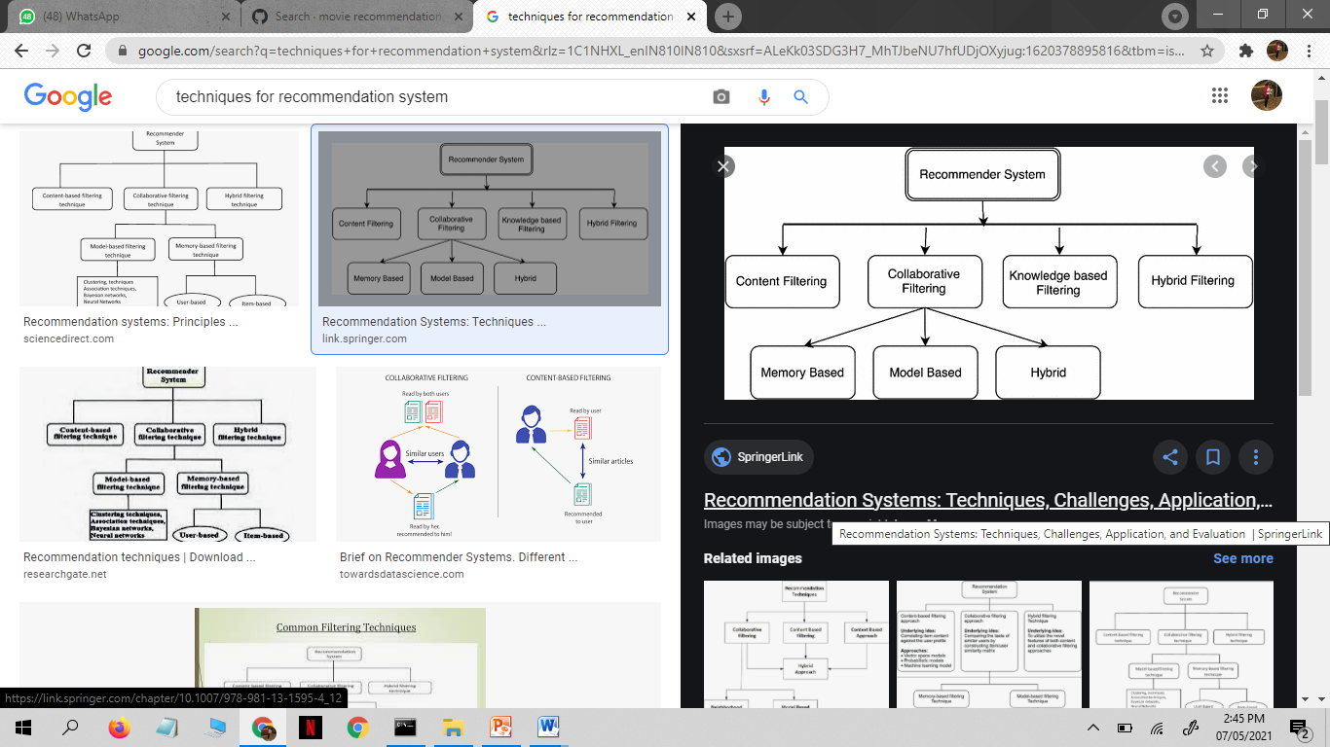

Recommender systems open new opportunities of retrieving personalized information on the Internet.

It also helps to alleviate the problem of information overload which is a very common phenomenon with information retrieval systems and enables users to have access to products and services which are not readily available to users on the system.

This strategy helps in improving accuracy of the recommendations. It also helps in collecting authentic data with improved accuracy and makes the system more responsive.