Assignment No.1

Title: Implementation of Tokenization, Stemming, and Lemmatization on a Small Text Corpus

Aim: To implement Tokenization, Stemming, and Lemmatization techniques on a small corpus of text using Python.

Objectives:
- To understand the concept of text preprocessing in Natural Language Processing (NLP).
- To implement tokenization on a given text corpus.
- To apply stemming techniques to reduce words to their root form.
- To apply lemmatization to obtain meaningful base forms of words.
- To compare stemming and lemmatization results.
Expected Outcomes:
- Successful tokenization of a given text corpus into words.
- Correct implementation of stemming using appropriate algorithms.
- Correct implementation of lemmatization using lexical knowledge.
- Clear understanding of differences between stemming and lemmatization.
- Improved knowledge of basic NLP preprocessing techniques.
Theory
1. Introduction to Natural Language Processing (NLP)
Natural Language Processing (NLP) is a field of Artificial Intelligence that enables computers to understand, interpret, and process human language.
NLP is widely used in:
- Chatbots
- Sentiment analysis
- Machine translation
- Text classification
- Search engines
Before performing advanced NLP tasks, text must be preprocessed.
2. Text Preprocessing
Text preprocessing is the process of cleaning and preparing raw text data for analysis.
It includes:
- Tokenization
- Stemming
- Lemmatization
- Removing stopwords
- Lowercasing
These steps help improve model performance and accuracy.

3. Tokenization
Tokenization is the process of breaking text into smaller units called tokens.
Tokens can be:
- Words
- Sentences
- Characters
Example:
Input Text:
"I am learning Natural Language Processing."
Word Tokens:
I, am, learning, Natural, Language, Processing
Tokenization is the first step in most NLP tasks.
4. Stemming
Stemming reduces a word to its root or base form by removing suffixes.
It may not always produce meaningful words.
Example:
- playing → play
- studies → studi
- running → run
Stemming is faster but less accurate.
Common stemming algorithms:
- Porter Stemmer
- Snowball Stemmer
5. Lemmatization
Lemmatization reduces a word to its meaningful base form (lemma) using vocabulary and morphological analysis.
It returns valid dictionary words.
Example:
- running → run
- better → good
- studies → study
Lemmatization is slower than stemming but more accurate.

6. Difference Between Stemming and Lemmatization
Stemming and lemmatization are both text normalization techniques used in Natural Language Processing, but they differ in accuracy and approach. Stemming simply removes suffixes from words to produce a root form, and the output may not always be a meaningful word; for example, “studies” becomes “studi.” It is faster and computationally efficient but less accurate. In contrast, lemmatization uses vocabulary knowledge and linguistic rules to convert words into their correct dictionary base form, ensuring meaningful results; for example, “studies” becomes “study.” Although lemmatization is slower than stemming, it is more accurate and produces linguistically correct outputs.
Pseudocode:
START
INPUT:
Small text corpus
STEP 1: Import Required Libraries
Import NLTK library
Download necessary datasets (punkt, wordnet)
STEP 2: Preprocess Text
Convert text to lowercase
STEP 3: Perform Tokenization
Split text into word tokens
STEP 4: Perform Stemming
Initialize Porter Stemmer
Apply stemming to each token
Store stemmed words
STEP 5: Perform Lemmatization
Initialize WordNet Lemmatizer
Apply lemmatization to each token
Store lemmatized words
OUTPUT:
Original Tokens
Stemmed Words
Lemmatized Words
END

Algorithm
- Start the program.
- Input the text corpus.
- Convert the text into lowercase.
- Tokenize the text into words.
- Apply stemming to each word.
- Apply lemmatization to each word.
- Display the results.
- Stop the program.

Algorithm:
- Start the program.
- Input the text corpus.
- Convert the text into lowercase.
- Tokenize the text into words.
- Apply stemming to each word.
- Apply lemmatization to each word.
- Display the results.
- Stop the program.
Results:
- Tokenization:
Covert corpus in sentences using sent_tokenize()
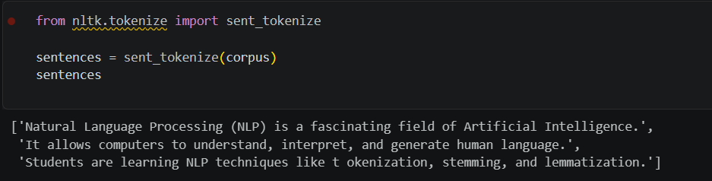
Getting word tokens from corpus
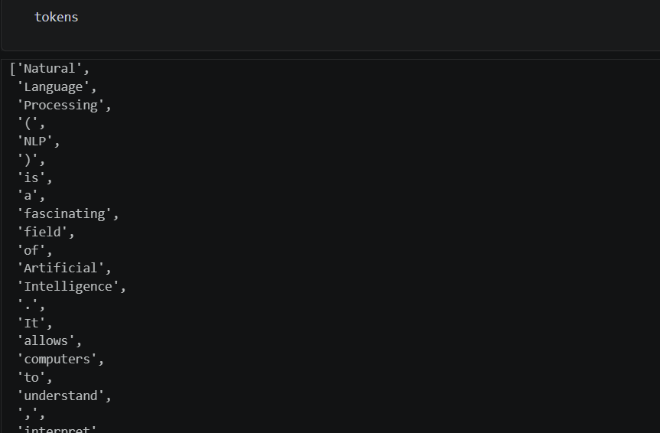
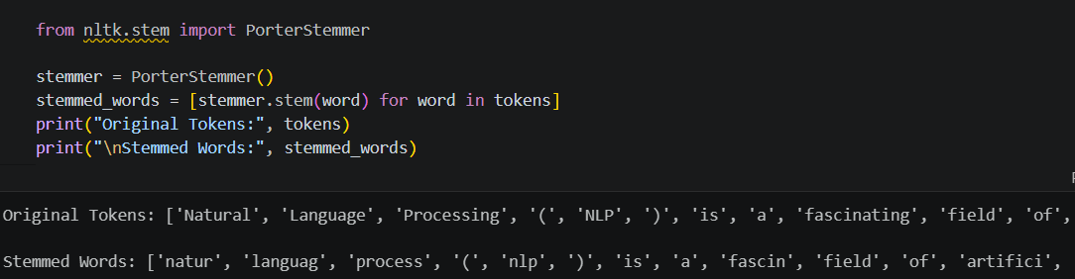
- Stemming

- Lemmatization

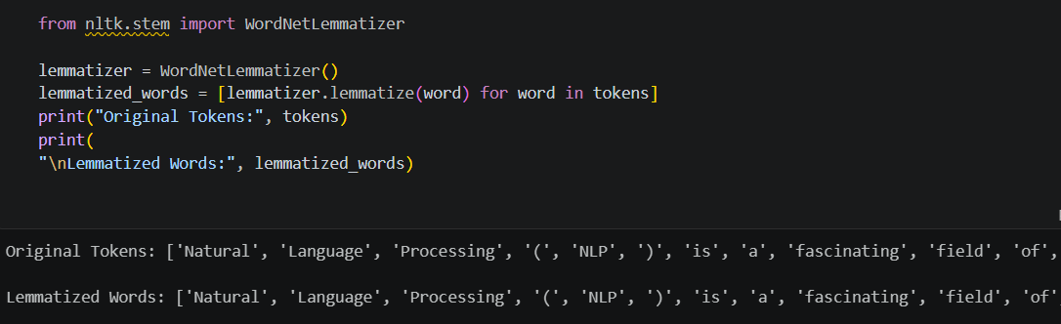
- Stop word Removal

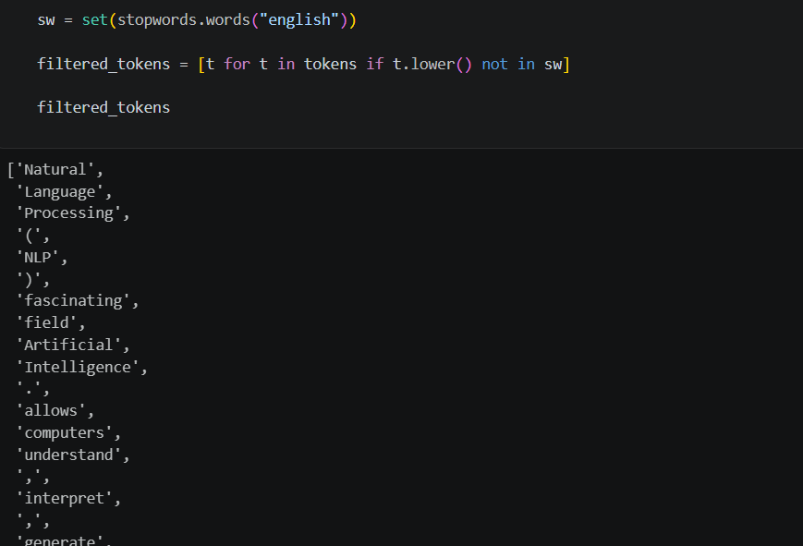
Tokens after removing stop words

Conclusion
Tokenization, stemming, and lemmatization are essential preprocessing steps in Natural Language Processing. Tokenization breaks text into meaningful units, stemming reduces words to root forms, and lemmatization converts words into their meaningful base forms. Among the two normalization techniques, lemmatization provides more accurate results, while stemming is computationally faster. These techniques form the foundation for advanced NLP applications such as text classification, sentiment analysis, and language modeling.

