Assignment No:- 11
Title: Implementation of NLP technique to extract noun phrases from a paragraph
Problem Statement:
Apply any NLP technique to extract noun phrases from a paragraph and explain the logic.
Objective:
- To understand the concept of Natural Language Processing (NLP).
- To study Part-of-Speech (POS) tagging and syntactic parsing.
- To implement noun phrase extraction using chunking techniques.
- To analyze grammatical structures for identifying meaningful phrases.
- To compare rule-based NLP techniques with traditional text processing methods.
Outcomes:
- Understand how POS tagging helps in grammatical analysis.
- Gain practical experience in noun phrase extraction using NLP libraries.
- Implement chunking using grammar rules.
- Build a system that extracts meaningful noun phrases from text.
- Analyze syntactic structure of sentences.
Theory
1. Natural Language Processing (NLP)
Natural Language Processing (NLP) is a branch of Artificial Intelligence that enables computers to understand, interpret, and generate human language.
One of the fundamental tasks in NLP is Noun Phrase (NP) Extraction.
What is a Noun Phrase?
A noun phrase is a group of words centered around a noun that acts as a subject, object, or complement in a sentence.
Examples:
- "The smart student"
- "A powerful machine learning model"
- "Natural language processing techniques"

2. Technique Used: POS Tagging + Chunking
To extract noun phrases, we use:
Step 1: Tokenization
Split paragraph into sentences and words.
Step 2: Part-of-Speech (POS) Tagging
Assign grammatical tags to each word.
Example:
The/DT smart/JJ student/NN solved/VBD the/DT problem/NN
Where:
- DT = Determiner
- JJ = Adjective
- NN = Noun
- VBD = Verb
Step 3: Chunking (Shallow Parsing)
Chunking groups words into meaningful phrases using grammar rules.
Grammar Rule for Noun Phrase:
NP: {<DT>?<JJ>*<NN.*>+}
Meaning:
- Optional Determiner (DT)
- Zero or more Adjectives (JJ)
- One or more Nouns (NN, NNS, NNP, NNPS)
Mathematical Representation
Let a sentence be:
$$S=w_{1},w_{2},w_{3},...,w_{n}$$
Where each word has a POS tag:
$$T=t_{1},t_{2},t_{3},...,t_{n}$$
A noun phrase is extracted when the tag sequence satisfies:
$$DT?+JJ*+NN+$$

Pseudocode
Algorithm NounPhraseExtraction
Input : Paragraph P
Output : List of Noun Phrases (NP_List)
Begin
Step 1: Initialize NP_List as an empty list.
Step 2: Divide the paragraph P into individual sentences.
Sentences ← SentenceTokenize(P)
Step 3: For each sentence S in Sentences do
Step 4: Split sentence S into words.
Words ← WordTokenize(S)
Step 5: Assign Part-of-Speech tags to each word.
TaggedWords ← POSTag(Words)
Step 6: Define noun phrase grammar pattern:
NP → (DT)? (JJ)* (NN|NNS|NNP|NNPS)+
Step 7: Apply chunk parsing on TaggedWords using the defined grammar.
ParseTree ← ChunkParse(TaggedWords)
Step 8: Identify all subtrees labeled as "NP".
Step 9: Extract words from each NP subtree and
append them to NP_List.
Step 10: End For
Step 11: Return NP_List.
End

Example
Input Paragraph:
"Natural language processing techniques are widely used in artificial intelligence applications. The intelligent system extracts meaningful information from large datasets."
Extracted Noun Phrases:
- Natural language processing techniques
- artificial intelligence applications
- The intelligent system
- meaningful information
- large datasets

Method | Context Awareness | Accuracy | Limitation
Regex Matching | No | Low | Cannot understand grammar
POS Tagging Only | Partial | Medium | No phrase grouping
POS + Chunking | Yes | High | Rule-based limitations

Result:
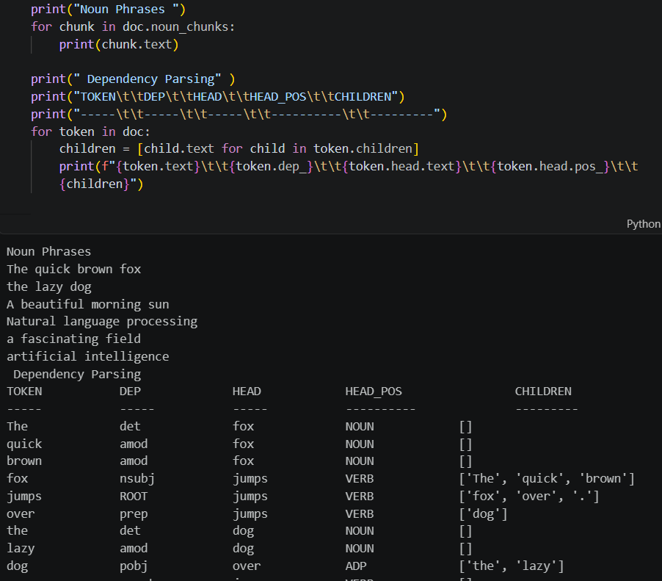
Conclusion
Noun phrase extraction is an important NLP task used in information retrieval, summarization, question answering, and knowledge extraction.
By using POS tagging and chunking techniques, we can effectively identify meaningful noun phrases from text. This approach is simple, efficient, and suitable for real-time applications, although it may not handle highly complex sentence structures.

