Assignment No.2
Aim
Develop a Python script to perform part-of-speech tagging on a short text dataset.
Objective
- To understand the concept of Part-of-Speech (POS) tagging in Natural Language Processing.
- To preprocess text data by cleaning, tokenizing.
- To implement POS Tagging using Python libraries such as NLTK and SpaCy.
- To evaluate tagging results on a sample dataset.
Expected Outcomes
- Successful preprocessing of the input data includes tokenization and Normalization
- Identification of Part-of-Speech and mapping of each word to its corresponding POS Tag (Noun , Verb , Adjective etc.).
- Working Implementation of POS Tagging.
- Better understanding of syntactic analysis in NLP
Theory
1.Introduction to Part-of-Speech Tagging
Part-of-Speech (POS) tagging is a fundamental task in Natural Language Processing (NLP) that involves assigning a grammatical category (tag) to each word in a sentence. These grammatical categories include noun, verb, adjective, adverb, pronoun, conjunction, etc.
Example : “The quick brown fox jumps over the lazy dog.”
Tagged Output:
- The → Determiner (DT)
- quick → Adjective (JJ)
- brown → Adjective (JJ)
- fox → Noun (NN)
- jumps → Verb (VBZ)
- over → Preposition (IN)
- the → Determiner (DT)
- lazy → Adjective (JJ)
- dog → Noun (NN)
Thus, POS tagging helps in identifying the syntactic structure of a sentence.

2. Parts of Speech and their Tags
Few common POS tags include:
Tag | Meaning
NN | Noun
VB | Verb
JJ | Adjective
RB | Adverb
PRP | Pronoun
DT | Determiner
IN | Preposition
CC | Conjunction

3. Why is POS Tagging Necessary?
English language has many homographs (i.e words with same spelling but different meaning) where the meaning of the word and grammatical role depends on the context.
Example: Word - “Book”
- book ( Noun) - I read a book.
- book (Verb) - I will book a ticket.
This generates ambiguity in the understanding of language. This is known as Lexical Ambiguity. POS tagging helps to resolve lexical ambiguity using context.
4. Types of POS Tagging Approaches
- Rule-Based POS Tagging
Rule based tagging uses hand-written grammatical rules. It applies rules based on word suffixes or surrounding words.
Example : If a word ends with “-ing”, it is likely a verb (VBG).
Advantages:
- Easy to understand
- No training data required
Disadvantages:
- Requires many complex rules
- Not scalable

- Statistical (Probabilistic) POS Tagging
Uses probability models trained on annotated corpora.
Common models:
- Hidden Markov Model (HMM)
- Maximum Entropy Model
It calculates:
P(tag∣previoustag)
Advantages:
- More accurate than rule-based
- Learns from real data
5. Pseudocode
START
INPUT: Text sentence or short text dataset

STEP 1: Import Required Libraries
Import nltk
Import word_tokenize from nltk.tokenize
Import pos_tag from nltk

STEP 2: Download Required Resources (only once)
Download‘punkt' tokenizer
Download‘averaged_perceptron_tagger'

STEP 3: Read Input Text
Store input sentence in a variable

STEP 4: Text Preprocessing
1. Convert text to lowercase
2. Remove unwanted characters
3. Tokenize text using word_tokenize()
4. Store tokens in a list

STEP 5: Apply POS Tagging
Call pos_tag() function on token list
Store output as (word, tag) pairs

STEP 6: Display Results
For each (word, tag) pair:
Print word and its POS tag
OUTPUT:
Word → POS Tag mapping
END

Results
POS Tagging for the small dataset
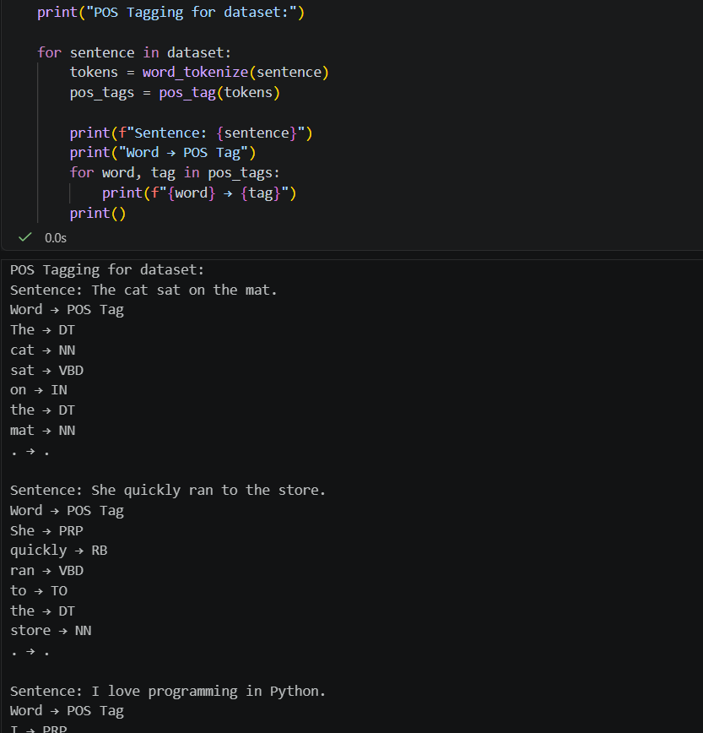

Conclusion
Part-of-Speech tagging is a fundamental task in Natural Language Processing that identifies the grammatical role of words in a sentence. In this assignment, POS tagging was implemented using Python to analyze a short text dataset. The system successfully examined the sentence structure and assigned appropriate grammatical categories to each word. The implementation demonstrated the practical application of syntactic analysis and contributed to resolving lexical ambiguity.

