Assignment No.3

Title: Implementation of an N-Gram Language Model for Next Word Prediction
Aim
To implement an N-gram Language Model in Python that analyzes a text sequence and predicts the most probable next word.
Objective
- To understand and generate N-grams (Unigram, Bigram, Trigram) from a given text dataset.
- To preprocess text data by cleaning, tokenizing, and preparing it for analysis.
- To calculate frequency counts and probabilities of word sequences in the dataset.
- To implement the N-gram model in Python using appropriate data structures.
- To predict the most probable next word based on the given input sequence.

Expected Outcomes
- Successful generation of N-grams (Unigram, Bigram, Trigram) from a given text dataset.
- Accurate calculation of word sequence frequencies and probabilities based on the training text.
- Working Python implementation of the N-gram language model.
- Ability to predict the most probable next word for a given input sequence.
- Improved understanding of probabilistic language modeling concepts & text prediction techniques.
Theory
1.Introduction to Language Models
A Language Model (LM) is a probabilistic model that assigns a probability to a sequence of words. It helps in predicting the likelihood of a sentence or predicting the next word in a sequence.
For example:
Input: "I love machine"
Output Prediction: "learning"
Language models are widely used in:
- Text prediction
- Speech recognition
- Machine translation
- Chatbots
- Spell correction
2.Probability in Language Modeling
Given a sentence:
W = w₁, w₂, w₃, ..., wₙ
The probability of the entire sentence is:
$$P(W)=P(w_{1},w_{2},w_{3},...,w_{n})$$
Using the Chain Rule of Probability, this can be written as:
$$P(W)=P(w_{1})×P(w_{2}∣w_{1})×P(w_{3}∣w_{1},w_{2})×...×P(w_{n}∣w_{1},...,w_{n-1})$$
But calculating this is computationally expensive because it requires large data and memory.

3.N-Gram Assumption (Markov Assumption)
To simplify computation, N-gram models use the Markov assumption, which states:
The probability of a word depends only on the previous (N-1) words.
Instead of:
$$P(w_{n}∣w_{1},w_{2},...,w_{n-1})$$
We approximate as:
$$P(w_{n}∣w_{n-1},w_{n-2},...,w_{n-}(N-1))$$
This reduces complexity significantly.

4.Types of N-Grams
🔹 Unigram (N = 1)
Probability depends only on the word itself.
$$P(w_{n})$$
Example:
"I love AI"
Unigrams:
I, love, AI
🔹 Bigram (N = 2)
Probability depends on previous one word.
$$P(w_{n}∣w_{n-1})$$
Example:
I love AI
Bigrams:
(I, love), (love, AI)
🔹 Trigram (N = 3)
Probability depends on previous two words.
$$P(w_{n}∣w_{n-2},w_{n-1})$$
Example:
I love AI
Trigrams:
(I, love, AI)

5.Probability Calculation
For a Bigram model:
$$P(w_{n}∣w_{n-1})=\frac{Count(w_{n-1},w_{n})}{Count(w_{n-1})}$$
For a Trigram model:
$$P(w_{n}∣w_{n-2},w_{n-1})=\frac{Count(w_{n-2},w_{n-1},w_{n})}{Count(w_{n-2},w_{n-1})}$$
6.Text Preprocessing
Before building an N-gram model, text must be processed:
- Convert to lowercase
- Remove punctuation
- Tokenize (split into words)
- Remove unwanted characters
This ensures consistent probability calculation.
7.Advantages of N-Gram Model
1.Simple to implement
2. Easy probability computation
3. Works well with small datasets
4. Computationally efficient

Pseudocode
START
INPUT:
Text corpus
N (order of N-gram)
Input sequence (for prediction)

STEP 1: Preprocess Text
1. Convert text to lowercase
2. Remove punctuation and special characters
3. Tokenize text into words
4. Store words in a list

STEP 2: Generate N-grams
FOR i from 0 to length(words) - N
context = words[i to i+N-2]
next_word = words[i+N-1]
Increase count of (context → next_word) in dictionary
END FOR

STEP 3: Calculate Probabilities
FOR each context in dictionary
total_count = sum of all next_word counts for that context
FOR each next_word in that context
probability = count(context, next_word) / total_count
Store probability
END FOR
END FOR

STEP 4: Predict Next Word
1. Take last (N-1) words from input sequence as context
2. If context exists in dictionary:
Select next_word with highest probability
Else:
Return "No prediction available"

OUTPUT:
Most probable next word

END

Results
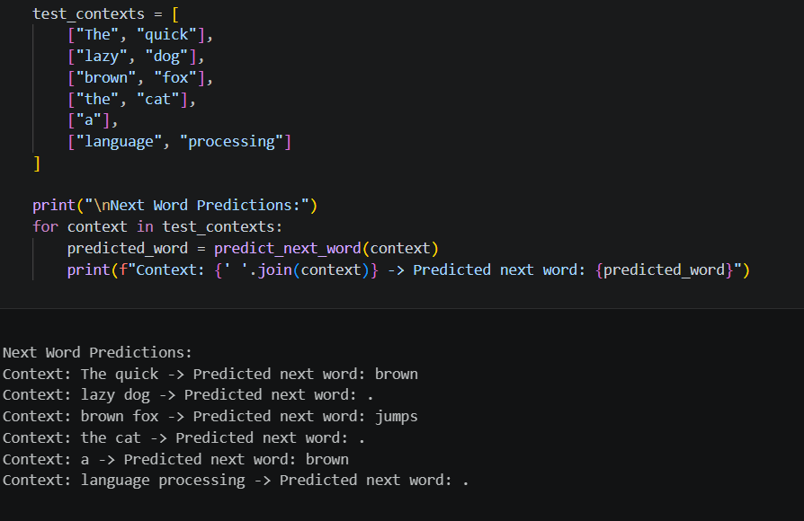

Conclusion
The N-gram language model is a simple probabilistic method used to predict the next word based on previous words. It works by calculating word sequence frequencies and probabilities from a given text. Although it has limitations like limited context handling, it forms the foundation for advanced language modeling techniques in NLP.

