Assignment No.7

Title: Implementation of LSTM Networks for Sequence Labeling using Python

Aim:
To implement a Long Short-Term Memory (LSTM) network using Python to perform sequence labeling on a small text dataset.

Objectives:
- To understand the concept of sequence labeling in Natural Language Processing.
- To study the working of Recurrent Neural Networks (RNN) and LSTM networks.
- To understand how LSTM handles sequential text data.
- To implement an LSTM model using TensorFlow or PyTorch for sequence labeling.
- To evaluate the performance of the model on a sample dataset.

Expected Outcomes:
- Understanding of sequence labeling tasks in NLP.
- Knowledge of LSTM architecture and its advantages over traditional RNNs.
- Ability to preprocess text data for deep learning models.
- Implementation of an LSTM-based sequence labeling model.
- Improved understanding of deep learning applications in Natural Language Processing.

Theory:

1. Introduction to Sequence Labeling:
Sequence labeling is a Natural Language Processing task where a label is assigned to each word in a sentence. It is widely used in applications such as:
- Part-of-Speech (POS) tagging
- Named Entity Recognition (NER)
- Chunking
- Speech recognition

Example Sentence: Ram lives in Pune
Sequence Labels (POS Tags):
Word | Label
Ram | NNP
lives | VBZ
in | IN
Pune | NNP
The goal of sequence labeling models is to predict the correct label for each word in the sequence.

2. Recurrent Neural Networks (RNN):
Recurrent Neural Networks are designed to process sequential data such as text, speech, and time series.
Key characteristics of RNN:
- Maintains memory of previous inputs.
- Suitable for sequential data.
- Processes one element at a time.
However, traditional RNNs suffer from:
- Vanishing gradient problem
- Difficulty in learning long-term dependencies.

3. Long Short-Term Memory (LSTM):
LSTM is a special type of Recurrent Neural Network designed to solve the limitations of traditional RNNs.
LSTM networks contain special memory cells that can store information for long periods.

Key Components of LSTM
- Cell State
  - Stores long-term information.
- Input Gate
  - Decides which new information should be stored.
- Forget Gate
  - Removes unnecessary information.
- Output Gate
  - Produces the output based on the cell state.
Advantages of LSTM:
- Handles long-term dependencies.
- Better performance for sequence tasks.
- Widely used in NLP tasks.

4. Applications of LSTM in NLP:
LSTM models are commonly used for:
- Text generation
- Machine translation
- Speech recognition
- Named entity recognition
- Part-of-speech tagging
- Chatbots

Pseudocode:
START
INPUT:
Text dataset containing sentences and corresponding labels
STEP 1: Import required libraries
Import TensorFlow / PyTorch
Import NumPy and NLP preprocessing libraries
STEP 2: Preprocess the text data
Tokenize the sentences
Convert words into numerical sequences
Pad sequences to equal length
STEP 3: Prepare training and testing data
STEP 4: Build the LSTM Model
Create embedding layer
Add LSTM layer
Add dense output layer
STEP 5: Compile the model
Specify loss function and optimizer
STEP 6: Train the model using training data
STEP 7: Predict labels for test sentences
OUTPUT:
Sequence labels predicted for each word
END

Algorithm
- Start the program.
- Import necessary libraries such as TensorFlow, NumPy, and preprocessing tools.
- Load the text dataset containing sentences and their labels.
- Preprocess the dataset by tokenizing the words.
- Convert words into numerical representations.
- Apply padding to make all sequences the same length.
- Build the LSTM neural network model.
- Train the model using the training dataset.
- Test the model on sample sentences.
- Display the predicted sequence labels.
- Stop the program.

Results:

NER Using LSTM

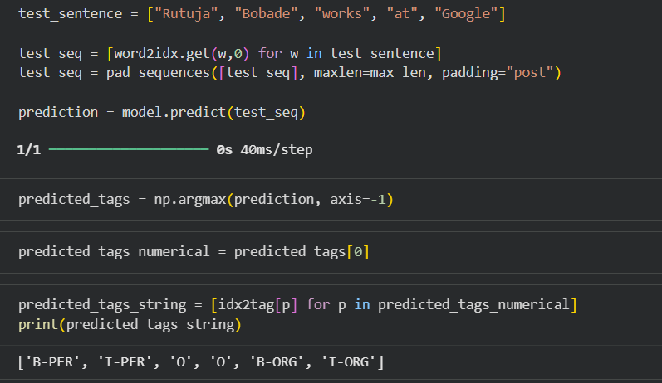

Conclusion
LSTM networks are powerful deep learning models for handling sequential data in Natural Language Processing. They effectively capture long-term dependencies in text and improve the performance of sequence labeling tasks such as POS tagging and named entity recognition. The implemented model demonstrates how LSTM can be applied to label words in a sequence accurately.

