Characteristics of Round-Robin Scheduling
Here are the important characteristics of Round-Robin Scheduling:
- Round robin is a pre-emptive algorithm
- The CPU is shifted to the next process after fixed interval time, which is called time quantum/time slice.
- The process that is preempted is added to the end of the queue.
- Round robin is a hybrid model which is clock-driven
- Time slice should be minimum, which is assigned for a specific task that needs to be processed. However, it may differ OS to OS.
- It is a real time algorithm which responds to the event within a specific time limit.
- Round robin is one of the oldest, fairest, and easiest algorithm.
- Widely used scheduling method in traditional OS.

Example of Round-robin Scheduling
Consider this following three processes
Process Queue | Burst time
P1 | 4
P2 | 3
P3 | 5
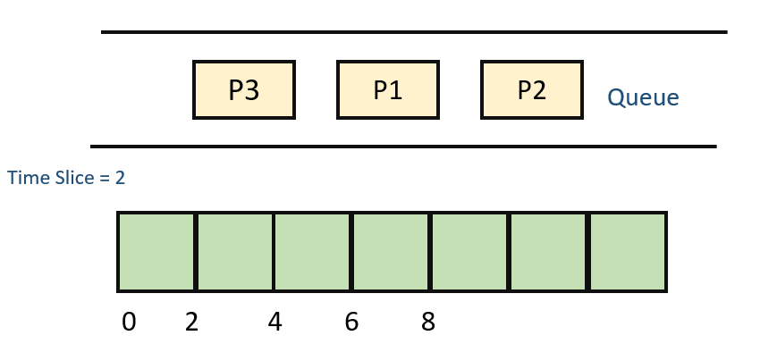
Step 1) The execution begins with process P1, which has burst time 4. Here, every process executes for 2 seconds. P2 and P3 are still in the waiting queue.
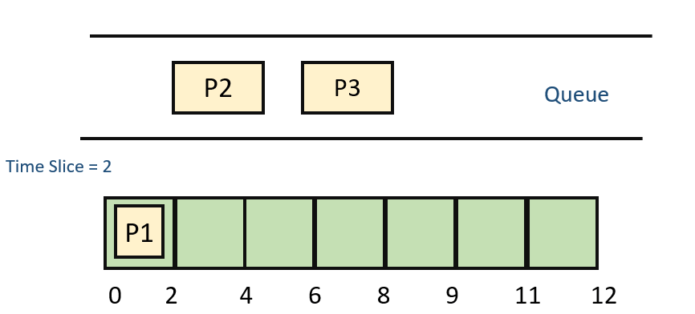
Step 2) At time =2, P1 is added to the end of the Queue and P2 starts executing
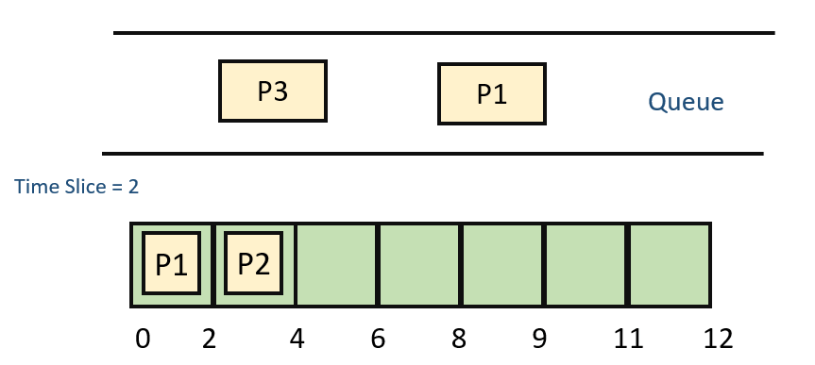

Step 3) At time=4 , P2 is preempted and add at the end of the queue. P3 starts executing.
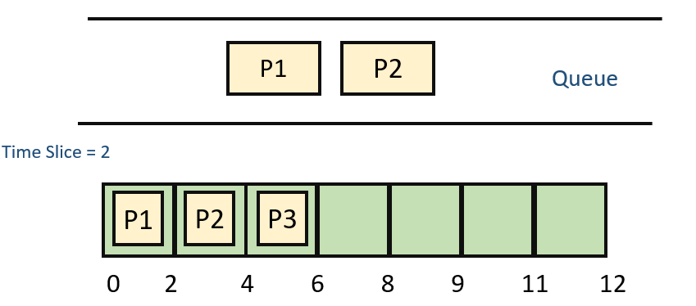
Step 4) At time=6 , P3 is preempted and add at the end of the queue. P1 starts executing.
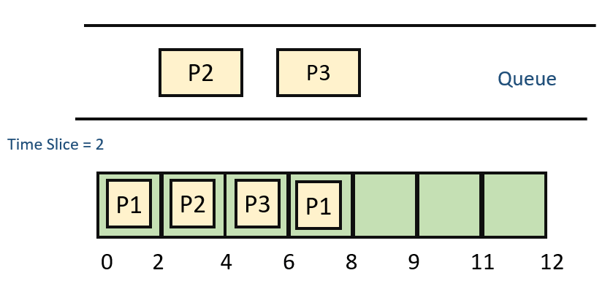

Step 5) At time=8 , P1 has a burst time of 4. It has completed execution. P2 starts execution
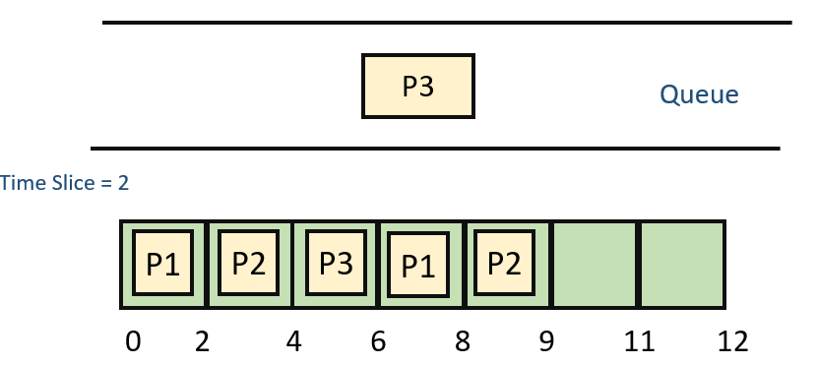
Step 6) P2 has a burst time of 3. It has already executed for 2 interval. At time=9, P2 completes execution. Then, P3 starts execution till it completes.
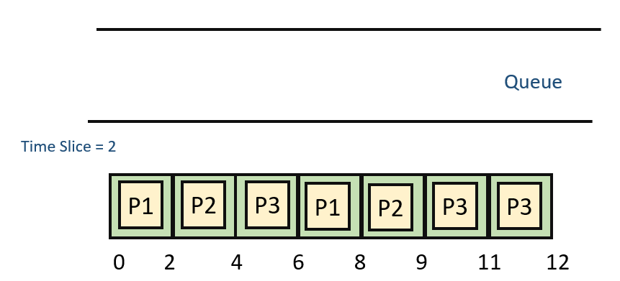
Step 7) Let’s calculate the average waiting time for above example.
Wait time
P1= 0+ 4= 4
P2= 2+4= 6
P3= 4+3= 7

Advantage of Round-robin Scheduling
Here, are pros/benefits of Round-robin scheduling method:
- It doesn’t face the issues of starvation or convoy effect.
- All the jobs get a fair allocation of CPU.
- It deals with all process without any priority
- If you know the total number of processes on the run queue, then you can also assume the worst-case response time for the same process.
- This scheduling method does not depend upon burst time. That’s why it is easily implementable on the system.
- Once a process is executed for a specific set of the period, the process is preempted, and another process executes for that given time period.
- Allows OS to use the Context switching method to save states of preempted processes.
- It gives the best performance in terms of average response time.

Disadvantages of Round-robin Scheduling
Here, are drawbacks/cons of using Round-robin scheduling:
- If slicing time of OS is low, the processor output will be reduced.
- This method spends more time on context switching
- Its performance heavily depends on time quantum.
- Priorities cannot be set for the processes.
- Round-robin scheduling doesn’t give special priority to more important tasks.
- Decreases comprehension
- Lower time quantum results in higher the context switching overhead in the system.
- Finding a correct time quantum is a quite difficult task in this system.

