Characteristics of SJF Scheduling
- It is associated with each job as a unit of time to complete.
- This algorithm method is helpful for batch-type processing, where waiting for jobs to complete is not critical.
- It can improve process throughput by making sure that shorter jobs are executed first, hence possibly have a short turnaround time.
- It improves job output by offering shorter jobs, which should be executed first, which mostly have a shorter turnaround time.

Non-Preemptive SJF
In non-preemptive scheduling, once the CPU cycle is allocated to process, the process holds it till it reaches a waiting state or terminated.
Consider the following five processes each having its own unique burst time and arrival time.
Process Queue | Burst time | Arrival time
P1 | 6 | 2
P2 | 2 | 5
P3 | 8 | 1
P4 | 3 | 0
P5 | 4 | 4
Step 0) At time=0, P4 arrives and starts execution.
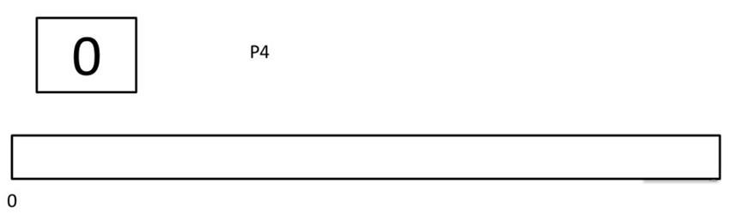
Step 1) At time= 1, Process P3 arrives. But, P4 still needs 2 execution units to complete. It will continue execution.
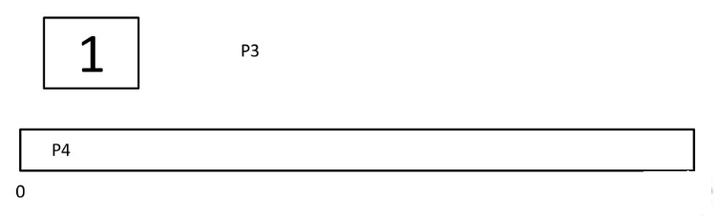
Step 2) At time =2, process P1 arrives and is added to the waiting queue. P4 will continue execution.
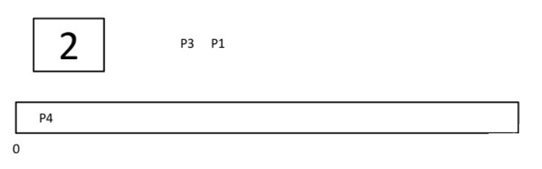
Step 3) At time = 3, process P4 will finish its execution. The burst time of P3 and P1 is compared. Process P1 is executed because its burst time is less compared to P3.
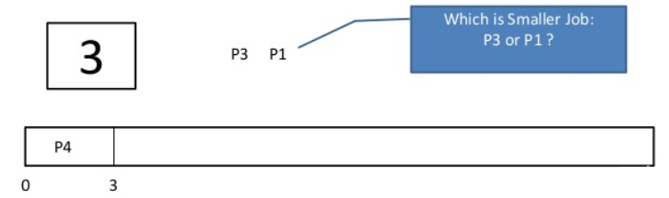

Step 4) At time = 4, process P5 arrives and is added to the waiting queue. P1 will continue execution.
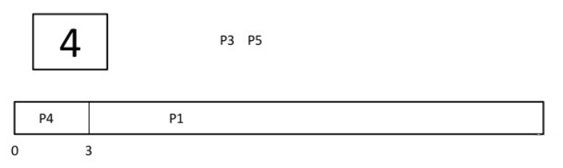
Step 5) At time = 5, process P2 arrives and is added to the waiting queue. P1 will continue execution.
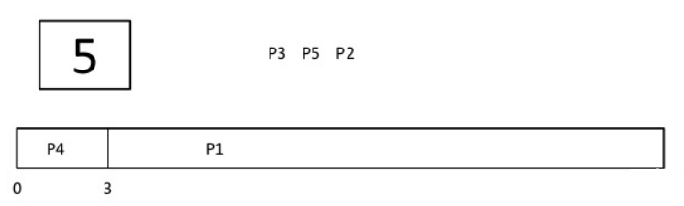
Step 6) At time = 9, process P1 will finish its execution. The burst time of P3, P5, and P2 is compared. Process P2 is executed because its burst time is the lowest.
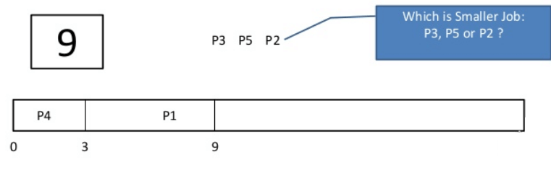

Step 7) At time=10, P2 is executing and P3 and P5 are in the waiting queue.
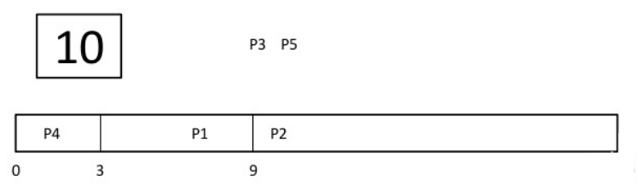
Step 8) At time = 11, process P2 will finish its execution. The burst time of P3 and P5 is compared. Process P5 is executed because its burst time is lower.
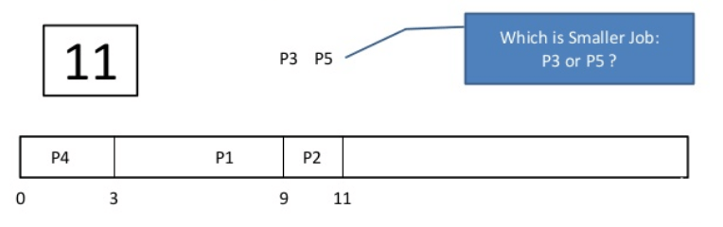
Step 9) At time = 15, process P5 will finish its execution.
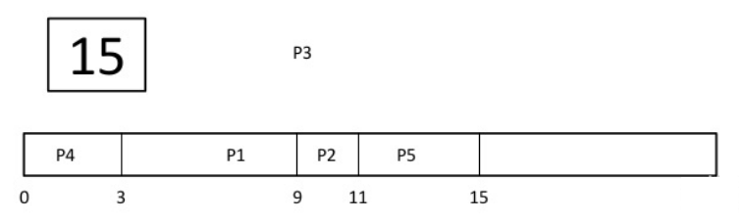

Step 10) At time = 23, process P3 will finish its execution.
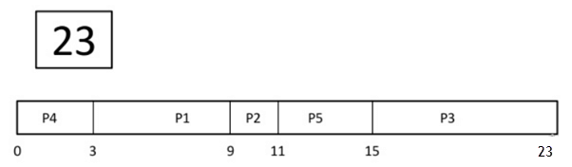
Step 11) Let’s calculate the average waiting time for above example.
Wait time
P4= 0-0=0
P1= 3-2=1
P2= 9-5=4
P5= 11-4=7
P3= 15-1=14

