PROJECT DOCUMENTATION
Jenkins CI/CD Pipeline
Netflix Movie Explorer on AWS EC2 with Docker
Created by Rutuja Naik

Item | Details
Platform | AWS EC2 (Amazon Linux), 30 GB storage
CI server | Jenkins on port 8080
Source control | Git and GitHub (main branch)
Container registry | Docker Hub
Deployed app | Nginx container on port 8081
Created by | Rutuja Naik
GitHub repository | https://github.com/Rutuja-Naik07/Project-Netflix-Jenkins-CI-CD.git
LinkedIn | https://www.linkedin.com/in/rutuja-naik07/

1. Project Overview
This project builds a complete CI/CD pipeline using Jenkins on an AWS EC2 instance. A static, Netflix-inspired movie website (HTML, CSS and JavaScript) is stored in a GitHub repository. Each time Jenkins runs the job, it pulls the latest code, builds a Docker image (Nginx serving the site), pushes the image to Docker Hub, and runs it as a container reachable from a browser.
What you will have at the end
- A working Jenkins server on EC2 (port 8080)
- A GitHub repository containing index.html and a Dockerfile
- A Docker image published to Docker Hub
- The Netflix Movie Explorer site running in a container (port 8081)

2. Architecture and Workflow
Stage | Tool | Purpose
1. Source | Git + GitHub | Stores index.html and Dockerfile
2. Build | Jenkins | Pulls the code and orchestrates the job
3. Package | Docker | Builds an Nginx image containing the site
4. Publish | Docker Hub | Stores the built image
5. Run | AWS EC2 | Runs the container, exposed on port 8081

Pipeline architecture diagram
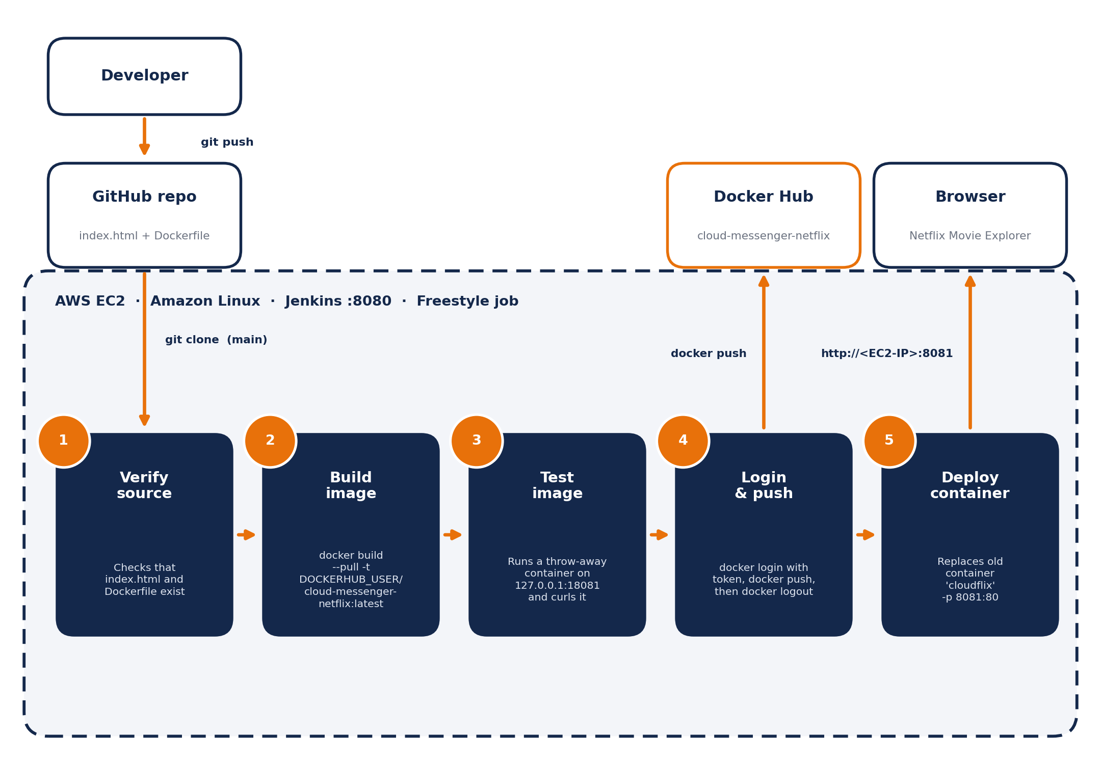
Flow: Developer → GitHub → Jenkins (:8080) → verify, build, test, push (Docker Hub) → deploy container cloudflix on EC2 (:8081) → Browser.

3. Prerequisites
- An AWS account with permission to launch EC2 instances
- A GitHub account and a Personal Access Token (PAT)
- A Docker Hub account
- Basic comfort with the Linux terminal and the vi editor

4. Step 1: Launch the EC2 Instance
Setting | Value
AMI | Amazon Linux
Instance type | A large instance, e.g. m7i.large
Key pair | Proceed without key pair (connect with EC2 Instance Connect)
Storage | 30 GB
Network settings | Allow SSH, HTTP and HTTPS
Open the extra ports
- Open the instance's Security Group and choose Edit inbound rules.
- Add Custom TCP rules for ports 8080 (Jenkins) and 8081 (deployed website).
- Save the rules, then Connect to the EC2 instance.

5. Step 2: Install Java and Jenkins
Run these commands in the EC2 terminal.
sudo su
yum update -y

# Java (required by Jenkins)
sudo yum install -y java-21-amazon-corretto
java -version

# Add the Jenkins repository and signing key
sudo wget -O /etc/yum.repos.d/jenkins.repo \
https://pkg.jenkins.io/rpm-stable/jenkins.repo
sudo rpm --import https://pkg.jenkins.io/rpm-stable/jenkins.io-2026.key

# Install and start Jenkins
sudo yum install -y jenkins
sudo systemctl enable jenkins
sudo systemctl start jenkins
sudo systemctl status jenkins

# First-time admin password
sudo cat /var/lib/jenkins/secrets/initialAdminPassword

Complete the Jenkins setup in the browser
- Open http://<EC2-public-IP>:8080.
- Paste the initial admin password and click Continue.
- Choose Install suggested plugins.
- Create the admin account.
- Confirm the Jenkins URL and click Start using Jenkins.

CHECKPOINT
You should now see a working Jenkins dashboard.

6. Step 3: Install Git and Docker
# Git
sudo yum install -y git
git --version

# Docker
sudo yum install -y docker
sudo systemctl enable --now docker
sudo systemctl status docker
sudo docker --version
sudo docker ps

# Let Jenkins and ec2-user run Docker without sudo
sudo usermod -aG docker jenkins
sudo usermod -aG docker ec2-user
sudo systemctl restart jenkins

docker ps

WHY THIS MATTERS
The usermod commands are essential. Without them, Jenkins fails with a *permission denied* error when it talks to the Docker daemon.

7. Step 4: Create the Git Repository

7.1 Project files
mkdir <your-project-folder> && cd <your-project-folder>
vi index.html # paste the website code
vi Dockerfile # paste the Dockerfile below

Dockerfile
# Use lightweight Nginx
FROM nginx:alpine

# Remove the default Nginx page
RUN rm -rf /usr/share/nginx/html/*

# Copy the website into the Nginx directory
COPY index.html /usr/share/nginx/html/index.html

# Expose the web server port
EXPOSE 80

# Start Nginx in the foreground
CMD ["nginx", "-g", "daemon off;"]

Instruction | What it does
FROM nginx:alpine | Starts from a small Nginx image
RUN rm -rf ... | Deletes Nginx's default welcome page
COPY index.html ... | Places the website where Nginx serves files
EXPOSE 80 | Documents that the container listens on port 80
CMD [...] | Runs Nginx in the foreground so the container stays alive

7.2 The website (index.html)
A single-file, responsive, Netflix-style movie explorer built with HTML, CSS and JavaScript.
- Fixed navigation bar with a live search box that filters movie cards
- Hero banner featuring Dune: Part Two with Play and More Info buttons
- Three rows of movies (Trending, Sci-Fi & Adventure, Action & Entertainment) generated from a JavaScript movies array
- Details popup with banner, genre, cast and description; closes with the X button, the Esc key, or a click outside
- TMDB poster images with a text fallback card if an image fails to load
- Responsive grid: 6 columns on desktop, 4 on tablets, 2 on phones

7.3 Push to GitHub
Create an empty repository on GitHub first, then run:
git init
git add . # or: git add index.html Dockerfile
git status
git commit -m "Landing Page"
git status
git branch -M main
git remote add origin <your-repo-url>
git push -u origin main

Project repository: https://github.com/Rutuja-Naik07/Project-Netflix-Jenkins-CI-CD.git
When prompted, enter your GitHub username, and use your GitHub Personal Access Token as the password (not your account password).

8. Step 5: Prepare Docker Hub
Create the repository
- Log in to Docker Hub and open Repositories.
- Click Create repository and give it a name, for example cloud-messenger-netflix.
Generate an access token
- Open Account settings, then Personal access token in the left menu.
- Click Generate new token.
- Enter an access token name.
- Set access permissions to Read & Write (repository).
- Click Generate and copy the token immediately. It is shown only once.

9. Step 6: Configure Jenkins

9.1 Add Docker Hub credentials
- Click the gear icon (Settings) in Jenkins and sign in if asked.
- Go to Credentials, then Global, then + Add Credentials.
- Choose Username with password and fill in the fields below, then click Create.

Field | Value
Username | Your Docker Hub account name
Password | The newly created Docker Hub token
ID | dockerhub-creds
Description | dockerhub-desc

9.2 Create the freestyle job
- From the dashboard click + New Item.
- Enter an Item name, choose Freestyle project, and click OK.
- Add any description.
Source Code Management
- Select Git and paste the GitHub repository URL.
- Credentials: choose from the drop-down. For a private repo, add a separate *Username with password* credential holding your GitHub username and PAT.
- Branch Specifier: change */master to */main.
Build Environment
- Tick Use secret text(s) or file(s).
- Under Bindings, click Add and choose Username and password (separated).
- Set the values in the table below.

Binding field | Value
Username Variable | DOCKERHUB_USER
Password Variable | DOCKERHUB_TOKEN
Credentials | dockerhub-creds
Build Steps
- Click Add build step, then Execute shell.
- Paste the script below and click Save.
#!/bin/bash
set -eu

echo "===================================="
echo "STEP 1: Verify source code"
echo "===================================="

test -s index.html
test -s Dockerfile

echo "Website source files found."

echo "===================================="
echo "STEP 2: Build Docker image"
echo "===================================="

IMAGE="$DOCKERHUB_USER/cloud-messenger-netflix:latest"

docker build --pull -t "$IMAGE" .

echo "Docker image built successfully."

echo "===================================="
echo "STEP 3: Test the Docker image"
echo "===================================="

docker run -d --rm \
--name cloudflix-test \
-p 127.0.0.1:18081:80 \
"$IMAGE"

trap 'docker stop cloudflix-test >/dev/null 2>&1 || true' EXIT

sleep 3

curl -fsS http://127.0.0.1:18081/ -o /tmp/cloudflix-test.html

if grep -qi "<html" /tmp/cloudflix-test.html; then
echo "Website test passed."
else
echo "ERROR: The website did not return valid HTML."
cat /tmp/cloudflix-test.html
exit 1
fi

docker stop cloudflix-test >/dev/null 2>&1 || true
trap - EXIT

echo "Test container cleaned up successfully."

echo "===================================="
echo "STEP 4: Login to Docker Hub"
echo "===================================="

printf '%s' "$DOCKERHUB_TOKEN" | \
docker login \
--username "$DOCKERHUB_USER" \
--password-stdin

echo "Docker Hub login successful."

echo "===================================="
echo "STEP 5: Push image to Docker Hub"
echo "===================================="

docker push "$IMAGE"

docker logout

echo "Image pushed successfully."

echo "===================================="
echo "STEP 6: Deploy container"
echo "===================================="

docker rm -f cloudflix || true

docker run -d \
--name cloudflix \
--restart unless-stopped \
-p 8081:80 \
"$IMAGE"

echo "===================================="
echo "CI/CD PIPELINE COMPLETED"
echo "===================================="

docker ps --filter "name=cloudflix" --format "table {{.Names}}\t{{.Status}}\t{{.Ports}}"

What the script does
Step | Action
1. Verify | Stops the build early if index.html or Dockerfile is missing or empty.
2. Build | Builds the image $DOCKERHUB_USER/cloud-messenger-netflix:latest with --pull to get the newest base image.
3. Test | Starts a temporary container on 127.0.0.1:18081, fetches the page with curl, and checks that it returns HTML. The container is removed automatically, even on failure (trap).
4. Login | Logs in to Docker Hub using the token through --password-stdin, so it never appears in the process list.
5. Push | Pushes the image to Docker Hub, then logs out.
6. Deploy | Removes any old cloudflix container and starts the new one on port 8081 with --restart unless-stopped.

TIP
set -eu makes the script exit on the first error or unset variable, so a failed test never reaches the push or deploy steps.

10. Step 7: Run the Pipeline and Verify
- Click Build Now.
- Open the build under Build History and check Console Output for Finished: SUCCESS.
- Confirm the image appears in your Docker Hub repository.
- Open http://<EC2-public-IP>:8081. The Netflix Movie Explorer should load.
On the server, docker ps should list the cloudflix container as *Up*.

11. Command Reference
Task | Command
Check Jenkins | sudo systemctl status jenkins
Restart Jenkins | sudo systemctl restart jenkins
Check Docker | sudo systemctl status docker
List containers | docker ps
View container logs | docker logs cloudflix
Stop and remove container | docker rm -f cloudflix
Initial Jenkins password | sudo cat /var/lib/jenkins/secrets/initialAdminPassword

12. Troubleshooting
Problem | Likely cause and fix
Cannot open :8080 or :8081 | Security group rule missing, or the service is not running.
*permission denied* on Docker in Jenkins | Run sudo usermod -aG docker jenkins, then restart Jenkins.
Git clone fails in Jenkins | Wrong repo URL, missing credentials for a private repo, or branch still */master.
docker login fails | Wrong or expired token, or token without write permission.
Port 8081 already allocated | An old container is running. Run docker rm -f cloudflix.
Posters not showing | TMDB image links may have changed. The text fallback card still appears.
Jenkins repo or key errors | Check the repo file and key URL. Jenkins periodically rotates its signing key.

13. Security Recommendations
This setup is designed for learning and demos. Before using anything similar beyond that, improve the following:
- Change the default admin credentials. Weak passwords such as admin/admin must never be used on a public server.
- Restrict ports 8080 and 8081 to your own IP address instead of 0.0.0.0/0 where possible.
- Use a key pair (or AWS Systems Manager) for controlled SSH access.
- Never commit tokens to Git. Keep the GitHub PAT and Docker Hub token only in Jenkins credentials.
- Rotate tokens regularly and grant minimum permissions.
- Put HTTPS in front of Jenkins and the website, for example with a reverse proxy and certificate.

14. Possible Enhancements
- Trigger builds automatically with a GitHub webhook or SCM polling
- Convert the freestyle job to a Jenkinsfile (pipeline as code)
- Tag images with the build number (:$BUILD_NUMBER) as well as latest
- Add a test or lint stage before the Docker build
- Use an Elastic IP so the public address does not change after a restart

15. Conclusion
This project covers the full path from code to running application: provisioning infrastructure on EC2, installing Jenkins, Git and Docker, storing code on GitHub, building and publishing an image to Docker Hub, and deploying the container automatically through a Jenkins job. It is a solid foundation for moving on to Jenkins pipelines, Kubernetes and cloud deployments.

16. Author
Detail | Link
Created by | Rutuja Naik
GitHub repository | https://github.com/Rutuja-Naik07/Project-Netflix-Jenkins-CI-CD.git
LinkedIn | https://www.linkedin.com/in/rutuja-naik07/

