Advance Cheque Tracking
How I Built It: Interview Explanation Guide

A guide to explain, in your own words, how this ERPNext module was designed and coded. Read the pitch first, then keep the code walkthrough and the questions nearby.

Contents
1. The 30-second pitch
2. The problem
3. How I worked, step by step
4. Architecture in one picture
5. Code walkthrough, file by file
6. One flow from start to end
7. Problems I faced and how I solved them
8. Frappe concepts I used
9. Likely interview questions and answers
10. Five-minute demo script
11. What I would improve
12. Numbers to remember

1. The 30-second pitch
Say this first
I built a custom ERPNext app called Advance Cheque Tracking. A company takes an advance cheque against a Sales Order. When the order is fully billed, or the advance is fully used, the original cheque must be collected back. My app records the cheque, watches Sales Invoices, and when the order is settled it moves the cheque to Return Pending by itself and reminds the Sales Person and the Accounts person with a pop-up, a bell notification and an email. When the cheque is marked Returned, the reminders stop. Management gets one report with filters and a dashboard. I wrote it on Frappe 16 with automated tests.

2. The problem
- Customers give advance cheques against Sales Orders.
- After the work is invoiced, the company must take the original cheque back.
- Before this module, nobody was clearly responsible, and cheques stayed with the customer or in a drawer.
- The need: record every cheque, remind the right people at the right moment, and report what is still pending.

3. How I worked, step by step
Interviewers like to hear a clear order of work. This is mine.
1. Understood the requirement and split it into three parts: recording, automatic reminders, reports.
2. Wrote a design document first (what data, which statuses, what triggers the reminder, who gets it).
3. Created the DocType Advance Cheque with all fields, and a small Advance Cheque Settings for defaults.
4. Wrote the controller rules: sales order must be submitted, amount above zero, no duplicate cheque number, return date rules.
5. Hooked into Sales Invoice submit and cancel, to decide when an order is settled and change the cheque status.
6. Built the reminders: Notification Log for the bell and email, a realtime pop-up, a reminder at login, and a daily digest.
7. Made one report with a Status filter, and a workspace with number cards and a chart.
8. Wrote 21 automated tests and loaded sample records to test the whole flow like a user.
9. Cleaned the code to keep it simple: small files, short functions, standard hooks file, no unused code.
10. Wrote documents: a technical design, a user manual and this guide.

4. Architecture in one picture
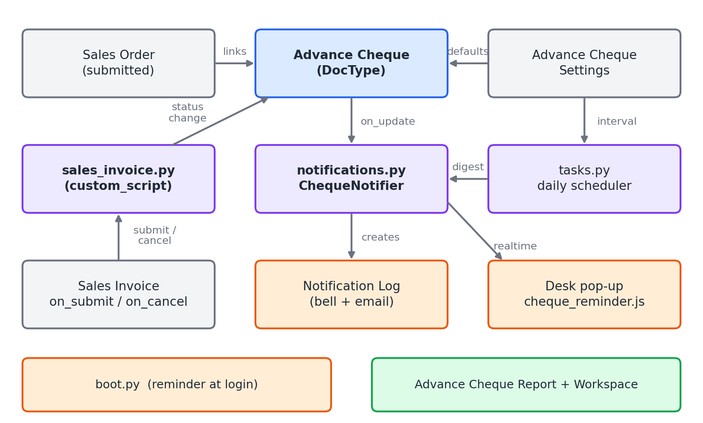
Figure 1. How the parts connect
In words: a Sales Invoice event calls my settlement check. The check changes the status on the Advance Cheque. The Advance Cheque's on_update then calls the notifier, which writes the bell notification and sends the pop-up. A daily job and a login hook handle the repeat reminders.

5. Code walkthrough, file by file

5.1 Where everything lives
advance_cheque_tracking/
hooks.py connects my code to Frappe
notifications.py who to alert and how
tasks.py daily reminder job
boot.py reminder when a user logs in
public/js/
cheque_reminder.js the pop-up on screen
advance_cheque_tracking/
custom_script/
sales_invoice/ Sales Invoice handlers
doctype/
advance_cheque/ the main DocType (+ tests)
advance_cheque_settings/ settings
report/
advance_cheque_report/ the one report
number_card/ dashboard_chart/ workspace/ dashboard
tests/ invoice and report tests

The folder custom_script/<doctype>/ holds code that reacts to another doctype. For Sales Invoice it is custom_script/sales_invoice/sales_invoice.py. A Payment Entry handler would go in custom_script/payment_entry/payment_entry.py.

5.2 hooks.py: the entry point
hooks.py tells Frappe when to run my code. I kept the standard file and filled only what I need.
required_apps = ["erpnext"]
app_include_js = "/assets/advance_cheque_tracking/js/cheque_reminder.js"
boot_session = "advance_cheque_tracking.boot.boot_session"

doc_events = {
"Sales Invoice": {
"on_submit": "...custom_script.sales_invoice.sales_invoice.on_submit",
"on_cancel": "...custom_script.sales_invoice.sales_invoice.on_cancel",
}
}

scheduler_events = {
"daily": ["advance_cheque_tracking.tasks.send_pending_return_reminders"],
}

5.3 The DocType and its controller
Advance Cheque has the sales order, customer, sales person, accounts person, cheque number, amount, issue date, status, return dates and remarks. The controller advance_cheque.py holds the rules. validate calls small methods, one rule each:
def validate(self):
...
self.validate_sales_order() # must be submitted
self.validate_amount() # more than zero
self.validate_duplicate() # same number not twice on one order
self.validate_return_date() # needed when Returned, not before issue date
self.set_sales_person() # from the order's sales team
self.set_return_pending_since()

def on_update(self):
if not self.has_value_changed("cheque_status"):
return
notifier = ChequeNotifier(self)
if self.cheque_status == "Return Pending":
notifier.notify_return_pending()
else:
notifier.clear()

Why has_value_changed: alerts go out only when the status really changes, so saving the form again never sends a second alert.
The form buttons call two whitelisted methods, mark_return_pending() and mark_returned(), so the same validation runs whether the user edits the field or clicks a button.

5.4 Deciding when an order is settled
This is the heart of the module, in custom_script/sales_invoice/sales_invoice.py.
def on_submit(doc, method=None):
for sales_order in get_sales_orders(doc):
if is_settled(sales_order):
change_status(sales_order, "Issued", "Return Pending", doc.name)

def is_settled(sales_order):
order = frappe.db.get_value("Sales Order", sales_order, ["per_billed", "advance_paid"], as_dict=True)
if flt(order.per_billed) >= 100:
return True # fully billed

advance_paid = flt(order.advance_paid)
used = get_allocated_advance(sales_order) # advance used on invoices
return advance_paid > 0 and used >= advance_paid

Two rules decide it: the order is fully billed, or the advance is fully used. The second rule is why the reminder can fire before the last invoice.

5.5 Sending the reminder
ChequeNotifier in notifications.py has three jobs:
Method | What it does
get_users() | Returns the Accounts person and the Sales Person's user, once each, enabled users only.
notify_return_pending() | For each user: creates a Notification Log (bell and email) and publishes a realtime event for the pop-up.
clear() | Marks the cheque's unread notifications as read when it is Returned, so the reminder stops.

The Sales Person is a master, not a user, so I follow Sales Person to Employee to User ID. If that link is missing, the form shows a warning and only the Accounts person is alerted.

5.6 Other reminders
- Login reminder: boot.py puts the user's pending cheques into the page data. cheque_reminder.js shows one pop-up per browser session.
- Live pop-up: the same JavaScript listens for the realtime event advance_cheque_return_pending.
- Daily digest: tasks.py runs once a day. It collects Return Pending cheques that are due again, groups them by user and sends one summary each.

5.7 The report and dashboard
- One script report, Advance Cheque Report, with a Status filter: Pending (default), Issued, Return Pending, Returned, or empty for all.
- Other filters: customer, Sales Order, sales person, accounts person, issue date range, return date range.
- It shows days pending for Return Pending cheques and the actual return date for Returned ones, with a total row and summary.
- The workspace has four number cards, a status chart and shortcuts.

6. One flow from start to end
Example: Sales Order of 50,000 with a 20,000 advance cheque.
1. Accounts opens Advance Cheque > New, picks the Sales Order. Customer and sales person fill in. They enter number, amount, date and save. Status: Issued.
2. The company delivers and submits a Sales Invoice for the full 50,000.
3. Frappe runs my on_submit hook. is_settled sees the order is 100% billed.
4. change_status finds the Issued cheque, sets Return Pending, saves it and adds a timeline comment naming the invoice.
5. The save triggers on_update. The notifier creates a bell notification for the Accounts person and the Sales Person's user, and publishes the pop-up.
6. Both see Collect Advance Cheque. If they are offline they see it at login, and in the daily digest.
7. Accounts collects the cheque, clicks Mark As > Returned, enters the date.
8. on_update runs again. clear() marks the alerts read. The cheque leaves the Pending view and shows under Returned.

7. Problems I faced and how I solved them
Problem | What I found | What I did
Detecting "advance fully used" | After an advance is allocated on an invoice, ERPNext changes the Payment Entry's reference from the Sales Order to the Sales Invoice. My first query, which looked for payments referencing the order, returned zero. | I printed the SQL and the data, saw the references had moved, and changed the query to add up advances on the submitted invoices of that order.
Invoice must never fail because of my code | A bug in my hook would stop an accountant from submitting an invoice. | Each cheque update runs in a try/except. On error it logs to Error Log and the invoice still posts.
Repeated or noisy reminders | Saving a cheque again, or more invoices on the same order, could alert again. | Alerts fire only when cheque_status changes, and the hook only moves cheques that are still Issued.
Who is the Sales Person user? | Sales Person is a master, not a login. | Resolve Sales Person to Employee to User, and warn on save if the link is missing.
Three reports were more than needed | Three screens with the same query. | Merged into one report with a Status filter and removed the shared helper code.
Code looked too generated | Extra constants, long comments, a generated type-hint block and role checks inside the code. | Simplified the code, kept hooks.py in the standard Frappe layout, and moved permissions to the site (Role Permission Manager) instead of code.
No separate test site | No database root access to create one. | Each test creates its own data inside a transaction that rolls back, and allow_tests is on only for the run.

8. Frappe concepts I used
Concept | How I used it | One-line explanation
DocType and controller | Advance Cheque, Advance Cheque Settings | A table plus a form, with Python class for rules.
doc_events | Sales Invoice on_submit and on_cancel | Run my function when another doctype is saved, submitted or cancelled.
on_update and has_value_changed | Send alerts only on a status change | Run after a save, and check if a field changed.
Whitelisted method | mark_returned, get_sales_order_defaults | A Python method the browser can call.
Notification Log | Bell and email | Frappe's standard alert record.
publish_realtime | Live pop-up | Send an event to a user's open browser over Socket.IO.
boot_session | Reminder at login | Add data to the page when the desk loads.
scheduler_events | Daily digest | Run a function on a schedule.
Script Report | Advance Cheque Report | A report written in Python and JavaScript.
Number Card, Dashboard Chart, Workspace | Management dashboard | Dashboard pieces defined as records.
Custom DocPerm | Role permissions on the site | What Role Permission Manager saves.
Frappe Query Builder | Sum of allocated advances | Write SQL in Python, safe from injection.

9. Likely interview questions and answers
Q. Walk me through the module.
Use the 30-second pitch, then the flow in Section 6.
Q. How do you know when to ask for the cheque back?
I hook Sales Invoice submit. For each order on the invoice I check two things: is the order fully billed, or is its advance fully used. If either is true, the Issued cheques of that order become Return Pending.
Q. Why `doc_events` and not a custom button or a scheduled job?
The event happens on invoice submit, so a hook reacts at once and only for the orders involved. A scheduled job would be late and would scan everything.
Q. What if your code fails during invoice submit?
I catch the error per cheque, write it to Error Log and let the invoice post. Cheque tracking is secondary and must not block accounting.
Q. How do you avoid sending the same alert again?
Alerts are sent in on_update only when has_value_changed('cheque_status') is true, and the hook changes only cheques that are still Issued.
Q. How do you find the sales person's login user?
Sales Person has an Employee, and Employee has a User ID. I follow that chain and store the user on the cheque. If it is missing, I warn and still alert the Accounts person.
Q. How does the pop-up work?
The server calls frappe.publish_realtime with an event name and the user. A small JavaScript file loaded through app_include_js listens for that event and opens a dialog. Offline users get the bell notification and a reminder at login through boot_session.
Q. How does the reminder stop?
Marking Returned triggers clear(), which sets the notifications to read. The cheque is no longer Return Pending, so it drops out of the login reminder, the daily digest and the Pending view of the report.
Q. How did you test it?
21 integration tests. Each builds its own sales order and users and rolls back. They cover validation, invoice submit and cancel, partial and combined invoices, the alerts, and every report filter. I also loaded sample records and ran the full flow.
Q. How is the report built?
A script report. get_filters builds the conditions, get_data runs frappe.get_list so permissions apply, and get_summary adds the totals. The Status filter value Pending means Issued plus Return Pending.
Q. How do you handle permissions?
Not in code. I set them on the site in Role Permission Manager so the company can change them. The code does not hard-code any role.
Q. What was the hardest part?
Detecting that the advance was fully used. ERPNext moves the payment reference from the order to the invoice, so my first query found nothing. I debugged it with the real data and changed the query.
Q. What would you do differently?
See Section 11.
Q. Is it safe for money data?
It does not post any accounting entry. It only reads billing data and changes the cheque record, with a timeline comment on each change.

10. Five-minute demo script
1. Show the form (Advance Cheque > New). Pick a Sales Order and point out that customer and sales person fill in. Save. Status is Issued.
2. Show the rules. Try amount 0 and a duplicate number. Show the messages.
3. Make the final invoice from the Sales Order and submit it.
4. Show the result. The cheque is now Return Pending, the pop-up appears, the bell has a notification, and the timeline names the invoice.
5. Mark it Returned with Mark As > Returned and a date. Show the alerts are read.
6. Open the Advance Cheque Report. Status Pending no longer lists it. Set Status to Returned and show the date. Try the filters.
7. Show the dashboard: number cards and the status chart.
8. Show the code in 60 seconds: hooks.py, then sales_invoice.py (is_settled), then advance_cheque.py (on_update).

11. What I would improve
- Notify every Sales Person on the order, not just the first one.
- Convert currencies before comparing the advance with the allocated amount.
- Add escalation: tell a manager if a cheque is still pending after N days.
- Add a proper email template instead of the standard notification layout.
- Add a hook for Payment Entry (in custom_script/payment_entry/) if advances can be returned or reversed.
- Add role-based row-level access if sales people should see only their own cheques.

12. Numbers to remember
Item | Value
Frappe / ERPNext | Version 16
DocTypes | 2 (Advance Cheque, Advance Cheque Settings)
Statuses | 3 (Issued, Return Pending, Returned)
Triggers | Sales Invoice submit, Sales Invoice cancel, daily scheduler, login
Reminder channels | Pop-up, bell, email, login reminder, daily digest
Reports | 1 report with a Status filter
Dashboard | 4 number cards, 1 chart, 1 workspace
Automated tests | 21
Python files with logic | 5 (controller, sales_invoice handler, notifications, tasks, boot) plus the report

