Advance Cheque Tracking
Return Reminder Module for ERPNext
Technical Software Design Document

Item | Detail
App | advance_cheque_tracking (Frappe / ERPNext version-16)
Frappe / ERPNext | Frappe 16.34.0, ERPNext 16.35.0
Module | advance_cheque_tracking
Document version | 1.0, 21 October 2026
Author | Rutuja Chavan
Status | Implemented. 21 automated tests passing. Demo data loaded on site1.com

Contents
1. Overview
2. Scope and assumptions
3. Architecture
4. Data model
5. Status lifecycle
6. Process flows
7. Component design
8. Security and permissions
9. Reports and dashboard
10. Error handling and reliability
11. Testing
12. Installation and configuration
13. Demo walkthrough on the user interface
14. Limitations and future work
Appendix A. File map
Appendix B. Hook reference

1. Overview

1.1 Business scenario
The company issues advance cheques against Sales Orders. When the advance is fully used, or the final invoice is submitted, the original cheque must be collected back. Without tracking, cheques stay with the customer or in the office and nobody is clearly responsible.

1.2 What the module does
- Records each advance cheque against a Sales Order, with customer, amount, dates, sales person and the Accounts person responsible.
- Detects when the Sales Order is settled (fully billed, or its advance is fully used) and moves the cheque to Return Pending automatically.
- Reminds the Sales Person and the Accounts person with a desk pop-up, a bell notification, an email, a reminder at login and a daily digest.
- Stops reminding as soon as the cheque is marked Returned with the actual return date.
- Reports pending and returned cheques in one report with a Status filter, plus a workspace dashboard.

1.3 Requirement coverage
Requirement | How it is met | Where
Record cheque details | Advance Cheque DocType with all required fields and a status field | Section 4
Automatic reminder at settlement | Sales Invoice hooks + notifier: pop-up, bell, email | Sections 6.2, 6.3
Reminder stops when Returned | Alerts marked read; cheque leaves every reminder query | Section 6.5
Pending cheques report | Advance Cheque Report, Status = Pending (Issued + Return Pending) | Section 9
Returned cheques with return date | Advance Cheque Report, Status = Returned | Section 9
Details and filters | Shared filters: status, customer, Sales Order, sales person, date ranges | Section 9
Demonstration with sample records | demo.py plus five sample cheques covering every status | Section 13

2. Scope and assumptions

2.1 In scope
- Recording and tracking advance cheques against submitted Sales Orders.
- Status automation from Sales Invoice submit and cancel.
- Notifications to two roles per cheque: Sales Person and Accounts Responsible Person.
- Three script reports, number cards, a chart and a workspace.

2.2 Out of scope
- Bank deposit, clearing or bounce handling.
- Accounting entries for the cheque itself.
- Printing or scanning cheque images.

2.3 Assumptions
- Each Sales Person that should receive alerts has an Employee linked, and that Employee has a User. If not, only the Accounts person is notified and a warning is shown when the cheque is saved.
- A Sales Order and its invoices use the same currency, so advance amounts can be compared directly.
- Email delivery needs an outgoing Email Account. Pop-ups and bell notifications work without it.
- Pop-ups in real time need the Socket.IO service (part of bench start or the production supervisor).

2.4 Definition of "settled"
A Sales Order is settled when either condition is true after a Sales Invoice is submitted:
1. Fully billed: per_billed >= 100 on the Sales Order.
2. Advance fully utilised: the Sales Order has advance_paid > 0, and the total allocated_amount of advances on submitted Sales Invoices of that order is at least advance_paid.
The second rule lets the reminder fire when the advance is used up even though later invoices are still to come.

3. Architecture
The module is a standard Frappe app. It adds one transactional DocType, one settings DocType, event hooks on Sales Invoice, a daily scheduled job, a desk script for pop-ups, and one report.
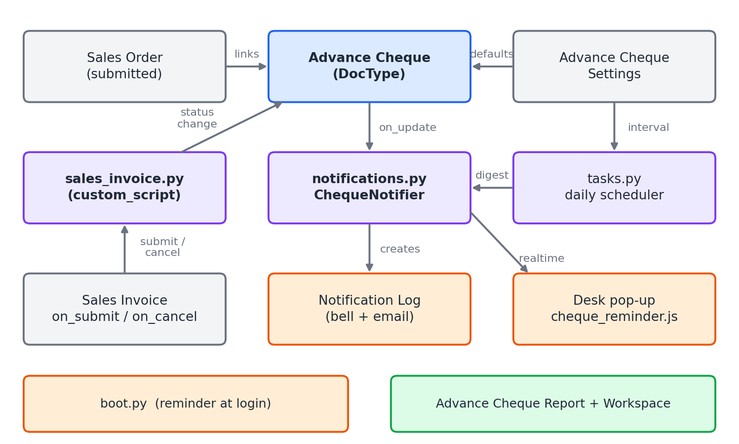
Figure 1. Components and how they call each other
Layer | Component | Responsibility
Data | Advance Cheque | Record, validation, status rules, whitelisted actions
Data | Advance Cheque Settings | Default Accounts person, daily reminder switch and interval
Automation | custom_script/sales_invoice/sales_invoice.py | Detect settlement on Sales Invoice submit and cancel; change cheque status
Automation | tasks.py | Daily digest for cheques still in Return Pending
Delivery | notifications.py | Resolve recipients, write Notification Log, publish pop-up, clear alerts
Delivery | boot.py + cheque_reminder.js | Pop-up on live event and reminder at login
Insight | Advance Cheque Report | One script report with a Status filter
Insight | Workspace, number cards, chart | Management dashboard

4. Data model

4.1 Advance Cheque
Naming: ACH-{YYYY}-{#####}. Title field: cheque number. Change tracking is on, so every edit is in the timeline. Not submittable.
Field | Type | Rules
sales_order | Link: Sales Order | Mandatory. Must be submitted. Indexed.
customer | Link: Customer | Fetched from the Sales Order. Read-only. Must match the order.
company | Link: Company | Fetched from the Sales Order. Read-only.
sales_person | Link: Sales Person | Defaults to the first Sales Person on the order. Editable.
sales_person_user | Link: User | Read-only. Resolved as Sales Person, then Employee, then User.
accounts_responsible_person | Link: User | Mandatory. Defaults from Settings.
cheque_number | Data | Mandatory. Unique per Sales Order.
cheque_amount | Currency | Mandatory. Must be greater than zero.
cheque_issue_date | Date | Mandatory. Defaults to today.
cheque_status | Select | Issued, Return Pending or Returned. Default Issued. Indexed.
return_pending_since | Date | Set by the system when status becomes Return Pending. Drives days pending.
actual_return_date | Date | Shown and mandatory only when Returned. Not before issue date. Cleared otherwise.
last_reminded_on | Date | Hidden. Set when an alert or digest is sent. Drives the daily interval.
remarks | Small Text | Free text. Return remarks are appended.

4.2 Advance Cheque Settings (single)
Field | Type | Purpose
enable_daily_reminder | Check | Turns the daily digest on or off. Default on.
reminder_interval_days | Int | Days between digests for the same cheque. Minimum 1. Default 1.
default_accounts_responsible_person | Link: User | Used when a cheque is saved without an Accounts person.

4.3 Validation rules
# | Rule | Error type
1 | Sales Order must be submitted. | ValidationError
2 | Customer, if set, must match the Sales Order customer. | ValidationError
3 | Cheque amount must be greater than zero. | ValidationError
4 | Same cheque number cannot be recorded twice for the same Sales Order. | DuplicateEntryError
5 | Returned needs an Actual Return Date. The date cannot be before the issue date. | ValidationError

5. Status lifecycle
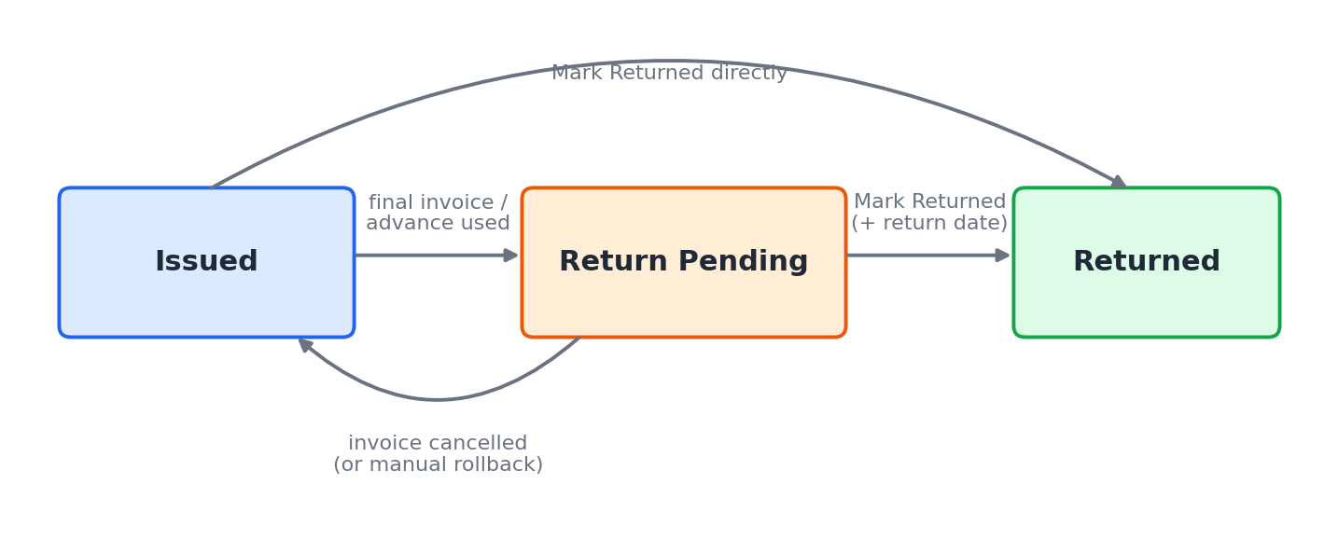
Figure 2. Cheque status transitions
From | To | Triggered by | Who | Side effects
Issued | Return Pending | Settlement detected, or Mark As > Return Pending | System or user | Sets return_pending_since. Alerts to both people.
Return Pending | Returned | Mark As > Returned | User | Return date saved. Alerts cleared.
Issued | Returned | Mark As > Returned | User | For cheques handed back early. Alerts cleared.
Return Pending | Issued | Sales Invoice cancelled and order no longer settled (or the field edited by hand) | System or user | return_pending_since cleared. Alerts cleared.
Returned | Any | Edit status | User | Return date cleared.

6. Process flows

6.1 Recording a cheque
1. User opens Advance Cheque > New and picks a Sales Order. The picker lists only submitted orders.
2. The form fills Customer and Company (fetch from Sales Order). A server call get_sales_order_defaults fills the Sales Person from the order's sales team.
3. User enters cheque number, amount and issue date. Accounts person defaults from Settings.
4. On Save, validate() runs in this order: default Accounts person, Sales Order check, amount check, duplicate check, return-date rules, Sales Person user lookup, Return Pending date.
5. If the Sales Person has no linked User, an orange alert tells the user that only the Accounts person will be notified.
6. The record is stored with status Issued. No alert is sent yet.

6.2 Settlement detection (the core flow)
Sales Invoice submitted
-> ERPNext updates Sales Order billing and advance data
-> hook: custom_script/sales_invoice/sales_invoice.on_submit(doc)
for each Sales Order on the invoice items:
is_settled(order)
= per_billed >= 100
OR advance_paid > 0 AND allocated_advance >= advance_paid
if settled:
change_status(order, 'Issued', 'Return Pending')
for each cheque of that order with status 'Issued':
set status, save, add timeline comment
on error: log it and carry on

Hooks run after ERPNext's own submit logic, so billing and advance values are already up to date when the check runs.
Why allocated advance is read from the invoice
When an advance is allocated to an invoice, ERPNext repoints the Payment Entry reference from the Sales Order to the Sales Invoice. The link back to the order then exists only through the invoice, so get_allocated_advance() sums Sales Invoice Advance.allocated_amount over submitted invoices whose items reference the order.

6.3 Delivering the reminder
When cheque_status changes to Return Pending, AdvanceCheque.on_update() calls ChequeNotifier.notify_return_pending(). The notification goes to the Accounts person and the Sales Person user, once each.
Channel | How | Reaches
Desk pop-up | frappe.publish_realtime('advance_cheque_return_pending') to the user, after commit. cheque_reminder.js shows a dialog with a link. | Users who are logged in now
Bell + email | A Notification Log of type Alert with a link to the cheque. Frappe emails it by the user's notification settings. | Everyone, including offline users
Login reminder | boot_session adds the user's Return Pending cheques. The desk shows one dialog per browser session. | Users who log in later
Daily digest | tasks.send_pending_return_reminders() sends one Notification Log per user listing all their open cheques. | Anyone still holding open cheques

6.4 Daily digest
1. Scheduler runs send_pending_return_reminders() once a day.
2. It stops if Send Daily Reminder is off in Settings.
3. It loads all Return Pending cheques and keeps those never reminded, or last reminded at least the configured interval (in days) ago.
4. It groups the cheques by recipient and calls send_digest(user, cheques) once per user.
5. It stamps last_reminded_on on the cheques it included.

6.5 Returning the cheque
1. The user opens the cheque and clicks Mark As > Returned.
2. A prompt asks for the Actual Return Date (default today) and optional remarks.
3. mark_returned() sets the status and date, appends the remarks, and saves.
4. Validation confirms the date is present and not before the issue date.
5. on_update() sees the status change and calls ChequeNotifier.clear(): unread Notification Logs for this cheque are marked read, and last_reminded_on is cleared.
6. The cheque no longer appears in the login reminder, the daily digest, the Pending report or the pending number cards. It appears in the Returned report with its return date.

6.6 Invoice cancelled
1. on_sales_invoice_cancel re-checks each Sales Order on the invoice.
2. If the order is no longer settled, its Return Pending cheques go back to Issued, with a comment in the timeline.
3. Cheques already Returned are never touched.

7. Component design

7.1 Classes and functions
Unit | Role
AdvanceCheque (controller) | Validation; on_update sends or clears alerts; mark_return_pending() and mark_returned() for the form buttons.
get_sales_order_defaults() | Whitelisted. Returns the first Sales Person of a Sales Order for the form.
is_settled() | True when the Sales Order is fully billed or its advance is fully used.
get_allocated_advance() | Adds up advances allocated on the order's submitted invoices.
change_status() | Moves the cheques of an order between statuses. Logs an error instead of failing the invoice.
ChequeNotifier | get_users(), notify_return_pending(), clear(). Writes the Notification Log and publishes the pop-up.
send_digest() | One Notification Log per user for the daily digest.
get_sales_person_user() | Sales Person to Employee to User.
execute() | Report entry point. get_filters() builds the query, get_data() runs frappe.get_list and adds days pending, get_summary() adds the totals.
advance_cheque.reminder (JS) | Listens for the realtime event, reads boot data, builds the dialog with escaped values.

7.2 Key design decisions
Decision | Reason
Errors in the invoice hook are logged, not raised | Cheque tracking is secondary. A fault must never stop someone posting an invoice.
Notify only on status change | Posting more invoices cannot send repeat alerts, because only Issued cheques are changed.
Store sales_person_user on the cheque | The login reminder filters on a stored field with no joins.
Alerts use Notification Log | Standard Frappe bell, read state and email. No custom table to maintain.
One report with a Status filter | Pending, Returned and all cheques come from one query, so users learn one screen and filters behave the same.

8. Security and permissions
This app ships without any role permissions. They are set on the site, through Role Permission Manager, so each company can choose its own roles. Until that is done, only Administrator can open the DocTypes, reports and workspace.

8.1 What to set up on the site
Item | Where | What to decide
Advance Cheque | Role Permission Manager | Which roles can read, create, write and delete cheques
Advance Cheque Settings | Role Permission Manager | Which roles can change the reminder settings
Advance Cheque Report | Report, Roles table | Which roles can open the report
Workspace | Workspace, Roles table | Which roles see the workspace in the sidebar

8.2 Permissions set on site1.com
Added in Role Permission Manager (stored as Custom DocPerm records on the site, not in the app):
Role | Advance Cheque | Advance Cheque Settings
Sales User | Read, create, write, report | None
Sales Manager | Read, create, write, report, export | None
Accounts User | Read, create, write, report, export, print, email | None
Accounts Manager | All of the above, plus delete and share | Read, write
System Manager | All rights | Read, create, write

The reports have no role list, so they follow Advance Cheque read access. The workspace has no role list either. Sales users see all cheques; there is no row-level restriction.

8.3 Things to know
- Anyone who can write an Advance Cheque can mark it Returned. If only Accounts should do this, restrict write access to Accounts roles.
- The login reminder and alerts go to the users named on the cheque, whatever their permissions. A user who cannot read Advance Cheque will see the pop-up but not be able to open the link.
- Reports use frappe.get_list, so they follow whatever permissions and user restrictions you set on Advance Cheque.
- Pop-up and email content escapes all record values.

9. Reports and dashboard

9.1 Advance Cheque Report
A single script report. It opens with Status set to Pending. Change the Status filter to see other groups.
Status filter | Rows shown
Pending (default) | Issued and Return Pending, that is every cheque not yet received back
Issued | Issued only
Return Pending | Return Pending only
Returned | Returned only, with the actual return date
(empty) | All cheques

Columns: cheque, Sales Order, customer, cheque number, amount, issue date, status, return pending since, days pending, actual return date, sales person, Accounts person and remarks. Days pending is filled only for Return Pending, and actual return date only for Returned. The report has a total row and a summary (cheque count and total amount).
Filter | Applies to
Status | Cheque status, or Pending for Issued plus Return Pending
Customer, Sales Order, Sales Person, Accounts Person | Exact match
Issued From / To | Cheque Issue Date range
Returned From / To | Actual Return Date range

9.2 Workspace
The Advance Cheque Tracking workspace has four number cards (Cheques Return Pending, Return Pending Amount, Cheques Issued, Cheques Returned), a donut chart of cheques by status, and shortcuts to the list, the Cheque Report and Settings.

10. Error handling and reliability
Situation | Behaviour
Status change fails while an invoice is submitted | Logged in Error Log. The invoice still posts.
Sales Person has no User | Warning on save. Accounts person still notified.
Recipient user disabled | Skipped.
Email not configured | Pop-up and bell still work. Email sits in the queue.
Socket.IO down | Bell entry and login reminder still show the cheque.
Browser blocks storage | The login dialog may show again. Harmless.
Several invoices on one order | Only Issued cheques change, so no repeat alerts.
Daily job runs twice | last_reminded_on and the interval prevent a second digest the same day.

10.2 Performance
- Indexes on sales_order, customer, cheque_number and cheque_status.
- The settlement check runs one small aggregate query per Sales Order on the invoice.
- The boot query returns only the current user's Return Pending cheques and lists at most ten.

11. Testing
21 integration tests run with bench --site <site> run-tests --app advance_cheque_tracking. Each test builds its own users, Sales Person, Employee, item and Sales Order inside a transaction that is rolled back.
Area | Tests
Validation and rules (6) | defaults from Sales Order; zero amount rejected; duplicate number rejected; unsubmitted order rejected; Returned sets date and clears alerts; return date before issue date rejected
Invoice events (6) | partial invoice keeps Issued; final invoice moves to Return Pending; both users alerted; two invoices together settle the order; cancel reverts; Returned is never touched
Report (9) | all statuses with no filter; Pending excludes Returned; Returned shows the return date; single-status filter; days pending only for Return Pending; Sales Order filter; issue date range; return date range; customer and sales person filters

Verification status
Verified: all 21 tests pass. Not verified by automation: the visual look of the pop-up dialog and the workspace in a browser. Check these once on the user interface (Section 13).

A shared test site was not available (no database root access), so the suite runs on the development site. Set allow_tests only for the run:
bench --site site1.com set-config allow_tests true
bench --site site1.com run-tests --app advance_cheque_tracking
bench --site site1.com set-config allow_tests false

12. Installation and configuration

12.1 Install
bench get-app <repo-url> --branch version-16
bench --site <site> install-app advance_cheque_tracking
bench --site <site> migrate
bench build --app advance_cheque_tracking # production only
bench --site <site> enable-scheduler # daily digest needs the scheduler

12.2 Configure
1. Open Advance Cheque Settings. Set the default Accounts Responsible Person, switch the daily reminder on, and set the interval.
2. For each Sales Person who must be notified, open the Sales Person, set Employee, and make sure the Employee has a User ID.
3. Set permissions for Advance Cheque, the reports and the workspace in Role Permission Manager (Section 8).
4. Make sure an outgoing Email Account is set up if email alerts are wanted.

13. Demo walkthrough on the user interface

13.1 Sample data on site1.com
bench --site site1.com execute advance_cheque_tracking.demo.run created these records through the same server code the screens use. It can be run again safely.
Cheque | Sales Order | Customer | No. | Amount | What happened | Status now
ACH-2026-00001 | SAL-ORD-2026-00011 | Sharma Enterprises | 100001 | 20,000 | Final invoice, order fully billed | Return Pending
ACH-2026-00002 | SAL-ORD-2026-00012 | Mehta Trading Co. | 100002 | 35,000 | Not invoiced yet | Issued
ACH-2026-00003 | SAL-ORD-2026-00013 | Patel Industries | 100003 | 25,000 | Advance used on a part invoice (33% billed) | Return Pending
ACH-2026-00004 | SAL-ORD-2026-00014 | Rajesh Kumar | 100004 | 15,000 | Final invoice, then marked Returned | Returned
ACH-2026-00005 | SAL-ORD-2026-00015 | Gupta Textiles | 100005 | 40,000 | Not invoiced yet | Issued

User | Linked to | Password | Gets alerts for
demo.accounts@example.com | Accounts person on all cheques | Demo@12345 | All five cheques
demo.sales1@example.com | Sales Person Amit Joshi | Demo@12345 | 00001, 00004
demo.sales2@example.com | Sales Person Priya Desai | Demo@12345 | 00002, 00005

The demo users have no roles. Log in as Administrator for the walkthrough, or give a demo user access in Role Permission Manager first.
Before going live
These three demo users and the demo passwords are for testing only. Disable or delete them on a production site.

13.2 Steps to repeat on the screen
Log in as Administrator (or a user you have given access) and follow these steps to see the complete process.
1. Record a cheque. Open Advance Cheque Tracking > Advance Cheque > New. Pick a submitted Sales Order. Customer and Sales Person fill by themselves. Enter cheque number, amount and issue date. Save. Status is Issued. (The five sample orders already have a cheque, so create a new Sales Order for a fresh record, or add a second cheque with a different number.)
2. Trigger the reminder. Open a Sales Order that has a cheque, choose Create > Sales Invoice, tick Allocate Advances Automatically (FIFO) (or use Get Advances Received) if the order has an advance, and submit the invoice for the full amount.
3. See the alert. The cheque is now Return Pending. If the Sales Person or Accounts user is logged in, a Collect Advance Cheque pop-up appears. The bell icon shows a notification for each. A comment in the cheque timeline names the invoice.
4. Check the login reminder. Log in as demo.sales1@example.com (after giving it access). A pop-up lists ACH-2026-00001.
5. Confirm the return. Open the cheque, choose Mark As > Returned, enter the actual return date and remarks, and confirm.
6. Check the reminder is gone. The status shows Returned. The bell entries are read. The cheque is missing from Advance Cheque Report when Status is Pending.
7. Check the report. Open Advance Cheque Report and set Status to Returned. The cheque shows with its return date. Try the filters: Sales Order, customer, sales person, date ranges.
8. Check the dashboard. Open the Advance Cheque Tracking workspace. Number cards and the status chart match the list.

13.3 Expected results at a glance
Check | Expected
Partial invoice, advance not used up | Cheque stays Issued
Final invoice | Return Pending; pop-up, bell and email to Sales Person and Accounts person
Advance fully used on part invoice | Return Pending (SAL-ORD-2026-00013)
Cancel the final invoice | Back to Issued
Mark Returned | Alerts read; leaves Pending report; shows in Returned report with date

14. Limitations and future work
Item | Detail | Possible improvement
Currency | Advance utilisation compares amounts without conversion. | Convert to company currency before comparing.
Several Sales Persons on one order | Only the first Sales Person is used. | Notify every Sales Person on the team.
Advance not linked to the order | Advances allocated on the order's invoices count, even if paid for another order. | Match by Payment Ledger entries.
Escalation | No escalation to a manager after many days. | Add an escalation days setting and a manager recipient.
Email wording | Emails use the standard Notification Log template. | Add a dedicated Email Template.
Multiple cheques per order | Supported. All cheques of a settled order change together. | Allow per-cheque amounts against invoice value.

Appendix A. File map
advance_cheque_tracking/
hooks.py hooks (Appendix B)
notifications.py ChequeNotifier, digest, recipients
tasks.py daily digest job
boot.py login reminder data
demo.py sample data
public/js/
cheque_reminder.js pop-up listener and login dialog
advance_cheque_tracking/
custom_script/sales_invoice/ sales_invoice.py: submit and cancel handlers
doctype/advance_cheque/ .json .py .js _list.js test_*.py
doctype/advance_cheque_settings/ .json .py
report/advance_cheque_report/ .json .py .js
number_card/ dashboard_chart/ workspace/
tests/
utils.py test_events.py test_reports.py

Convention: code that reacts to another doctype lives in advance_cheque_tracking/custom_script/<doctype>/<doctype>.py, with a hook entry in hooks.py. A Payment Entry handler would go in custom_script/payment_entry/payment_entry.py.

Appendix B. Hook reference
Hook | Value
required_apps | erpnext
app_include_js | cheque_reminder.js
boot_session | advance_cheque_tracking.boot.boot_session
doc_events Sales Invoice on_submit | ...custom_script.sales_invoice.sales_invoice.on_submit
doc_events Sales Invoice on_cancel | ...custom_script.sales_invoice.sales_invoice.on_cancel
scheduler_events daily | advance_cheque_tracking.tasks.send_pending_return_reminders

