Open Ended Assignment
Project Title: Blood Donation and Request Management System
Course: DBMS Project
Department: Electronics And Telecommunication
Guide: DR.Mrudul Dixit
Date : 8/10/2024
Name of Student :
- Rutuja Shete: UEC202361
- Vidisha Thool: UEC202367
- Archana Sanap: UEC2024015
- Devshree Ugane: UIN2023260

Abstract
The Blood Donation and Request Management System is a database-driven platform designed to automate and streamline the process of managing blood donations, requests, and inventory within a centralized environment. The system aims to create an efficient and transparent network that connects donors, recipients, hospitals, and administrators, ensuring that blood is made available promptly to those in need while maintaining accurate data on blood stock and donor eligibility. By digitalizing traditional manual operations, the system eliminates redundancy, minimizes human error, and enhances the overall speed and reliability of blood management processes.
The system operates through three major user roles Donor, Recipient, and Admin each having specific access rights and functionalities. Donors can register through an online form by submitting personal details .The system automatically checks donor eligibility based on the three-month minimum donation gap to ensure safety and compliance with medical guidelines. Recipients or hospitals can submit blood requests by specifying the required blood type, quantity, and urgency. Once a request is raised, the system searches for matching donors in the database or checks the availability of the requested blood type in the blood stock records.
The Admin module acts as the system’s control center, where administrators validate new donor registrations, manage incoming blood requests, monitor blood stock levels, and approve or reject requests based on availability. The admin can also assign matched donors to recipients, update inventory after each donation, and record the completion of requests. Every donation and request transaction is logged into the system, maintaining a detailed history record that helps in analytics, report generation, and future decision-making.
Technically, the system is built using Python (Flask) as the backend framework, with a MySQL relational database serving as the core data storage. The frontend is designed using HTML and CSS for a responsive and user-friendly interface.
Overall, the Blood Donation and Request Management System provides an end-to-end solution that simplifies donor and recipient interactions while maintaining a reliable record of blood transactions. The expected outcome of the project is to build a socially impactful, secure, and scalable platform that encourages voluntary blood donation, reduces shortages, and supports healthcare institutions in delivering timely and life-saving medical support.

Table of Contents
- With page numbers

Introduction
Blood is one of the most essential resources in healthcare, playing a critical role in surgeries, emergency treatments and managing chronic medical conditions such as anemia, cancer, and hemophilia. Every day, hospitals and blood banks require a continuous and reliable supply of blood to save lives. Traditionally, blood donation and request processes have been handled manually through physical records, phone calls, or local hospital networks. This approach is often inefficient, leading to delays in identifying eligible donors, tracking blood stock, and fulfilling urgent requests. Incomplete information can result in critical shortages, especially in emergencies, putting patient lives at risk.The growing population and increasing demand for blood due to accidents, medical procedures, and disasters further exacerbate the problem. Additionally, manual systems make it difficult to maintain accurate records of donor eligibility, donation history, and blood inventory Hospitals and administrators spend significant time coordinating with donors and other centers, often resulting in delays in blood availability.
This project is motivated by the need to blood donation management through a centralized digital system. By connecting donors, recipients, hospitals, and administrators on a single platform, the system aims to automate registration, eligibility checks, blood request handling, and inventory management. It promotes efficiency, transparency, and faster response during emergencies while encouraging voluntary blood donation. Ultimately, the project strives to create a socially impactful, reliable, and user-friendly platform that supports healthcare institutions in delivering timely and life-saving medical services.

Problem Statement
In conventional blood management systems:
- Donor records are maintained manually, making tracking difficult.
- Blood stock availability is often unclear, causing delays in fulfilling urgent requests.
- Donor eligibility checks and request matching are time-consuming and prone to errors.
- Communication between donors, recipients, and administrators is inefficient.
These issues can lead to critical delays in blood supply, especially in emergencies, potentially risking lives. The problem is to design a system that efficiently manages donor registration, blood requests, and stock inventory while ensuring accurate, real-time data and faster response times.

Objectives of the Project
The main objectives of the Blood Donation and Request Management System are:
- To create a centralized platform connecting donors, recipients, and administrators.
- To enable donor registration with automated eligibility verification.
- To allow recipients or hospitals to raise blood requests and track their status.
- To maintain real-time blood inventory and update it after every donation.
- To provide administrators with tools to approve requests, assign donors, and generate reports.
- To encourage voluntary blood donation by simplifying access and communication.

Scope and Limitations
Scope:
- Centralized management of donors, recipients, and administrators.
- Donor registration with eligibility tracking.
- Blood request submission and real-time status tracking.
- Automatic inventory updates after donations or request fulfillment.
- Admin control for request approval, donor assignment, and report generation.
- Donation and request history tracking for analytics.
Limitations:
- Health checks like hemoglobin levels are not verified by the system.
- Blood testing and cross-matching are not included.
- Notifications depend on internet and third-party services.
- Geolocation-based donor matching is optional.
- Limited mobile or offline access.

System Analysis
Existing system and its drawbacks :
An existing system used in hospitals and blood banks is MAK-SYSTEM eProgesa, a software platform for managing blood donations, requests, and inventory. It provides features like donor registration, blood request handling, blood stock management, and administrative control.
Drawbacks:
- The system is designed for large-scale, enterprise-level operations, making it complex for smaller institutions or academic projects.
- It requires trained personnel to operate efficiently.
- Implementation and maintenance can be expensive for small organizations.
- Limited flexibility for customization in local or community-level setups.

Proposed System and How It Improves Things:
The proposed Blood Donation and Request Management System is a centralized, digital solution that automates the management of donors, blood requests, and inventory. Unlike traditional manual processes, this system offers a simplified and organized approach suitable for hospitals, blood banks, and community projects.
Advantages of the Proposed System:
- Donor Management: Donors can register online, and the platform automatically verifies eligibility based on the last donation date, reducing human errors.
- Request Handling: Recipients or hospitals can submit requests for specific blood groups and quantities, with real-time updates on status.
- Inventory Tracking: Blood stock is updated automatically after each donation or request, providing accurate and up-to-date information.
- Administrative Control: Admins can efficiently approve requests, assign donors, manage inventory, and view transaction history.
- User-Friendly Interface: The system is easy to navigate, requiring minimal guidance for donors, recipients, and staff.
Overall, this system streamlines the entire blood management process, ensures quick access to required blood units, improves communication between stakeholders, and minimizes delays and errors compared to manual or semi-digital methods.

Feasibility Study

1. Technical Feasibility
The system is built using Python (Flask) for backend, MySQL for the database, and HTML,CSS for the frontend. It can run on normal computers or standard web servers. The design is simple, easy to maintain, and can be expanded later if needed.
2. Economic Feasibility
The project uses free and open-source tools, which keeps the cost low. It reduces the need for manual work, paperwork, and staff time, saving money for hospitals or organizations. Only basic training is required for users to operate the system.
3. Operational Feasibility
The system is easy to use for donors, recipients, and admins. It automates key tasks like checking donor eligibility, tracking blood requests, and updating inventory, making day-to-day operations faster and more reliable. It also helps improve coordination among all users and ensures blood is available when needed.

System Design
Aplication layer
Database
Presentation layer
MySql
Flask(python)
Flask
ER Diagram:
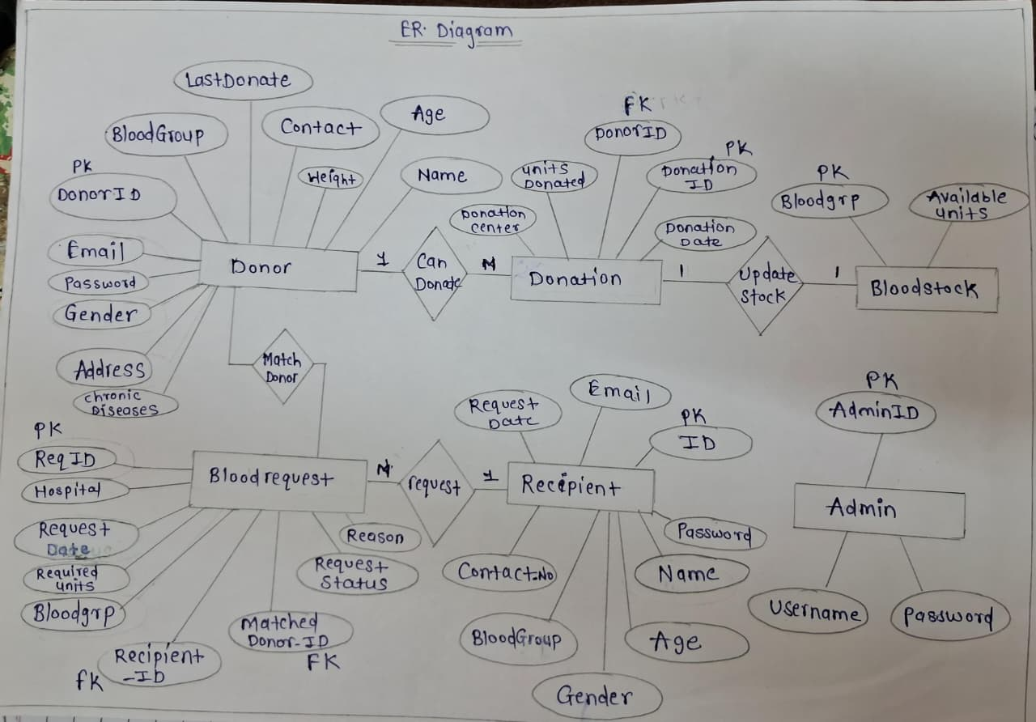

Scheme Design:
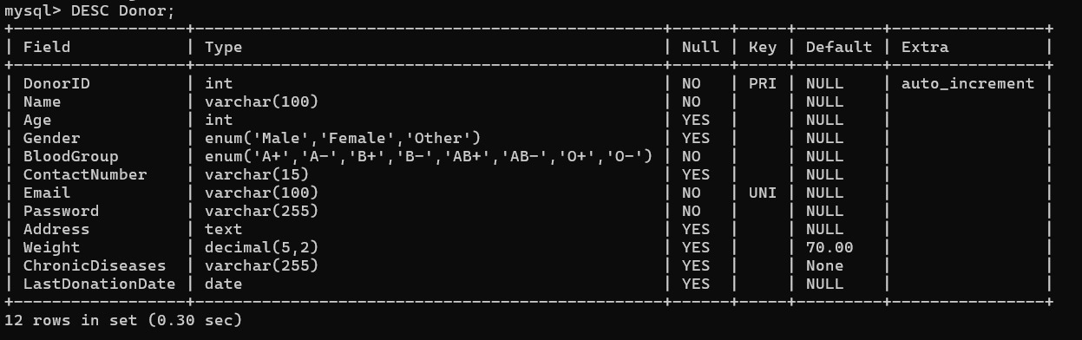
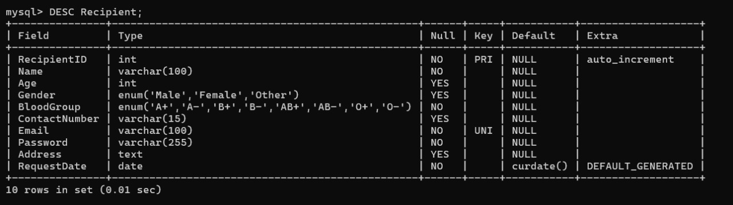
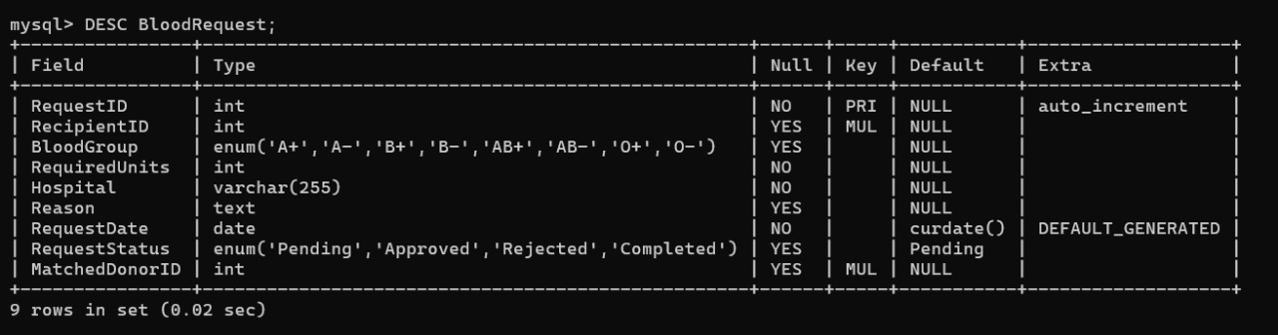
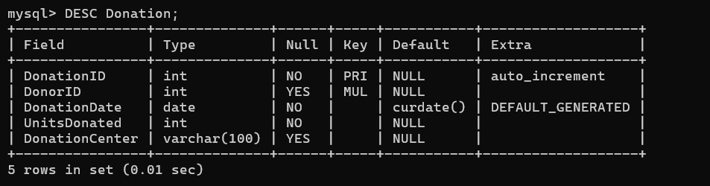
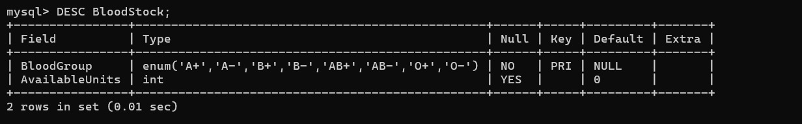
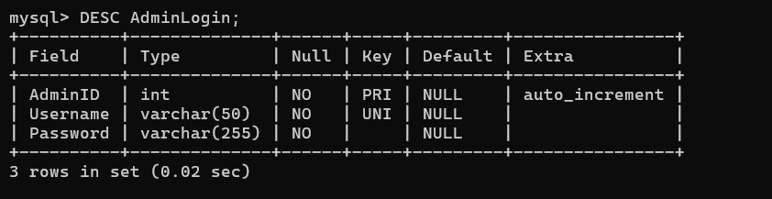
Implementation
Technologies Used
- Frontend: HTML, CSS
- Backend: Python, Flask, Flask-Bcrypt, Flask-Login
- Database: MySQL
- Frameworks/Libraries: Flask, bcrypt
- Tools: VS Code , MySQL Workbench, Git/GitHub

Interfacing Code:
- app.py
from flask import Flask, render_template, request, redirect, url_for, session, flash, g
from flask_mysqldb import MySQL
from datetime import datetime, timedelta
from functools import wraps

# --- Configuration ---
app = Flask(__name__)
# IMPORTANT: Use a complex key in production!
app.config['SECRET_KEY'] = 'a_very_secure_secret_for_flask_sessions'

# MySQL Database Configuration (!!! REPLACE WITH YOUR CREDENTIALS !!!)
app.config['MYSQL_HOST'] = '127.0.0.1'

app.config['MYSQL_USER'] = 'root'
app.config['MYSQL_PASSWORD'] = 'root@123'
app.config['MYSQL_DB'] = 'blood_donation_db'
app.config['MYSQL_CURSORCLASS'] = 'DictCursor'

app.config['MYSQL_AUTOCOMMIT'] = False

mysql = MySQL(app)

# --- Decorators and Utility Functions ---

def login_required(role):
"""A decorator to restrict access to certain roles."""
def wrapper(f):
@wraps(f)
def decorated_function(*args, **kwargs):
if not g.user or g.role != role:
flash(f"Access Denied. Please log in as a {role.capitalize()}.", 'danger')
return redirect(url_for(role + '_page', view='login'))
return f(*args, **kwargs)
return decorated_function
return wrapper

def get_db_cursor():
"""Initializes and returns a database cursor, handling connection errors."""
if 'cursor' not in g:
try:
g.conn = mysql.connection
g.cursor = g.conn.cursor()
except Exception as e:
flash(f"Database connection failed. Check your MySQL settings. Error: {e}", 'danger')
return None
return g.cursor

@app.teardown_appcontext
def close_db(e=None):
"""Closes the database connection at the end of the request."""
g.pop('cursor', None)
g.pop('conn', None)

def update_blood_stock(blood_group, units_change, cursor, conn):
"""Adds/removes units from BloodStock table."""
try:
# Check if the BloodGroup exists
cursor.execute("SELECT BloodGroup FROM BloodStock WHERE BloodGroup = %s", [blood_group])
if cursor.fetchone() is None:
# If group doesn't exist, insert it (shouldn't happen with the provided schema)
cursor.execute("INSERT INTO BloodStock (BloodGroup, AvailableUnits) VALUES (%s, %s)", (blood_group, units_change))
return True

cursor.execute("UPDATE BloodStock SET AvailableUnits = AvailableUnits + %s WHERE BloodGroup = %s", (units_change, blood_group))
return True
except Exception as e:
flash(f"Stock update failed: {e}", 'danger')
return False

def check_donor_eligibility(donor_data):
"""Implements the eligibility logic (age, weight, last donation, medical)."""
age = donor_data.get('Age')
weight = donor_data.get('Weight')
last_donation_date = donor_data.get('LastDonationDate')
chronic_diseases = donor_data.get('ChronicDiseases', 'None')

# 1. Age check
try:
age = int(age)
if not (18 <= age <= 65):
return False, "Age must be between 18 and 65."
except:
return False, "Invalid age provided."

# 2. Weight check
try:
weight = float(weight)
if weight < 50:
return False, "Weight must be over 50 kg."
except:
# If weight is None/missing in DB, allow them to proceed to fill the form.
if weight is None or weight == 0:
return True, "Eligible to donate, but please update weight/details."
return False, "Invalid weight provided."

# 3. Last Donation Date check (90 days wait)
if last_donation_date:
try:
last_date = last_donation_date # Assumes it's a date object from DB query
if isinstance(last_donation_date, str):
last_date = datetime.strptime(last_donation_date, '%Y-%m-%d').date()
elif isinstance(last_donation_date, datetime):
last_date = last_donation_date.date()

today = datetime.now().date()
if today < (last_date + timedelta(days=90)):
wait_days = 90 - (today - last_date).days
return False, f"Must wait {wait_days} more days since last donation."
except Exception:
# If the date format is wrong, we treat it as ineligible for safety
return False, "Error processing last donation date format."

# 4. Chronic Diseases (simplified check)
if chronic_diseases and str(chronic_diseases).lower() not in ['none', 'n/a', '']:
return False, "Medical condition recorded. Please consult a doctor."

return True, "Eligible to donate."

# --- Before Request Middleware ---
@app.before_request
def load_logged_in_user():
"""Load user data into Flask's global context (g)."""
g.user = None
g.role = session.get('user_role')
user_id = session.get('user_id')

if user_id and g.role:
cursor = get_db_cursor()
if cursor is None: return

table = g.role.capitalize()

# Adjust table name for AdminLogin
if g.role == 'admin':
table = 'AdminLogin'
cursor.execute(f"SELECT * FROM {table} WHERE AdminID = %s", [user_id])
else:
# Note: We use string formatting here for table name as it's not user input
cursor.execute(f"SELECT * FROM {table} WHERE {table}ID = %s", [user_id])

g.user = cursor.fetchone()

# --- 1. Homepage Route ---
@app.route('/')
def homepage():
"""Entry point: shows roles and blood stock summary."""
cursor = get_db_cursor()
if cursor is None:
return render_template('homepage.html', stock_levels=[], db_error=True)

try:
cursor.execute("SELECT BloodGroup, AvailableUnits FROM BloodStock")
stock_levels = cursor.fetchall()
except Exception:
flash("Database query failed. Please ensure the MySQL server is running.", 'danger')
stock_levels = []

return render_template('homepage.html', stock_levels=stock_levels, db_error=False)

# --- 2. Donor Workflow ---
@app.route('/donor', methods=['GET', 'POST'])
def donor_page():
view = request.args.get('view', 'login')
cursor = get_db_cursor()
if cursor is None: return redirect(url_for('homepage'))
conn = g.conn
today = datetime.now().date().strftime('%Y-%m-%d')

if g.user and g.role == 'donor':
# LOGGED IN: Dashboard & Donation Submission Logic

# POST: Donation Recording and Profile Update
if request.method == 'POST' and 'donation_form' in request.form:
try:
# 1. Gather & Check Eligibility based on new/updated form data
updated_age = request.form['age']
updated_weight = request.form['weight']
updated_gender = request.form['gender']
updated_blood_group = request.form['blood_group']
updated_contact = request.form['contact']
updated_address = request.form['address']
updated_diseases = request.form.get('diseases', 'None')

current_eligibility_check = {
'Age': updated_age,
'Weight': updated_weight,
'LastDonationDate': g.user.get('LastDonationDate'),
'ChronicDiseases': updated_diseases
}
is_eligible, eligibility_reason = check_donor_eligibility(current_eligibility_check)

if not is_eligible:
flash(f'Donation failed. You are currently ineligible: {eligibility_reason}', 'danger')
return redirect(url_for('donor_page', view='dashboard'))

# 2. Update Donor Profile (with placeholder 'Password' and the new health details)
# Assumes Donor table has Password, Weight, ChronicDiseases, ContactNumber, Address
cursor.execute("""
UPDATE Donor
SET Age = %s, Weight = %s, Gender = %s, BloodGroup = %s, ChronicDiseases = %s, ContactNumber = %s, Address = %s
WHERE DonorID = %s
""", (updated_age, updated_weight, updated_gender, updated_blood_group, updated_diseases, updated_contact, updated_address, g.user['DonorID']))

# 3. Record Donation
date_str = request.form['date']
units = int(request.form['units'])
hospital = request.form['hospital']

cursor.execute("INSERT INTO Donation (DonorID, DonationDate, UnitsDonated, DonationCenter) VALUES (%s, %s, %s, %s)",
(g.user['DonorID'], date_str, units, hospital))

# 4. Update Donor's LastDonationDate
cursor.execute("UPDATE Donor SET LastDonationDate = %s WHERE DonorID = %s", (date_str, g.user['DonorID']))

# 5. Update Blood Stock
if not update_blood_stock(updated_blood_group, units, cursor, conn):
raise Exception("Failed to update blood stock.")

conn.commit()
flash('Donation recorded and stock updated! Thank you.', 'success')
return redirect(url_for('donor_page', view='dashboard'))
except Exception as e:
conn.rollback()
flash(f'Error recording donation: {e}', 'danger')
return redirect(url_for('donor_page', view='dashboard'))

# GET: Dashboard View
donor = g.user

# Recalculate eligibility with the currently loaded data for the display
donor_data_for_display = {
**donor,
'Weight': donor.get('Weight') or 70,
'ChronicDiseases': donor.get('ChronicDiseases') or 'None'
}
eligible_for_display, reason_for_display = check_donor_eligibility(donor_data_for_display)

# Fetch History
cursor.execute("SELECT DonationDate, UnitsDonated, DonationCenter FROM Donation WHERE DonorID = %s ORDER BY DonationDate DESC", [donor['DonorID']])
donation_history = cursor.fetchall()

return render_template('donor_page.html', view='dashboard', donor=donor, today=today, eligibility_status=f"Status: {'Eligible' if eligible_for_display else 'Ineligible'}. Reason: {reason_for_display}", donation_history=donation_history)

# --- Login/Register Logic ---
if request.method == 'POST':
conn = g.conn
try:
email = request.form['email']
password = request.form['password'] # Must match HTML form input name

# 1. Attempt Login
cursor.execute("SELECT * FROM Donor WHERE Email = %s AND Password = %s", [email, password])
donor = cursor.fetchone()

if donor:
# SUCCESS: Existing user found and logged in
session['user_id'] = donor['DonorID']
session['user_role'] = 'donor'
flash('Login successful! Welcome back.', 'success')
return redirect(url_for('donor_page', view='dashboard'))

# 2. If Login failed, check if email is registered (for feedback)
cursor.execute("SELECT DonorID FROM Donor WHERE Email = %s", [email])
existing_email_record = cursor.fetchone()

if existing_email_record:
# Email found, but password was wrong.
flash('Invalid Password for the registered email. Please try again.', 'danger')
return redirect(url_for('donor_page', view='login'))

# 3. Automatic Registration (Email not found in DB)
if view == 'login' or view == 'register':
# Provide default required data for instant registration
name = request.form.get('name') or email.split('@')[0].capitalize()

# Assumes Donor table has Password, Weight, ChronicDiseases columns
cursor.execute("""
INSERT INTO Donor (Name, Age, Gender, BloodGroup, ContactNumber, Email, Address, Password, Weight, LastDonationDate, ChronicDiseases)
VALUES (%s, %s, %s, %s, %s, %s, %s, %s, %s, %s, %s)
""", (
name, 25, 'Other', 'O+', 'N/A', email, 'Unknown', password, 70, None, 'None'
))

conn.commit()

# Fetch the newly created user ID
cursor.execute("SELECT DonorID FROM Donor WHERE Email = %s", [email])
new_donor = cursor.fetchone()

session['user_id'] = new_donor['DonorID']
session['user_role'] = 'donor'

flash('Account created automatically! Please fill in all details during your first donation.', 'success')
return redirect(url_for('donor_page', view='dashboard'))

except Exception as e:
conn.rollback()
flash(f'An error occurred during login/registration: {e}', 'danger')
return redirect(url_for('donor_page', view='login'))

# GET: Login/Register Forms
return render_template('donor_page.html', view=view)

# --- 3. Recipient Workflow ---
@app.route('/recipient', methods=['GET', 'POST'])
def recipient_page():
view = request.args.get('view', 'login')
cursor = get_db_cursor()
if cursor is None: return redirect(url_for('homepage'))
conn = g.conn

if g.user and g.role == 'recipient':
# LOGGED IN: Dashboard & Request Submission Logic
# ... (Dashboard logic remains unchanged)
recipient = g.user

# POST: Blood Request Submission
if request.method == 'POST' and 'request_form' in request.form:
try:
# ... (Blood request submission logic remains unchanged)
blood_group = request.form['blood_group']
units = int(request.form['units'])
hospital = request.form['hospital']
reason = request.form['reason']

cursor.execute("""
INSERT INTO BloodRequest (RecipientID, BloodGroup, RequiredUnits, RequestStatus, Hospital, Reason)
VALUES (%s, %s, %s, 'Pending', %s, %s)
""", (recipient['RecipientID'], blood_group, units, hospital, reason))

conn.commit()
flash('Blood request submitted successfully and sent to Admin for review!', 'success')
return redirect(url_for('recipient_page', view='dashboard'))
except Exception as e:
conn.rollback()
flash(f'Error submitting request: {e}', 'danger')
return redirect(url_for('recipient_page', view='dashboard'))

# GET: Dashboard View
# ... (Dashboard view logic remains unchanged)
cursor.execute("""
SELECT RequestID, BloodGroup, RequiredUnits, RequestDate, RequestStatus
FROM BloodRequest
WHERE RecipientID = %s
ORDER BY RequestDate DESC
""", [recipient['RecipientID']])
request_history = cursor.fetchall()

# Fetch current stock for reference
cursor.execute("SELECT BloodGroup, AvailableUnits FROM BloodStock")
blood_stock = cursor.fetchall()

return render_template('recipient_page.html', view='dashboard', recipient=recipient, request_history=request_history, blood_stock=blood_stock)

# --- Login/Register Logic (MODIFIED) ---
if request.method == 'POST':
try:
# The initial credentials submitted by the user
initial_email = request.form.get('email')
initial_password = request.form.get('password')

# 1. Registration Submission (Happens when view='register' and the full form is posted)
if view == 'register':
# Full Registration details from the form
name = request.form['name']
age = request.form['age']
gender = request.form['gender']
blood_group = request.form['blood_group_needed']
contact = request.form['contact']
address = request.form['address']

# Retrieve the original login credentials from the hidden fields/URL parameters
# In this implementation, we will use the URL parameters to get the credentials
# The HTML modification below ensures these are passed in the POST request (via hidden fields)
registration_email = request.form['registration_email']
registration_password = request.form['registration_password']

# Insert new recipient
cursor.execute("""
INSERT INTO Recipient (Name, Age, Gender, BloodGroup, ContactNumber, Email, Address, Password)
VALUES (%s, %s, %s, %s, %s, %s, %s, %s)
""", (name, age, gender, blood_group, contact, registration_email, address, registration_password))

conn.commit()

# Fetch the newly created user ID
cursor.execute("SELECT RecipientID FROM Recipient WHERE Email = %s", [registration_email])
new_recipient = cursor.fetchone()

session['user_id'] = new_recipient['RecipientID']
session['user_role'] = 'recipient'
flash('Registration successful! You are now logged in.', 'success')
return redirect(url_for('recipient_page', view='dashboard'))

# 2. Attempt Login (Happens when view='login' is posted)

# 1. Attempt Login with full credentials
cursor.execute("SELECT * FROM Recipient WHERE Email = %s AND Password = %s", [initial_email, initial_password])
recipient = cursor.fetchone()

if recipient:
# Login successful
session['user_id'] = recipient['RecipientID']
session['user_role'] = 'recipient'
flash('Login successful! You can now make a blood request.', 'success')
return redirect(url_for('recipient_page', view='dashboard'))

# 2. Login Failed: Check if user exists by email only
cursor.execute("SELECT RecipientID FROM Recipient WHERE Email = %s", [initial_email])
existing_user = cursor.fetchone()

if existing_user:
# User exists, but password was wrong
flash('Invalid Password for existing account. Please try again.', 'danger')
return redirect(url_for('recipient_page', view='login', email=initial_email))
else:
# User does not exist, redirect to registration page
flash('Account not found. Please complete your registration.', 'info')
# Pass the email and password to pre-fill or use in the registration form
return redirect(url_for('recipient_page', view='register', email=initial_email, password=initial_password))

except Exception as e:
conn.rollback()
flash(f'An error occurred: {e}', 'danger')
return redirect(url_for('recipient_page', view='login'))

# GET: Login/Register Forms
# We pass the parameters to the template for pre-filling/hidden fields
return render_template('recipient_page.html', view=view, email=request.args.get('email', ''), password=request.args.get('password', ''))

# --- 4. Admin Workflow ---
@app.route('/admin', methods=['GET', 'POST'])
def admin_page():
# Always default view to 'login' for URL/GET requests
view = request.args.get('view', 'login')
cursor = get_db_cursor()
if cursor is None: return redirect(url_for('homepage'))
conn = g.conn

# 1. Check for Authentication
if not g.user or g.role != 'admin':
# If unauthenticated, handle only the POST login attempt
if request.method == 'POST':
# Check if the required login fields are present
if 'username' in request.form and 'password' in request.form:
username = request.form['username']
password = request.form['password']

cursor.execute("SELECT AdminID FROM AdminLogin WHERE Username = %s AND Password = %s", (username, password))
admin = cursor.fetchone()

if admin:
session['user_id'] = admin['AdminID']
session['user_role'] = 'admin'
flash('Admin login successful!', 'success')
# Redirect after successful login
return redirect(url_for('admin_page', view='dashboard'))
else:
# Handle auto-creation/login failure for new/invalid user
cursor.execute("SELECT AdminID FROM AdminLogin WHERE Username = %s", [username])
if cursor.fetchone():
flash('Invalid Password', 'danger')
else:
try:
# Auto-create Admin (simple registration)
cursor.execute("INSERT INTO AdminLogin (Username, Password) VALUES (%s, %s)", (username, password))
conn.commit()
cursor.execute("SELECT AdminID FROM AdminLogin WHERE Username = %s", [username])
new_admin = cursor.fetchone()
session['user_id'] = new_admin['AdminID']
session['user_role'] = 'admin'
flash('New Admin record created and logged in!', 'success')
return redirect(url_for('admin_page', view='dashboard'))
except Exception as e:
conn.rollback()
flash(f"Error creating admin: {e}", 'danger')

else:
# This catches POST requests from the dashboard (like Reject)
# when the user session has expired. Prevents the KeyError.
flash('Session expired or access denied. Please log in.', 'danger')

# Render login page if unauthenticated (GET or failed POST)
return render_template('admin_page.html', view='login')

# 2. Authenticated Admin Dashboard Logic
# We are now guaranteed g.user and g.role == 'admin'
view = 'dashboard'

# --- POST: Admin Action Handlers (Request Management) ---
if request.method == 'POST':
try:
# 1. Request Management
if 'request_action' in request.form:
req_id = request.form['request_id']
action = request.form['request_action']

# CRITICAL FIX: Convert ID to integer immediately for safer use in queries
req_id_int = int(req_id)

if action == 'Approve':
# Use req_id_int for query parameter
cursor.execute("SELECT RequiredUnits, BloodGroup, RequestStatus FROM BloodRequest WHERE RequestID = %s", [req_id_int])
request_details = cursor.fetchone()

if request_details and request_details['RequestStatus'] == 'Pending':
units_needed = request_details['RequiredUnits']
blood_group = request_details['BloodGroup']

# Deduct stock upon approval (THIS IS THE DEDUCTION LOGIC)
if update_blood_stock(blood_group, -units_needed, cursor, conn):
# Use list for query parameters: [status, id]
cursor.execute("UPDATE BloodRequest SET RequestStatus = %s WHERE RequestID = %s", ['Approved', req_id_int])
flash(f'Request {req_id} Approved. {units_needed}mL of {blood_group} deducted from stock (Reserved).', 'success')
else:
flash(f'Approval failed: Insufficient stock of {blood_group} ({units_needed}mL needed).', 'danger')
else:
flash('Only Pending requests can be Approved.', 'danger')

elif action == 'Reject':
# Rejection logic (no stock change needed)
# Use list for query parameters: [status, id]
cursor.execute("UPDATE BloodRequest SET RequestStatus = %s WHERE RequestID = %s", ['Rejected', req_id_int])
flash(f'Request {req_id} Rejected.', 'info')

elif action == 'Complete':
# Update status to Completed. Stock deduction already occurred at Approval.
cursor.execute("SELECT RequestStatus FROM BloodRequest WHERE RequestID = %s", [req_id_int])
request_details = cursor.fetchone()

if request_details and request_details['RequestStatus'] == 'Approved':
# Use list for query parameters: [status, id]
cursor.execute("UPDATE BloodRequest SET RequestStatus = %s WHERE RequestID = %s", ['Completed', req_id_int])
flash(f'Request {req_id} Completed. Stock was previously reserved upon Approval.', 'success')
else:
flash('Cannot complete a request that is not Approved.', 'danger')

# THE MANUAL STOCK UPDATE BLOCK WAS REMOVED HERE.
# Stock management is now ONLY driven by Donor Submissions and Request Approvals.

conn.commit()
return redirect(url_for('admin_page', view='dashboard'))

except Exception as e:
conn.rollback()
flash(f'Transaction failed: {e}', 'danger')
return redirect(url_for('admin_page', view='dashboard'))

# --- GET: Dashboard Data Fetching ---

# 1. Fetch Blood Stock
cursor.execute("SELECT BloodGroup, AvailableUnits FROM BloodStock")
blood_stock = cursor.fetchall()

# 2. Fetch Requests
cursor.execute("""
SELECT br.*, r.Name AS RecipientName
FROM BloodRequest br JOIN Recipient r ON br.RecipientID = r.RecipientID
ORDER BY br.RequestDate DESC
""")
all_requests = cursor.fetchall()

pending_requests = [req for req in all_requests if req['RequestStatus'] == 'Pending']
approved_requests = [req for req in all_requests if req['RequestStatus'] == 'Approved']

# 3. Fetch Donors and Recipients
cursor.execute("SELECT DonorID, Name, BloodGroup, Email, LastDonationDate FROM Donor")
all_donors = cursor.fetchall()

# Calculate eligibility for Admin view
for donor in all_donors:
# Need to refetch all details for eligibility check (or assume defaults)
cursor.execute("SELECT * FROM Donor WHERE DonorID = %s", [donor['DonorID']])
full_donor_data = cursor.fetchone()

# Ensure required keys exist with defaults for safety in check_donor_eligibility
donor_data_for_check = {
**full_donor_data,
'Weight': full_donor_data.get('Weight') or 70.0,
'ChronicDiseases': full_donor_data.get('ChronicDiseases') or 'None',
'LastDonationDate': full_donor_data.get('LastDonationDate')
}

eligible, _ = check_donor_eligibility(donor_data_for_check)
donor['EligibilityStatus'] = 'Eligible' if eligible else 'Ineligible'

cursor.execute("SELECT RecipientID, Name, BloodGroup, ContactNumber FROM Recipient")
all_recipients = cursor.fetchall()

# 4. Reporting Summary
cursor.execute("SELECT SUM(UnitsDonated) AS total_donations FROM Donation")
total_donations = cursor.fetchone()['total_donations'] or 0

cursor.execute("SELECT RequestStatus, COUNT(*) as count FROM BloodRequest GROUP BY RequestStatus")
request_counts_raw = cursor.fetchall()
request_counts = {item['RequestStatus']: item['count'] for item in request_counts_raw}

reports = {
'total_donations': total_donations,
'total_requests': sum(request_counts.values()),
'pending_requests': request_counts.get('Pending', 0),
'approved_requests': request_counts.get('Approved', 0),
'rejected_requests': request_counts.get('Rejected', 0),
'completed_requests': request_counts.get('Completed', 0),
}

return render_template('admin_page.html', view=view, blood_stock=blood_stock, pending_requests=pending_requests, approved_requests=approved_requests, all_donors=all_donors, all_recipients=all_recipients, reports=reports)

# --- General Logout ---
@app.route('/logout')
def logout():
session.pop('user_id', None)
session.pop('user_role', None)
flash('You have been logged out.', 'info')
return redirect(url_for('homepage'))

if __name__ == '__main__':
# NOTE: In a production environment, use a proper WSGI server (e.g., Gunicorn)
# and ensure you replace the default database credentials.
app.run(debug=True)

- Admin Page:
{% extends "base.html" %}

{% block title %}Admin Portal{% endblock %}

{% block content %}

{% if view == 'login' %}
<h1>Admin Login 🛠</h1>
<form method="POST">
<label for="username">Username:</label><input type="text" id="username" name="username" required>
<label for="password">Password:</label><input type="password" id="password" name="password" required>
<button type="submit" class="btn btn-warning">Login / Auto-Register</button>
</form>
<p style="margin-top: 20px;">Use the sample data provided: **admin1** / **admin@123**</p>

{% elif view == 'dashboard' %}
<h1>Admin Dashboard - System Management</h1>

<div class="card-panel" style="border-left-color: var(--warning-orange);">
<h3 id="reports">Reports Summary</h3>
<div style="display: flex; justify-content: space-around; text-align: center; font-size: 1.1em;">
<div><p>Total Donations (mL):</p><strong>{{ reports.total_donations }}</strong></div>
<div><p>Total Requests:</p><strong>{{ reports.total_requests }}</strong></div>
<div><p>Pending:</p><strong class="status-orange">{{ reports.pending_requests }}</strong></div>
<div><p>Approved:</p><strong class="status-green">{{ reports.approved_requests }}</strong></div>
<div><p>Completed:</p><strong class="status-blue">{{ reports.completed_requests }}</strong></div>
</div>
</div>

<hr>
<h2 id="stock">Blood Stock Management (mL)</h2>
<p class="flash info">Update the available units directly. This is an overwrite, not an increment.</p>
<table>
<thead><tr><th>Blood Group</th><th>Available Units</th><th>Update Manually</th></tr></thead>
<tbody>
{% for stock in blood_stock %}
<tr>
<td><strong>{{ stock.BloodGroup }}</strong></td>
<td>{{ stock.AvailableUnits }}</td>
<td>
<form method="POST" style="display:inline;">
<input type="hidden" name="update_stock" value="1">
<input type="hidden" name="blood_group" value="{{ stock.BloodGroup }}">
<input type="number" name="units" min="0" value="{{ stock.AvailableUnits }}" style="width: 100px;" required>
<button type="submit" class="btn btn-warning" style="padding: 5px; margin-top: 0;">Update</button>
</form>
</td>
</tr>
{% endfor %}
</tbody>
</table>

<hr>
<h2 id="requests">Approve/Reject Pending Requests</h2>
{% if pending_requests %}
<table>
<thead><tr><th>ID</th><th>Recipient</th><th>Group</th><th>Units (mL)</th><th>Action</th></tr></thead>
<tbody>
{% for req in pending_requests %}
<tr>
<td>{{ req.RequestID }}</td>
<td>{{ req.RecipientName }}</td>
<td>{{ req.BloodGroup }}</td>
<td>{{ req.RequiredUnits }}</td>
<td>
<form method="POST" style="display:inline;">
<input type="hidden" name="request_id" value="{{ req.RequestID }}">
<input type="hidden" name="request_action" value="Approve">
<button type="submit" class="btn btn-success" style="padding: 5px;">Approve</button>
</form>
<form method="POST" style="display:inline;">
<input type="hidden" name="request_id" value="{{ req.RequestID }}">
<input type="hidden" name="request_action" value="Reject">
<button type="submit" class="btn btn-danger" style="padding: 5px;">Reject</button>
</form>
</td>
</tr>
{% endfor %}
</tbody>
</table>
{% else %}
<p class="flash info">No pending blood requests.</p>
{% endif %}

<hr>
<h2 id="approved_requests">Approved Requests (Ready for Completion)</h2>
{% if approved_requests %}
<table>
<thead><tr><th>ID</th><th>Recipient</th><th>Group</th><th>Units (mL)</th><th>Status</th><th>Action</th></tr></thead>
<tbody>
{% for req in approved_requests %}
<tr>
<td>{{ req.RequestID }}</td>
<td>{{ req.RecipientName }}</td>
<td>{{ req.BloodGroup }}</td>
<td>{{ req.RequiredUnits }}</td>
<td><strong class="status-green">Approved</strong></td>
<td>
<form method="POST" style="display:inline;">
<input type="hidden" name="request_id" value="{{ req.RequestID }}">
<input type="hidden" name="request_action" value="Complete">
<button type="submit" class="btn btn-blue" style="padding: 5px;">Mark as Complete & Deduct Stock</button>
</form>
</td>
</tr>
{% endfor %}
</tbody>
</table>
{% else %}
<p class="flash info">No approved requests ready for completion status.</p>
{% endif %}

<hr>
<h2 id="donors">View Donors</h2>
<table>
<thead><tr><th>ID</th><th>Name</th><th>Group</th><th>Email</th><th>Last Donation</th><th>Eligibility</th></tr></thead>
<tbody>
{% for donor in all_donors %}
<tr>
<td>{{ donor.DonorID }}</td><td>{{ donor.Name }}</td><td>{{ donor.BloodGroup }}</td><td>{{ donor.Email }}</td>
<td>{{ donor.LastDonationDate if donor.LastDonationDate else 'N/A' }}</td>
<td>
<strong class="{% if donor.EligibilityStatus == 'Eligible' %}status-green{% else %}status-red{% endif %}">
{{ donor.EligibilityStatus }}
</strong>
</td>
</tr>
{% endfor %}
</tbody>
</table>

<hr>
<h2 id="recipients">View Recipients</h2>
<table>
<thead><tr><th>ID</th><th>Name</th><th>Group Needed</th><th>Contact</th></tr></thead>
<tbody>
{% for recipient in all_recipients %}
<tr>
<td>{{ recipient.RecipientID }}</td><td>{{ recipient.Name }}</td><td>{{ recipient.BloodGroup }}</td>
<td>{{ recipient.ContactNumber }}</td>
</tr>
{% endfor %}
</tbody>
</table>

{% else %}
<h1 class="flash danger">Access Denied. Please log in.</h1>
{% endif %}

{% endblock %}

- Base Page
<!DOCTYPE html>
<html lang="en">
<head>
<meta charset="UTF-8">
<meta name="viewport" content="width=device-width, initial-scale=1.0">
<title>{% block title %}Blood Donation System{% endblock %}</title>
<style>
/* CSS variables for theme colors */
:root {
--primary-red: #D9534F;
--secondary-green: #5CB85C;
--warning-orange: #F0AD4E;
--info-blue: #5BC0DE;
--light-gray: #f8f8f8;
--dark-gray: #333;
}

/* Basic Resets and Typography */
body { font-family: 'Segoe UI', Tahoma, Geneva, Verdana, sans-serif; margin: 0; padding: 0; background-color: var(--light-gray); color: var(--dark-gray); }
h1, h2 { color: var(--primary-red); border-bottom: 2px solid #eee; padding-bottom: 10px; margin-top: 20px; }

/* Navigation Bar */
.navbar { background-color: var(--primary-red); padding: 10px 0; box-shadow: 0 2px 4px rgba(0,0,0,0.2); }
.navbar .nav-links { width: 90%; max-width: 1200px; margin: 0 auto; display: flex; justify-content: space-between; align-items: center; }
.navbar a { color: white; text-decoration: none; padding: 8px 15px; font-weight: 600; border-radius: 4px; transition: background-color 0.3s; }
.navbar a:hover { background-color: #C9302C; }

/* Main Container and Forms */
.container { width: 90%; max-width: 1200px; margin: 30px auto; background: white; padding: 25px; border-radius: 10px; box-shadow: 0 0 20px rgba(0, 0, 0, 0.1); }
form label { display: block; margin-top: 15px; font-weight: 600; }
form input, form select, form textarea {
width: 100%; padding: 10px; margin-top: 5px; border: 1px solid #ccc; border-radius: 5px; box-sizing: border-box; transition: border-color 0.3s; }
form input:focus, form select:focus, form textarea:focus { border-color: var(--primary-red); outline: none; }

/* Buttons */
.btn { padding: 10px 20px; border: none; border-radius: 5px; cursor: pointer; margin-top: 15px; display: inline-block; text-decoration: none; font-weight: 600; transition: background-color 0.3s, transform 0.1s; }
.btn-primary { background-color: var(--secondary-green); color: white; }
.btn-primary:hover { background-color: #4CAF50; }
.btn-danger { background-color: var(--primary-red); color: white; }
.btn-danger:hover { background-color: #C9302C; }
.btn-warning { background-color: var(--warning-orange); color: white; }
.btn-warning:hover { background-color: #E3993E; }

/* Flash Messages */
.flash { padding: 15px; margin-bottom: 20px; border-radius: 5px; font-weight: 600; border: 1px solid transparent; }
.flash.success { background-color: #d4edda; color: #155724; border-color: #c3e6cb; }
.flash.danger { background-color: #f8d7da; color: #721c24; border-color: #f5c6cb; }
.flash.warning { background-color: #fff3cd; color: #856404; border-color: #ffeeba; }
.flash.info { background-color: #d1ecf1; color: #0c5460; border-color: #bee5eb; }

/* Tables and Panels */
table { width: 100%; border-collapse: collapse; margin-top: 20px; }
th, td { border: 1px solid #ddd; padding: 12px; text-align: left; }
th { background-color: var(--primary-red); color: white; }
.card-panel { background-color: #f9f9f9; padding: 15px; border-radius: 8px; margin-top: 20px; border-left: 5px solid var(--info-blue); }
.role-buttons { display: flex; justify-content: center; gap: 20px; margin: 30px 0; }
.role-buttons .btn { min-width: 150px; text-align: center; }

/* Specific Styles to clean up inline errors */
.status-green { color: var(--secondary-green); font-weight: bold; }
.status-red { color: var(--primary-red); font-weight: bold; }
.status-blue { color: var(--info-blue); font-weight: bold; }
.status-orange { color: var(--warning-orange); font-weight: bold; }
</style>
</head>
<body>
<div class="navbar">
<div class="nav-links">
<div><a href="{{ url_for('homepage') }}">🩸 Blood Donation System</a></div>
<div>
{% if g.user %}
<a href="{{ url_for(g.role + '_page') }}">Dashboard</a>
<a href="{{ url_for('logout') }}" class="btn-danger" style="padding: 5px 10px;">Logout</a>
{% else %}
<a href="{{ url_for('donor_page', view='login') }}">Donor Login</a>
<a href="{{ url_for('recipient_page', view='login') }}">Recipient Login</a>
<a href="{{ url_for('admin_page') }}">Admin Login</a>
{% endif %}
</div>
</div>
</div>
<div class="container">
{% with messages = get_flashed_messages(with_categories=true) %}
{% if messages %}
{% for category, message in messages %}
<div class="flash {{ category }}">{{ message }}</div>
{% endfor %}
{% endif %}
{% endwith %}
{% block content %}{% endblock %}
</div>
</body>
</html>

- Homepage.Html
{% extends "base.html" %}

{% block title %}Welcome - Select Your Role{% endblock %}

{% block content %}

<!-- Navigation Bar -->
<nav class="navbar navbar-expand-lg navbar-dark bg-danger">
<div class="container">
<a class="navbar-brand" href="#">🩸 Blood Donation System</a>
<button class="navbar-toggler" type="button" data-bs-toggle="collapse" data-bs-target="#navbarNav">
<span class="navbar-toggler-icon"></span>
</button>
<div class="collapse navbar-collapse" id="navbarNav">
<ul class="navbar-nav ms-auto">
<li class="nav-item"><a class="nav-link text-white" href="{{ url_for('homepage') }}">Home</a></li>
<li class="nav-item"><a class="nav-link text-white" href="{{ url_for('donor_page', view='login') }}">Donor</a></li>
<li class="nav-item"><a class="nav-link text-white" href="{{ url_for('recipient_page', view='login') }}">Recipient</a></li>
<li class="nav-item"><a class="nav-link text-white" href="{{ url_for('admin_page') }}">Admin</a></li>
</ul>
</div>
</div>
</nav>

<!-- Hero Section -->
<div class="text-center py-5" style="background: linear-gradient(to right, #a02c2c, #cc9292); color: white; margin-top: 56px;">
<h1 class="display-4">Welcome to the Blood Donation Management System</h1>
<p class="lead">Saving lives one donation at a time</p>

<div class="my-4">
<a href="{{ url_for('donor_page', view='login') }}" class="btn btn-light btn-lg mx-2">🔴 Donor</a>
<a href="{{ url_for('recipient_page', view='login') }}" class="btn btn-light btn-lg mx-2">🧑‍🤝‍🧑 Recipient</a>
<a href="{{ url_for('admin_page') }}" class="btn btn-warning btn-lg mx-2">🛠 Admin</a>
</div>
</div>

<!-- System Info Card -->
<div class="container my-5">
<div class="card shadow p-4 text-center">
<h3>System Information</h3>
<p>The system efficiently manages blood stock, tracks donations, and handles blood requests from patients.</p>
<p><strong>Emergency Contact:</strong> 📞 +91-12345-67890 (24/7 Helpline)</p>
</div>
</div>

<!-- Blood Stock Table -->
<div class="container my-5">
<h2 class="text-center mb-4">Quick Check: Blood Stock Availability (Units in mL)</h2>
<table class="table table-striped table-bordered text-center shadow">
<thead class="table-danger">
<tr>
<th>Blood Group</th>
<th>Available Units (mL)</th>
</tr>
</thead>
<tbody>
{% for stock in stock_levels %}
<tr>
<td><strong>{{ stock.BloodGroup }}</strong></td>
<td>
<span class="{% if stock.AvailableUnits < 500 %}text-danger fw-bold{% else %}text-success fw-bold{% endif %}">
{{ stock.AvailableUnits }}
</span>
</td>
</tr>
{% endfor %}
</tbody>
</table>
</div>

{% endblock %}

- Recipent.html
{% extends "base.html" %}

{% block title %}Recipient Portal{% endblock %}

{% block content %}

{% if view == 'login' %}
<h1>Recipient Login 🧑‍🤝‍🧑</h1>
<p class="flash info">Enter your credentials. If your account is not found, you will be automatically redirected to registration.</p>
<form method="POST">
<label for="email">Email (Login ID):</label><input type="email" id="email" name="email" value="{{ request.args.get('email', '') }}" required>
<label for="password">Password:</label><input type="password" id="password" name="password" required>
<button type="submit" class="btn btn-primary">Login</button>
</form>

{% elif view == 'register' %}
<h1>Recipient Registration 🧑‍🤝‍🧑</h1>
<p class="flash info">Please complete your patient details. Your login credentials have been saved from the previous screen.</p>
<form method="POST">
<input type="hidden" name="registration_email" value="{{ request.args.get('email', '') }}" required>
<input type="hidden" name="registration_password" value="{{ request.args.get('password', '') }}" required>

<h2>Patient Details</h2>
<label for="name">Name:</label><input type="text" id="name" name="name" required>
<label for="age">Age:</label><input type="number" id="age" name="age" required>
<label for="gender">Gender:</label>
<select id="gender" name="gender" required><option value="Male">Male</option><option value="Female">Female</option><option value="Other">Other</option></select>
<label for="blood_group_needed">Required Blood Group:</label>
<select id="blood_group_needed" name="blood_group_needed" required><option value="O+">O+</option><option value="A+">A+</option><option value="B+">B+</option><option value="AB+">AB+</option><option value="O-">O-</option><option value="A-">A-</option><option value="B-">B-</option><option value="AB-">AB-</option></select>
<label for="contact">Contact Number:</label><input type="text" id="contact" name="contact">
<label for="address">Address:</label><textarea id="address" name="address"></textarea>

<button type="submit" class="btn btn-success">Complete Registration</button>
</form>
<p style="margin-top: 20px;"><a href="{{ url_for('recipient_page', view='login') }}">Back to Login</a></p>

{% elif view == 'dashboard' and recipient %}
<h1>Recipient Dashboard for {{ recipient.Name }}</h1>

<div class="card-panel" style="border-left-color: var(--primary-red);">
<h2>Submit a New Blood Request</h2>
<form method="POST">
<input type="hidden" name="request_form" value="1">
<div style="display: flex; gap: 20px;">
<div style="flex-basis: 50%;">
<label for="blood_group">Blood Group Required:</label>
<select id="blood_group" name="blood_group" required>
{% set blood_groups = ['O+', 'A+', 'B+', 'AB+', 'O-', 'A-', 'B-', 'AB-'] %}
{% for group in blood_groups %}
<option value="{{ group }}" {% if recipient.BloodGroup == group %}selected{% endif %}>{{ group }}</option>
{% endfor %}
</select>

<label for="units">Units Required (mL):</label>
<input type="number" id="units" name="units" min="100" placeholder="e.g., 500" required>
</div>
<div style="flex-basis: 50%;">
<label for="hospital">Hospital Name:</label>
<input type="text" id="hospital" name="hospital" placeholder="e.g., City General Hospital" required>
<label for="reason">Reason for Request:</label>
<textarea id="reason" name="reason" rows="2" placeholder="e.g., Emergency Surgery, Transfusion" required></textarea>
</div>
</div>
<button type="submit" class="btn btn-primary" style="margin-top: 15px;">Submit Request</button>
</form>
</div>

<hr>
<h2>Quick Check: Current Blood Stock</h2>
<table style="width: 50%;">
<thead><tr><th>Blood Group</th><th>Available Units (mL)</th></tr></thead>
<tbody>
{% for stock in blood_stock %}
<tr><td>{{ stock.BloodGroup }}</td><td>{{ stock.AvailableUnits }}</td></tr>
{% endfor %}
</tbody>
</table>

<hr>
<h2 id="status">Request Status & History</h2>
<table>
<thead><tr><th>Request ID</th><th>Group</th><th>Units</th><th>Date</th><th>Status</th></tr></thead>
<tbody>
{% for req in request_history %}
<tr>
<td>{{ req.RequestID }}</td>
<td>{{ req.BloodGroup }}</td>
<td>{{ req.RequiredUnits }}</td>
<td>{{ req.RequestDate }}</td>
<td>
<strong class="
{% if req.RequestStatus == 'Approved' %}status-green
{% elif req.RequestStatus == 'Rejected' %}status-red
{% elif req.RequestStatus == 'Completed' %}status-blue
{% else %}status-orange
{% endif %}
">
{{ req.RequestStatus }}
</strong>
</td>
</tr>
{% else %}
<tr><td colspan="5">No blood requests submitted yet.</td></tr>
{% endfor %}
</tbody>
</table>
{% else %}
<h1 class="flash danger">Access Denied. Please log in or register.</h1>
{% endif %}
{% endblock %}

Testing
Test Case ID | Input | Expected Output | Actual Output | Status
DR-01 | Name: Ravi, Age: 30, BloodGroup: O+, Email: ravi@example.com | Donor successfully registered | Donor successfully registered | Pass
DR-02 | Age: 16 | Error: "Donor must be 18 or older" | Error: "Donor must be 18 or older" | Pass
DR-03 | BloodGroup: ABX | Error: "Invalid blood group" | Error: "Invalid blood group" | Pass

Test Case ID | Input | Expected Output | Actual Output | Status
DD-01 | DonorID: 1, Units: 500, Center: Ruby Hall | Donation recorded, BloodStock updated +500 | Donation recorded, BloodStock updated +500 | Pass
DD-02 | Units: -100 | Error: "Invalid donation units" | Error: "Invalid donation units" | Pass

Test Case ID | Input | Expected Output | Actual Output | Status
BR-01 | BloodGroup: O+, Units: 500 | Request created, Pending | Request created, Pending | Pass
BR-02 | Units: 0 | Error: "Units must be greater than 0" | Error: "Units must be greater than 0" | Pass
BR-03 | BloodGroup: Z+ | Error: "Invalid blood group" | Error: "Invalid blood group" | Pass

Test Case ID | Input | Expected Output | Actual Output | Status
AD-01 | Approve request ID 1 | BloodStock reduced by requested units, request marked Approved | BloodStock reduced, request Approved | Pass
AD-02 | Reject request ID 2 | Request marked Rejected, BloodStock unchanged | Request marked Rejected, BloodStock unchanged | Pass

Testing Types
Unit Testing
- Test individual modules in isolation:
- Donor Registration function
- Donation submission function
- Blood request creation
- Admin approval/rejection functions
Integration Testing
- Test combined workflows:
  - Donor registers → submits donation → BloodStock updated → Admin sees history
  - Recipient requests blood → Admin approves → BloodStock reduced → Recipient notified
System Testing
- Test complete system end-to-end:
  - Donor + Recipient + Admin + Database
  - Forms, dashboards, notifications, eligibility checks, reports

Area | Validation / Security Measure
Donor / Recipient Registration | Age ≥ 18, valid blood group, email format, required fields
Login | Password hashing (Flask-Bcrypt), session management (Flask-Login)
Donation Submission | Units > 0, Last donation ≥ 3 months ago
Blood Request | Units > 0, valid blood group, check stock before approval
Admin Actions | Only admin can approve/reject requests, edit BloodStock
SQL Injection Prevention | Use parameterized queries / ORM methods
Input Validation | Both frontend (JS) and backend (Python) checks

Results / Snapshots
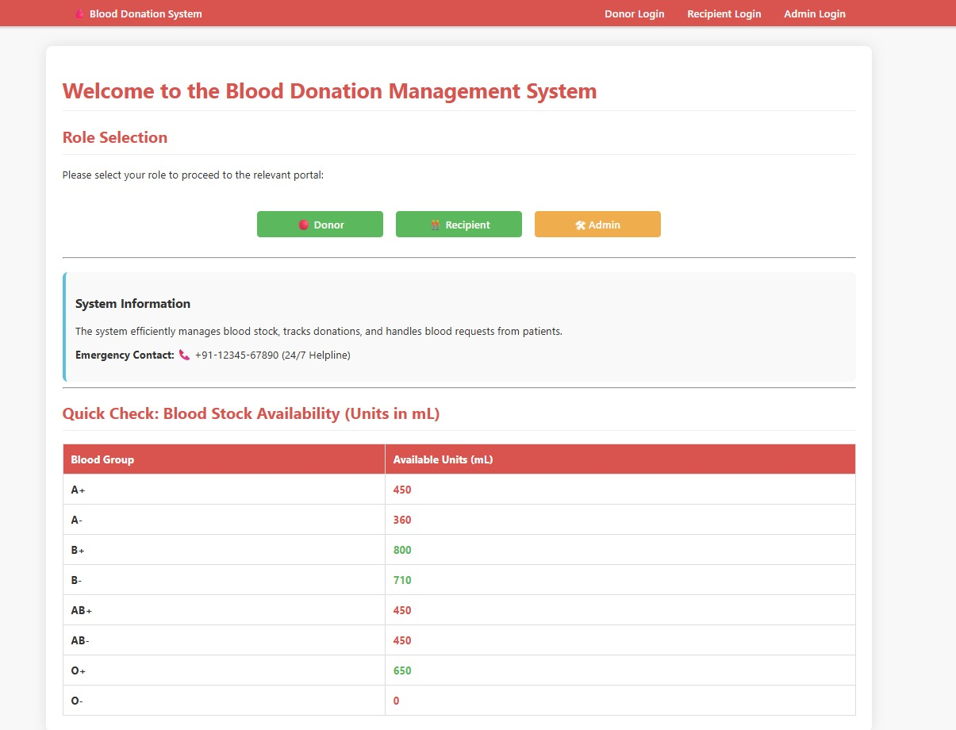

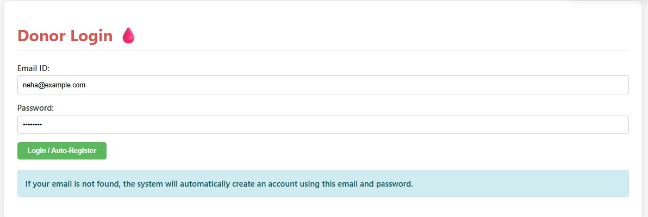

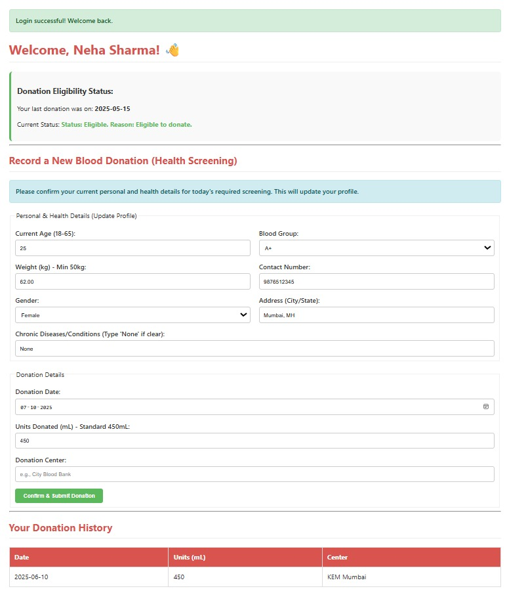
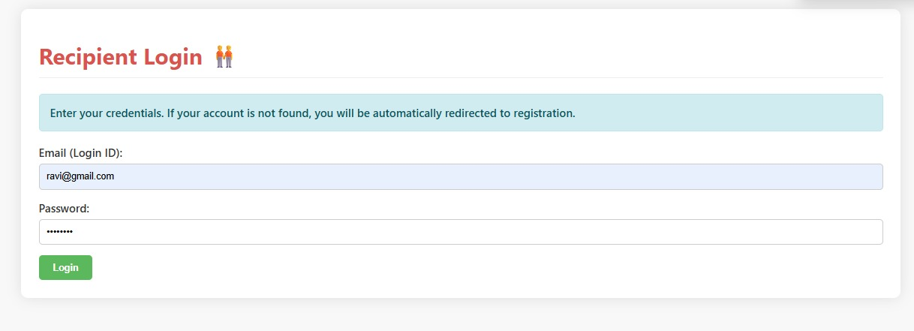
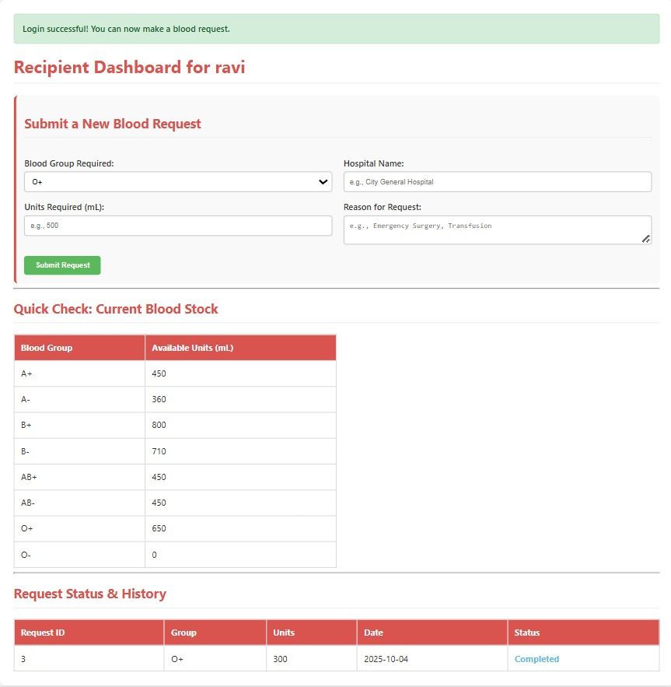
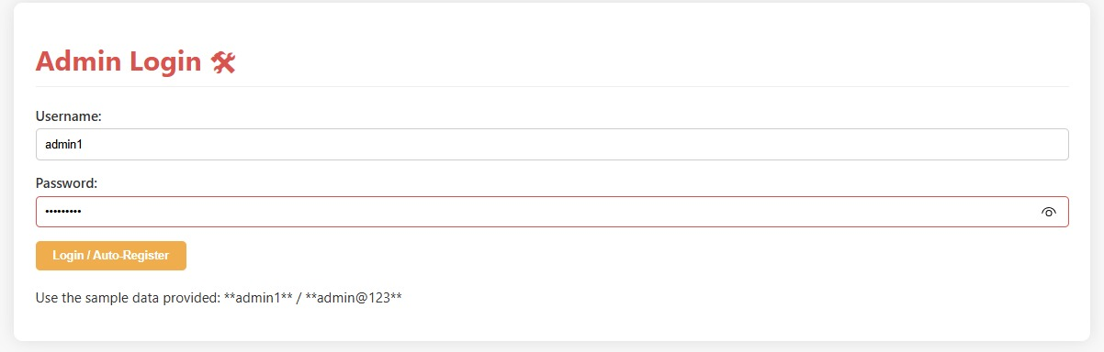
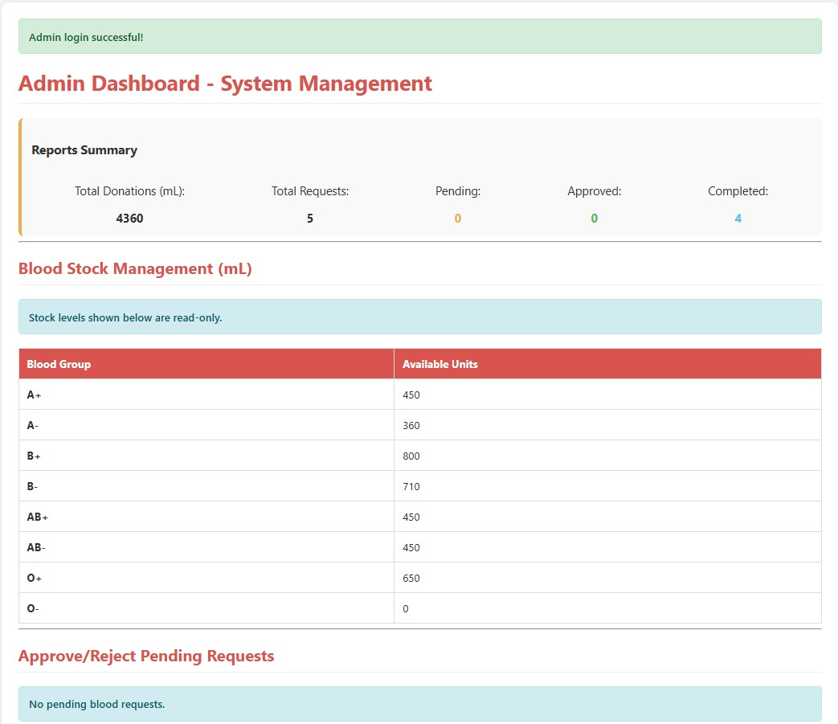

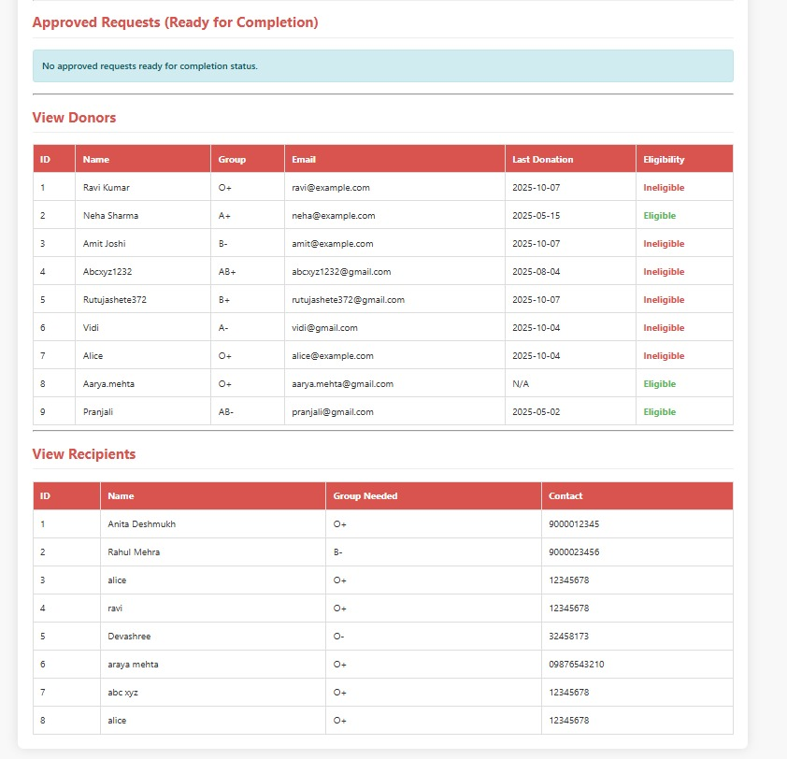

Sample queries and outputs from DBMS
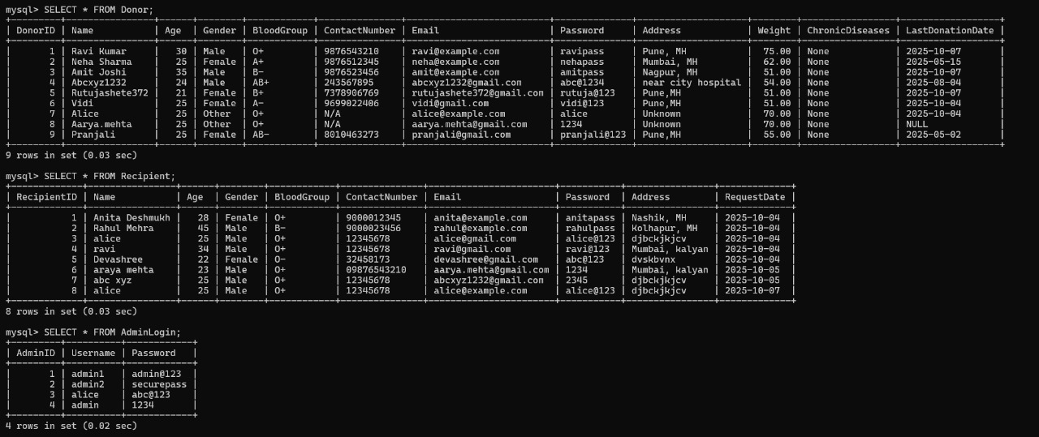

Conclusion
The Blood Donation and Request Management System efficiently automates donor registration, blood request handling, and stock monitoring through a centralized platform. It connects donors, recipients, and administrators, ensuring quick and reliable access to blood when needed. The system simplifies record management, reduces manual effort, and improves accuracy in tracking donations and availability.
Benefits include faster donor–recipient matching, enhanced transparency, secure login and data handling, and better coordination among users. It promotes awareness and encourages voluntary blood donation while maintaining safety and data integrity.
However, some limitations remain, such as the lack of real-time location tracking, limited hospital integration, and absence of a mobile version. Future improvements could include AI-based donor recommendations, mobile app access, and cloud integration for scalability. Overall, the system provides an impactful, technology-driven solution for efficient blood management.

Future Enhancements
1.Integration with IoT Devices
Connect IoT-based health monitoring devices (like blood pressure or hemoglobin sensors) to automatically update donor health eligibility before donation.
Enhance accuracy and safety in donor screening.

2. Integration with Hospitals and NGOs
Connect the system with hospital management systems and NGO networks for automatic request forwarding and better collaboration.
Support real-time inventory sharing between blood banks

3.Predictive Stock Management
Use predictive analytics to estimate future shortages of specific blood types.
Help blood banks maintain optimal stock levels and minimize wastage.

References
https://www.irjmets.com/uploadedfiles/paper/issue_4_april_2023/35976/final/fin_irjmets1681586396.pdf
https://www.ijcrt.org/papers/IJCRT2105420.pdf

