

Automation Testing and Report Generation of

Park-EZY



Revision Records-
Version | Document History | Prepared by | Reviewed by | Approved by | Date
1 | Wipro-Pari (Park EZY) | Rutuja |  |  | 27/01/24

Table 1: Revision Records

Table of Contents-
- Park-EZY (Wipro Pari) - 5
Objective- 5
- System Overview- 5
- Basic Requirements- 6
i) Development Environment: 6
ii) Build Tool: 6
iii) Serenity BDD Dependencies: 6
iv) Feature Files: 6
v) Page Objects: 6
vi) Task Classes: 6
vii) Step Definitions: 6
viii) Testing Framework: 6
ix) Browser Drivers: 6
- Task List- 7
i) Environment: 7
ii) Feature File: 7
iii) Step Definition File: 7
iv) Task File: 7
v) Pages: 7
- Screenshots- 8
i) Testing report by Graph- 8
ii) Testing Report by Steps- 8
- Logs - 9
i) When Test Case Passed- 9
ii) When Test case Failed- 9

List of Figures-
- Figure 1: System Overview 6
- Figure 2 : Testing report by graph 9
- Figure 3 Testing report by each steps 9

List of Tables-

- Table 1: Revision Records 2

Park-EZY (Wipro Pari) -

Objective-
“The objective of automation testing and report generation for a desktop app using Serenity BDD is to ensure the app works as expected, detect bugs early, and save time by running tests automatically. Serenity BDD helps create clear, detailed reports that show test results and link them to business requirements. This makes it easier to understand issues, track progress, and ensure quality.”

System Overview-
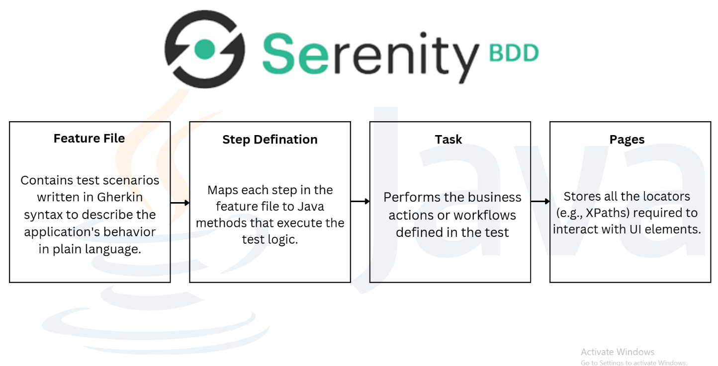

Figure 1: System Overview

Basic Requirements-

i) Development Environment:
Java Development Kit (JDK): Installed and properly configured and Integrated Development Environment (IDE): Tools like IntelliJ IDEA.

ii) Build Tool:
Maven: For managing dependencies and running tests.

iii) Serenity BDD Dependencies:
Include Serenity core, Serenity, Serenity Cucumber dependencies in your pom.xml (Maven)

iv) Feature Files:
Written in Gherkin syntax (.feature files) to define test scenarios.

v) Page Objects:
Classes containing locators (like XPaths, CSS selectors) for UI elements.

vi) Task Classes:
Classes to encapsulate business actions or workflows.

vii) Step Definitions:
Java methods to map Gherkin steps to actions or validations.

viii) Testing Framework:
Use Cucumber as the test runner.

ix) Browser Drivers:
Web Driver binaries (Chrome Driver) to interact with browser.
x) Reports:
Serenity automatically generates detailed reports, so ensure proper configuration for report generation.

Task List-

i) Environment:
Create a proper environment for automation testing which should have dependencies, JAVA version.

ii) Feature File:
Contains test scenarios written in Gherkin syntax to describe the application's behaviour in plain language.

iii) Step Definition File:
Maps each step in the feature file to Java methods that execute the test logic.

iv) Task File:
Performs the business actions or workflows defined in the test.

v) Pages:
Stores all the locators (e.g. XPaths) required to interact with UI elements.

Screenshots-

i) Testing report by Graph-

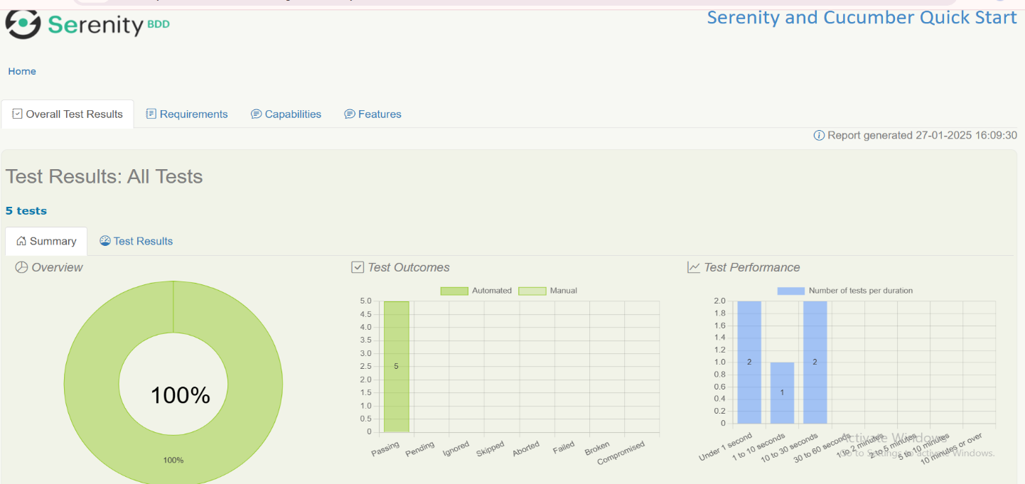

Figure 2 : Testing report by graph

ii) Testing Report by Steps-

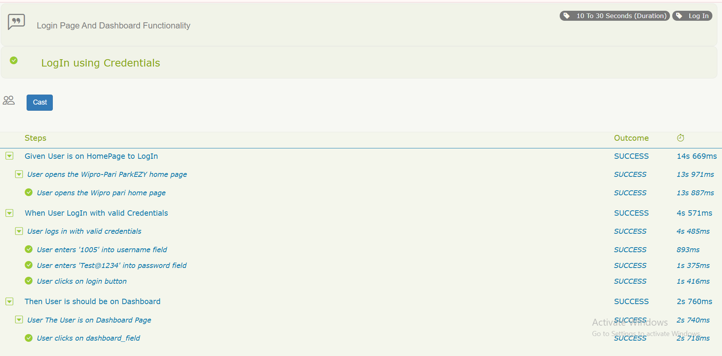
Figure 3 Testing report by each steps

Logs -

i) When Test Case Passed-
1 Scenarios (1 passed)
3 Steps (3 passed)
0m19.419s

ii) When Test case Failed-
1 Scenarios (1 passed)
3 Steps (2 passed 1failed)
0m20.617s

