**OS_Assignment2**

What will the following commands do?

1) **echo "Hello, World!"**

-This command will print Hello, World on terminal

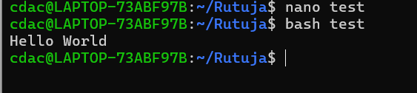

2) **name="Productive"**

- Here we assigned string value “Productive” in variable name and printed on terminal using echo.

Ip

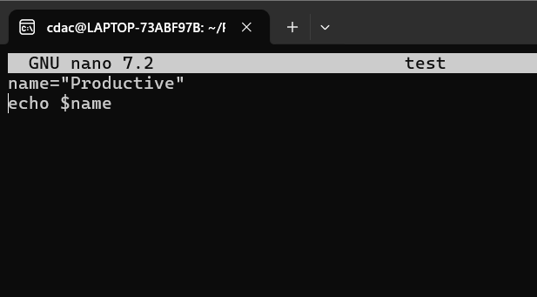

Op

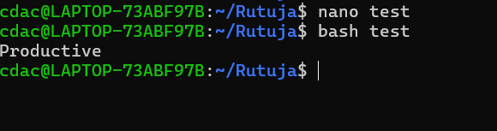

3) **touch file.txt**

- touch command is used to create file of any name in directory with extension

or without extension.

- here **.txt** is not considered as extension, file.txt is whole file name.

4) **ls -a**

- Lists all files, including hidden files (files that start with a dot .)

5) **rm file.txt**

- Command rm filename used to remove file from directory.

6) **cp file1.txt file2.txt**

- This command is used to copy all data of file1 into file2.

7) **mv file.txt /path/to/directory/**

- Used to move file to particular destination.

-eg mv file.txt / home/cdac/demo/

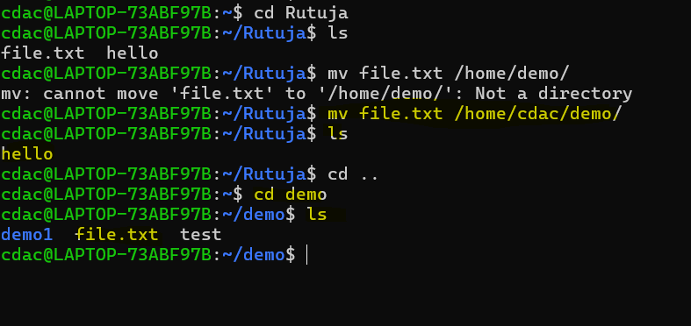

8) **chmod 755 script.sh**

- This command is used to change the permission of file or directory for user/owner, group ,other.

- Here 755 is rwx permission to user/owner and read, execute permission to group and for other read and execute permission. (r=4, w=2, x=1)

9) **grep "pattern" file.txt**

- This command lets you use a pattern to find lines from a file.

- We can modify this command with other option as well.

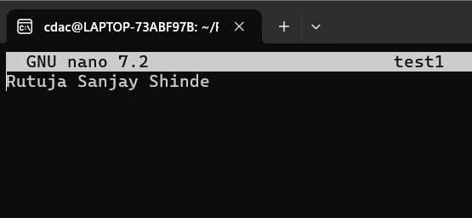

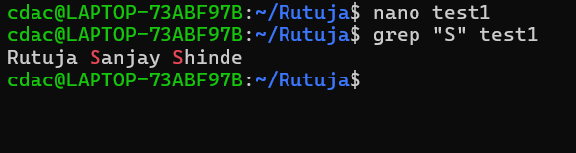

10) **kill PID**

-Used to kill/terminate process ,If we know process ID we can directly use and kill process.

- If we don’t know process ID we can find by command $ps aux

a: Show processes for all users.

u: Show the user/owner of the process.

x: Show processes not attached to a terminal.

11) **mkdir mydir && cd mydir && touch file.txt && echo "Hello, World!" > file.txt && cat file.txt**

- create mydir directory after it change directory to mydir, create touch file.txt into it and redirect echo “Hello, word !” into file.txt and print this file by cat command.

12) **ls -l | grep ".txt"**

- grep used to match pattern so by grep we found file.txt and ls -l command showed detailed information of file.

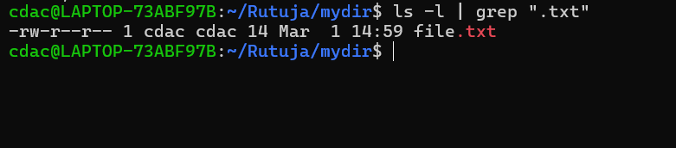

13) **cat file1.txt file2.txt | sort | uniq**

-This command concatenate data from file1 and file2 and sort them alphabetically and uniq command used to show uniq data, duplicate entries ignored.

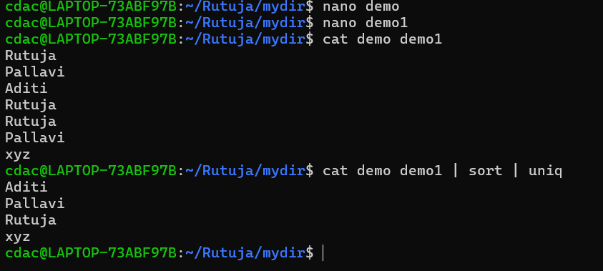

14) **ls -l | grep "^d"**

- grep “^d” command shows all directories present in current directory and ls -l gives detailed information about those directories.

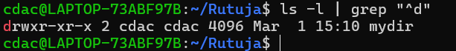

15) **grep -r "pattern" /path/to/directory/**

This command grep -r "pattern" /path/to/directory/ searches for the string/word **"pattern"** inside all files within the specified directory and its **subdirectories**, and it shows output if any line with this word found.

16) **cat file1.txt file2.txt | sort | uniq –d**

- This command is used to show duplicate data from two files in sorted manner.

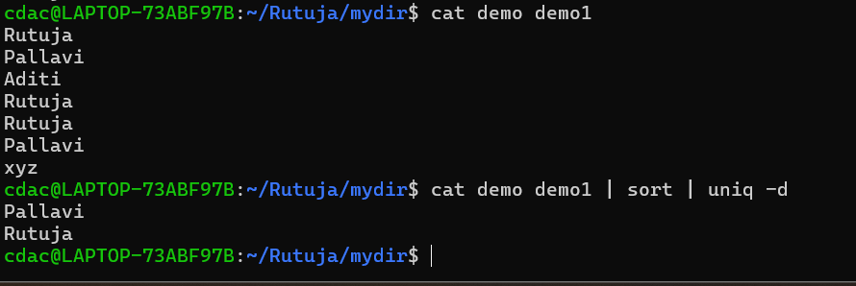

17) **chmod 644 file.txt**

- This command is used to give read write permission to user or owner, read permission to group and other of file.txt

18) **cp -r source_directory destination_directory**

- This command is used to copy entire data (including directory, sub directory and files)from one directory to another directory.

19) **find /path/to/search -name "*.txt"**

- This command is used to **search for files** with a specific pattern within a given directory and its subdirectories. (in this case, files ending with .txt)

20) **chmod u+x file.txt**

-This command is used to give execute permission to user of file file.txt

21) echo $PATH

- This command is used to show environment variable path.

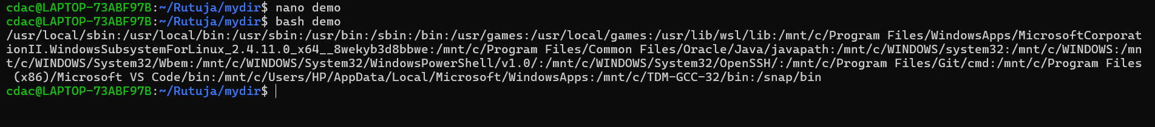

**Part B**

**Identify True or False:**

1. ls is used to list files and directories in a directory.

**True**

1. mv is used to move files and directories.

**True**

1. cd is used to copy files and directories.

**False**

1. pwd stands for "print working directory" and displays the current directory.

**False**

1. grep is used to search for patterns in files.

True

1. chmod 755 file.txt gives read, write, and execute permissions to the owner, and read and execute permissions to group and others.

True

1. mkdir -p directory1/directory2 creates nested directories, creating directory2 inside directory1 if directory1 does not exist.

True

1. rm -rf file.txt deletes a file forcefully without confirmation.

True

**Identify the Incorrect Commands:**

1. chmodx is used to change file permissions.

chmod

1. cpy is used to copy files and directories.

cp

1. mkfile is used to create a new file.

nano filename or touch filename

1. catx is used to concatenate files.

cat file1 file2

1. rn is used to rename files.

mv filename

**Part c**

Question 1: Write a shell script that prints "Hello, World!" to the terminal.

echo "Hello, World"

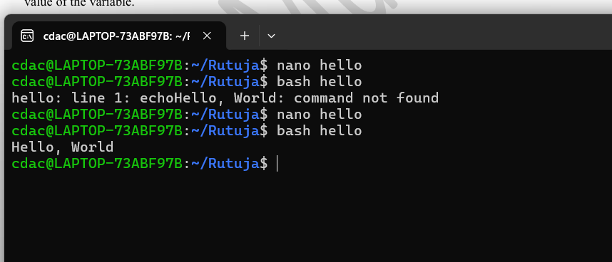

Question 2: Declare a variable named "name" and assign the value "CDAC Mumbai" to it. Print the value of the variable.

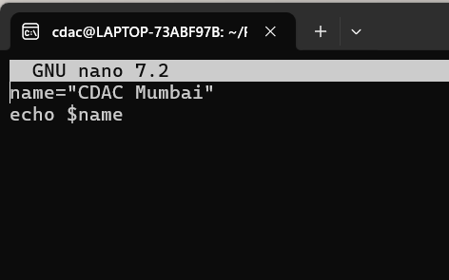

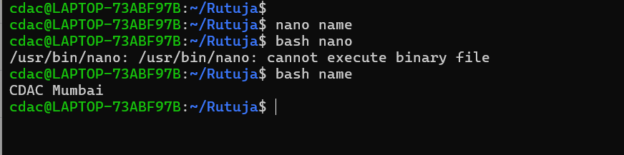

Question 3: Write a shell script that takes a number as input from the user and prints it.

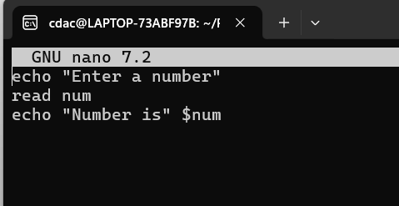

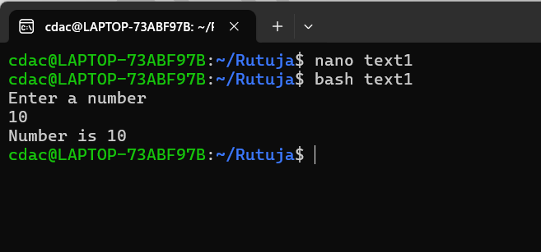

Question 4: Write a shell script that performs addition of two numbers (e.g., 5 and 3) and prints the result.

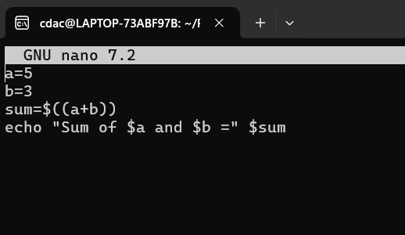

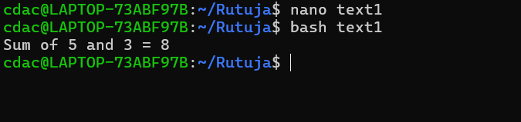

Question 5: Write a shell script that takes a number as input and prints "Even" if it is even, otherwise prints "Odd".

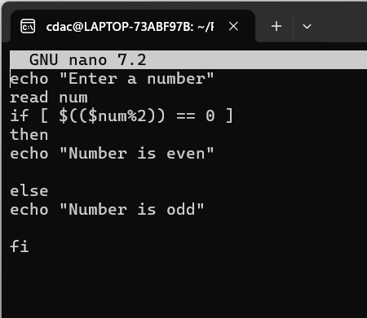

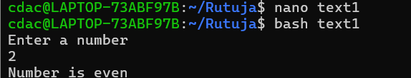

Question 6: Write a shell script that uses a for loop to print numbers from 1 to 5.

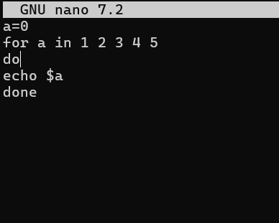

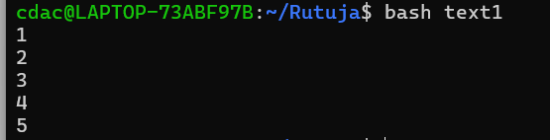

Question 7: Write a shell script that uses a while loop to print numbers from 1 to 5.

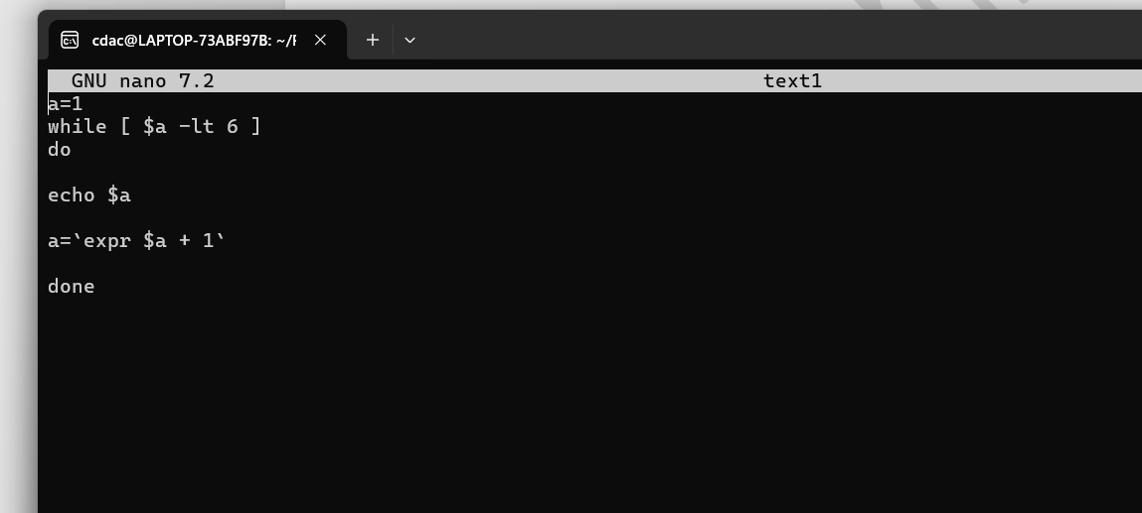

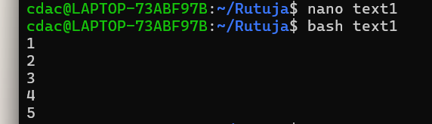

Question 8: Write a shell script that checks if a file named "file.txt" exists in the current directory. If it does, print "File exists", otherwise, print "File does not exist".

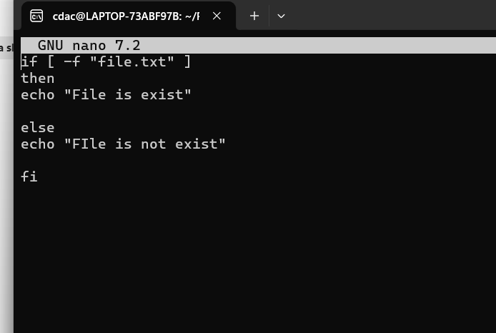

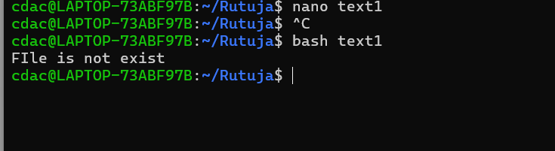

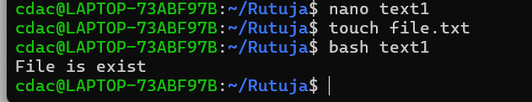

Question 9: Write a shell script that uses the if statement to check if a number is greater than 10 and prints a message accordingly.

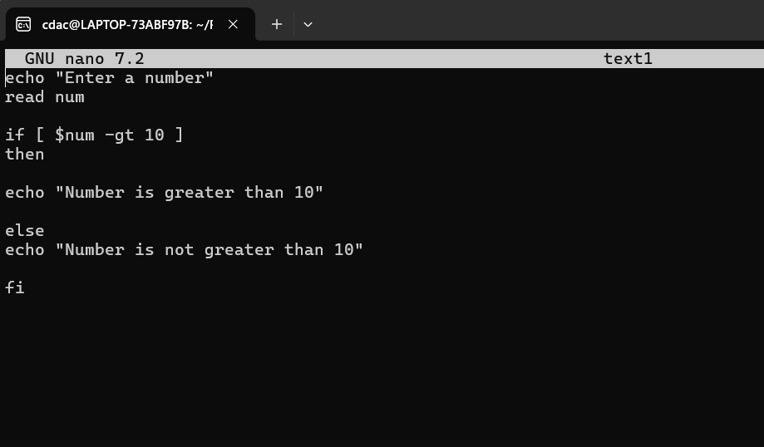

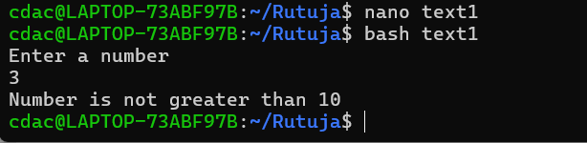

Question 10: Write a shell script that uses nested for loops to print a multiplication table for numbers from 1 to 5. The output should be formatted nicely, with each row representing a number and each column representing the multiplication result for that number.

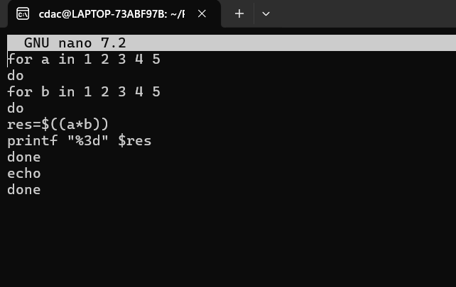

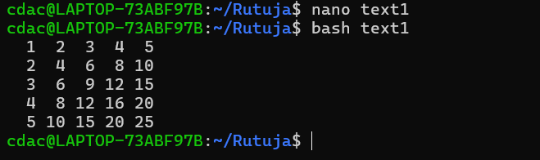

Question 11: Write a shell script that uses a while loop to read numbers from the user until the user enters a negative number. For each positive number entered, print its square. Use the break statement to exit the loop when a negative number is entered.

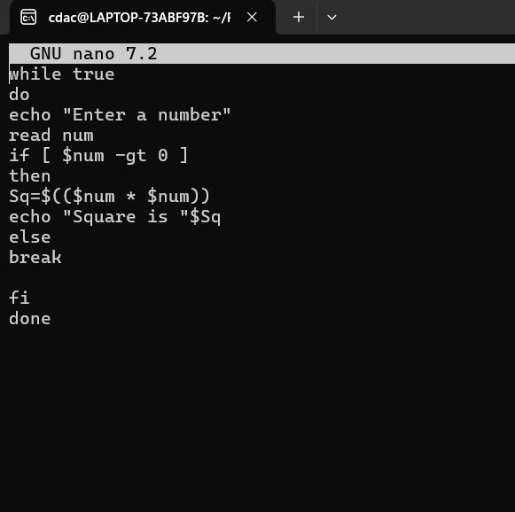

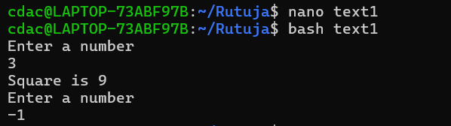

**Part E**

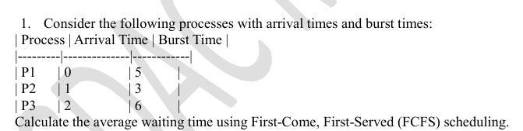

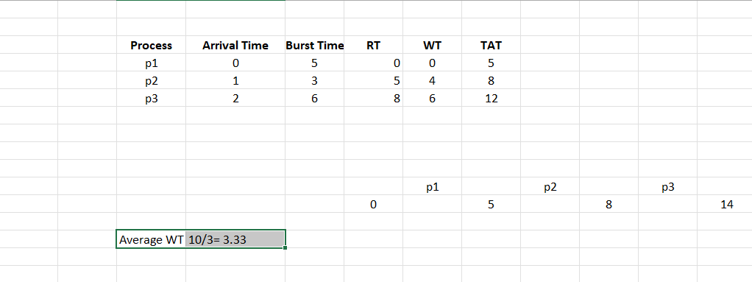

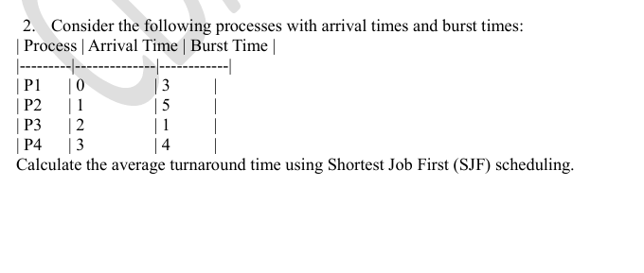

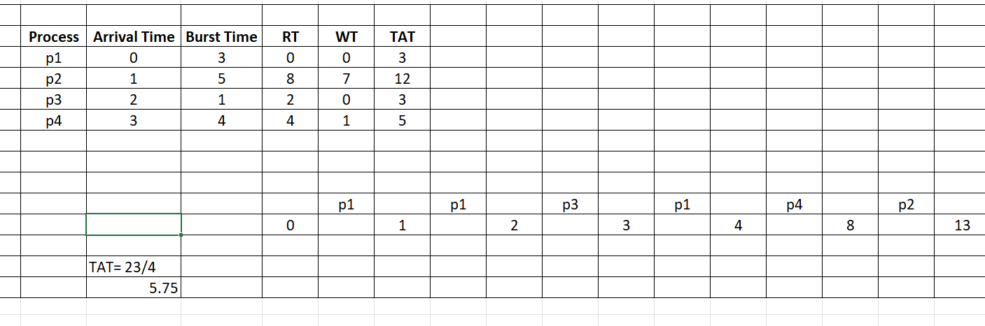

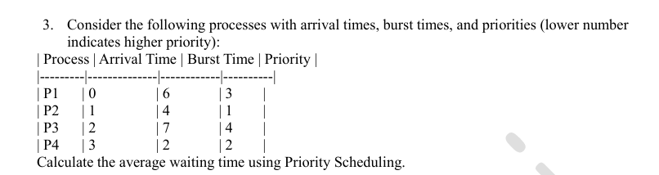

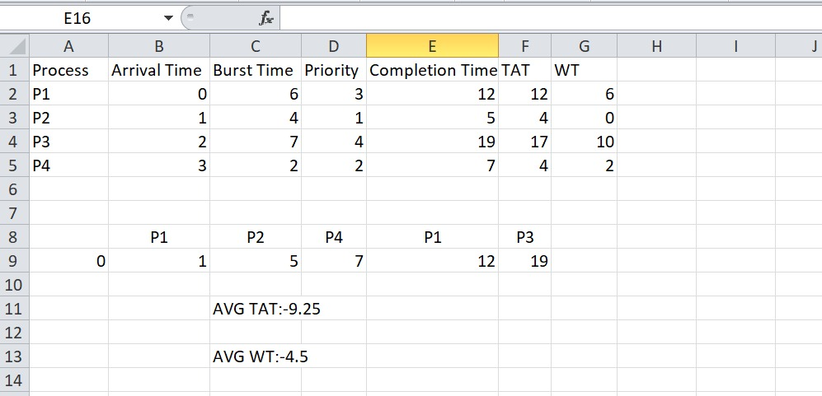

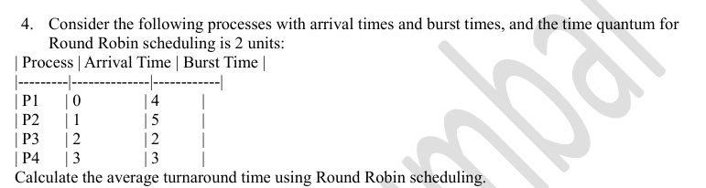

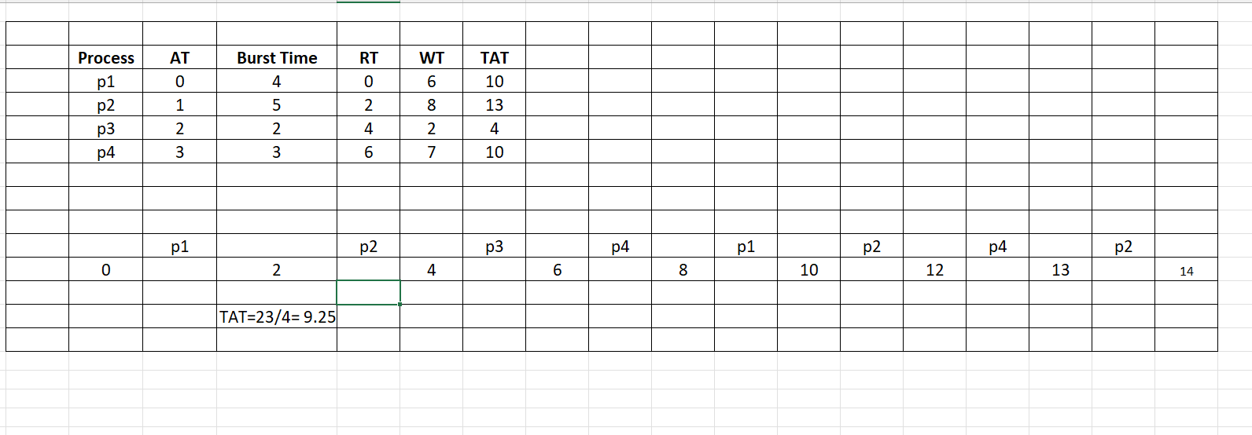

1. Consider a program that uses the fork() system call to create a child process. Initially, the parent process has a variable x with a value of 5. After forking, both the parent and child processes increment the value of x by 1. What will be the final values of x in the parent and child processes after the fork() call?

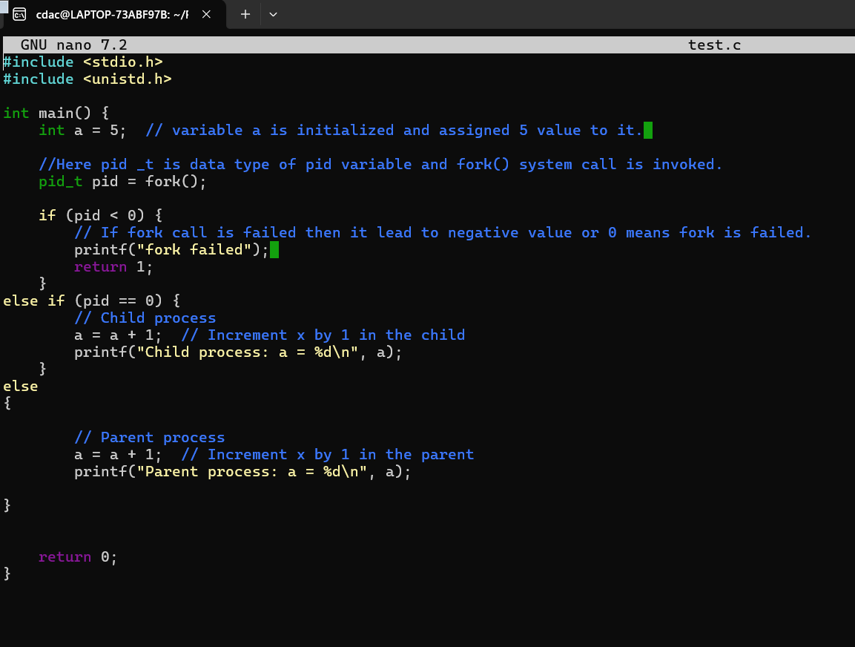

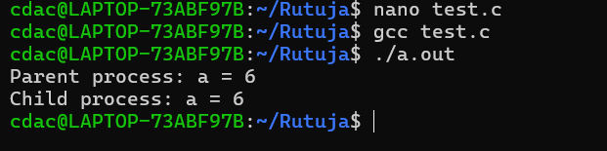

After execution of following code fork will create exact replica of the program. but here first main program is getting executed and then child process/program/replica is getting executed.