**Title: Raja Ravi Varma Paintings: A Virtual Experience.**

**Overview:** The project aims to create an immersive Virtual Reality (VR) experience that allows users to explore and interact with the timeless paintings of the renowned Indian artist, Raja Ravi Varma. The VR environment provides a unique opportunity for users to engage with art in a dynamic and educational manner, gaining insights into the artist's techniques, historical context, and the cultural significance of his work.

**About Raja Ravi Varma**

Raja Ravi Varma was part of the royal family of the erstwhile Parappanad, Malappuram district. He was born to M. R. Ry. Ravi Varma, Koil Thampuran of Kilimanoor at Kilimanoor palace in the erstwhile princely state of Travancore, present-day Kerala. The title Raja was conferred as a personal title by the Viceroy and Governor-General of India.

He learned the basics of painting in Madurai. Later, he was trained in water painting and in oil painting as well.

He often modeled Hindu Goddesses on Indian women and particularly noted for his paintings depicting episodes from the story of Dushyanta and Shakuntala, and Nala and Damayanti, from the Mahabharata.

**Key Components:**

1. **Scene 1: Narrator's Introduction at Museum Entrance.**

**Description:** As the user steps into the virtual realm, they find themselves at the entrance of a grand, classical museum. The ambient sounds of soft classical music fill the air, Soft lighting casts a warm glow, inviting the user to embark on a journey into the world of Raja Ravi Varma's timeless art.

A virtual guide, elegantly dressed in traditional attire, appears to welcome the user. The guide's avatar exudes a sense of warmth and knowledge, ready to accompany the user on this artistic exploration.

**Interaction:** As the user begins to navigate, the guide introduces Raja Ravi Varma and sets the stage for an immersive encounter with his masterpieces.

**Assets: narrators avatar, audio clip of classical music, 3D model of entrance hall, narrator voice.**

1. **Floor Plan of the museum**

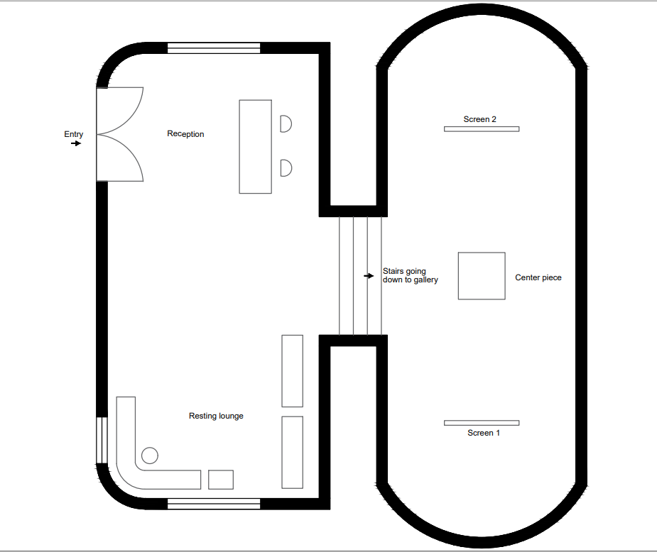

**3d model.**

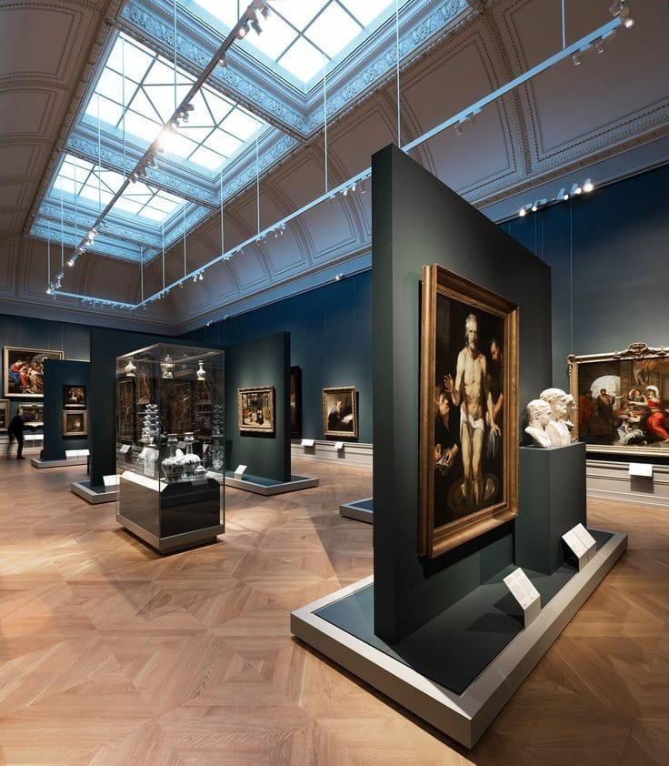

1. **Assets**

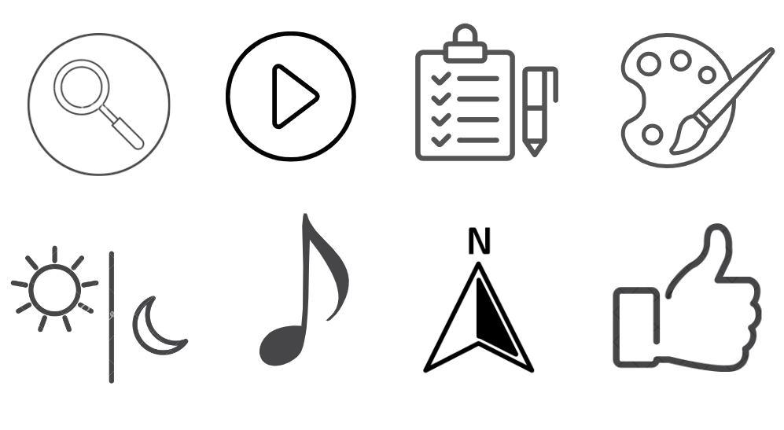

1. **Entrance of museum and architecture:**

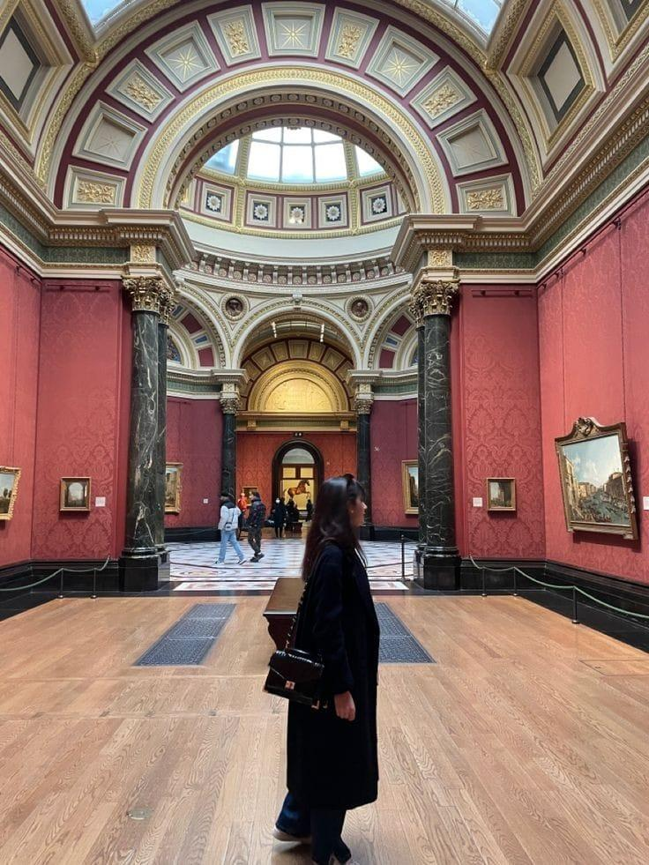

1. **Painting 1: Shri Krishna as Envoy**

**Description:** As the user explores the painting “Krishna as envoy” in museum while riding through the experiences of Raja Ravi Varma’s world of paintings. Lord Krishna is the envoy or the ambassador here. He has come as a messenger of peace. He tries to convince Duryodhana to give half of his kingdom to his cousins and make peace. An interactive guide invites users to explore the "Krishna as Envoy" exhibit.

Key elements, such as Krishna, celestial beings, and the environment, are meticulously modelled for an immersive experience.

Users can trigger animations or informational pop-ups explaining the symbolism of objects associated with Krishna.

As soon as the user opens the painting, he will learn about its background: when Krishna went to the kingdom of Hastinapur to put an end to the war between the Kauravas and the Pandavas, the king, Duryodhana, treated Krishna with contempt and his men attempted to capture Krishna. These are the main four characters of our painting: Krishna, King Duryodhan, his follower, and Satyaki, who is a devotee of Krishna.

A great devotee of Krishna named Satyaki draws his sword to defend Krishna, but he is stopped by him. He then goes on to reveal his divinity, or Vishwaroopam, to everyone in the court, a revelation that has great significance in the Mahabharta.

The user will be able to see interactions between the 3D models in this painting, giving them the impression that they are actually a part of it. The characters' 3D models will have some movement capabilities, and the user will be able to hear recorded audio that represents their dialogue.

**Interaction:** Users can use VR controllers or gaze-based interaction to zoom in and pan across the painting, exploring the details of Krishna, his attire, and other elements.

Users can engage in virtual conversations with characters within the painting, including Krishna and other figures.

Krishna may share wisdom, respond to inquiries, or convey messages of peace and prosperity.

**Assets:** 3D Models, Textures, Audio Assets, User Interface (UI) Elements.

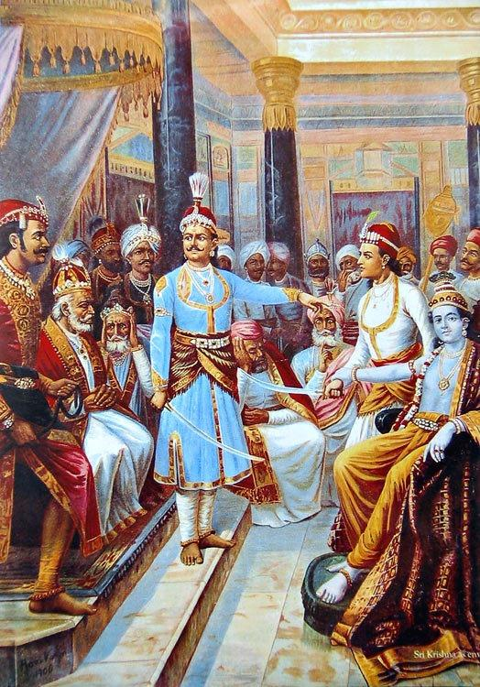

1. **Painting 2: Galaxy of musicians**

**Description:** A Galaxy of Musicians, one of Ravi Varma's most famous paintings, depicts 11 Indian women who appear to be in the midst of an elaborate musical performance. Some sit, others stand. Some hold instruments, others seem to listen.

Users approach the "Galaxy of Musicians" exhibit, triggering an introduction by a virtual guide. The guide provides historical context about the painting, detailing Ravi Varma's inspiration and the cultural significance of classical Indian music. Each musician, their instrument are modelled in a 3D way

The painting shows a group of Indian women from various backgrounds playing their traditional instruments;from the Muslim courtesan on the right to the Nair woman playing a veena on the left, the painting emphasizes the dresses and adornments of women from each part of India.

Ravi Varma focused on each group's customs and how they all characterized music in one painting.

In this the narrator first will narrate the information of painting then according to clicking on a specific women she will start playing her instrument by doing the gestures while at the same time the other characters will start vibing(will be showcased as lost in listening and feeling of instrumental music), each character will have its instrumental music according to the instrument she holds.

**Interaction:** Each musician plays their instrument, and users can control the mix or focus on individual instruments.

Audio changes dynamically as users move around, creating an immersive auditory experience. Users can virtually "play" or manipulate the instruments using motion controllers.

**Assets:** 3D Models, Textures, Audio Assets, User Interface (UI) Elements.

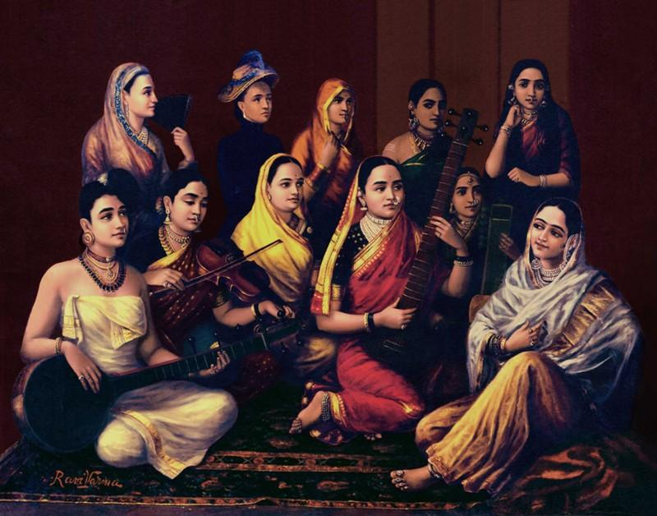

1. **Key Features**: Binaural Sounds: Immerse users with an authentic auditory experience. Cultural and heritage side of Raja Ravi Varma’s painting and its portrayed in VR 3D. Immersive chance of experiencing the details and beauty of paintings in VR.
2. **Additional Considerations:** To Include snippets and nuggets of information to enhance the educational aspect. To Ensure a UX-centric VR experience providing valuable insights Raja Ravi Varma’s painting. Incorporate a selfie opportunity for user engagement.