**Introduction**

* **Domain Introduction**

**Blockchain** is immutable data structure used to record participants and transactions, records added in block are time-stamped and agreed by participants which cannot be modified by anyone once added to block.

* **Current trends**

Shared ledger, privacy, smart contract, trust, decentralization

E.g. Decentralized currency (Bitcoin,Ethereum,Monera), Supply chains.

**Need for work**

In business network, participants needs to share data, records of exchange, proof of ownership etc. Traditionally each participating member maintains their own records and forward it to central authority to collect, distribute and verify. Currently data of businesses is growing so fast and big. Many partners share same kind of records but still keep different records thus increasing cost,complexity and errors. There is need to keep business records safe and accessible. Distributed ledger technology aims to solve these problems by letting us create a shared ledger on business network which is immutable, distributed, permissioned. It provides ability to keep all participants on track and updated.

We need to identify type of business networks, the objects and type of transactions. Model business requirements to fit on blockchain network. There is need to design an API to make network interactable, provide and user interface which should be easy to understand and there should be no need of technical knowledge to make transactions.

**Problem statement and Objectives of project**

To create a distributed ledger for a business network to keep the records of the ownership of assets and provide an simple interactable user interface for end users.

**Objectives**

1. Model network into required ledger keeping form.
2. Give it ability to add new types of assets, participants.
3. Make law enforcement agency as participant with special permission in network.
4. Make customer to customer / business to business transactions possible eliminating any intermediary.
5. Provide facility to sell asset or auction it.
6. Provide facility to identify participant.
7. Provide a wallet facility.
8. Selective endorsement facility.

**Proposed work**

* **Diagrammatic description of topic**

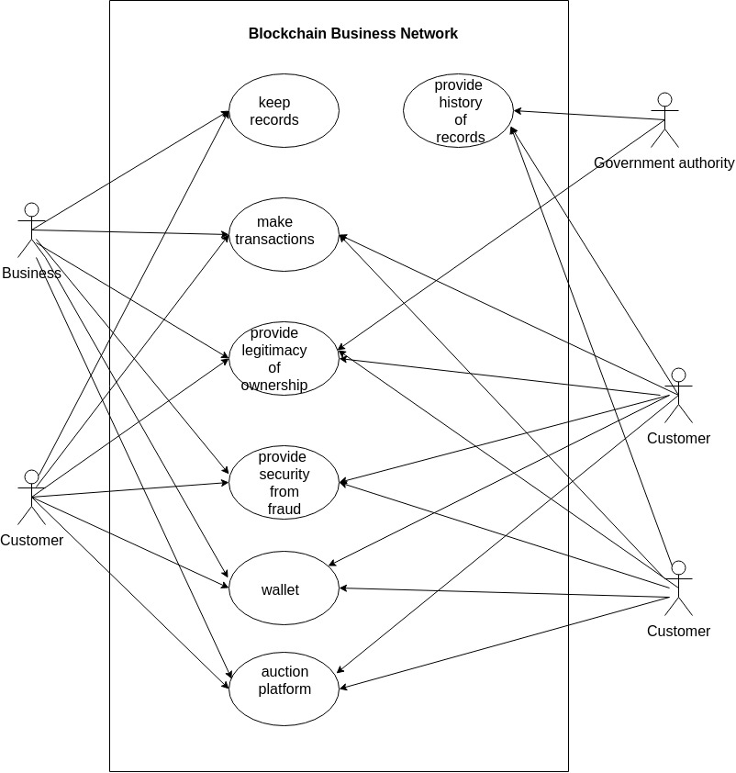

* **Use of modular approach**

Problem will be implemented in object oriented fashion. Depending on what kind of transaction is fired the relevant part of chaincode will be executed on network.

**Implementation Details**

* **Technology to be used**

1. Blockchain

Hyperledger composer

Hyperledger fabric

1. World Wide Web

HTML,CSS,JavaScript

Node.js

REST API

YEOMAN

LOOPBACK

3. For Documentation

Markdown

HTML

* **Software and Hardware requirements**

1. Desktop/Laptop with internet connection
2. Web browser