AN INTERNSHIP REPORT

SUBMITTED TO THE SAVITRIBAI PHULE PUNE UNIVERSITY, PUNE

IN THE FULFILLMENT OF THE REQUIREMENT

OF

**THIRD YEAR OF Information Technology**

SUBMITTED BY

Name of Student: Rutuja Bhausaheb Kapuskar

PRN: 72153372J

Mobile No: 8262914712

Email ID: kapuskarrutuja@gmail.com

WITH INDUSTRY

**Company Name: Suvidha Foundation**

**Mailing Address: info@suvidhafoundationedutech.org**

UNDER SUPERVISION OF

Supervisor Name: Amandeep Kaur

Email ID: suvidhafoundation@gmail.com

Start Date for Internship: 03/02/2022

End Date for Internship: 03/03/2023



## DEPARTMENT OF COMPUTER ENGINEERING

## STES’S SINHGAD INSTITUTE OF TECHNOLOGY AND SCIENCE

**NARHE, PUNE - 411041**

## 2022-2023

**Certificate**

This is to certify that, Mr./Mrs. **Rutuja Bhausaheb Kapuskar** of class **TE– IT**, Division **1**, Roll no. **3301027** and PRN no. **72153372J** has successfully completed all the Internship work and submitted in the subject Internship and his performance was satisfactory in the said subject as prescribed by Savitribai Phule Pune University, Pune for the academic year 2023 - 24, Semester - II.

Date :

Prof. Priti Yadav Prof. T. D. Khadtare Dr. S. D. Markande

Name of Subject Teacher Head of Department Principal

**ACKNOWLEDGEMENT**

I would like to thank **Mr.** Amandeep Kaur **,** Supervisor/HR, of suvidha foundation for giving me the opportunity to do an internship within the organization.

I also would like to thank all the people that worked along with me in the organization with their patience and openness they created an enjoyable working environment.

It is indeed with a great sense of pleasure and immense sense of gratitude that I acknowledge the help of these individuals.

I am highly indebted to Principal **Dr. S. D. Markande** and Vice-principal **Prof. S. A. Kulkarni,** for the facilities provided to accomplish this internship.

I would like to thank my Head of the Department **Mr T.D.Khadtare** for her constructive criticism throughout my internship.

I would like to thank **Mrs Shrushti Gunthe ,** Internship Coordinator Department of Information Technology for his support and advices to get and complete internship in above said organization.

I am extremely grateful to my department staff members and friends who helped me in successful completion of this internship.

Name and Sign of Student: Rutuja Bhausaheb Kapuskar

Place: Pune

Date:

**COMPANY/ORGANIZATION BACKGROUND**

|  |  |
| --- | --- |
| Name of Company | Suvidha Foundation |
| Company address | Satya Niketan, south west New Delhi, India-110021 |
| Contact number of company | 7914487078 |
| Company background | Suvidha Foundation internship program is designed to provide interns with a wide range of skills and knowledge related to Android Development.  Some of the key skills that can be learned during the program include developing logic in the language, clearing basics such as Bulding Machine learning model, Regression, Git: Version control system,Python . |
| Name of supervisor | Amerdeep kaur |
| Contact number of supervisor | 09967357277 |
| Email ID of supervisor | **info@suvidhafoundationedutech.org** |

**CONTENTS**

|  |  |  |
| --- | --- | --- |
| **Sr. No.** | **Title** | **Page No** |
| 1 | Abstract | 5 |
| 2 | Introduction to Internship | 6 |
| 3 | Mode of Internship | 7 |
| 4 | Domain of Internship | 7 |
| 5 | Objectives of Internship | 7 |
| 6 | Motivation/Scope of Internship | 8 |
| 7 | Methodologies learnt in Internship | 9 |
| 8 | Outcome/Results of Internship | 10 |
| 9 | Suggestions for improvement by Industry | 10 |
| 10 | Conclusion | 10 |
|  | References | 11 |
|  | Internship Offer Letter | 12 |
|  | Completion Letter | 13 |
|  |  |  |

**1.Abstract**

This internship report provides an overview of my experience during my internship at Suvidha Foundation .The report covers the company's background, my roles and responsibilities, the skills and knowledge gained, challenges faced, and accomplishments achieved during my internship. The report also includes an evaluation of the internship program, including the company culture, supervisor support, and overall experience. The content is structured with clear headings and sections, providing a comprehensive and accurate reflection of my experience. The report concludes with recommendations for future interns and how the organisation can improve its internship program. The report serves as a valuable tool for both the organisation and myself, providingin sights into the effectiveness of the internship program and my potential for future employment.

**2.INTRODUCTION TO INTERNSHIP**

An internship is a professional learning experience that offers meaningful, practical work related to a student's field of study or career interest. An internship gives a student the opportunity for career exploration and development, and to learn new skills. An internship can provide unique opportunities for learning outside of academic settings. It can expose you to new tasks and help you learn goal .specific skills to complete those tasks. Internships also give you experience with technology, people and projects that may relate to your career goals. An internship can give you an authentic experience in a job role by providing you with an introductory experience to a career path, its duties and daily operations. They also may assist you with developing additional skills to list on your resume, which can emphasize your value as a candidate. While doing an undergraduate program in Information Technology at Sinhgad Institute of Technology and Science, Narhe, I considered a few programming courses over a period of last 3 years. From 3rd Feb 2023 to 3rd March 2023, I worked at Suvidha Foundation as a machine learning Intern. Suvidha foundation is a ground-based organization that aims at building the future through nourishing the present. This entry level position report covers the whole temporary job time that I have finished with progress concerning the coding, style and improvement

**3. MODE OF INTERNSHIP**

Mode of Internship: Online

**4. DOMAIN OF INTERNSHIP**

Machine Learning is an interdisciplinary field that uses scientific methods, processes, algorithms and systems to extract knowledge and insights from noisy, structured and unstructured data, and apply knowledge and actionable insights from data across a broad range of application domains. Data science is related to data mining, machine learning and big data. Data science is a "concept to unify statistics, data analysis, informatics, and their related methods" in order to "understand and analyze actual phenomena" with data. It uses techniques and theories drawn from many fields within the context of mathematics, statistics, computer science, information science, and domain knowledge. However, data science is different from computer science and information science. Turing Award winner Jim Gray imagined data science as a "fourth paradigm" of science (empirical, theoretical, computational, and now data-driven) and asserted that "everything about science is changing because of the impact of information technology" and the data deluge. A data scientist is someone who creates programming code and combines it with statistical knowledgeto create insights from data.

**5. Problem Statement**

Build a predictive model and find out the sales of each product at a particular store.Using this model, BigMart will try to understand the properties of products and stores which play a key role in increasing sales.i.e.How mush Sales is going to generate .

**DataSet Link** :

https://www.kaggle.com/datasets/shivan118/big-mart-sales-prediction-datasets

**6.OBJECTIVES OF INTERNSHIP**

1.Become a team player:

Being an intern can also be stressful and overwhelming at times. During internship we can collaborate with our team members, manager, colleagues to perform your work ethic is crucial in the tech industry.

2.Gain Machine learning Knowledge and Experience in real-life Situation:

One of the main reasons one will accept an internship is to gain knowledge and experience. Many movies or TV shows portray interns as someone who goes and gets coffee for their bosses, but that will not be your task as a software intern.

3.Establish your tech network through internship

One significant aspect of an internship is the ability to network while on the job. Throughout the internship, you will be able to connect with many influential people at your company and throughout the tech industry that could help you advance your career.

**5. MOTIVATION/SCOPE OF INTERNSHIP**

**Motivation:**

**1. Interest in programming**: Many people pursue a Machine Learning internship because they have a passion for programming and are interested in developing ML model using python.

**2. Career development:** An internship can provide valuable experience and skills that can help students or beginners kick-start their careers in Machine Learning.

**3.Learning new technologies:** Interns can gain exposure to new technologies and tools that are widely used in the industry, which can help them stay up-to-date with the latest trends and practices.

**Scope:**

**1. Robotics :** Robotics is a field that attracts the attention of both researchers and the general public. Many researchers are still attempting to build robots that imitate human brain functions. They employ neural networks, artificial intelligence, machine learning, computer vision, and a host of other cutting-edge technologies in this study.

**2. Vision Processing via a Computer System**

**:** Using computer vision, a computer or machine can see. The improvement we had achieved from a 26% error rate in 2011 to a 3% error rate in 2016 is tremendously influential, as Google's Head of AI Jeff Dean famously noted. According to my romantic vision of things, computers are finally capable of seeing.

**3.Project management:** Interns can learn how to work on a project as part of a team, communicate effectively, and manage project timelines and deliverables.

**7. METHODOLOGIES LEARNT IN INTERNSHIP**

Methodologies are commonly used to assist the development by offering a strict plan and structure for each task to be completed.

**1.Hypothesis Generation :**

Since we’re talking about stores and products, lets make different sets for each.Store level Hypothesis

**2.Data Exploration :**

explore and visualize data to uncover insights from the start or identify areas or patterns to dig into more. Using interactive dashboards and point-and-click data exploration, users can better understand the bigger picture and get to insights faster

**3.Data Cleaning:**

the process of fixing or removing incorrect, corrupted, incorrectly formatted, duplicate, or incomplete data within a dataset.

4**.Model Building**:

Contextualise machine learning in your organisation

Explore the data and choose the type of algorithm

Prepare and clean the dataset

Split the prepared dataset and perform cross validation

Perform machine learning optimisation

Deploy the model

By following these methodologies, I was able to perform a given tasks more efficiently and correctly.

**8. OUTCOME/RESULTS OF INTERNSHIP**

**Outcome:**

Get the Latest trend updates-

By enrolling in the best training institute for java you can ensure the latest trend updates. The training courses offer vast knowledge to the students. Students can execute skills of various national and international projects and can become expert Java developers.

Get Professional help-

Professionals provide core Java training in Kolkata. The specialists grab a good knowledge of Java trends, tools, architecture, design, coding, and more. The help from the experts allows the students to enjoy a better future. Java development also allows for a better salary outcome, which ultimately helps the students to secure their future.

Grow your confidence-

The knowledge of Java Programming Language helps to boost our confidence. Our confidence increases when we can perform well and produce good results with an expert’s help.

Build good communication skills- T

The training in Java can help to build corporate communication skills. These skills will help us enjoy a handsome salary from a reputed MNC. It not only helps us in convenient communication with the audiences. Allowing us to write, code, and perform other activities in the java applications.

**Model Result:**

**Linear Regression:**

**R2 Score :** 0.5041875773270634

Mean Absolute Error :880.99990440845

Mean Square Error: 1162.4412631603452

**Random Forest Regression:**

**R2 Score :** 0.5501591616309669

Mean Absolute Error : 780.6116839715728

Mean Square Error: 1107.2399720814844

**Web Deployment Output:**

**FrontEnd:**

**Giving Input By user At runtime:**

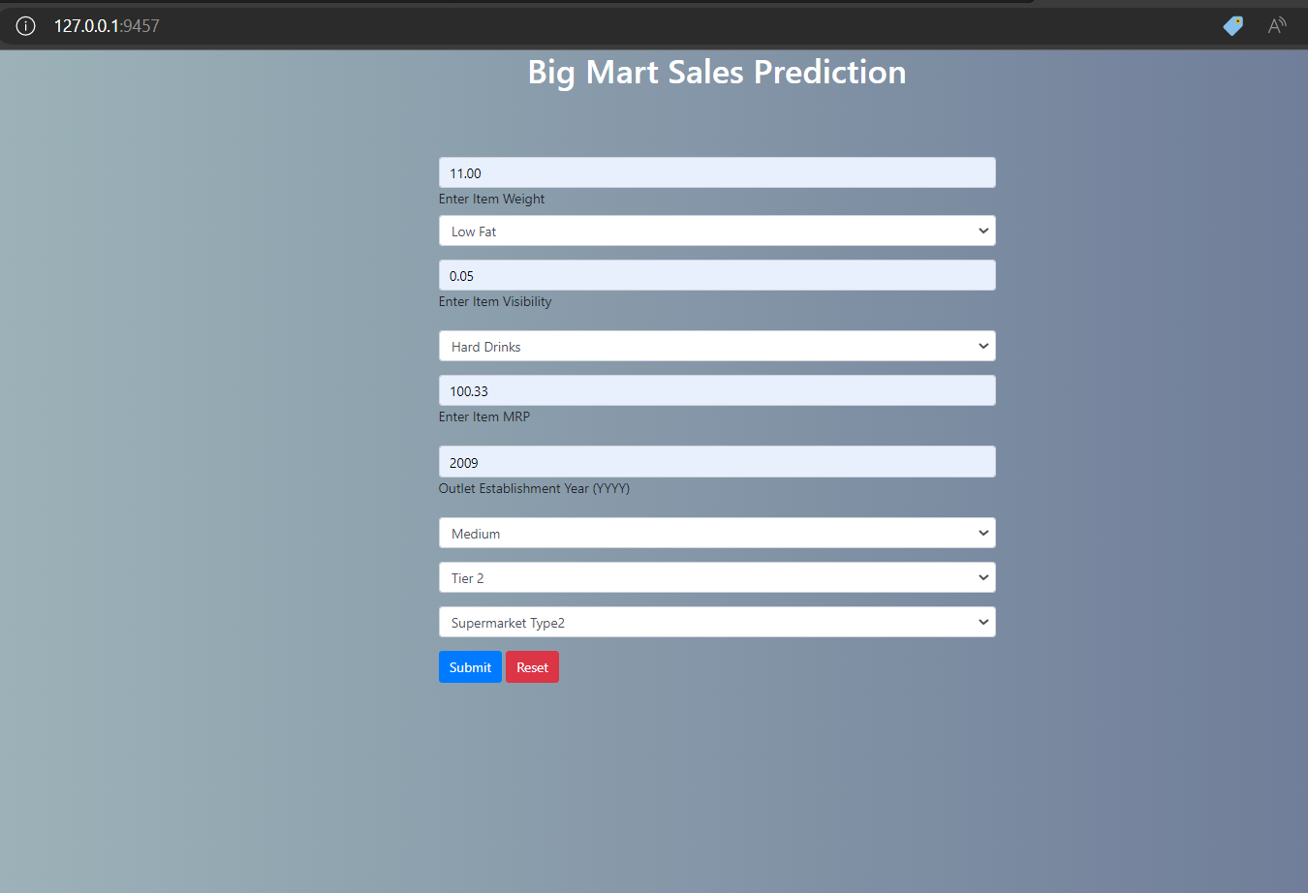

**Prediction model With output:**

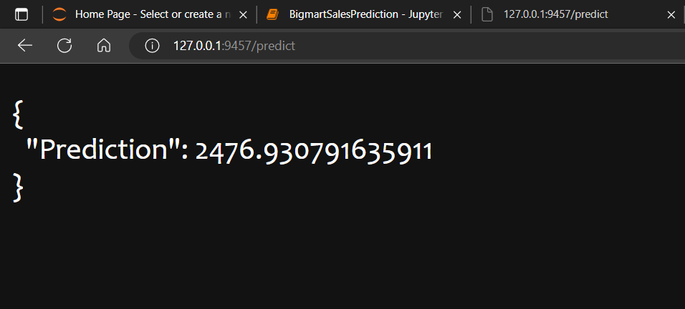

**9. SUGGESTIONS FOR IMPROVEMENT BY INDUSTRY**

**Familiarize with Python APIs:**

Python has a vast collection of APIs that provide pre-built code for a variety of functionalities. To improve your Java skills, it is important to familiarize yourself with these APIs and know how to use them effectively in your code.

**Participate in Open Source Projects:**

Contributing to open-source ML projects is a great way to improve your Java programming skills. You can work on real-world projects, collaborate with other developers, and gain valuable experience that you can apply in your own projects

**Practice coding :**

To improve your programming skills, it is important to practice coding regularly. This will help you become familiar with python syntax and learn to solve problems efficiently

**Attend Machine Learning Conference :**

Attending Java conferences and workshop is a great way to learn about the latest trends, best practices, and tools in Java programming. You can also network with other developers, and gain valuable experience that you can apply in your own projects.

**10. CONCLUSION**

In a nutshell, this internship has been an excellent and rewarding experience. I can conclude that there have been a lot I’ve learnt from my work at Suvidha Foundation. Needless to say, the technical aspects of the work I’ve done are not flawless and could be improved provided enough time. As someone with no prior experience with Machine Learning whatsoever I believe my time spent in research and discovering it was well worth it and contributed to finding an acceptable solution to build a fully functional web service.

Two main things that I’ve learned are the importance of time-management skills and self-motivation. It also helps to boost self-confidence and improve communication skills that is going to help me in my Corporate world as employee.

In short, This was a great experience. One of the major highlights of my internship was the exposure to various tools such as Integrated Development Environments (IDEs) like VS code, version control systems like Git, and testing frameworks like JUnit. These tools have helped me become more proficient and efficient in my coding practices. Furthermore, I had the opportunity to work with a team of experienced developers who mentored me and guided me throughout the internship. This experience helped me build strong communication and collaboration skills, which are essential in the software development industry.

So, Overall my Machine Learning internship has been a valuable experience, which has equipped me with the skills and knowledge needed to succeed in software development industry.

**11.REFERENCES**

[1] https://www.kaggle.com/datasets/shivan118/big-mart-sales-prediction-datasets

[2] <https://www.w3schools.com/java/java_intro.asp>

[3] <https://www.linkedin.com/pulse/future-scope-machine-learning-one-finest-careere>

[4] <https://www.youtube.com/watch?v=R_8ignXnNRc>

[5] <https://www.mygreatlearning.com/blog/oops-concepts-in-python/>

**12.Internship Offer Letter**

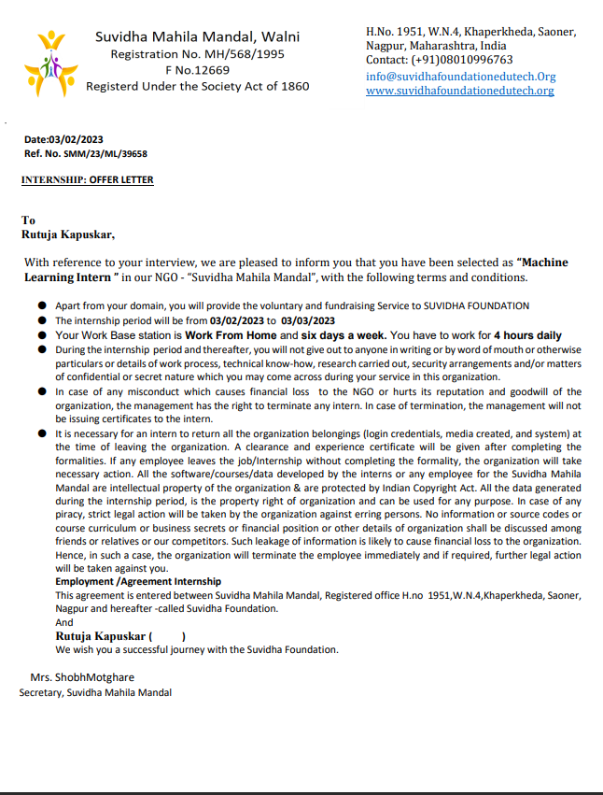

13.**Completion Letter**

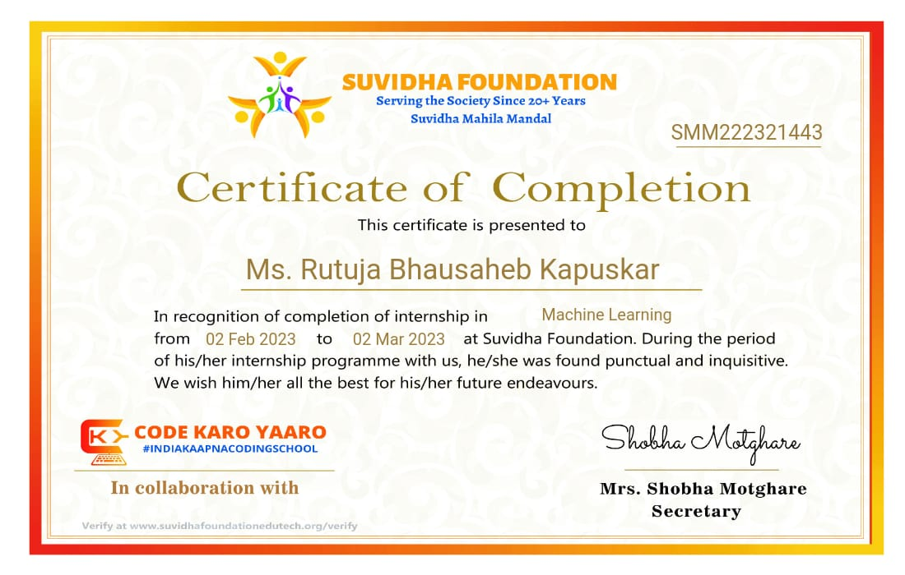

**ANNEXURE I**

**INTERNSHIP DIARY**

Name of Student: Rutuja Bhausaheb Kapuskar

Mode of Internship: Online

Name of Supervisor: Shobha Mothare

Name of Organization: Suvidha Foundation

|  |  |  |  |  |
| --- | --- | --- | --- | --- |
| **Sr. No.** | **Date/Week** | **Description of Activities done during the day, Knowledge acquired, Practical Skills obtained and plan for next day** | **Signature of Supervisor** | **Signature of Faculty Coordinator/Guide** |
| 1 | 03/02/2023 | Introduction Linear Regression |  |  |
| 2 | 06/02/2023 | Logistic Regression Evaluation metrics |  |  |
| 3 | 11/02/2023 | KNN & SVM Decision tree & Ensemble Learning |  |  |
| 4 | 13/02/2023 | Problem Statements Unsupervised Learning - I |  |  |
| 5 | 18/02/2023 | Proble Unsupervised Le m Statements arning - I |  |  |
| 6 | 20/02/2023 | Unsupervised Learning - II Add-on topics |  |  |
| 7 | 25/02/2023 | Fundamentals & Tools |  |  |
| 8 | 27/02/2023 | Visualization & Cleaning Feature selection |  |  |
| 9 | 29/02/2023 | Normalization & Transformation Cross Validations |  |  |

**ANNEXURE II**

**ATTENDANCE RECORD**

|  |  |  |  |  |
| --- | --- | --- | --- | --- |
| **Date/Week** | **Topic in Detail** | **Present** | **Absent** | **Sign** |
| 04/02/2023 | • Understanding prediction system  • Machine Learning v/s Deep Learning  Forms of ML - Supervised & Unsupervised  • Regression & Classification  • Sklearn Library  • Prediction pipeline  • Architecture of Linear Regression  • Best fit line & prediction | P |  |  |
| 06/02/2023 | • Regression v/s Classification  • Logistic Regression's architecture • Sigmoid functions  • Binary v/s Multiclass data  • Loss functions - RMSE, MSE, MAE  • Accuracy - pros & cons  • Confusion metrics  • Precision, Recall & F1 Score | P |  |  |
| 11/02/2023 | Hyperplanes & Support Vectors  • Architecture of SVM Classifiers • K-Nearest Neighbors classifiers  • Accuracy comparisons  • Tree based models  • Bagging & Boosting  • Concept of Ensemble models  • Random Forest Classifier | P |  |  |
| 13/02/2023 | • Wine Quality Prediction  • Diabetes prediction  • House price prediction | P |  |  |
| 18/02/2023 | • Titanic dataset  • Need of unsupervised learning  • K-means clustering  • Training kmeans | P |  |  |
| 20/02/2023 | • Mean shift clustering  • K-means v/s Mean Shift clustering  • Industrial use cases of unsupervised learning  • Hyperparameter tuning  • Grid Search CV & Randomized Search CV  • Best Estimators & Best params | P |  |  |
| 25/04/2023 | Introduction & Need  • Types of Data - NOIR  • introduction to Pandas  • Numpy arrays v/s Series v/s Dataframe | P |  |  |
| 27/02/2023 | • Various plots & graphs  • Data sources  • Missing values  • Describe & Info Methods  • Correlation & Variance  • Domain understanding  • Feature & Label split | P |  |  |
| 29/02/2023 | • Normalization  • Dimensionality Reduction  • Label encoding  • One hot encoding  • Linear Split  • Train-test split  • KFold CV  • Stratified KFold  • Leave one out CV | P |  |  |
|  |  |  |  |  |