Project B: Parallel Universe

Net Id: rpk9907

This report outlines the goals, usage and outcomes of my project and includes images and definitions of the objects created.

Section 1: User’s Guide

The goal of this project was to create a three-dimensional world with interesting shapes that viewer can explore. This world contains a ground plane on which all the shapes rest. The viewer can look at this world and its objects from two different view ports. At least two objects in the world have a diffuse shading. This world consists of the following objects.

1. Main axes (x,y,z)

2. Axes on the Robot’s head (x,y,z)

3. Grid Plane

4. Robot with oscillating arms

5. Car moving on horizontal plane

6. Rotating cuboid like asteroids

7. Rotating flying object

When one opens the html file in the Web-GL compatible browser, there is a canvas which contains all the graphical illustrations that are created and beneath it is a set of instructions on how to alter objects on the screen or move the camera around the world space. The user has complete freedom of movement around the world space and can interact with a few different objects on the screen. The axes of the world are located and are displayed at the origin and the head of the moving robot also has its own 3D axes, which rotates with the attached object.

Before discussing the results of the project, we will first discuss the interactions and functionalities available to the user and classify different objects that can be seen on the canvas.

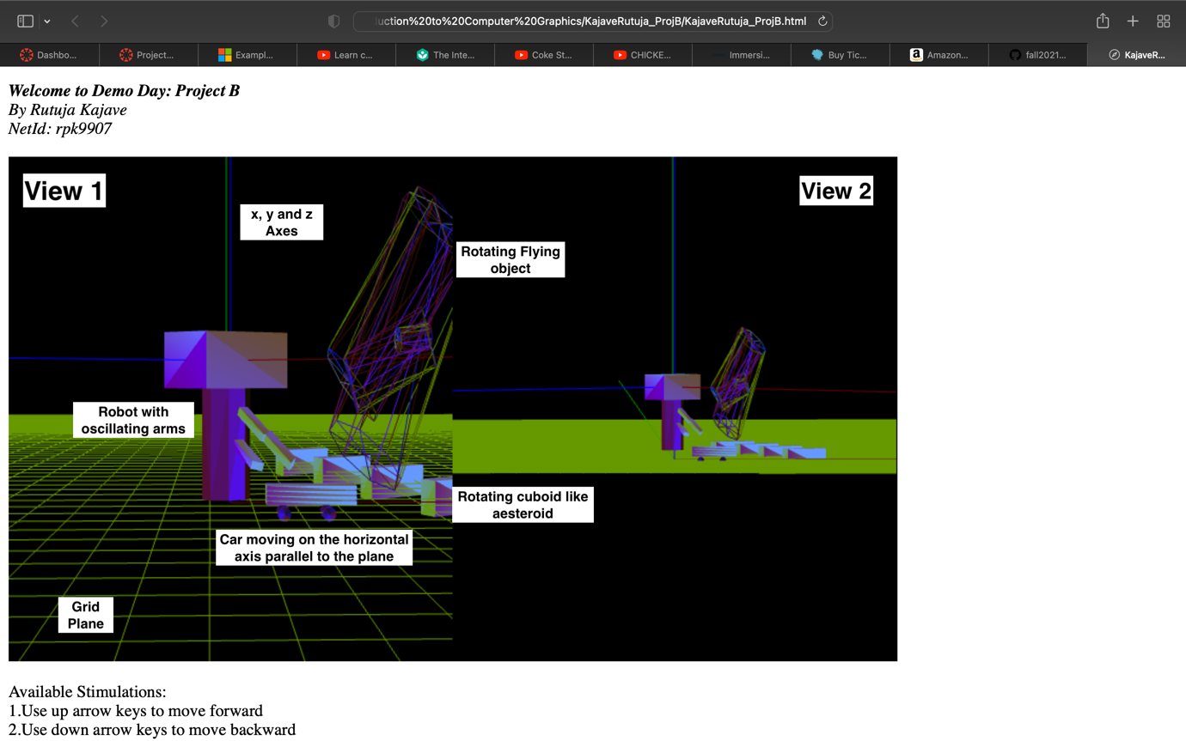

(1) Labels of all the objects on the screen

(2) Opening Scene when one opens the .html file

As seen above, Fig (1) shows all objects labelled with the classification that will be used throughout. Fig (2) shows the scene that can be seen on the screen as one opens the .html file. Some objects will have joints with separate names which will be clarified when referenced.

Now, let’s look at the controls and interactions available to users.

1. When user presses the “up” arrow key, the view zooms in which can be seen in View 1.
2. When user presses the “down” arrow key, the view zooms out which can be seen in View 1.
3. When user presses the “right” arrow key, the view pans to the right which can be seen in View 1.
4. When user presses the “left” arrow key, the view pans to the left which can be seen in View 1.
5. When user presses “W” key, we can view the created objects from a top angle.
6. When user presses “S” key, we can view the created objects from a bottom angle.
7. When user presses “A” key, we can view the created objects from a left angle.
8. When user presses “D” key, we can view the created objects from a right angle.
9. User can drag mouse on the screen to make the cubes rotate.

Section 2: Result

Multiple views available:

(3) All instructions mentioned on the browser.

(4) Zoomed in view

(5) View after rotating the cuboid like asteroids using mouse drag action

(6) View from the top angle

(7) Zoomed out view

One can find all expected implementations when one opens the .html file in a browser that supports Web-GL.