Centre for Development of Advanced Computing (C-DAC)
Advanced Computing Training School, Pune (ACTS)
(C-DAC ACTS, C-DAC Innovation Park, S. No. 34/B/1, Panchavati, Pashan, Pune – 411008)

Batch: Online Diploma May 2021 Date: 5th May 2021

General Instructions for Students

Welcome to ACTS! ACTS will now be your alma mater. It will induct you into a new culture. ACTS will help you to become a well-trained professional in this most advanced technology.

- Students should strictly follow the instructions given by the concerned Members of ACTS, C-DAC.
- English will be the official language for all sessions and communication. All students are expected to follow the same.
- A minimum of 75% attendance is compulsory for both Classroom & Lab online sessions for the student to appear in the exams for both Theory and Lab. However we encourage you to maintain complete attendance for quality outcome of the trainings delivered. A student must inform the respective Course Coordinator in case of any absence.
- Students are advised to arrange for their own devices (laptops/desktops) along with a stable internet connection to ensure seamless access for the session’s delivery.
- In case of Laptop, the student must keep his/her device sufficiently charged before the commencement of the lectures to avoid any disturbance of power failure.
- Class timings must be followed strictly and must ensure that they are available with above mentioned requirements in all aspects.
- Absence from online sessions shall be allowed with prior approval only.
- Proper naming convention must be followed while registering in the online platform. For example, student name Chetan Joshi, PRN 180240123036 should fill his name as : 036 Chetan Joshi
(First Name: Last 3 digits of PRN. Eg : 036 Last Name: your entire name. Eg : Chetan Joshi )

- Students must have their C-DAC ID card photo as their online profile display picture.
- Before the commencement of the session, students are required to:
  - Dress up neatly for all the sessions.
  - Join class at least ten minutes before the commencement of the class to ensure a proper connection and quality online learning experience.
  - Entry to the online scheduled classroom session will not be allowed after ten minutes from the commencement of the session.
  - Stay on mute and turn off the video while joining the session.
  - Sit in a well lit and a quiet place.
- During the Theory session delivery, students are expected to perform the following:
  - Attend the sessions with concentration.
  - Doubts to be cleared with the faculty by using the feature ‘raising hand’ or from the chat window.
  - Avoid unnecessary chat comments. This will help in avoiding distraction to all.
  - Be responsive in the class, once questions are asked.

- During the Lab session delivery, students are expected to:
  - Attend the session with concentration and solve the given assignments in parallel, and follow the instruction given by the LAB Faculty.
  - Clear the doubts with the faculty by using the feature ‘raising hand’ or ‘share screen’ or from the chat window.
  - Click the ‘Share Screen’ icon at the bottom of the screen to share their desktop, if required.
- Assignments are to be completed on time & students are required to be present online for lab evaluation.
- Giving online feedback (Mid Module, End Module) is mandatory.
- Misbehavior/malpractices will not be entertained and will be dealt strictly.

- Limited access to the recorded sessions shall be made available to the students. Any student found misusing the facility will be appropriately punished.
- C-DAC, gives utmost priority for discipline and thus students are bound to follow the rules and regulations of the institute.
- In case of any problem not attended to in reasonable time you may wish to escalate the matter to higher management.

General Instructions for EXAM

- Students should make themselves available 15 minutes prior to the online examination (both Theory & Lab). Permission to take the exam after fifteen minutes of the commencement of the exam (both Theory & Lab) will not be allowed.
- Student should arrange proper IT infrastructure like PC/Laptop/Webcam/Wi-Fi/Mobile Data Arrangement for the online examination.
- Kindly note that Webcam should remain switched on during the online examination.
- In case any student failed/absent (with prior approval) in any module exam / Lab evaluation, only one retest will be conducted for the failed / absent (with prior approval) student. Kindly note, 20% marks will be deducted from the marks obtained in the retest.
- If a student is caught cheating/misbehaving/not following instructions given by Proctor/Online Examiner, he/she will be liable for expulsion from the course.
- Students should not browse outside examination windows during the examination.
- Only those students who have successfully passed all the modules will be eligible for award of final Diploma and Online placement activity. The rules for online placement activity will be announced at the appropriate time.

If one observes these simple ground rules, one can look forward to sustaining a vibrant centre of excellence, of creativity and of knowledge, which will make you proud as its worthy Alumnus.

Issued By:
HoD, C-DAC ACTS, Pune

I have read the instructions and ground rules stated above and I promise you that I will abide by them throughout the duration of the course and failing which you are free to take any action against me.



oto

Signature: 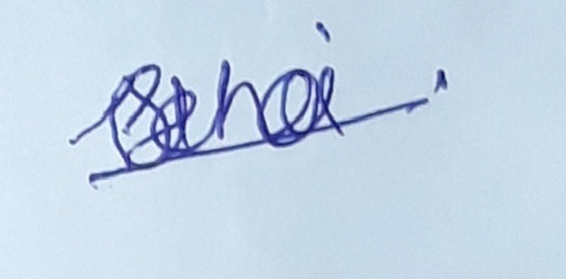

Name of the Student: Uday Sunil Bhoi
Course Name: eDAC
PRN: 210540181215

Place: Dhule

