**OS ASSIGNMENT**

one

apple

banana

cat

dog

elephant

two

fish

gun

horse

icecream

three

jelly

kitkat

lolipop

marshmallow

four

new

oppo

vivo

china

/home -> mkdir EVERYONE

chmod 777 EVERYONE

Create a file with every user (whoami >> username.txt)

oppo -> primary group change -> one

vivo -> primary group change -> two

jelly,kitkat, lolipop, marshmallow -> add these users to sudo group

fish,gun -> add these users to one group as well (secondary group)

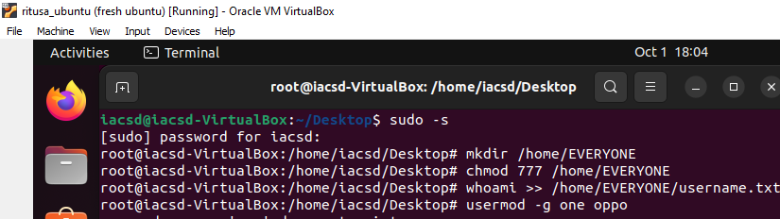

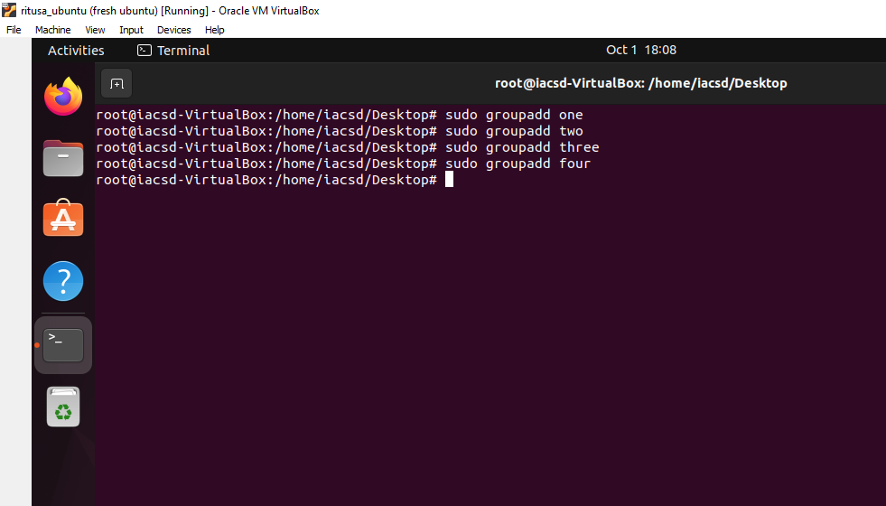

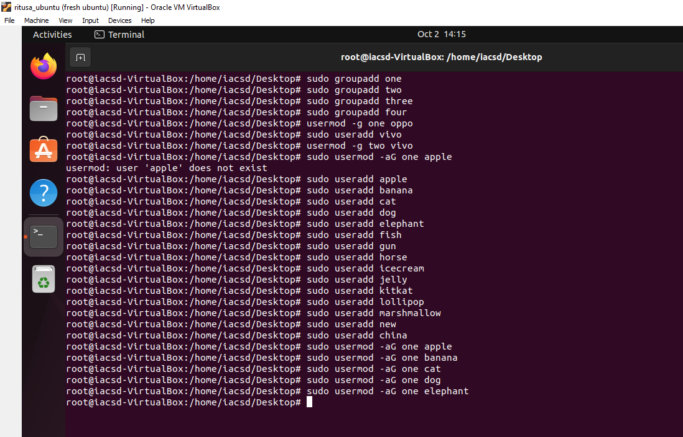

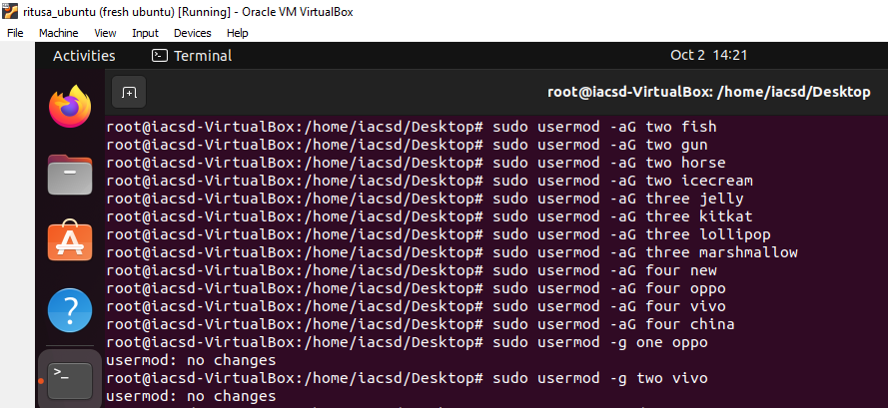

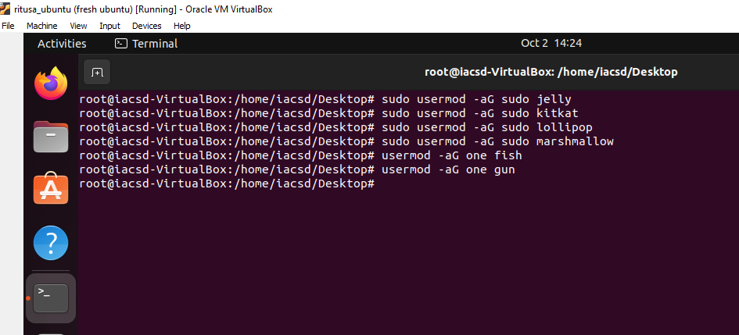

|  |  |
| --- | --- |
|  |  |

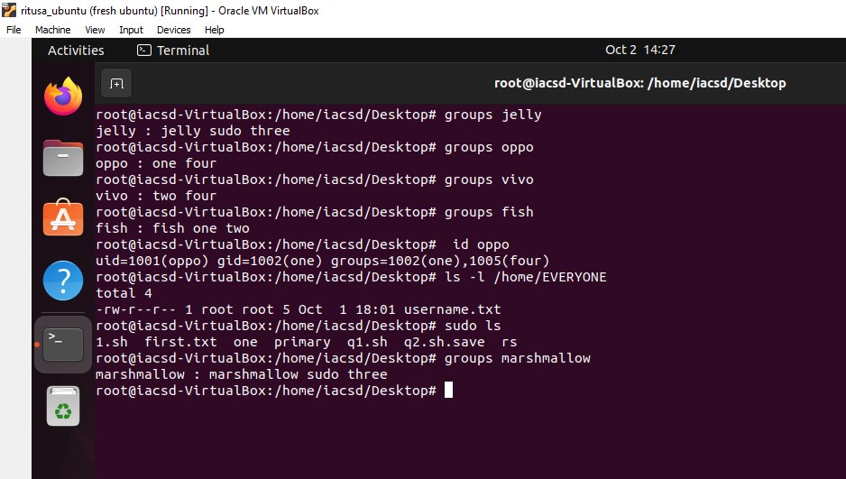

Assignment 1

1. Creating empty practice files in your home directory:

* To  Create six songs files following command is used

touch songs{1..6}.mp3

* To  Create six snap files following command is used

touch snap{1..6}.jpg

* To Create six film files following command is used

touch film{1..6}.avi

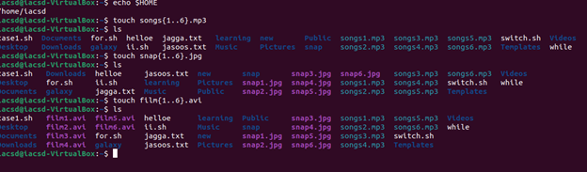

2. Moving the files to their respective subdirectories:

* To Move songs files to Music subdirectory the command is :

mv songs*.mp3 Music

* To  Move snap files to Pictures subdirectory

mv snap*.jpg Picture

* To Move film files to Videos subdirectory

mv film*.avi Videos

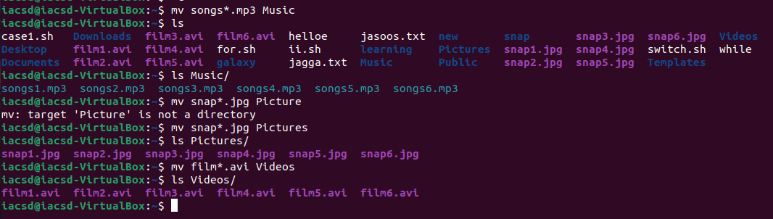

3. Creating subdirectories:

* To Create friends, family, and work subdirectories

mkdir friends family work



4. Copying files to their respective subdirectories based on numbers the command is :

* Copy files with numbers 1 and 2 to the friends folder

cp songs{1,2}.mp3 ../friends

cp snap{1,2}.jpg../friends

cp film{1,2}.avi../friends

* Copy files with numbers 3 and 4 to the family folder

cp songs{3,4}.mp3 ../family

cp snap{3,4}.jpg../family

cp film{3,4}.avi ../family

* Copy files with numbers 5 and 6 to the work folder

cp songs{5,6}.mp3 ../work

cp snap{5,6}.jpg ../work

cp film{5,6}.avi ../work

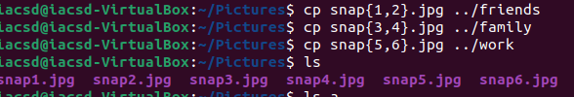

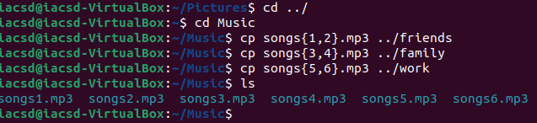

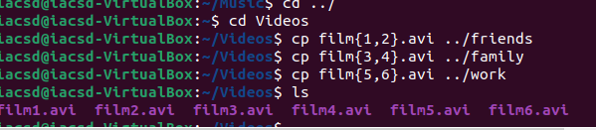

Assignment 2

6) To Delete all files in the family subdirectory:

rm -r family



7) to Delete the friends subdirectory:

rm -r friends



8) to Create users tom, bob, sam, and prince:

sudo useradd tom

sudo useradd bob

sudo useradd sam

sudo useradd prince

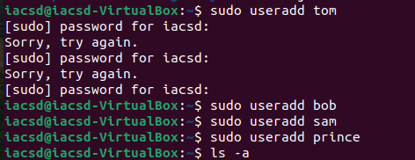

9) To Create groups dac, dbda, and ditiss:

sudo groupadd dac

sudo groupadd dbda

sudo groupadd ditiss

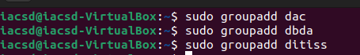

10) To Add users to their respective groups:

sudo usermod -aG dac tom

sudo usermod -aG dbda bob

sudo usermod -aG ditiss sam



11) login as prince and create iacsd directory  in /tmp and create 4 files in iacsd with name project-1 project-2 upto 4

12. assign permissions to project files as below

Project-1 – tom should be owner of this

Project-2 – dac should be owner of this

Project-3 --- others should not have any permission but tom should have rw access

Project-4 – dbda group should have rwx permissions.

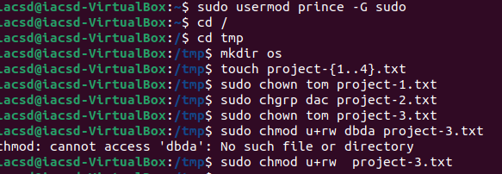

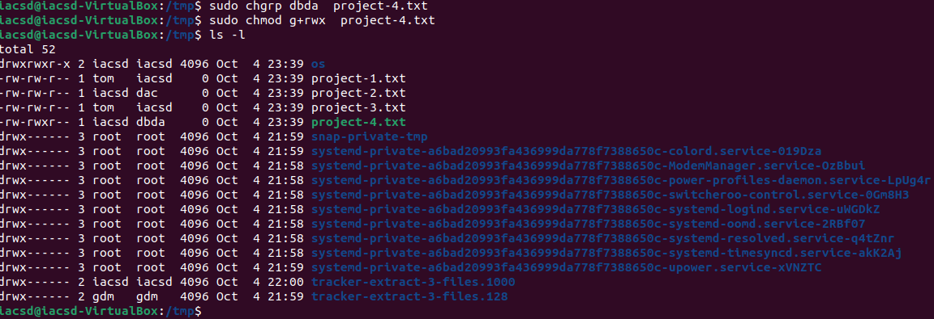

Assignment 4

1) Write a shell script tp print

* your are logged in as which user

-whoami

* in which directory you are

-pwd

* and in which terminal you are working

-tty

* total number of files and directories in current directory

-ls-l

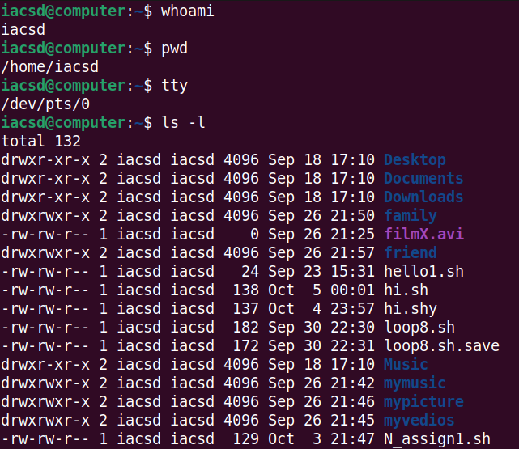

2).Write a shell script to create a menu driven program for adding, deletion or finding a record in a database. Database should have the field like rollno, name, semester and marks of three subjects. Last option of the menu should be to exit the menu.

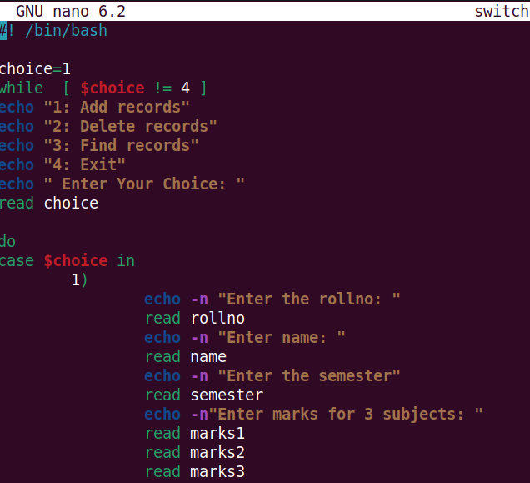

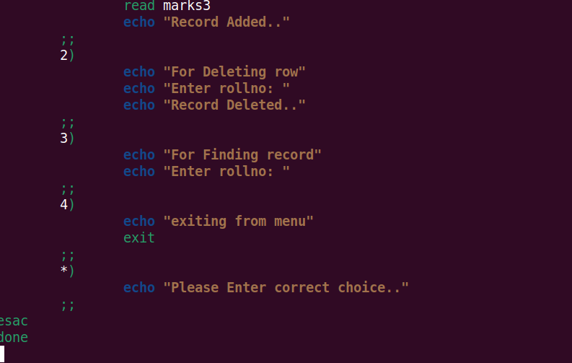

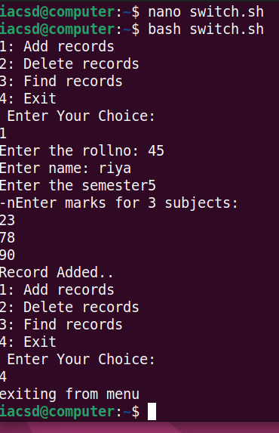

3) Write a Linux shell script to accept 10 number and tell how many are +tive, -tive and zero.

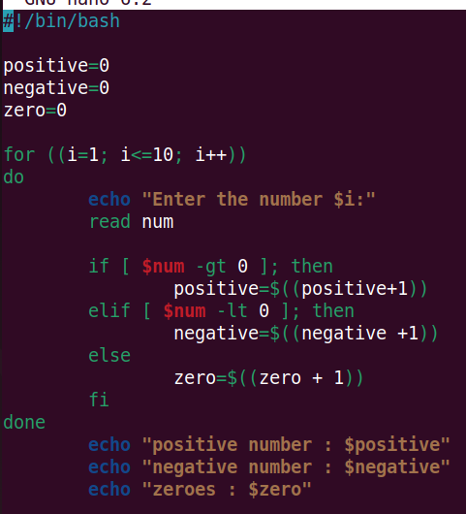

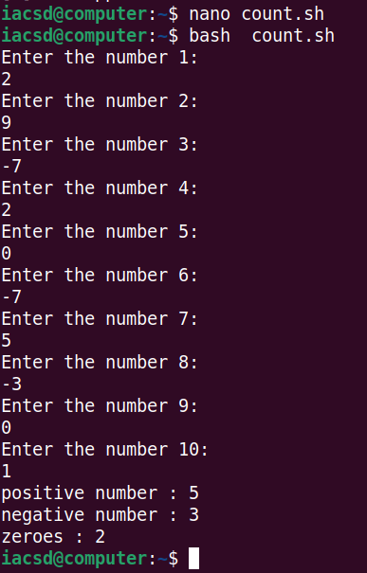

4) Write a shell script to accept five number and display max and min value.

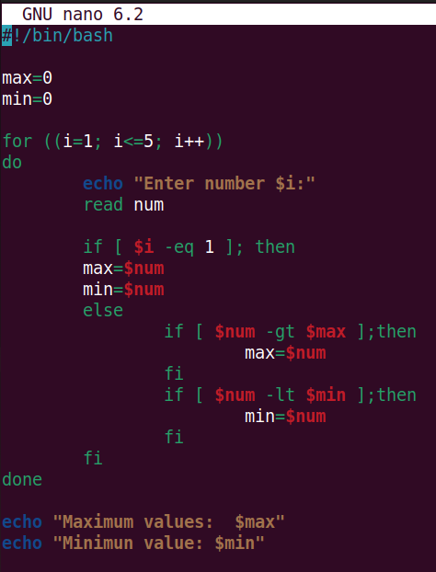

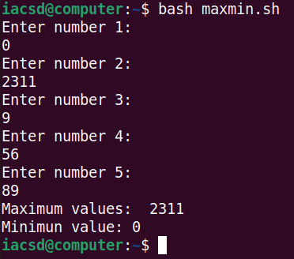

5) Write a script to find out String is palindrome or not.

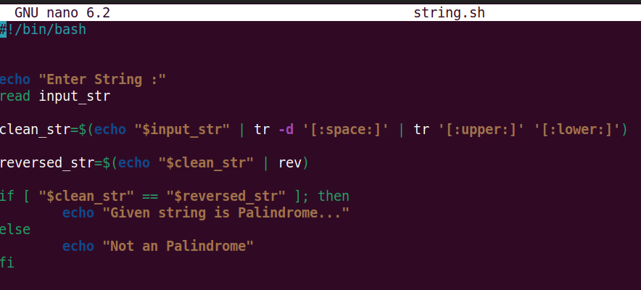

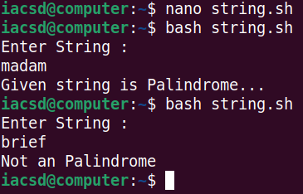

6) Write a shell script to print given number’s sum of all digits (eg. If number is 123, then it’s sum of all digits will be 1+2+3=6)

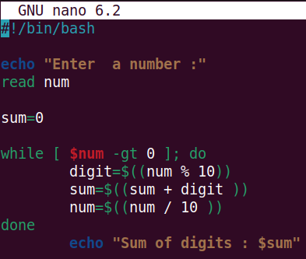

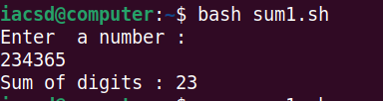

7) Create a script to

Create user , Delete user , Create group , delete Group using case

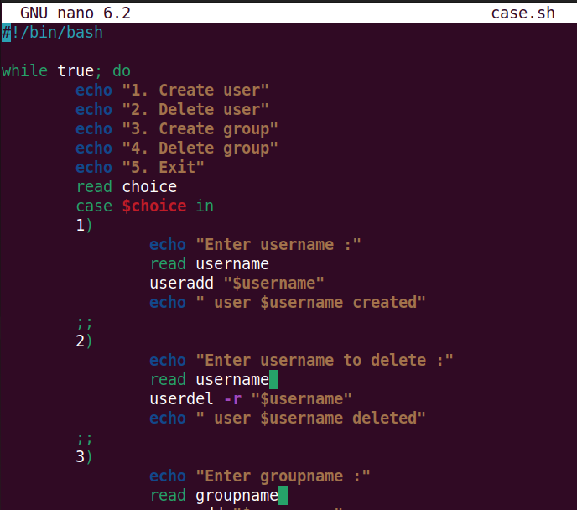

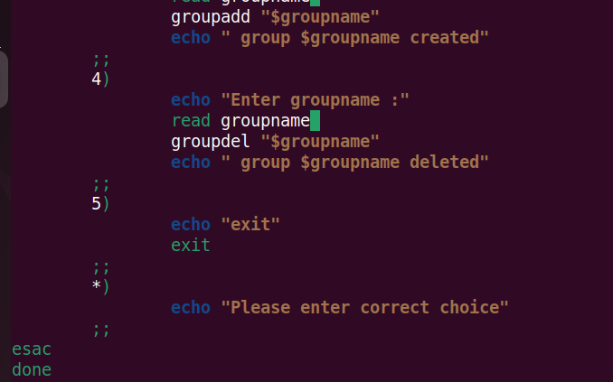

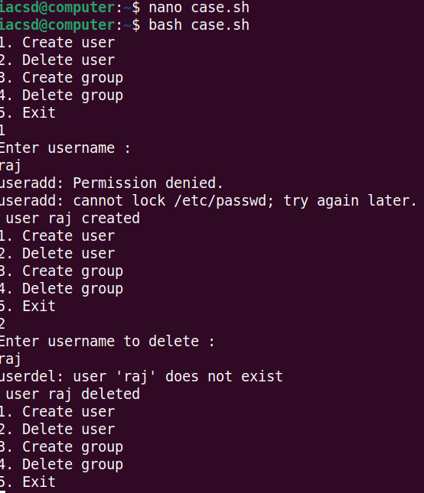

Exercise

Q1.

#!/bin/bash

read -p "enter first number:" fir

read -p "enter second number:" sec

if (($fir > $sec))

then

echo "$fir is the bigger number..."

else

echo "$sec is the bigger number..."

fi

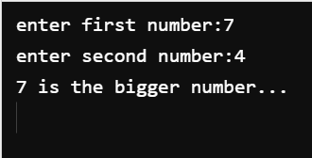

Q2.

#!/bin/bash

read -p "enter first number:" fir

read -p "enter second number:" sec

read -p "enter third number:" thr

if (($fir > $sec))

then

if (($fir > $thr))

then

echo "$fir is the bigger number..."

else

echo "$thr is the bigger number..."

fi

elif [ $sec -gt $fir ]

then

if (($sec > $thr))

then

echo "$sec is the bigger number..."

else

echo "$thr is the bigger number..."

fi

else

echo "invalid..."

fi

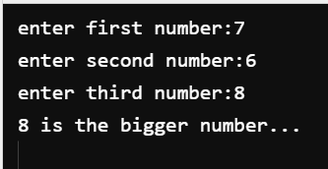

Q3.

#!/bin/bash

read -p "enter num number:" num

if (($num > 0))

then

echo "number is positive..."

elif (($num == 0 ))

then

echo "number is zero..."

else

echo "number is negative..."

fi

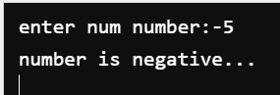

Q4.

#!/bin/bash

read -p "enter number:" num

if (($num % 5==0))

then

if (( $num%11==0))

then

echo "$num is divisible by 5 and 11..."

else

echo "$num is not divisible by 5 and 11..."

fi

else

echo "$num is not divisible by 5 and 11..."

fi

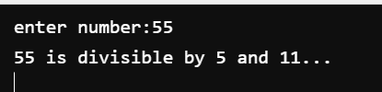

Q5.

#!/bin/bash

read -p "enter number:" num

if (($num % 2==0))

then

echo "$num is even..."

else

echo "$num is odd..."

fi

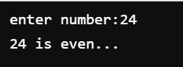

Q6.

read -p "Enter year:" year

if (( $year%4==0 ))

then

if (( $year%100==0 ))

then

if (( $year%400==0 ))

then

echo "Leap Year $year"

else

echo "Not a Leap Year"

fi

else

echo "Leap Year $year"

fi

else

echo "Leap Year $year"

fi

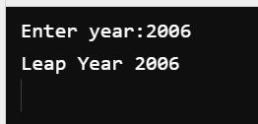

Q7.

read -p "Enter Number:" num

case $num in

1)

echo "One"

;;

2)

echo "Two"

;;

3)

echo "Three"

;;

4)

echo "Four"

;;

5)

echo "Five"

;;

6)

echo "Six"

;;

7)

echo "Seven"

;;

8)

echo "Eight"

;;

9)

echo "Nine"

;;

10)

echo "Ten"

;;

esac

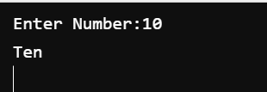

Q8.

read -p "Enter Id:" id

case $id in

1)

echo "Clerk"

;;

2)

echo "Manager"

;;

3)

echo "Analyst"

;;

4)

echo "Salesman"

;;

5)

echo "President"

;;

esac

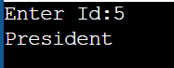

Q9.

#!/bin/bash

read -p "Set Password:" pword

echo "...Password Set Successfully..."

read -p "Enter Password:" password

case $password in

$pword)

echo "Password Accepted..."

;;

*)

echo "Invalid Password..."

;;

esac

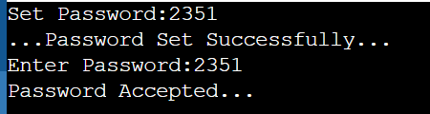

Q10.

#!/bin/bash

read -p "Enter day of week(1-7):" day

case $day in

1)

echo "Monday"

;;

2)

echo "Tuesday"

;;

3)

echo "Wednesday"

;;

4)

echo "Thursday"

;;

5)

echo "Friday"

;;

6)

echo "Saturday"

;;

7)

echo "Sunday"

;;

*)

echo "Enter Valid Day...."

esac



Q11.

#!/bin/bash

read -p "Enter First Number:" num1

read -p "Enter Second Number:" num2

read -p "Enter operation(+,-,/,*):" operation

case $operation in

+)

sum=$(($num1+$num2))

echo "Sum $num1+$num2="$sum

;;

-)

Sub=$(($num1-$num2))

echo "Sub $num1-$num2="$Sub

;;

/)

Division=$(($num1/$num2))

echo "Division $num1/$num2="$Division

;;

*)

Multiply=$(($num1*$num2))

echo "Multiply $num1*$num2="$Multiply

;;

esac

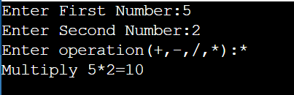

Loops

Q1.

#!/bin/bash

for I in {1..10}

do

echo $i

((i++))

done

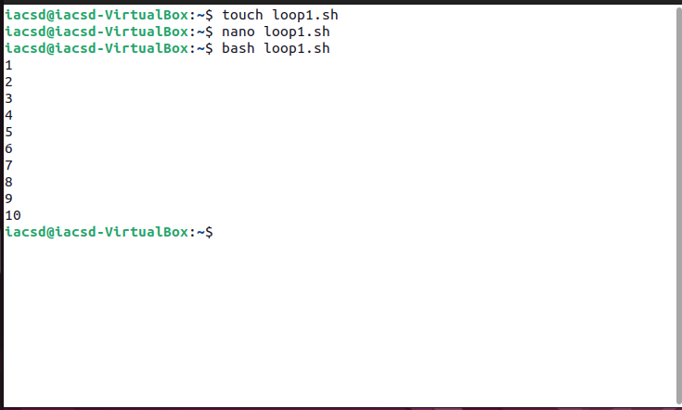

Q2.

#!/bin/bash/

sum=0

for((i=0;i<=10;i++))

do

echo –n “$i ”

sum=$((sum+i))

done

echo –e “The Sum is:” $sum

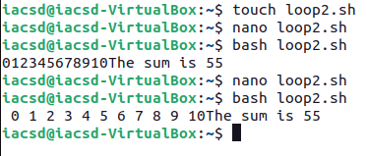

Q3.

#!/bin/bash/

Read –p “Enter a number” num

sum=0

echo “First $sum natural numbers are:”

for((i=0;i<=$num;i++))

do

echo –n “$i ”

sum=$((sum+i))

done

echo –e “Sum is:” $sum

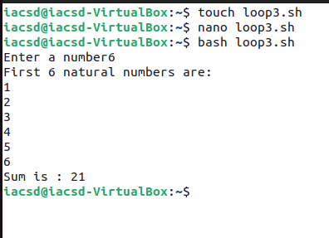

Q4.

#!/bin/bash/

sum=0

cnt=10

echo –n “Enter 10 numbers:”

for((i=0;i<=cnt;i++))

do

read n

sum=$((sum+n))

done

avg=$((sum/cnt))

echo “the sum is $sum”

echo “average is $avg”

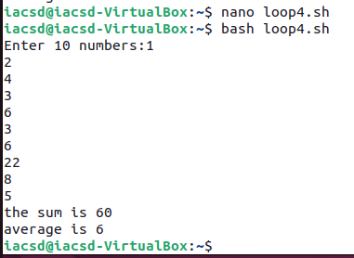

Q5.

#!/bin/bash

echo “Enter a number”

read num

for((i=1;i<=num;i++))

do

cube=$((i*i*i))

echo “Number is $i and cube is $cube”

done

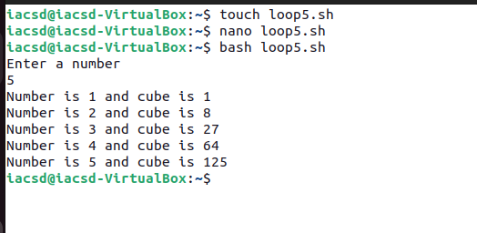

Q6.

#!/bin/bash

echo “Enter a number”

read num

for((i=1;i<=10;i++))

do

result=$((num *i))

echo “$num * $i=$result”

done

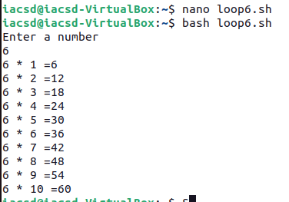

Q7.

#!/bin/bash

echo "Enter upto the table number starting from 1:"

read num

for((i=1;i<=num;i++))

do

for((j=1;j<=10;j++))

do

pro=$((i*j))

echo "$i * $j = $pro"

done

echo ""

done

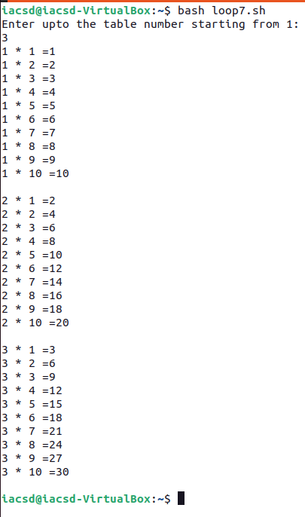

O8. #!/bin/bash

echo "input num of terms: "

read n

count=0

odd="

cur=1

while [$count -lt $n]

do

if [ $((cur % 2)) -ne 0 ]; then

odd="$odd $cur"

Sum=$((sum+ cur))

count=$((count+ 1))

fi

cur=$((cur +1))

done

echo "The odd numbers are :$odd"

echo "The sum of odd natural number upto $n terms :$sum"

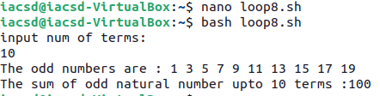

Q9.

#!/bin/bash

echo “Enter number of rows”

read row

for(i=1;i<=row;i++))

do

for(j=1;j<=i;j++))

do

echo –n “*”

done

echo “”

done

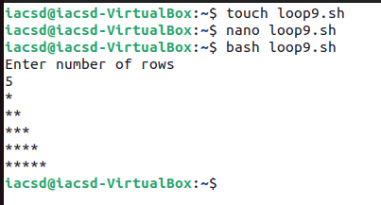

Q10.

#!/bin/bash

echo “Enter number of rows”

read row

for(i=1;i<=row;i++))

do

for(j=1;j<=i;j++))

do

echo –n “$j”

done

echo “”

done

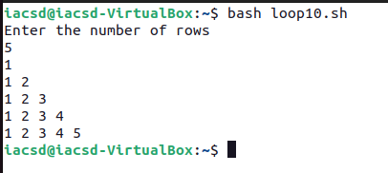

Q11.

#!/bin/bash

echo “Enter number of rows”

read n

for(i=1;i<=n;i++))

do

for(j=1;j<=i;j++))

do

echo –n “$i”

done

echo “”

done

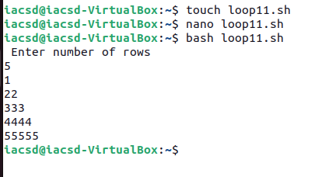

Q12.

#!/bin/bash

echo “Enter number of rows”

read row

num=1

for(i=1;i<=row;i++))

do

for(j=1;j<=i;j++))

do

echo –n “$num ”

num=$((num+1))

done

echo “”

done

