WEEK 6 TASK

DEPLOYMENT, MAINTENANCE, AND PROJECT REFLECTION

Project Title: ShopSphere – Full Stack E-Commerce Application
Submitted By: Rutuja Shendure
Course: Master of Computer Applications (MCA)
Internship Project: Full Stack Development
Task: Week 6 – Deployment, Maintenance, and Project Reflection
Academic Year: 2025–2026
Project Status: Deployed and tested
Live Application: https://ecommerce-platform-1ssocahgd-rutujashenduretech.vercel.app/
GitHub Repository: https://github.com/RutujaShenduretech/Ecommerce-Platform.git

TABLE OF CONTENTS
- Introduction
- Project Overview
- Objectives of Week 6
- Technologies and Tools Used
- Application Architecture
- Pre-Deployment Preparation
- Environment Variable Configuration
- Deployment Guide
- Neon Database Configuration
- Production Deployment Verification
- User Acceptance Testing
- Security Best Practices
- Common Deployment Issues and Troubleshooting
- Application Maintenance Strategy
- Logging and Error Reporting
- Database Backup and Recovery Strategy
- Application Update and Version Control Procedures
- Performance Monitoring and Optimization
- Maintenance Schedule
- Project Reflection
- Challenges Faced and Solutions
- Skills and Knowledge Gained
- Areas for Future Improvement
- Conclusion
- References
- Submission Deliverables

1. INTRODUCTION
Deployment and maintenance are important stages in the software development lifecycle. Developing an application locally is not sufficient because users must be able to access and use the application through a public hosting environment.
The Week 6 task focuses on deploying the developed full-stack application, configuring production environments, verifying application functionality, preparing a maintenance strategy and reflecting on the complete development process.
For this task, I worked on deploying my full-stack eCommerce application, ShopSphere, using Vercel as the application hosting platform and Neon as the cloud PostgreSQL database provider.
The application was originally developed and tested in a local development environment. To make it accessible publicly, I configured the production environment, connected the application to the Neon database, deployed it using Vercel and tested the major application functionalities.
During deployment, I encountered database connection and configuration issues. These issues were investigated and resolved by checking environment variables, correcting the database connection configuration and redeploying the application.
After deployment, I verified product retrieval and order creation using the production database.
This report explains the deployment process, production configuration, testing procedures, maintenance strategy, troubleshooting methods and personal learning outcomes.

2. PROJECT OVERVIEW

2.1 About ShopSphere
ShopSphere is a full-stack eCommerce web application developed to provide users with an online shopping experience.
The platform allows customers to browse available products, view product details, register, log in, add products to a shopping cart, update quantities, place orders, view order history and generate printable invoices.
The application uses Next.js and React.js for the frontend, Next.js API routes for backend functionality, PostgreSQL for database storage and Drizzle ORM for database operations.
The application is deployed using Vercel, while Neon provides the hosted PostgreSQL database.

2.2 Main Features
The major features implemented in ShopSphere include:
1. User Authentication
- User registration.
- User login.
- Authentication and session management.
- Access to user-specific functionality.
2. Product Management
- Displaying available products.
- Product images and descriptions.
- Product pricing.
- Product categories.
- Product ratings, sizes and colors.
- Product detail pages.
3. Shopping Cart
- Adding products to the cart.
- Increasing product quantities.
- Decreasing product quantities.
- Removing products.
- Calculating cart totals.
4. Checkout
- Processing customer checkout information.
- Calculating subtotal and applicable charges.
- Applying discount calculations.
- Creating customer orders.
- Saving order information in PostgreSQL.
5. Order Management
- Storing customer orders.
- Storing individual order items.
- Retrieving order information.
- Displaying order history in the dashboard.
6. Invoice Generation
- Displaying customer information.
- Showing purchased products.
- Displaying order totals.
- Generating printable invoices.

2.3 Project Objective
The primary objective of ShopSphere is to develop a functional online shopping application that demonstrates the integration of frontend development, backend API development, relational database management and cloud deployment.
The Week 6 objective was to make the application publicly accessible and prepare it for reliable ongoing maintenance.

3. OBJECTIVES OF WEEK 6
The main objectives of this task were:
- Prepare the application for production deployment.
- Configure production environment variables.
- Deploy the full-stack application using a public hosting platform.
- Connect the application to a hosted PostgreSQL database.
- Verify application functionality after deployment.
- Perform user acceptance testing.
- Follow security best practices.
- Identify and troubleshoot common deployment problems.
- Prepare a maintenance strategy.
- Document logging and error reporting procedures.
- Define database backup and recovery procedures.
- Establish application update procedures.
- Reflect on the complete development experience.
- Identify future improvements.

4. TECHNOLOGIES AND TOOLS USED
The following technologies and services were used during the development and deployment of ShopSphere.
Technology | Purpose
Next.js | Full-stack web application framework
React.js | User interface development
JavaScript | Application logic
TypeScript | Type checking and application development
HTML5 | Page structure
Tailwind CSS | Responsive styling
shadcn/ui | User interface components
Next.js API Routes | Backend API functionality
Node.js | JavaScript runtime
PostgreSQL | Relational database
Neon | Hosted PostgreSQL database
Drizzle ORM | Database queries and schema management
Git | Version control
GitHub | Source code hosting
VS Code | Development environment
Postman | API testing
Vercel | Application hosting and deployment
Vitest | Unit testing

5. APPLICATION ARCHITECTURE

5.1 Architecture Overview
ShopSphere follows a full-stack architecture consisting of three main layers:
Frontend Layer
The frontend is developed using Next.js and React.js. It provides the user interface for browsing products, managing the cart, authentication, checkout and order history.
Backend Layer
The backend uses Next.js API routes to handle application requests. It processes authentication, product retrieval, cart operations and order management.
Database Layer
PostgreSQL stores product information, user accounts, cart items, orders and invoice-related information. Drizzle ORM is used to interact with PostgreSQL.
Neon hosts the PostgreSQL database, and Vercel hosts the Next.js application.

5.2 Application Architecture Diagram
CUSTOMER
|
v
NEXT.JS FRONTEND
(React Components)
|
v
NEXT.JS API ROUTES
|
v
DRIZZLE ORM
|
v
NEON POSTGRESQL
|
v
DATABASE TABLES
|
-----------------------
| | |
v v v
PRODUCTS USERS ORDERS
|
v
ORDER ITEMS
|
v
BILLS

5.3 Application Data Flow
- The user opens the ShopSphere website.
- The frontend displays the available products.
- The frontend sends API requests to the backend.
- The backend processes the requests.
- Drizzle ORM executes database operations.
- Neon PostgreSQL stores or retrieves the requested information.
- The backend returns the response.
- The frontend displays the result to the user.

6. PRE-DEPLOYMENT PREPARATION
Before deploying ShopSphere, I prepared the application for a production environment.
The following activities were considered.

6.1 Source Code Verification
The project source code was reviewed to ensure that the required application files were present.
Important files included:
- package.json
- package-lock.json
- next.config.ts
- drizzle.config.ts
- src/db/index.ts
- src/db/schema.ts
- Application components.
- API route files.
- Environment configuration files.

6.2 Dependency Installation
The required project dependencies were installed using:
npm install
This command installs the dependencies specified in the package configuration.

6.3 Production Build Verification
Before deployment, I used:
npm run build
This command checks whether the application can be compiled for production.
The production build was successfully completed after resolving earlier build issues.

6.4 Unit Testing
Vitest was used to test application calculation functions and components.
The project previously passed 11 unit tests across four test files.
The tested functionality included:
- Total calculation.
- Cart total calculation.
- Discount calculation.
- Unit test component behavior.
Command:
npm test -- --run

6.5 Environment Configuration
The application requires database connection details to communicate with PostgreSQL.
The local environment uses environment configuration files, while the production environment receives its variables through Vercel settings.
Sensitive credentials were not intended to be included in the public source code.

7. ENVIRONMENT VARIABLE CONFIGURATION
Environment variables are used to store configuration values separately from the source code.
They allow the application to connect to the correct database without exposing database credentials directly in application files.

7.1 Local Environment Configuration
During local development, the application uses environment files such as:
.env
.env.local
These files contain database connection configuration.
Example:
DATABASE_URL="YOUR_NEON_POOLED_CONNECTION_STRING"
DIRECT_URL="YOUR_NEON_DIRECT_CONNECTION_STRING"
The actual connection strings are private and must not be published.

7.2 Production Environment Configuration
For production deployment, the environment variables were configured in Vercel.
The following variables were added:
Variable | Purpose
DATABASE_URL | Neon pooled PostgreSQL connection
DIRECT_URL | Neon direct PostgreSQL connection
The DATABASE_URL variable is used by the application runtime.
The DIRECT_URL variable is available for database operations that require a direct connection, depending on the Drizzle configuration.
The application uses the pooled Neon connection for its runtime database access.

7.3 Steps to Configure Variables in Vercel
- Log in to the Vercel dashboard.
- Open the ShopSphere project.
- Navigate to Settings.
- Open Environment Variables.
- Select Add New.
- Enter DATABASE_URL as the variable name.
- Paste the Neon pooled connection string as the value.
- Select the required deployment environments.
- Save the variable.
- Repeat the process for DIRECT_URL, using the Neon direct connection string.
Environment variable values must not contain unnecessary quotation marks when entered in the Vercel dashboard.

7.4 Importance of Environment Variables
Environment variables help to:
- Protect database credentials.
- Separate development and production configurations.
- Avoid hardcoding sensitive information.
- Simplify deployment configuration.
- Change database settings without modifying source code.

8. DEPLOYMENT GUIDE USING VERCEL

8.1 Introduction to Vercel
Vercel is a cloud hosting platform that supports modern frontend and full-stack web applications, including Next.js.
It provides application deployment, production hosting, deployment previews and runtime logs.
Vercel was selected for ShopSphere because it provides a convenient deployment environment for Next.js applications.
Website: https://vercel.com/

8.2 Step 1 – Prepare the GitHub Repository
The application source code should be available in a GitHub repository.
The repository contains the application source code, configuration files and package information.
Before connecting it to Vercel, sensitive files such as .env and .env.local must be excluded from version control.

8.3 Step 2 – Create a Vercel Account
- Visit https://vercel.com/.
- Sign up or log in.
- Connect the GitHub account.
- Authorize access to the project repository.

8.4 Step 3 – Import the Project
- Open the Vercel dashboard.
- Select Add New.
- Select Project.
- Choose the ShopSphere GitHub repository.
- Import the repository.

8.5 Step 4 – Configure Build Settings
Vercel detects Next.js automatically.
The standard build settings are:
Setting | Configuration
Framework | Next.js
Build Command | npm run build
Install Command | npm install
Output Directory | Next.js default
The project root directory must point to the folder containing the actual package.json.
For ShopSphere, the application folder is:
ecommerce-website/

8.6 Step 5 – Configure Environment Variables
During deployment configuration, add the Neon environment variables.
DATABASE_URL
DIRECT_URL
Use the correct Neon connection strings.
The runtime database connection must use the pooled URL.

8.7 Step 6 – Deploy the Application
After configuring the project:
- Click Deploy.
- Vercel installs the dependencies.
- Vercel builds the Next.js application.
- Vercel generates the production deployment.
- The deployment status is displayed.
When the deployment succeeds, the application receives a public URL.

8.8 Step 7 – Redeployment
During the deployment process, I discovered that environment variables added to Vercel do not automatically become available to an already-created deployment.
Therefore, after configuring the database variables, I redeployed the application.
The redeployment allowed the application to use the updated Neon connection configuration.

8.9 Step 8 – Access the Live Application
After deployment, the public URL can be opened in a browser.
The deployed website can be accessed without starting the local development server.
The production application was tested using its public URL.

9. NEON DATABASE CONFIGURATION

9.1 Introduction to Neon
Neon is a managed PostgreSQL database platform.
It provides hosted PostgreSQL databases that can be accessed by applications through database connection strings.
Website: https://neon.tech/
Neon was used to host the ShopSphere production database.

9.2 Database Connection
The application uses Drizzle ORM and the PostgreSQL driver to connect to Neon.
The database connection file is:
src/db/index.ts
The connection code is:
import { drizzle } from "drizzle-orm/node-postgres";
import { Pool } from "pg";
import * as schema from "./schema";

const pool = new Pool({
connectionString: process.env.DATABASE_URL,
max: 1,
});

export const db = drizzle(pool, { schema });
The connection reads the database URL from the environment rather than hardcoding credentials.

9.3 Database Tables
The Neon database was checked using the Neon SQL Editor.
The following tables were verified:
No. | Table name | Purpose
1 | users | Stores user information
2 | products | Stores product details
3 | cart_items | Stores cart information
4 | orders | Stores order records
5 | order_items | Stores products within orders
6 | bills | Stores bill information
7 | bill_items | Stores bill line items
8 | playing_with_neon | Additional database test table

9.4 Database Verification
The following SQL queries were used to verify the database.
Check whether the products table exists:
SELECT table_name
FROM information_schema.tables
WHERE table_schema = 'public'
AND table_name = 'products';
Retrieve products:
SELECT * FROM public.products;
Count products:
SELECT COUNT(*) AS total_products
FROM public.products;
Check database tables:
SELECT table_name
FROM information_schema.tables
WHERE table_schema = 'public'
ORDER BY table_name;
Check saved orders:
SELECT * FROM public.orders
ORDER BY id DESC;
These queries helped verify that the application data was present in the Neon database.

10. PRODUCTION DEPLOYMENT VERIFICATION
After configuring Vercel and Neon, the production application was tested.

10.1 Products API Verification
The following endpoint was opened:
https://YOUR-VERCEL-DOMAIN/api/products
The API was expected to return a JSON response containing product information.
Example response structure:
{
"success": true,
"products": [
{
"id": 1,
"name": "Aero Run Pro",
"category": "Running",
"price": "6999.00"
}
]
}
The deployed Products API successfully returned product information after the database connection was corrected.

10.2 Product Verification
The product information was also checked directly in Neon.
The database contained 20 product records.
The product records included names, categories, prices, descriptions, images, ratings, sizes and colors.

10.3 Order Verification
A test order was placed through the deployed application.
The order was successfully stored in the Neon database.
The verified order contained:
- Order ID: 1
- User ID: 1
- Total: ₹10,298.00
- Status: Pending
The order record demonstrated that the production application could perform a database write operation.

10.4 Result
The deployment verification confirmed that:
- The application was publicly accessible.
- The Products API could retrieve database records.
- The application could communicate with Neon.
- The order creation operation successfully saved an order.

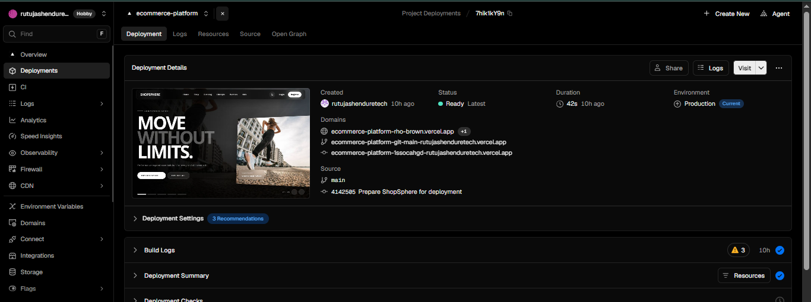

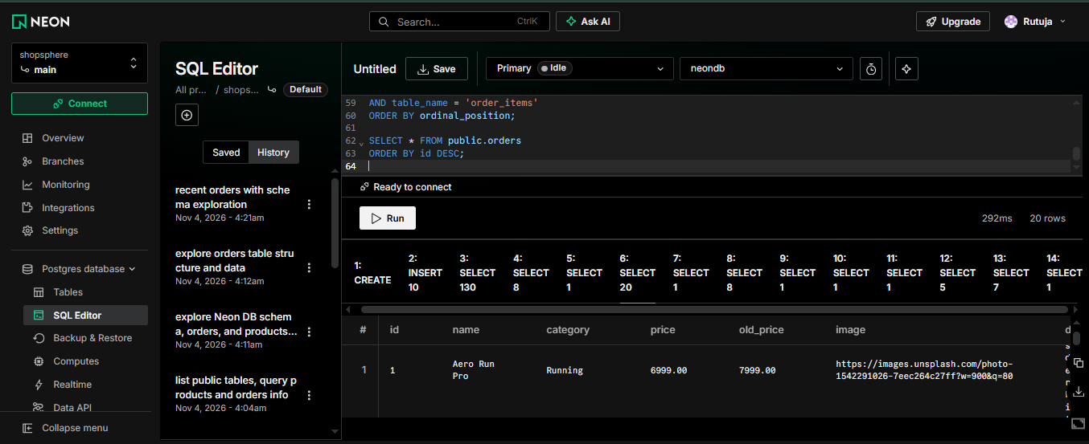
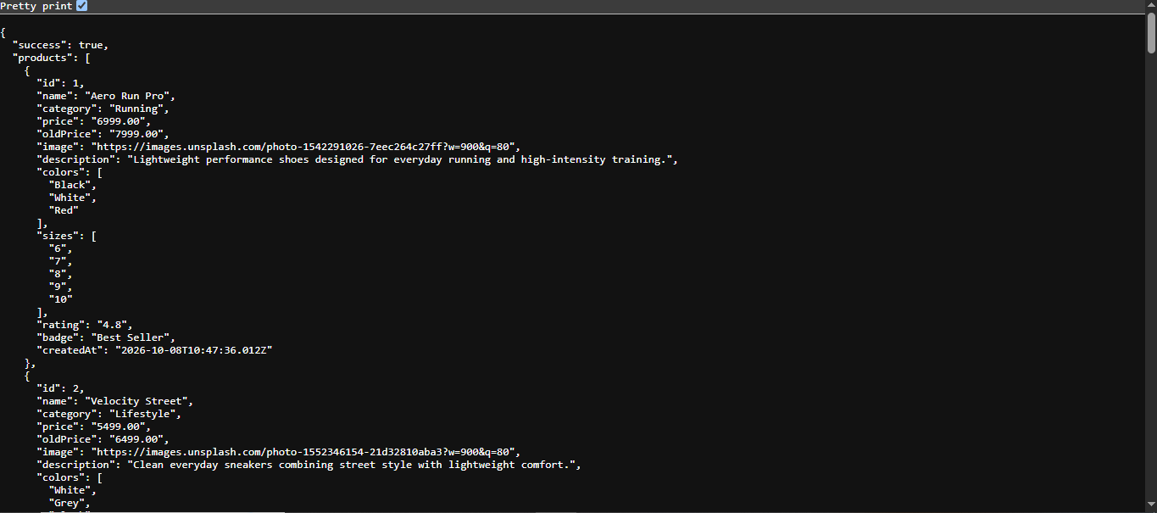

11. USER ACCEPTANCE TESTING

11.1 Introduction
User Acceptance Testing (UAT) is performed to verify that an application meets its intended functional requirements from the user's perspective.
For ShopSphere, UAT focused on testing the major user journeys through the deployed website.

11.2 Testing Environment
Item | Description
Application | ShopSphere
Hosting platform | Vercel
Database | Neon PostgreSQL
Browser | Google Chrome
Testing type | Manual functional testing
API verification | Browser and database SQL queries
Unit testing | Vitest

11.3 UAT Test Cases
Test ID | Test scenario | Expected result
UAT-01 | Open homepage | Homepage loads
UAT-02 | Browse products | Product listings appear
UAT-03 | Open product details | Correct details appear
UAT-04 | Register account | Account is created
UAT-05 | Login | User can access account
UAT-06 | Add product to cart | Product is added
UAT-07 | Increase quantity | Quantity updates
UAT-08 | Decrease quantity | Quantity updates
UAT-09 | Remove product | Product is removed
UAT-10 | Open checkout | Checkout page loads
UAT-11 | Place order | Order is created
UAT-12 | Check Neon orders table | Order record is saved
UAT-13 | Open dashboard | Order history appears
UAT-14 | View invoice | Invoice details appear
UAT-15 | Print invoice | Browser print interface opens

11.4 UAT Results
The following results were verified during the deployment work:
Test | Observed result
Products API | Successful
Neon product records | 20 records verified
Neon database tables | Tables verified
Order creation | Successful
Order persistence | Order saved in Neon
Other user-interface and account-related tests should be recorded as passed only after they have been individually tested on the final production deployment.

11.5 Unit Testing
Vitest was used to test important calculation functionality.
The previously reported test result was:
- 4 test files.
- 11 tests.
- All tests passed.
The tests covered cart calculations, discount calculations, total calculations and component behavior.
Command:
npm test -- --run

11.6 Importance of UAT
UAT helps to:
- Verify real user workflows.
- Detect functionality problems.
- Confirm database operations.
- Check the deployed application.
- Improve application reliability.
- Identify issues before final submission.

12. SECURITY BEST PRACTICES
Security is important when an application is accessible publicly.
The following security practices are recommended for ShopSphere.

12.1 Protect Environment Variables
Database credentials must be stored in environment variables.
They should never be hardcoded in source files or uploaded to public GitHub repositories.
Files such as:
.env
.env.local
should be included in .gitignore.

12.2 Secure Database Access
The application should use authenticated database connections.
Neon database credentials should be kept private and rotated if they are accidentally exposed.
The application should use a restricted database account where supported.

12.3 User Authentication
The application should verify user authentication before allowing access to protected account features.
Protected API routes should verify the current user's identity.

12.4 Password Protection
Passwords should never be stored as plain text.
A secure password hashing algorithm should be used, such as bcrypt or Argon2, according to the application's authentication implementation.

12.5 Input Validation
User-provided information should be validated before database operations.
Validation should be applied to:
- Registration details.
- Login credentials.
- Product quantities.
- Checkout information.
- Customer details.

12.6 Authorization
Users should only be able to access their own account-related information.
For example, an order history API should retrieve orders associated with the authenticated user rather than trusting a user ID supplied by the browser.

12.7 HTTPS
The deployed application should be accessed through HTTPS.
HTTPS protects information transmitted between the browser and server.

12.8 Error Handling
Error responses should not expose sensitive database credentials, connection strings or internal implementation details.
Detailed errors should be recorded securely in server logs.

12.9 Dependency Security
Dependencies should be reviewed periodically.
The following command can identify known package vulnerabilities:
npm audit
Updates should be reviewed and tested before production deployment.

13. COMMON DEPLOYMENT ISSUES AND TROUBLESHOOTING
During the ShopSphere deployment process, I encountered database-related errors.
Troubleshooting involved identifying the actual error, checking configuration and verifying the database.

13.1 Issue 1 – Database Authentication Failure
Error:
password authentication failed
Cause:
The application could not authenticate with the PostgreSQL database.
Possible reasons included an incorrect or outdated database connection string.
Solution:
- Opened the Neon dashboard.
- Checked the correct database connection details.
- Copied the Neon pooled connection string.
- Updated DATABASE_URL in Vercel.
- Saved the environment variable.
- Redeployed the application.
Result:
The database connection was corrected.

13.2 Issue 2 – Products Table Does Not Exist
Error:
relation "products" does not exist
Cause:
The application was unable to find the expected products table in the database it was accessing.
This required checking the database and schema configuration.
Solution:
- Opened the Neon SQL Editor.
- Checked whether the products table existed.
- Retrieved the table records.
- Verified the database tables.
- Checked the database connection configuration.
The Neon database was found to contain the products table and 20 product records.

13.3 Issue 3 – Environment Variables Not Applied
Problem:
The application did not immediately use the newly configured environment variables.
Cause:
The existing deployment had been created before the updated variables were applied.
Solution:
- Opened Vercel project settings.
- Checked the environment variables.
- Saved the correct database configuration.
- Opened Deployments.
- Redeployed the latest application.
Result:
The deployed Products API began returning product records correctly.

13.4 Issue 4 – Products Not Displaying
Problem:
Products were not loading correctly on the deployed application.
Investigation:
The Products API was tested directly in the browser.
The API returned:
{
"success": false,
"message": "Failed to fetch products"
}
Solution:
The database connection and environment configuration were investigated.
After correcting the Neon connection and redeploying, the Products API returned product data successfully.

13.5 Issue 5 – Orders Not Appearing Initially
Problem:
The application needed verification that checkout information was being saved to the cloud database.
Investigation:
The Neon SQL Editor was used to inspect the orders table.
Initially, the table contained zero orders.
Solution and Verification:
A new order was placed through the deployed application.
The order was subsequently found in the Neon orders table.
The order was also verified through its saved total and Pending status.

13.6 General Troubleshooting Procedure
For future deployment issues, the following process will be followed:
- Identify the exact error message.
- Reproduce the issue.
- Check Vercel deployment status.
- Inspect runtime logs.
- Verify environment variables.
- Check database connectivity.
- Verify database tables and records.
- Apply the appropriate correction.
- Redeploy when necessary.
- Retest the affected functionality.
This systematic approach avoids unnecessary code changes.

14. APPLICATION MAINTENANCE STRATEGY

14.1 Introduction
Application maintenance is the process of keeping software functional, secure and reliable after deployment.
A maintenance strategy is required to identify problems, fix errors, improve performance and ensure that the application continues to operate correctly.
For ShopSphere, the maintenance strategy focuses on the application, database, security, performance and source code.

14.2 Types of Maintenance
1. Corrective Maintenance
Corrective maintenance involves fixing defects discovered after deployment.
Examples:
- Fixing Products API errors.
- Correcting checkout calculation problems.
- Fixing order history display issues.
- Resolving database connection errors.
2. Adaptive Maintenance
Adaptive maintenance involves updating the application when its environment or dependencies change.
Examples:
- Updating Next.js versions.
- Adjusting database configurations.
- Updating deployment settings.
- Adapting to changes in hosting platform requirements.
3. Perfective Maintenance
Perfective maintenance improves existing application functionality.
Examples:
- Improving product page loading speed.
- Enhancing mobile responsiveness.
- Improving search and filtering.
- Improving dashboard usability.
4. Preventive Maintenance
Preventive maintenance reduces the possibility of future failures.
Examples:
- Reviewing dependencies.
- Checking logs.
- Backing up database information.
- Testing updates before deployment.
- Monitoring database connectivity.

15. LOGGING AND ERROR REPORTING

15.1 Importance of Logging
Logging is important because it provides information about application activities and errors.
Logs help developers identify problems that may not be visible through the user interface.

15.2 Application Logging
The application uses server-side error handling.
For example, the Products API includes:
console.error("Error fetching products:", error);
This records the error in the server logs.
The information can be investigated through Vercel runtime logs.

15.3 Vercel Runtime Logs
Vercel provides runtime logs for deployed application functions.
The maintenance process includes:
- Open the Vercel dashboard.
- Select ShopSphere.
- Open Logs.
- Filter the relevant API request.
- Inspect the error details.
- Identify the affected route.
- Correct the underlying issue.
- Retest the API.

15.4 Error Reporting Strategy
The following errors should be monitored:
Error category | Monitoring requirement
API errors | Check failed requests
Database errors | Check connection failures
Authentication errors | Investigate unexpected failures
Checkout errors | Check order processing
Runtime errors | Review application logs
Build errors | Inspect deployment build logs

15.5 Future Logging Improvements
For a production-scale application, structured logging can be introduced.
Recommended improvements include:
- Timestamped log entries.
- Request identifiers.
- Error severity levels.
- API response status tracking.
- Centralized error reporting.
- Alerts for repeated failures.
Sensitive information such as passwords and database URLs must never be written to logs.

16. DATABASE BACKUP AND RECOVERY STRATEGY

16.1 Importance of Database Backups
The database contains important application information, including:
- User accounts.
- Product information.
- Shopping cart information.
- Customer orders.
- Order items.
- Invoice records.
Losing this data could affect the functionality of the application.
Therefore, a backup and recovery strategy is important.

16.2 Backup Strategy
The recommended maintenance process includes:
- Review Neon database backup and restore capabilities.
- Configure an appropriate recovery or backup policy.
- Export important database data periodically.
- Store backup files in a secure location.
- Restrict access to backup files.
- Verify that backups can be restored.

16.3 Recovery Procedure
If database information is lost or damaged:
- Identify the database problem.
- Stop potentially harmful operations.
- Review the available recovery points.
- Select an appropriate backup or restore point.
- Restore the database using the supported Neon recovery procedure.
- Verify the restored tables.
- Test the application database connection.
- Verify products, users and orders.

16.4 Backup Security
Database backups must be protected using appropriate access controls.
They should not be uploaded to public repositories.
Backup and restoration procedures should be tested periodically.

17. APPLICATION UPDATE AND VERSION CONTROL PROCEDURES

17.1 Git and GitHub
Git is used for version control.
GitHub stores the project source code and helps maintain the development history.
The maintenance process should follow these steps:
- Make code changes locally.
- Test the modified functionality.
- Run unit tests.
- Run a production build.
- Review the changes.
- Commit the changes.
- Push the code to GitHub.
- Review the Vercel deployment.
- Test the updated production application.

17.2 Common Git Commands
Check repository status:
git status
Stage changes:
git add .
Commit changes:
git commit -m "Update application functionality"
Push changes:
git push origin main

17.3 Production Update Procedure
When application updates are required:
- Identify the requested improvement or defect.
- Create and test the change locally.
- Verify database compatibility.
- Run the production build.
- Push the updated source code.
- Review the Vercel deployment.
- Verify the application after deployment.
Database schema changes should be handled through reviewed Drizzle migrations.

17.4 Rollback Strategy
If a new deployment introduces a serious issue:
- Identify the failed deployment.
- Review its logs.
- Identify the last known working deployment.
- Use Vercel's deployment rollback or redeployment facilities where appropriate.
- Verify that the restored application works.
- Investigate and correct the original issue before releasing another update.
Database changes require additional care because rolling back application code does not automatically reverse database changes.

18. PERFORMANCE MONITORING AND OPTIMIZATION

18.1 Importance of Performance
Performance affects user experience and application reliability.
Slow pages, delayed API responses and database queries can negatively affect customer interactions.

18.2 Performance Monitoring
The following areas should be reviewed:
- Homepage loading time.
- Product listing performance.
- Product image loading.
- API response times.
- Database query performance.
- Checkout response time.
- Mobile responsiveness.

18.3 Performance Improvement Methods
Recommended improvements include:
Image Optimization
Use appropriately sized images and Next.js image optimization where suitable.
API Optimization
Avoid unnecessary database requests and return only the required data.
Database Optimization
Use suitable database indexes and review frequently executed queries.
Frontend Optimization
Reduce unnecessary component rendering and load resources efficiently.
Responsive Design
Test the interface on different screen sizes.

18.4 Performance Review
Performance should be reviewed after major changes and periodically during maintenance.
Changes should be measured rather than assuming that an optimization has improved the application.

19. MAINTENANCE SCHEDULE
The following is the proposed maintenance schedule for ShopSphere.
Frequency | Maintenance activity
Daily or on active use | Check reported errors and deployment availability
Weekly | Review application logs and failed API requests
Weekly | Verify important user journeys
Monthly | Review dependencies and security advisories
Monthly | Review database health and backup status
Monthly | Review application performance
After each update | Run unit tests and production build
After deployment | Test products, login and checkout
Quarterly | Review security, access and recovery procedures
This schedule is a proposed maintenance plan, not a claim that all activities have already been performed automatically.

20. PROJECT REFLECTION

20.1 Introduction
The ShopSphere project provided practical experience in full-stack application development and production deployment.
During the development process, I worked on frontend components, backend APIs, database integration, authentication, shopping cart operations, checkout functionality, order management and invoice generation.
The Week 6 task provided an opportunity to understand how an application can be deployed and maintained outside the local development environment.
It also helped me understand that deployment involves more than uploading source code. The application must have the correct environment configuration, database connectivity, production build and testing procedures.

20.2 What Went Well
Several aspects of the project went well.
1. Frontend Development
I developed the application interface using Next.js, React.js and Tailwind CSS.
I gained experience creating reusable components and implementing product-related pages.
2. Backend Development
I implemented backend functionality using Next.js API routes.
This helped me understand how frontend requests communicate with server-side functionality.
3. Database Integration
I integrated PostgreSQL with Drizzle ORM.
I learned how to define database schemas and execute database queries.
4. Shopping Cart and Checkout
I worked on cart calculations, quantity updates, discounts and checkout operations.
This improved my understanding of how eCommerce workflows are implemented.
5. Cloud Deployment
I successfully deployed the application using Vercel and connected it to Neon PostgreSQL.
The deployed Products API successfully retrieved product records.
6. Order Persistence
I verified that a test order was stored in the Neon database.
This demonstrated that the deployed application could perform database write operations.

20.3 Challenges Faced During the Project
The project involved several technical challenges.
Challenge 1: Production Database Connection
During deployment, the Products API initially returned an error.
The error investigation revealed a database authentication problem.
I learned that local environment variables are not automatically available to a Vercel deployment.
I corrected the production environment variables and redeployed the application.
Challenge 2: Missing Database Table Error
The application also reported:
relation "products" does not exist
I investigated this using the Neon SQL Editor.
I checked the database tables and confirmed that the products table and product records existed in the Neon database.
This taught me to verify the actual database connection and database schema rather than making unnecessary changes to application code.
Challenge 3: Environment Variable Configuration
I initially needed to understand the difference between local PostgreSQL configuration and Neon production configuration.
I learned that the production application must use a hosted database connection rather than a localhost URL.
I configured the Neon pooled connection for application runtime access and a separate direct connection variable for operations requiring direct database access.
Challenge 4: Deployment Updates
After adding the environment variables, I learned that an existing deployment needs to be redeployed to use the updated configuration.
I redeployed the application and tested the Products API again.
Challenge 5: Order Verification
I needed to verify whether orders were actually stored in the cloud database.
I used SQL queries to inspect the orders table.
After placing a test order, I confirmed that the order record was saved in Neon.

20.4 How I Solved the Challenges
I followed a systematic troubleshooting process:
- Reproduced the issue in the deployed application.
- Checked the API response.
- Inspected the server error logs.
- Identified the database authentication issue.
- Checked Neon connection settings.
- Corrected Vercel environment variables.
- Redeployed the application.
- Tested the Products API.
- Verified database records through SQL queries.
- Tested order creation.
This process improved my debugging and problem-solving skills.

20.5 What I Learned
The project helped me understand:
- How Next.js applications are deployed.
- How Vercel handles production deployments.
- How Neon provides hosted PostgreSQL databases.
- How environment variables are managed.
- How Drizzle ORM connects applications with PostgreSQL.
- How frontend and backend components communicate.
- How API errors are investigated.
- How to verify database records using SQL.
- How orders are stored and retrieved.
- Why testing is important after deployment.
- Why security and maintenance are necessary.

20.6 Self-Assessment
Before working on the deployment task, I mainly focused on developing and testing the application locally.
During Week 6, I gained a better understanding of production deployment and cloud database configuration.
Initially, I found database connection errors difficult to understand. By inspecting error messages, checking environment variables and verifying database records, I became more confident in troubleshooting.
I also learned that it is important to test the complete application workflow rather than checking only whether the homepage loads.

20.7 Areas for Self-Improvement
The following are areas I would like to improve:
- Improve my understanding of advanced PostgreSQL queries.
- Learn more about database indexing and optimization.
- Improve API error handling and validation.
- Learn automated end-to-end testing.
- Understand CI/CD workflows in greater detail.
- Improve production logging and monitoring.
- Learn more about cloud infrastructure and deployment.
- Improve security practices for authentication and database access.
- Develop more confidence in independent debugging.
- Reduce dependency on external assistance by strengthening problem-solving skills.

21. FUTURE IMPROVEMENTS
Although ShopSphere provides the main eCommerce workflows, several improvements can be considered for future development.

21.1 Online Payment Integration
A payment gateway could be integrated to allow customers to pay online.
Possible options include Razorpay and Stripe, subject to the application's requirements and availability.

21.2 Admin Dashboard
An admin dashboard could be introduced to manage:
- Products.
- Product categories.
- Inventory.
- Customer accounts.
- Orders.
- Sales reports.

21.3 Inventory Management
Stock quantity tracking could be implemented to prevent customers from ordering unavailable products.

21.4 Email Notifications
Email notifications could be added for:
- Registration confirmation.
- Order confirmation.
- Order status changes.
- Invoice delivery.

21.5 Advanced Search and Filtering
The application could support more advanced product searches using price ranges, categories, sizes, colors and ratings.

21.6 Automated Testing
More unit tests, API tests and end-to-end tests could be added to improve application reliability.

21.7 Improved Monitoring
A centralized monitoring and error-reporting solution could be introduced to identify production issues more quickly.

22. LEARNING OUTCOMES
After completing this project and deployment task, I gained practical knowledge in the following areas:
Area | Learning outcome
Frontend | React and Next.js development
Styling | Responsive interfaces with Tailwind CSS
Backend | API route development
Database | PostgreSQL integration
ORM | Drizzle ORM queries and schemas
Deployment | Vercel production deployment
Cloud database | Neon PostgreSQL
Debugging | Investigating production errors
Testing | Unit and manual testing
Maintenance | Logging, updates and recovery planning
Security | Environment variable protection
Version control | Git and GitHub
The project strengthened my understanding of the complete application development lifecycle.

23. CONCLUSION
The Week 6 task provided practical experience in deployment, application maintenance and project reflection.
ShopSphere was deployed using Vercel and connected to a hosted Neon PostgreSQL database.
During deployment, database authentication and environment configuration issues were identified and investigated.
After correcting the configuration and redeploying the application, the Products API successfully retrieved product information.
The Neon database was verified, and a test order was successfully saved.
The task also helped me understand the importance of application logging, error reporting, database backups, security, version control, performance monitoring and regular maintenance.
Through this project, I gained practical knowledge of full-stack application development and the challenges involved in making a web application available in a production environment.
Overall, ShopSphere helped me improve my technical skills, debugging ability and understanding of real-world software development practices.

24. REFERENCES
The following official resources were used for learning and technical reference:
- Next.js Documentation – https://nextjs.org/docs
- React Documentation – https://react.dev/
- PostgreSQL Documentation – https://www.postgresql.org/docs/
- Drizzle ORM Documentation – https://orm.drizzle.team/
- Neon Documentation – https://neon.tech/docs
- Vercel Documentation – https://vercel.com/docs
- Git Documentation – https://git-scm.com/doc
- GitHub Documentation – https://docs.github.com/
- Vitest Documentation – https://vitest.dev/

25. SUBMISSION DELIVERABLES
The Week 6 task requires a single ZIP package containing the following documents.
Deliverable 1: Deployment Guide
Includes:
- Application preparation.
- Environment variable configuration.
- Vercel deployment procedure.
- Neon database setup.
- Production verification.
- Common deployment errors and solutions.
Deliverable 2: Maintenance Documentation
Includes:
- Maintenance strategy.
- Corrective, adaptive, perfective and preventive maintenance.
- Logging and error reporting.
- Database backup and recovery.
- Application update procedures.
- Performance monitoring.
- Maintenance schedule.
- Security best practices.
Deliverable 3: Project Reflection Report
Includes:
- Project overview.
- Development experience.
- What went well.
- Challenges faced.
- Solutions implemented.
- Skills gained.
- Self-assessment.
- Future improvements.
- Conclusion.
Final Application Links
Live Application: https://ecommerce-platform-1ssocahgd-rutujashenduretech.vercel.app/
GitHub Repository: https://github.com/RutujaShenduretech/Ecommerce-Platform.git
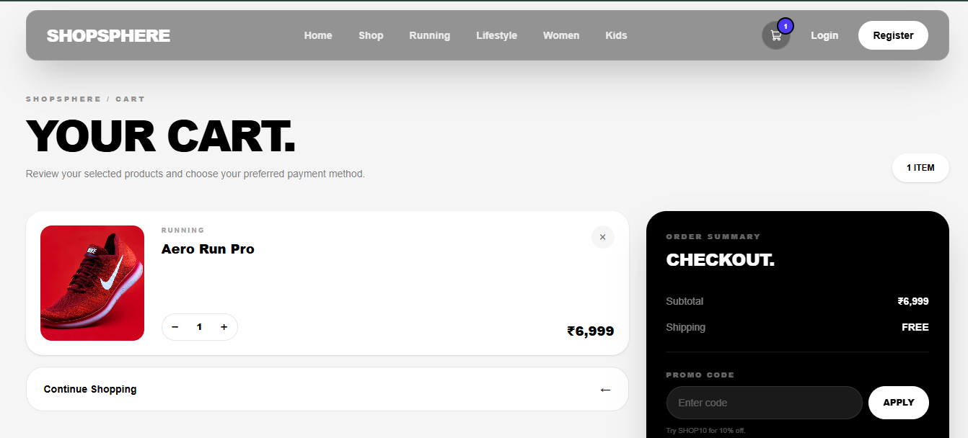
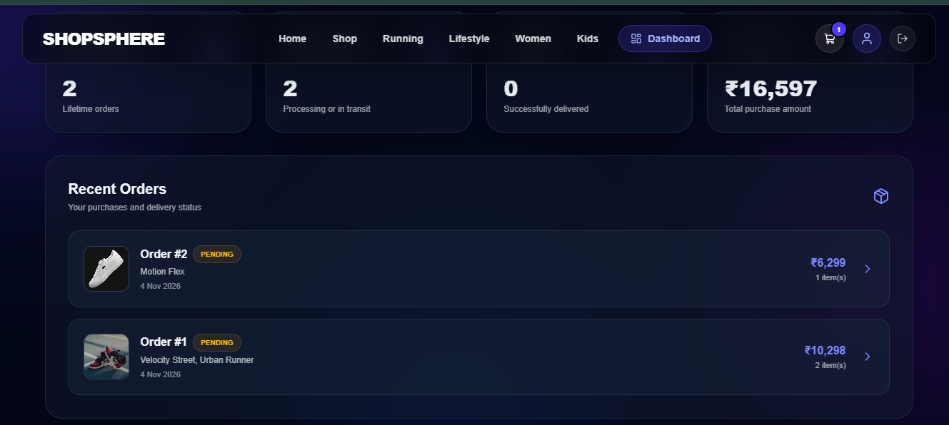

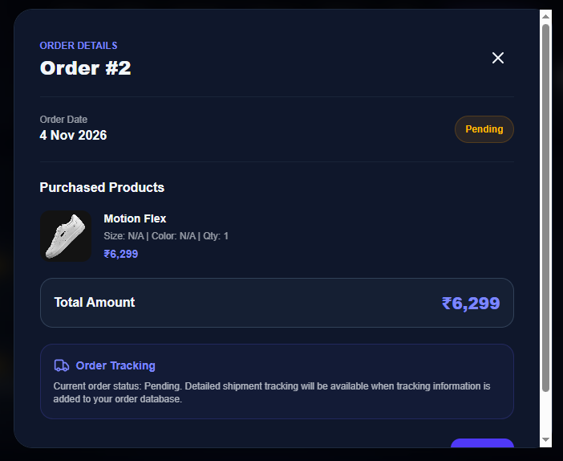

FINAL DECLARATION
I hereby submit this Week 6 documentation for the ShopSphere Full Stack E-Commerce Application.
This report presents the deployment process, maintenance strategy, testing activities and reflection on the development experience.
The project helped me understand the practical requirements of deploying, troubleshooting and maintaining a full-stack web application.
Submitted by: Rutuja Shendure
Project: ShopSphere – Full Stack E-Commerce Application
Task: Week 6 – Deployment, Maintenance, and Project Reflection

