**ASSIGNMENT: - 05**

**Problem Statement: -**

Visualize the data using R/Python by plotting the graphs for assignment no. 1 and 2. Consider a suitable data set.

a) Use Scatter plot, bar plot, Box plot and Histogram

OR

b) Perform the data visualization operations using Tableau for the given dataset.

**S/W, Library and Package:**

1. Software:

Python

Jupyter Notebook (for interactive visualization within Jupyter)

1. Libraries:

pandas: For data manipulation and handling

matplotlib: For creating visualizations such as scatter plot, bar plot, box plot, and histogram

seaborn (optional): For enhanced statistical visualizations

1. Packages:

NumPy: For numerical computations and array operations

**Theory:**

Methodology:

1. Scatter Plot: A scatter plot is used to visualize the relationship between two variables. Each point on the plot represents a data point with values for both variables.
2. Bar Plot: A bar plot is used to compare categorical data by showing the value of each category as bars of different heights.
3. Box Plot: A box plot (box-and-whisker plot) is used to display the distribution of a dataset and identify outliers, quartiles, and median.
4. Histogram: A histogram is used to represent the frequency distribution of continuous data by dividing it into bins and showing the number of data points in each bin.

Advantages:

1. Scatter Plot: Shows patterns and relationships between variables.
2. Bar Plot: Effective for comparing categories and displaying trends.
3. Box Plot: Provides insights into the spread and central tendency of data.
4. Histogram: Visualizes data distribution and helps identify data skewness.

Applications:

1. Scatter Plot: Used in regression analysis, correlation studies, and identifying clusters or patterns in data.
2. Bar Plot: Used in market research, sales analysis, and comparing performance across categories.
3. Box Plot: Used in statistical analysis, outlier detection, and comparing distributions across groups.
4. Histogram: Used in data preprocessing, understanding data distribution, and identifying data anomalies.

Limitations:

1. Scatter Plot: Limited in displaying multiple variables simultaneously.
2. Bar Plot: Not suitable for continuous data visualization.
3. Box Plot: May not show detailed data distribution compared to other plots.
4. Histogram: Sensitive to bin size, and interpretation can vary based on binning method.

Examples:

Creating a sales dashboard to monitor revenue trends and performance metrics.

Visualizing customer segmentation for targeted marketing strategies.

Analyzing website traffic patterns and user behavior through interactive dashboards.

**Working/ Algorithm:**

1. Import necessary libraries (pandas, numpy, matplotlib.pyplot, seaborn).
2. Load Mall Customers dataset from Excel file into a pandas DataFrame (mall).
3. Display first few rows of the DataFrame using mall.head().
4. Generate descriptive statistics for numeric columns using mall.describe().
5. Create scatter plot of Age vs CustomerID using plt.scatter and display using plt.show().
6. Create bar plot of Age vs CustomerID using plt.bar and display using plt.show().
7. Create box plot for Age column using sns.boxplot and display using plt.show().
8. Generate random data (10x10 array) using np.random.random.
9. Create heatmap of random data using plt.imshow, add color bar, and display using plt.show().
10. Create histogram of Age column using plt.hist and display using plt.show().

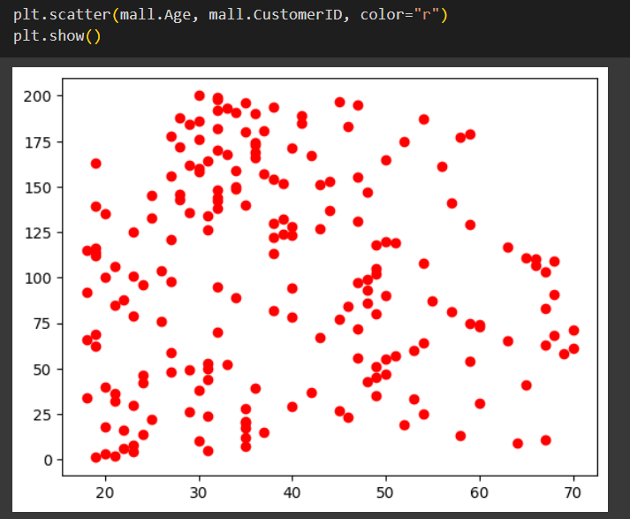

"Scatter plots reveal relationships between variables through dots scattered across a graph, showcasing patterns, trends, and correlations."

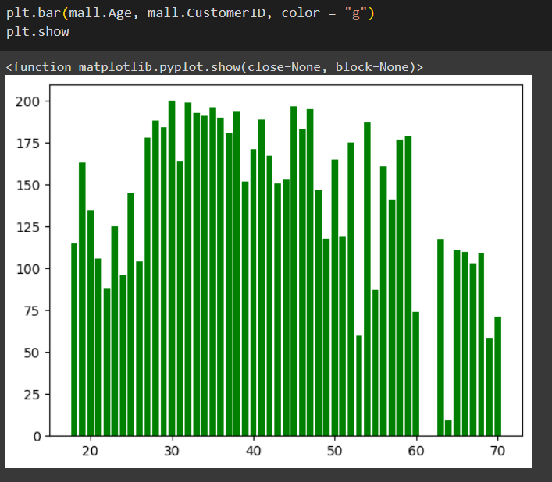

"Bar plots are a visual representation of categorical data using rectangular bars with lengths proportional to the values they represent."

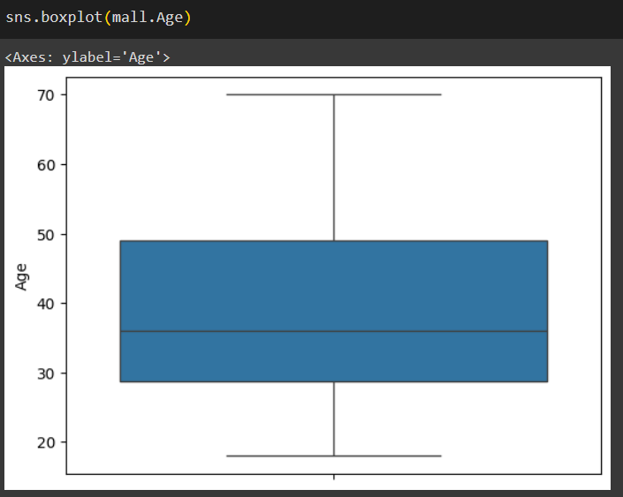

"Box plots are useful for visualizing the spread, central tendency, and outliers in a dataset, providing insights into the variability and distribution of the data."

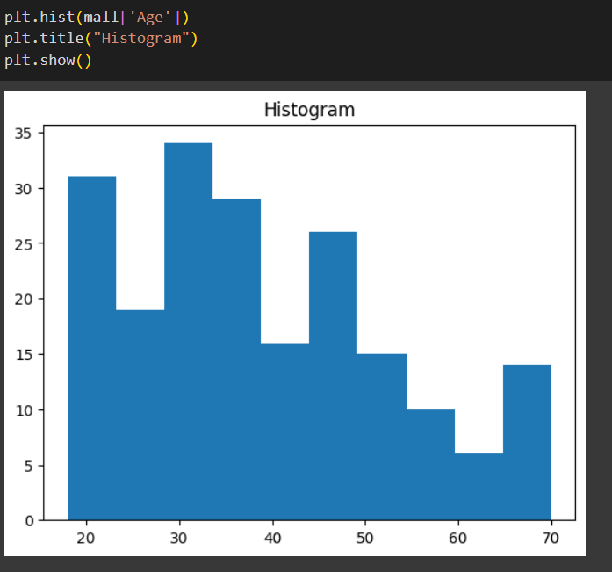

"A histogram graph is a visual representation of the distribution of numerical data, displaying the frequency of values within predefined intervals called bins."

**Conclusion:**

The visualizations reveal key insights:

1. Scatter Plot: Shows relationships between variables; no clear pattern observed in the sample data.
2. Bar Plot: Compares categorical data; category C has the highest value in the sample data.
3. Box Plot: Illustrates data distribution and outliers; category E has a higher median value compared to others.
4. Histogram: Depicts the frequency distribution of numerical data; values are evenly distributed across bins in the sample data.

Overall, these visualizations provide a comprehensive understanding of the dataset's characteristics, including relationships, distributions, and outliers, aiding in data analysis and decision-making.