Playwright

Application supported – Web browser apps, mobile web apps, API

Languages supported – Javascript, Typescript, Java, Python & .Net(C#)

Browsers supported – Chromium, WebKit(Safari) and Firefox (headed/headless)

OS supported – Windows, MacOS, Linux, Support CI Runs

Features Playwright:

1. Free & Open source
2. Multi – browser, Multi - Language, Multi-OS support
3. Automate: Functional, API, Accessibility testing (by using 3 party tool/integration)
4. Build-in reporters, custom reports
5. CI, CD, Docker
6. Parallel testing
7. Auto wait
8. Build – in assertions
9. Multi tab & multi window support (not in cypress)
10. Frames, shadow dom
11. Test parameter
12. Emulate mobile devices
13. Faster than Selenium & Cypress
14. Official documentation: <https://playwright.dev/>

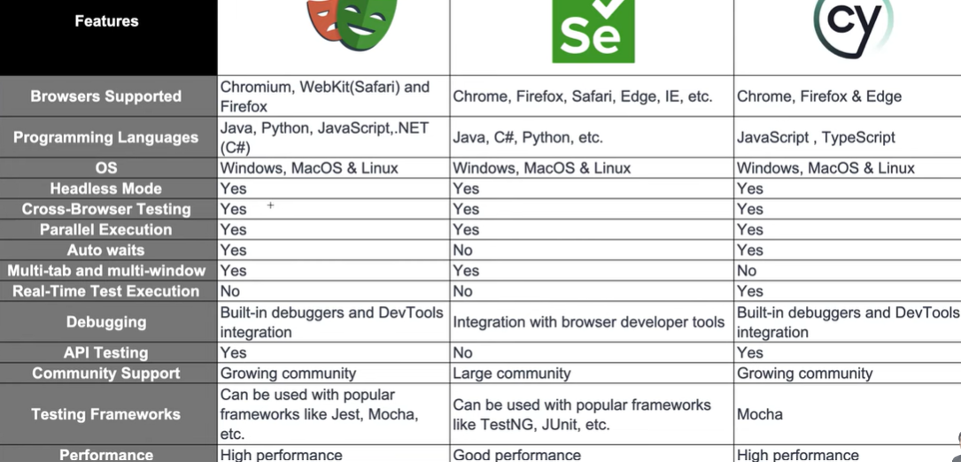

**Installation:**

**Steps:**

1. Install Node js: <https://nodejs.org/en/download/prebuilt-installer>
2. Commands: node -v ; node –version; npm -v; npm –version
3. Download VS Code Editor: <https://code.visualstudio.com/download>
4. Create project folder -> Open in VSCode
5. Install playwirght using Terminal: “npm init playwright@latest”

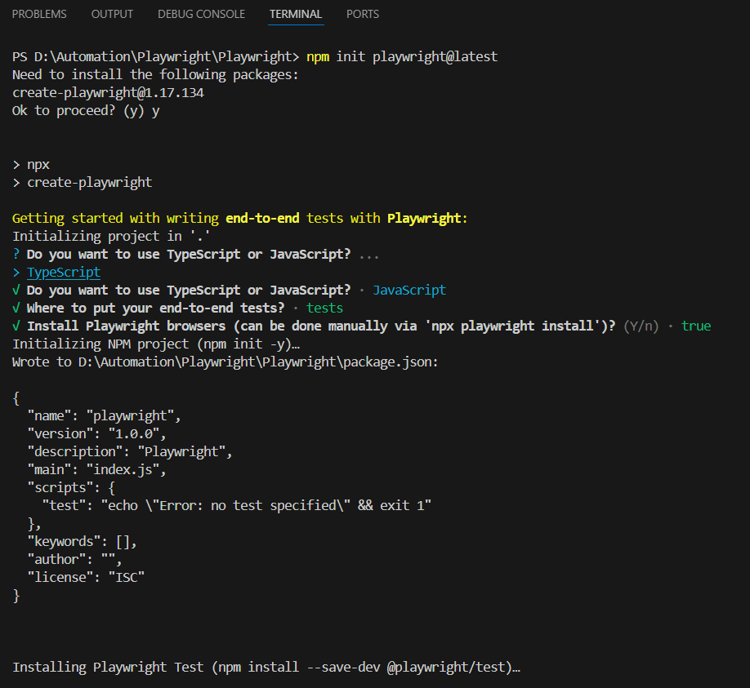

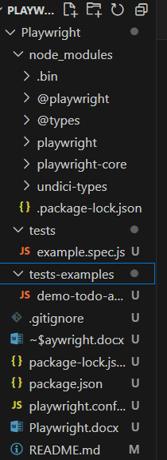

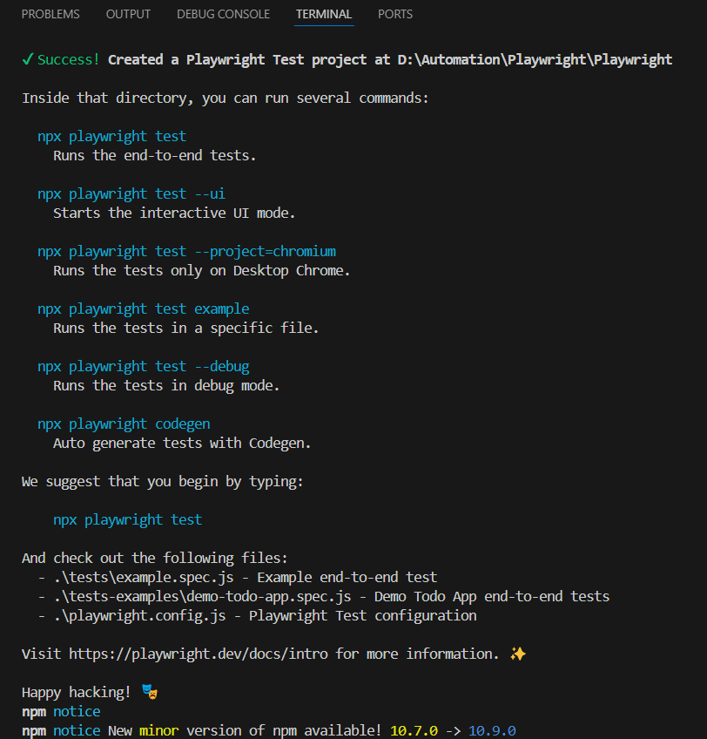

Default Path:

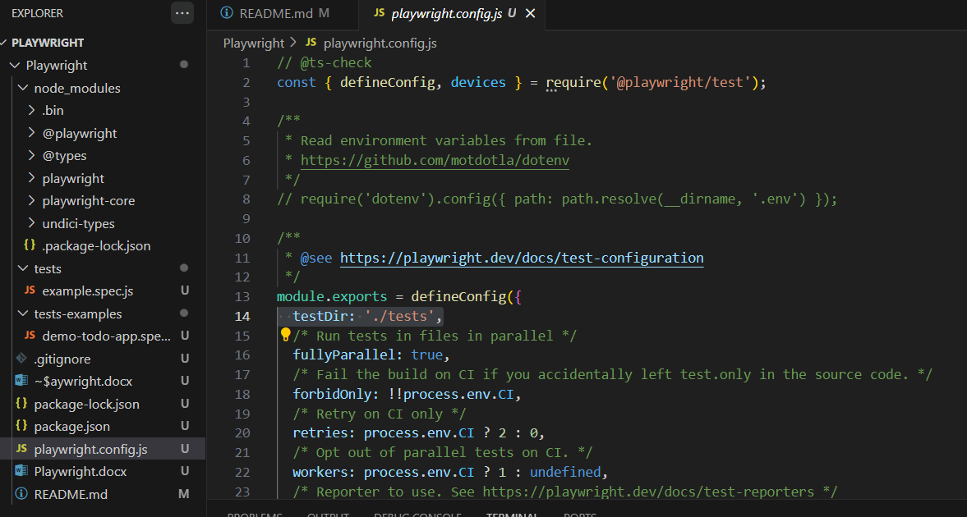

1. Files: **playwright.config.js** :

All configuration part

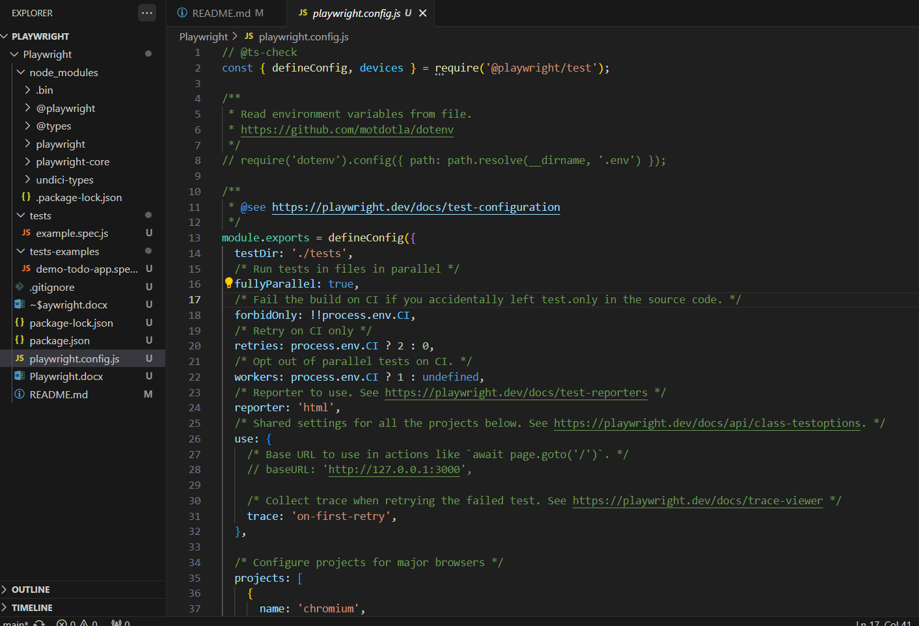

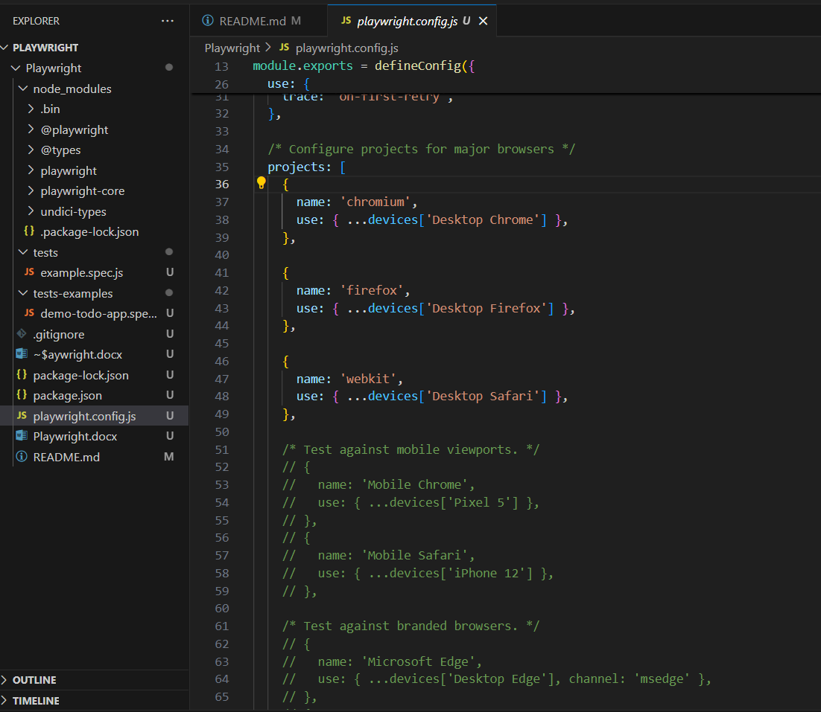

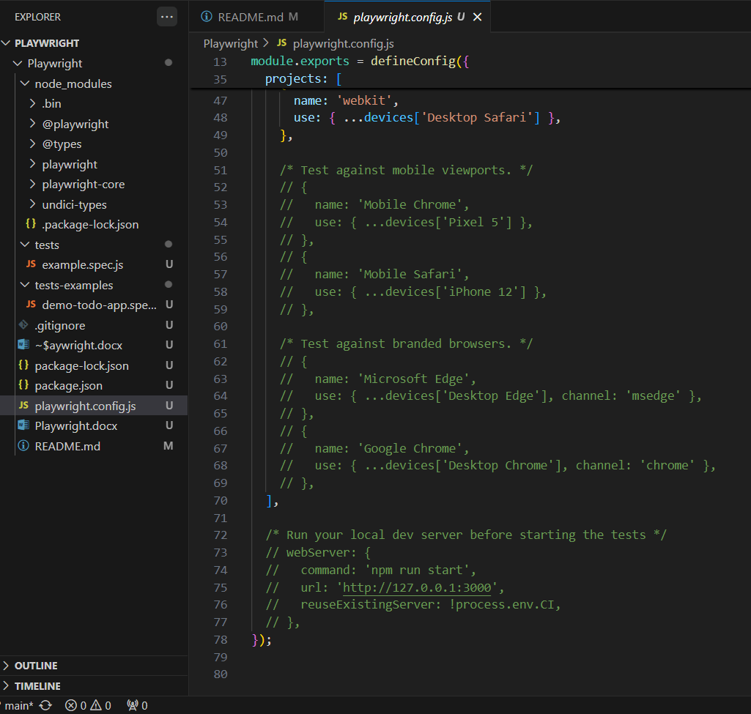

1. File: **package.json** -> similar to pom.xml file in maven project(in Selenium)

To add dependencies related to project

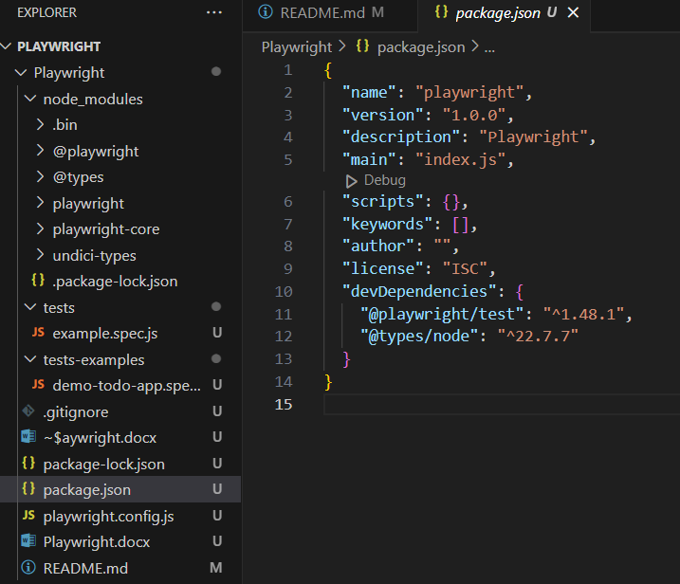

1. plawright.config: Configuration file; package.json: Project management file of node js projects
2. version of playwright installed:  npm playwright -v
3. VS code extension:

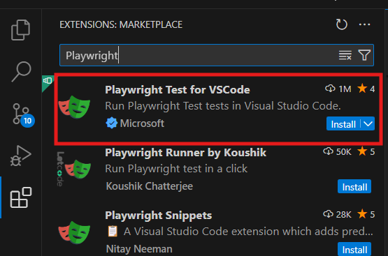

1. Command to run test: npx playwright test
2. Headed mode: npx playwright test –headed
3. Reports: npx playwright show-report

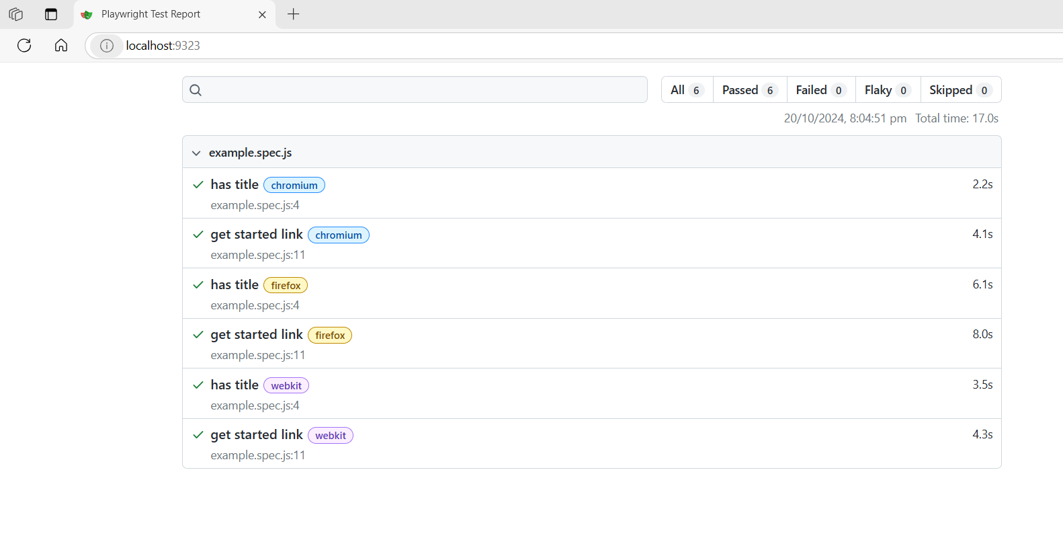

Installation:

1) Nodejs

2) VS Code

3) Create project file ---> open in VSCode

4) install playwright using terminal

npm init playwright@latest

package.json ---> node project management file

playwright.config.js ---> playwright configuration

tests ---> we can all teh playwright tests

npm playwright -v ---> return installed version of playwright

5) install playwright using vscode extension

![alt text](image-1.png)

6) Command to run test: npx playwright test

7) By default playwright will execute all the tests in hedles mode: so we will not see any browser launching/UI

8) To run in headed mode: npx playwright test --headed

9) Run Playwright test:

npx playwright test

npx playwright test --headed

npx playwright show-report ---> Will open/Show automatically created reports

![alt text](image-2.png)

**How to Create & Run test in Playwright**

Test:

Extension of test file: .spec.js (Ex: example.spec.js)

**# Create and Run tests commands**

1) npx playwright test ---> runs all the tests on all the browsers in headless mode

2) npx playwright test MyTest.spec.js ---> runs a specific test file

3) npx playwright test Mytest.spec.js --project=chromium ---> runs on specific browser

4) npx playwright test MyTest.spec.js --project=chromium --headed ---> runs on specific browser and headed mode

5) npx playwright test Mytest.spec.js --project=chromium --headed --debug ---> runs on specific browser, headed mode and dubuger on

**Locating Web Elements Locators-Property, XPath, CSS**

Locating Elements in Playwright:

1. Property
2. CSS
3. Xpath