**TECHNICAL DESIGN DOCUMENT**

**PROJECT NAME:** Avion Flight Reservation Service

**DEVELOPED BY:** Ruturaj Patil

**Introduction:**

Avion Flight Reservation Service is developed to passengers/customers cstomized flight reservation experience. It aims to make flight reservation user focused and relatively easy process.

**Functional Requirements:**

The functional requirements of the project are:

* Login
* Register
* Search Flights
* Tickets
* View Tickets
* Cancel Tickets

**Services**

The different micro-services in which this project is divided into are:

* **User Registration :** User can register on website to use all the services.
* **User Login :** User will have to just enter username and password for validation.
* **Search Flight:** User can search flight by providing source, destination.
* **Book Flight:** User can book any flight from all the available flights.
* **View Bookings:** User can view the reservations made by me.
* **Cancel Booking:** User can cancel booking made by him.

**Overall Architecture Diagram:**

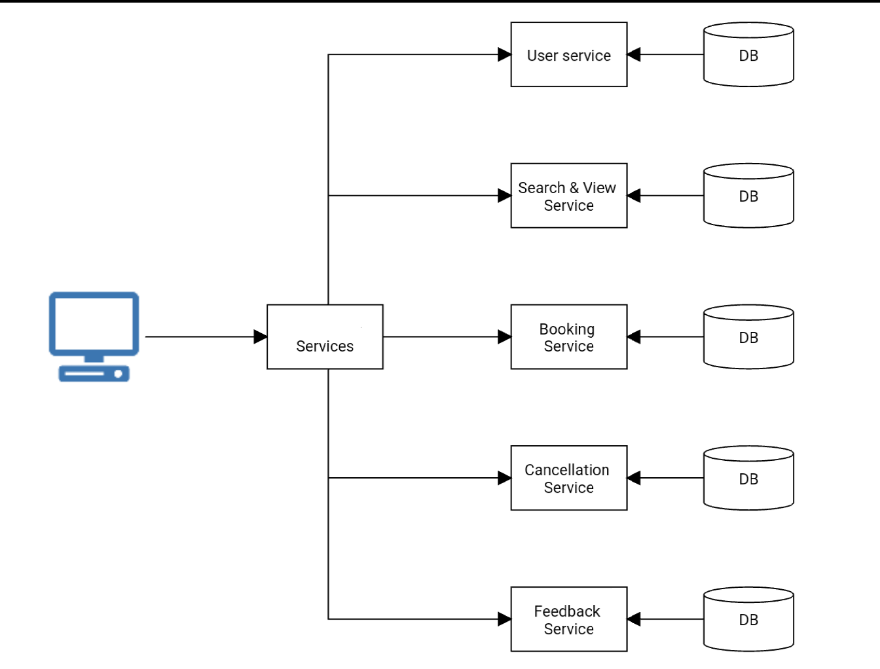

**Overall Entity Relationship Diagram:**

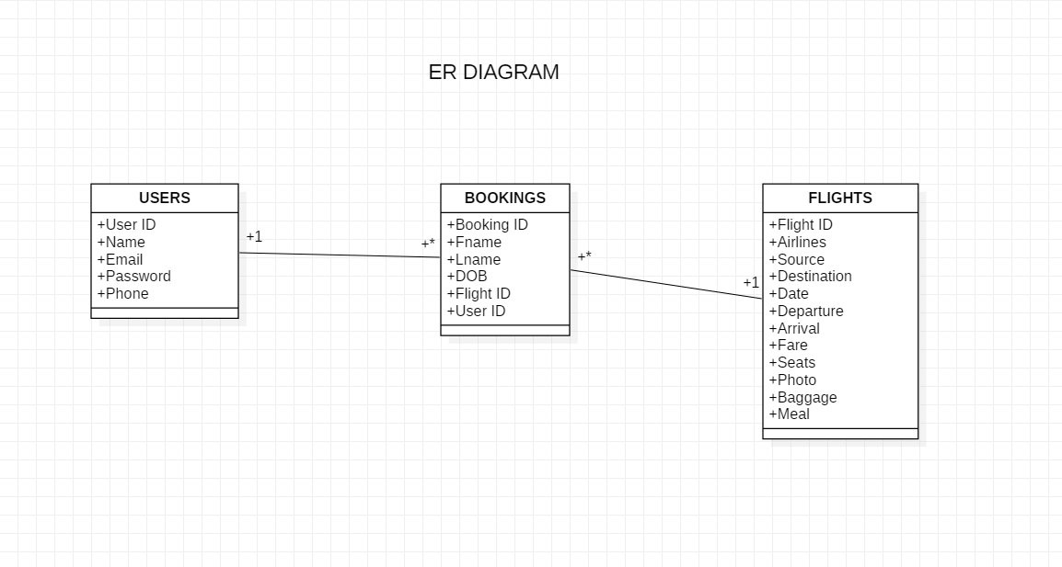

**Sequence Diagrams:**

**SIGN UP-**

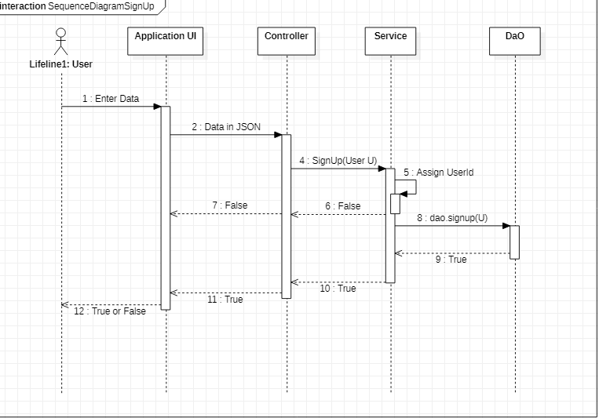

SIGN IN-

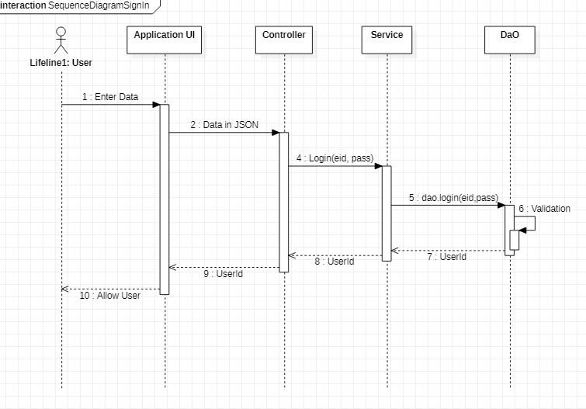

**Class Diagrams-**

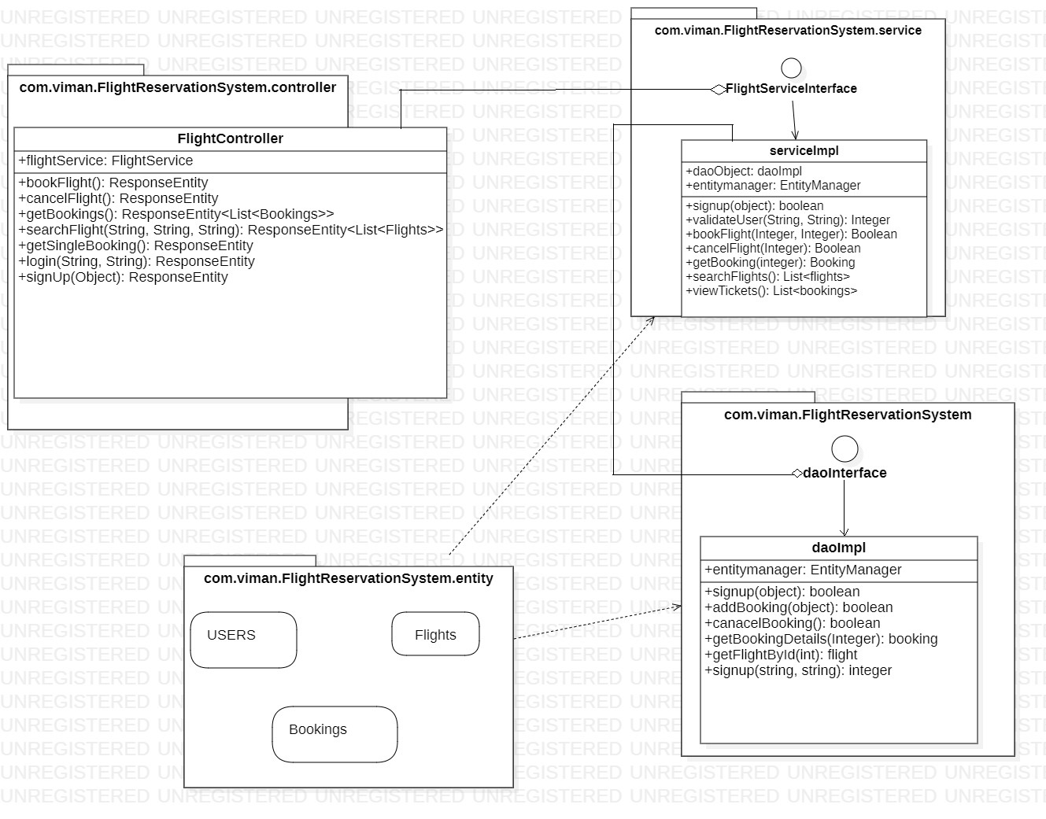

**Activity Diagrams-**

**SIGNUP-**

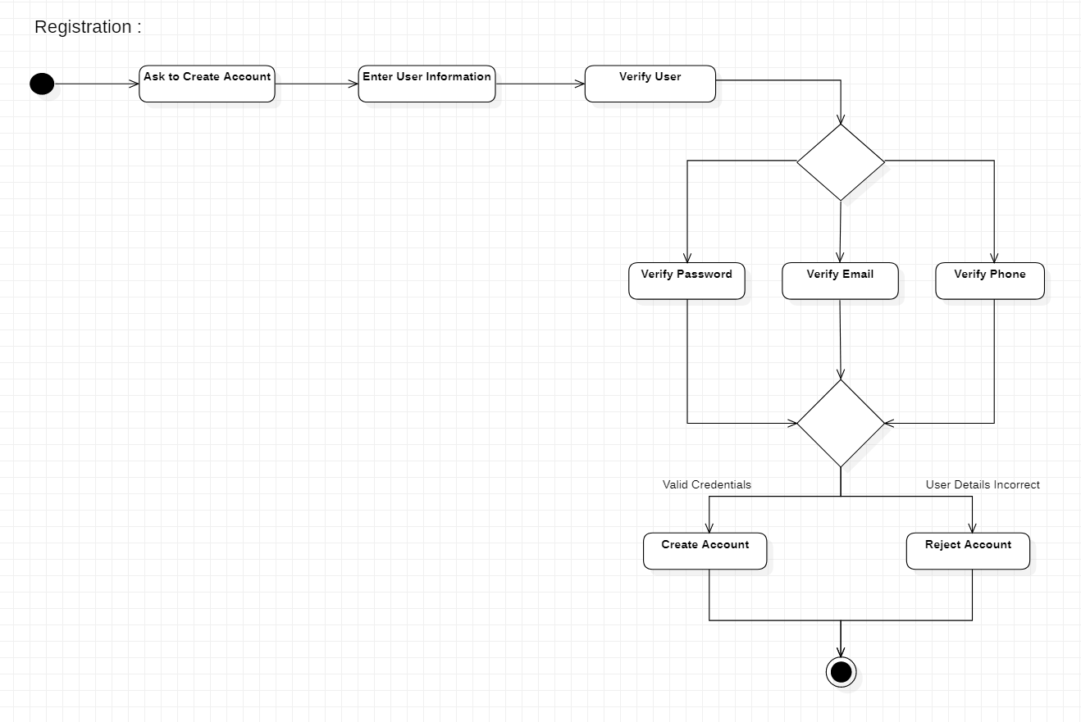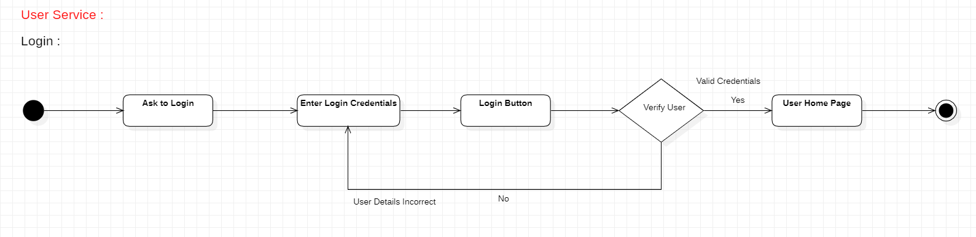

**LOGIN-**

**Wireframes-**

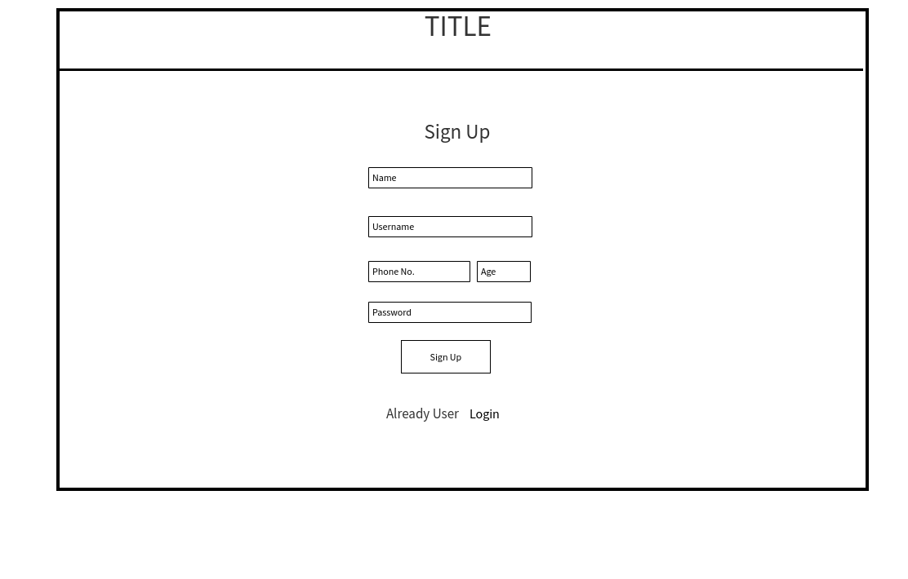**SIGNUP-**

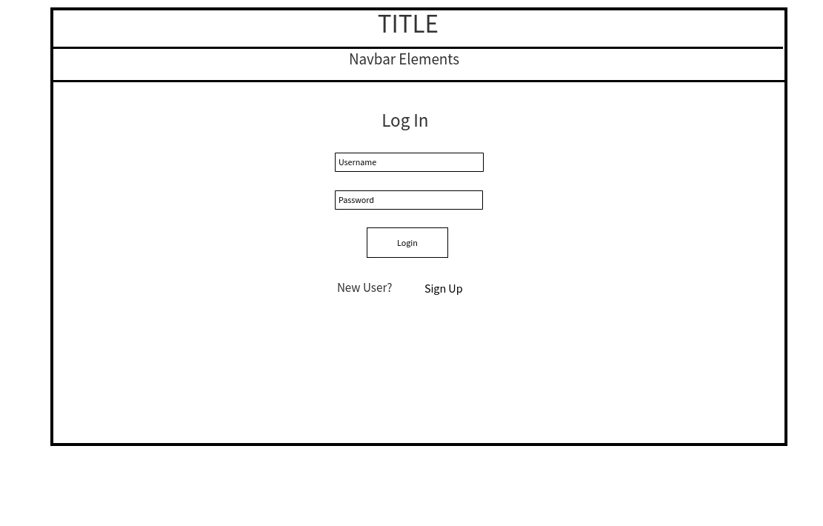

**LOGIN:**

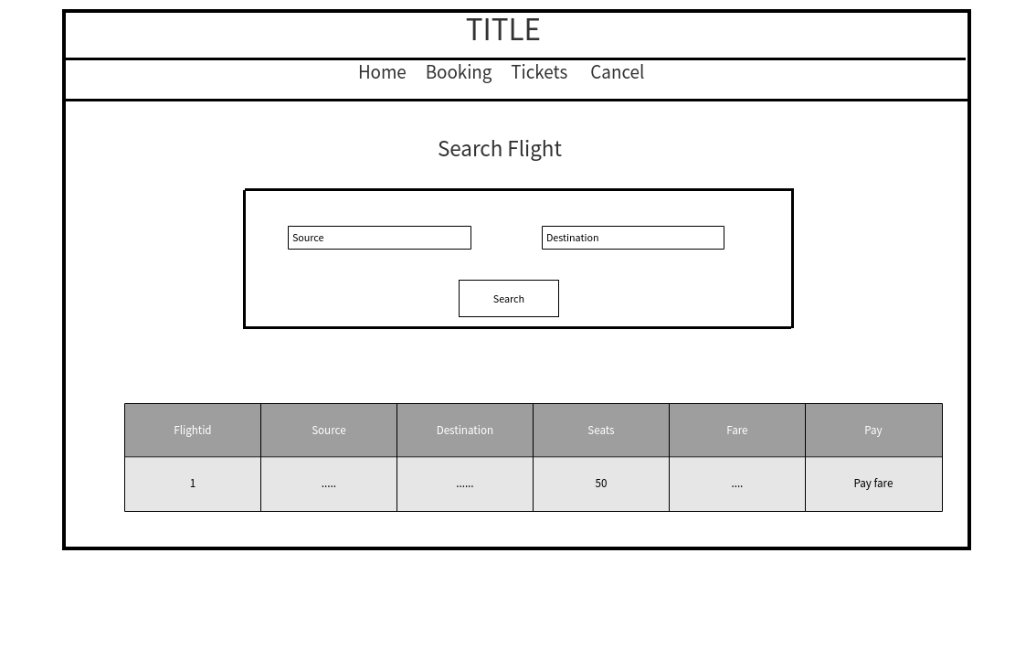

**SEARCH FLIGHT:**

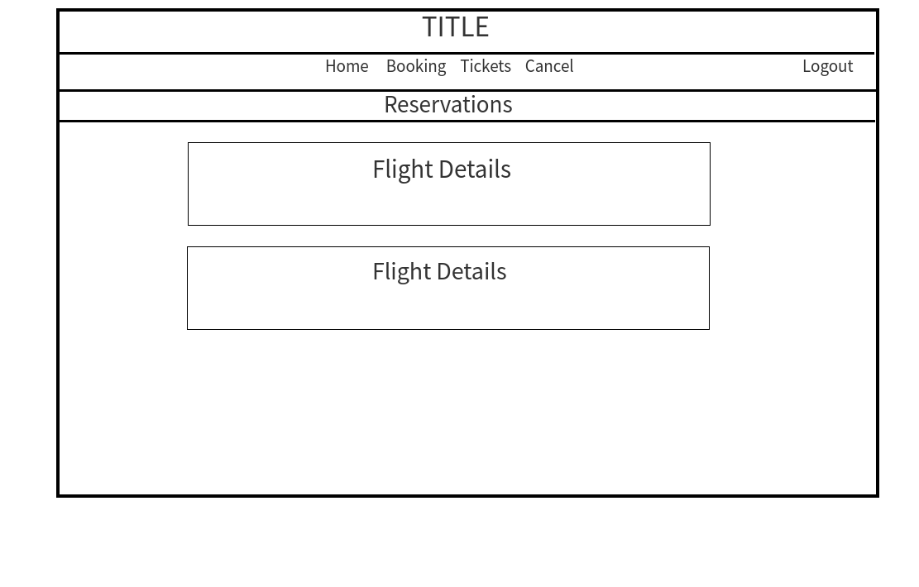

**VIEW FLIGHTS-**

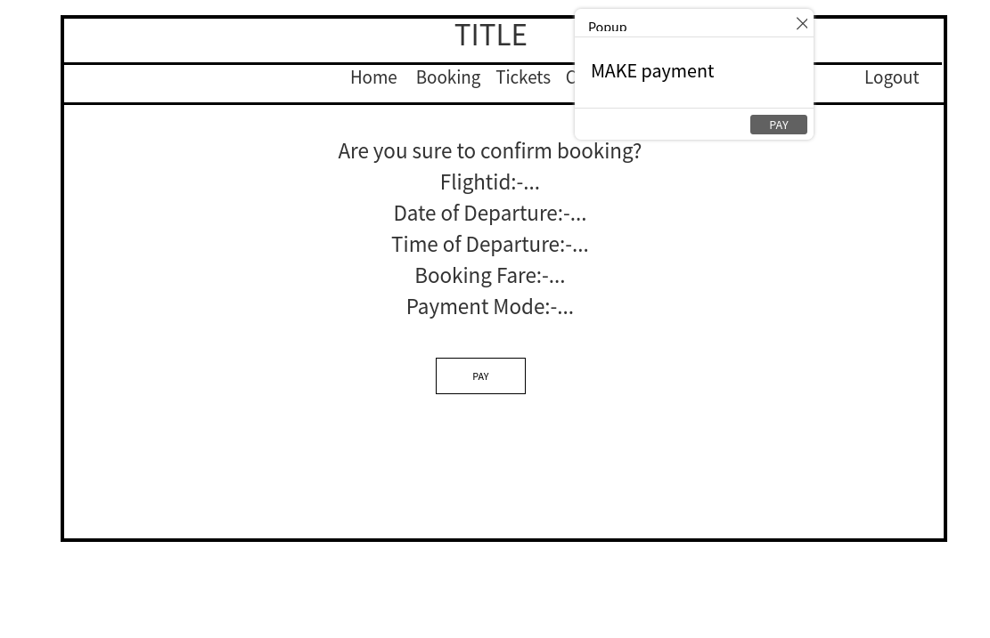

**PAYMENT GATEWAY-**



**VIEW BOOKINGS-**

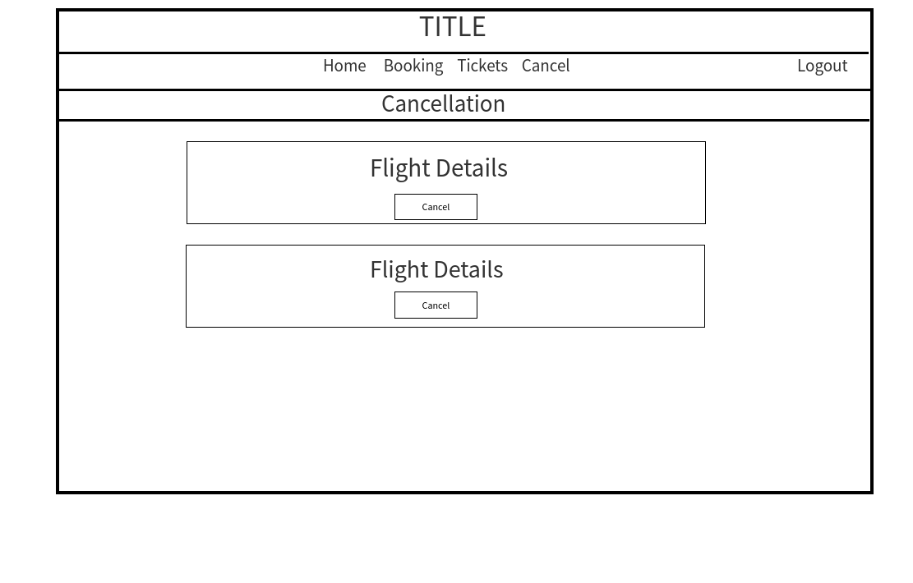

**CANCEL TICKETS-**