**D Y PATIL COLLEGE OF ENGINEERING & TECHNOLOGY**

**KASABA BAVADA, KOLHAPUR**

**DEPARTMENT OF COMPUTER SCIENCE AND ENGINEERING**

(Academic Year: 2017 - 2018)



A

Project Synopsis On

**“Bob vs ATM”**

Submitted by:

|  |  |  |
| --- | --- | --- |
| **S.N** | **Name** | **Roll. No.** |
| 1 | Dnyaneshwar Mahadeo Raut | 63 |
| 2 | Ruturaj Ravindra Sawant | 66 |
| 3 | Apurv Avinash Kumbhar | 58 |
| 4 | Rajahmed Bashir Sayyad | 68 |

**Under the guidance of**

**Prof. Mrs. D. R. Patil**

**Class: SE Div.: A Batch: S4**

**Introduction :**

* Due to shortage of ATMs, a bank decided to convert some arcade gaming machines into ATMs. Unfortunately, due to a bug, the converted machine will only dispense cash if the withdrawer can win the game. The game is played over a valid bracket sequence. Formally a valid bracket sequence is defined as:

1. An empty string is valid

2. If *A* is a valid bracket sequence, then (*A*) is also valid

3. If *A* and *B* are valid, *AB* is also valid

* In each move a player can erase such a non-empty valid sub-string of the remaining brackets such that they cannot be formed by concatenating 2 valid sequences. E.g. a player can erase (()) or (()()) but not ()() or (())(). The ATM always plays first. The player that is not able to make a move will lose the game. Assume that both the players play optimally.
* The first line of the input contains an integer *T* denoting the number of test cases. The description of *T* test cases follows.

Each of the test case consists of a single line containing the string *S* (the initial bracket sequence).

* For each test case, output a single line containing the winner — either ‘ATM’ or ‘Bob’ without quotes.
* Constraints:

• 1 <= T <= 105

• 2 <= length of S <= 105

• The sum of all lengths of S will be not more than 106

• S will be a valid bracket sequence

**Problem Statement:**

Bob is trying to withdraw money and is frustrated as he keeps losing against the machine. He suspects the machine is rigged and always wins the game. So, he has asked us to help him out. Given a valid bracket sequence, can you determine who wins the game ?

**Block Diagram:**

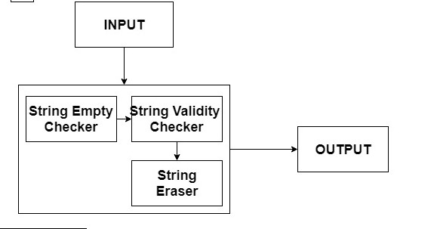

**Flow Chart:**

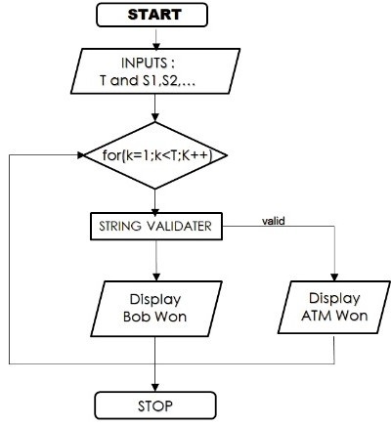

**Input:**

* The first line of the input contains an integer *T* denoting the number of test cases. The description of *T* test cases follows.
* Each of the test case consists of a single line containing the string *S* — the initial bracket sequence.

**Output:**

* For each test case, output a single line containing the winner — either ‘ATM’ or ‘Bob’ without quotes.

**Constraints :**

* 1 *<= T <=* 10000
* 2  *<= length of S <=* 10000
* The sum of all lengths of *S* will be not more than 1000000
* *S* will be a valid bracket sequence

**Applications:**

* To find correct algorithm and program to beat ATM game’s LOGIC.
* To find correct and wrong bracket sequences.

**Software Requirement Specification:**

* + Language : c++
  + Operating system : Windows 10 / Ubuntu 16,04
  + Compiler: : GNU G++
  + RAM : 1 GB
  + Processor : Pentium 4 onwards

**Reference:**

* [www.acmicpc.com](http://www.acmicpc.com)
* [www.google.com](http://www.google.com)
* [www.stackoverflow.com](http://www.stackoverflow.com)
* [www.cppreference.com](http://www.cppreference.com)
* [www.geeksforgeeks.com](http://www.geeksforgeeks.com)

**Conclusion:**

Here we are developing the program for Bob vs ATM to find string sequence is valid or invalid.